HW1

Corinna Hong

January 13, 2020

# 1. Mean Density of Adults

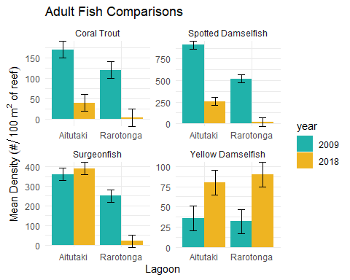

Coral trout, spotted damselfish, and surgeonfish all showed statistically significant differences in density between Rarotonga and Aitutaki both in 2009 and 2018. Coral trout, spotted damselfish, and surgeonfish had higher densities on Aitutaki than Rarotonga in both years.

Coral trout, spotted damselfish, and yellow damselfish showed a statistically significant difference in density between 2009 and 2018 for both Rarotonga and Aitutaki. Surgeonfish only showed a statistically significant difference in density between 2009 and 2018 at Rarotonga. Coral trout and spotted damselfish had higher densities in 2009 than in 2018 at both lagoons. Yellow damselfish had higher densities in 2018 than 2009 at both lagoons.

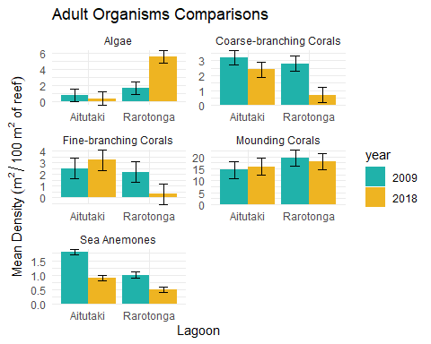

Sea anemones showed a significant difference in density between Rarotonga and Aitutaki in 2009 and 2018. Algae, coarse-branching corals, and fine-braching corals only showed a significant difference in density between Rarotonga and Aitutaki in 2018. Average sea anemone density was higher in Aitutaki than Rarotonga for both years. Average algae density was higher in Rarotonga than Aitutaki in 2018. Average coarse-branching coral and fine-branching coral density was higher in Aitutaki than Rarotonga in 2018.

Coarse-branching corals and sea anemones showed significant differences in density between 2009 and 2018 at both Rarotonga and Aitutaki. Algae showed a significant difference in density between 2009 and 2018 only at Rarotonga. Coarse-branching coral density was higher in 2009 than 2018. Sea anemones decreased in density between 2009 and 2018 at both Aitutaki and Rarotonga. Average algae density increased at Rarotonga from 2009 to 2018.

# 2. Mean Density of Recruit Organisms

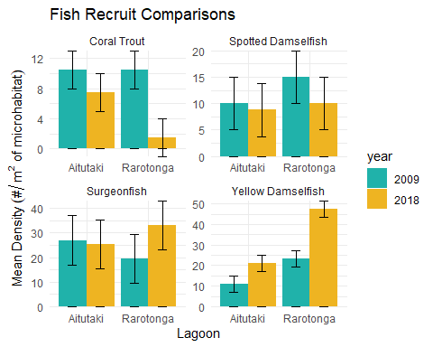

Yellow damselfish recruits showed a significant deifference in density between Aitutaki and Rarotonga in 2009 and 2018. Average yellow damselfish density was higher in Rarotonga than Aitutaki for both years. Coral trout showed a significant difference in density betwwen Aitutaki and Rarotonga in 2018. Average coral trout density was higher in Aitutaki than Rarotonga for that year.

Coral trout and yellow damselfish showed significant differences in density in 2009 and 2018 at both lagoons. Average coral trout density was higher in 2009 than 2018 at both lagoons. Average yellow damselfish density was higher in 2018 than 2009 at both lagoons. Surgeonfish at Rarotonga showed a significant difference in density between 2009 and 2018 where densities were higher in 2018 than 2009.

# 3. Mean Density of Recruits and Adults per Area of Reef

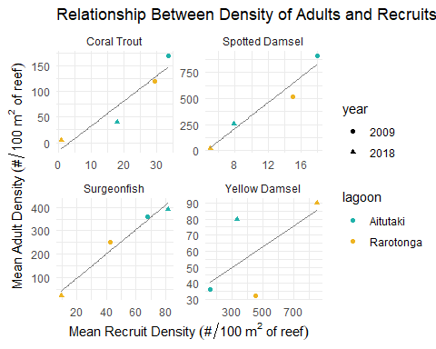

All species of fish show positive correlations between average adult fish density and average fish recruit density. The linear models fits the data for Surgeonfish the most, with R2 = 0.97. This means that the positive correlation between adult sugeonfish and surgeonfish recruits is mostly predicted by the value of the recruit density. The linear model for yellow damselfish has the lowest R2 value of 0.40. This means that, based on my linear model, the value of recuit density does not predict the value of adult fish density as well as the other models.

# 4. Adults and Microhabitat

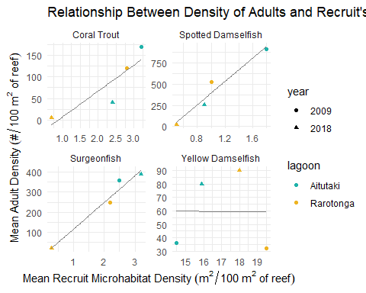

Coral trout, spotted damselfish, and surgeonfish all show a positive relationship between microhabitat density of their young and adult density. Yellow Damselfish shows no correlation between the two. Once again, the liner model fits the data for surgeonfish the best with am R2 value of 0.96. This means that the density of fish recruit microhabitat predicts the density of adult fish of the same species well. The model for yellow damselfish has an R2 value of 0.00, indicating that microhabitat density is not a strong predictor of adult fish density for that species.

# 5. Density of Adults per Area of Bottom Cover

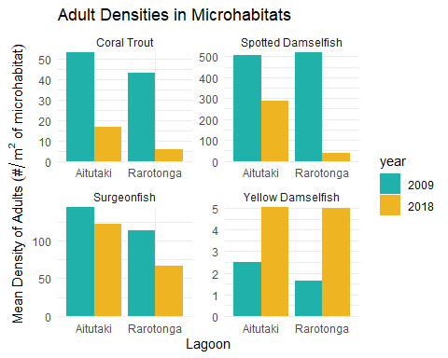

Difference bteween laggons

Average density of coral trout and surgeonfish is higher in Aitutaki than Rarotonga in 2009 and 2018. Average density in spotted damselfish in higher in Aitutaki than Rarotonga in 2018. Average yellow damselfish density is higher in Aitutaki than Rarotonga in 2009.

Coral trout and spotted damselfish show large differences in average density in 2009 and 2018 at both lagoons. Average surgeonfish density shows a large decline from 2009 to 2018 at Rarotonga. Average yellow damselfish density increases from 2009 to 2018 at both lagoons.

# 6. Fish Pair Comparisons

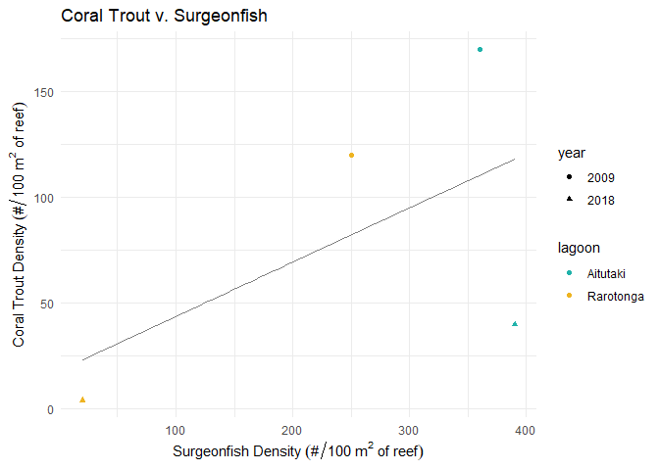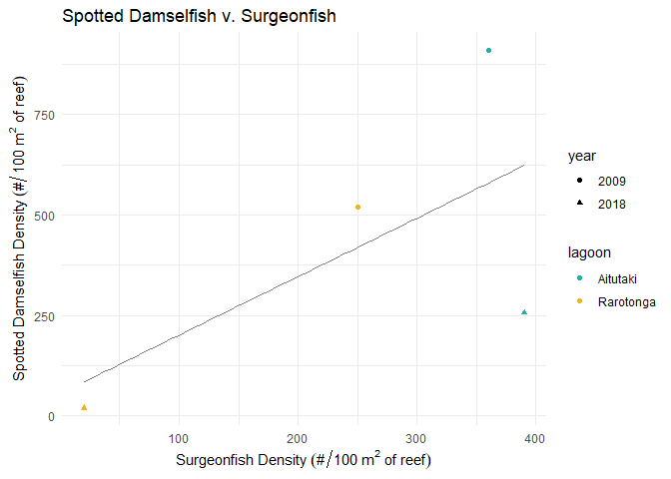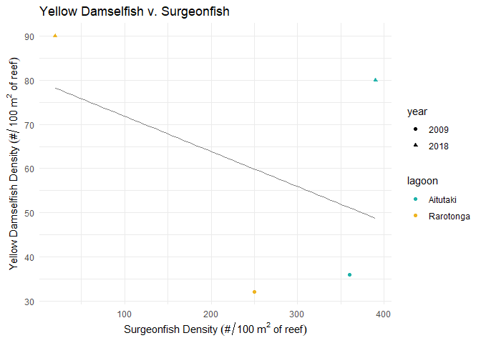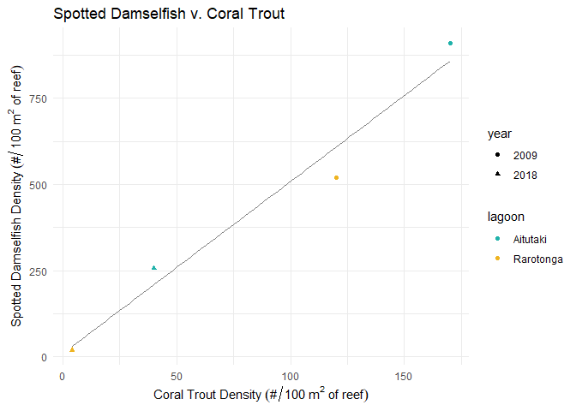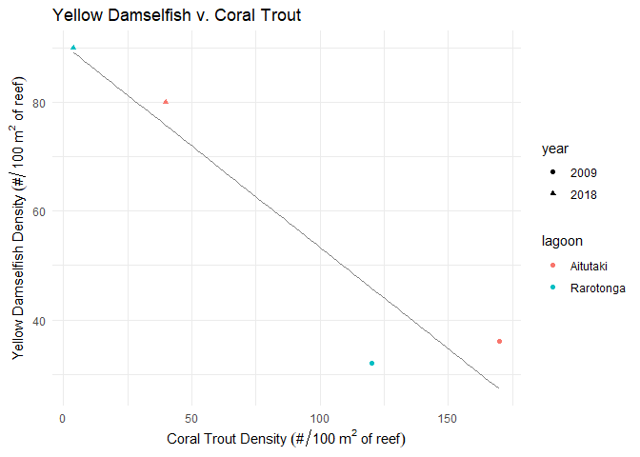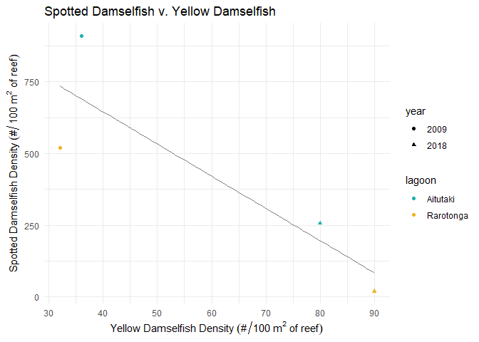

The pairs of surgeonfish and coral trout, surgeonfish and spotted damselfish, and coral trout and spotted damselfish all have positive relationships. This means that a high average density of one species is correlated with a high average density of the other. Out of the three pairs, coral trout and spotted damselfish have the highest R2 value of 0.97. Surgeonfish and yellow damselfish, coral trout and yellow damselfish, and spotted damselfish and yellow damselfish all have negative relationships. This means a high average density of one species is correlated with a low average density in the other. Out of the three pairs, coral trout and yellow damselfish have thie highest R2 value of 0.89.