Assignment 4

Corinna Hong

November 14, 2018

1. Lobster abundance and fishing pressure (2012 - 2017)

## Joining, by = c("SITE", "YEAR")

## Warning: Column `SITE` joining factor and character vector, coercing into  
## character vector

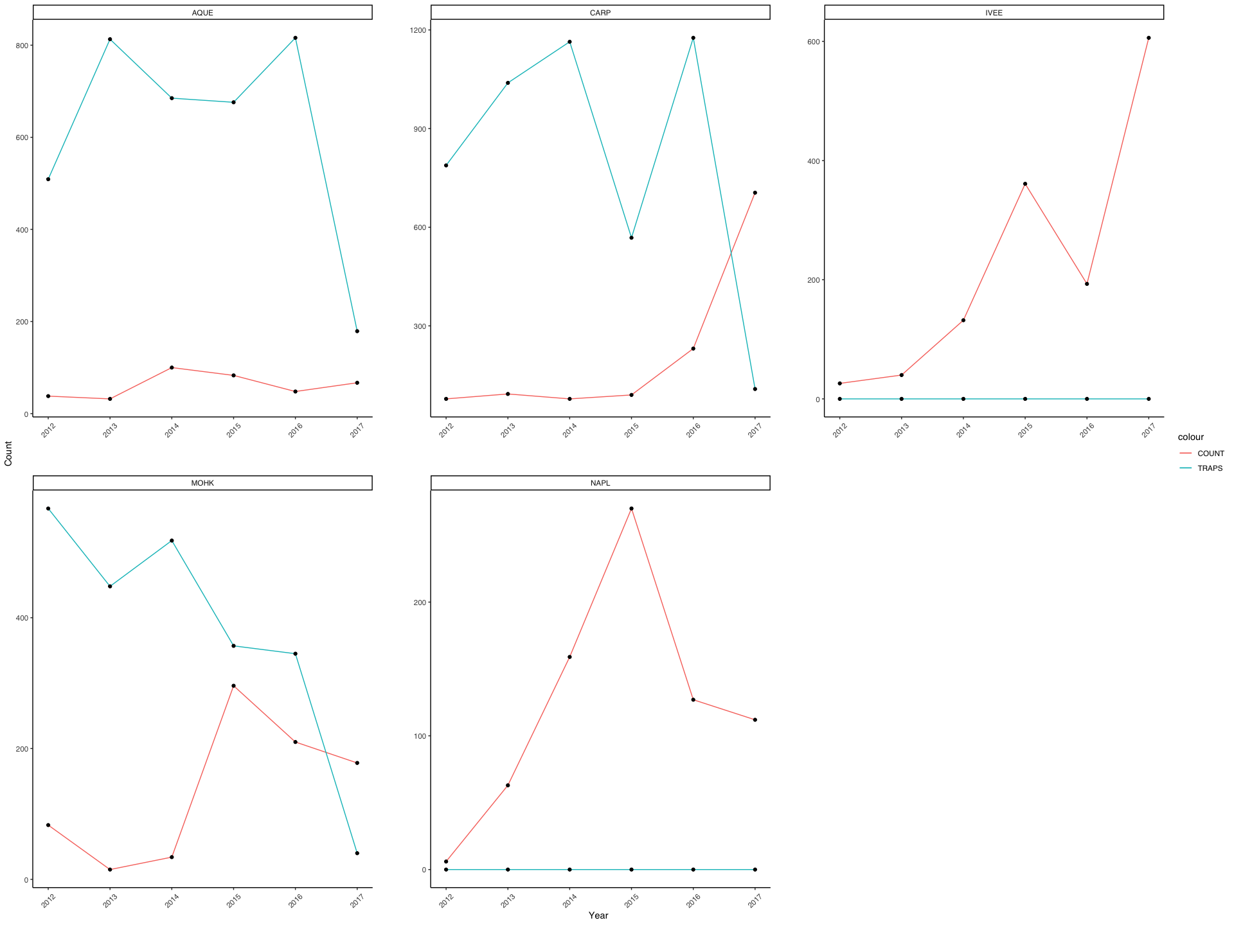

1. Compare mean lobster size by site in 2017

# New dataframe for only year 2017  
  
size_2017 <- lobster_abundance %>%   
 filter(YEAR == 2017) %>%   
 select(SITE, SIZE)   
  
  
  
# Data exploration  
  
#Histograms  
  
size_2017_hist <- ggplot(size_2017, aes(x = SIZE)) +  
 geom_histogram(bins = 12) +  
 facet_wrap(~ SITE, scale = "free") + # Create a histogram, split graphic visualization by site. Give each histogram its own y-axis scale  
 theme_classic()  
size_2017_hist

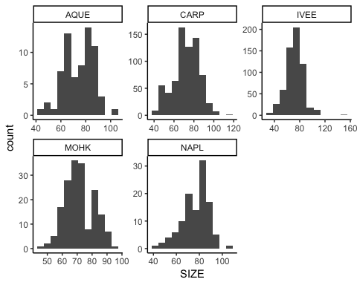

# QQ-Plots  
  
size_2017_qq <- ggplot(size_2017, aes(sample = SIZE)) +  
 geom_qq() +  
 facet_wrap(~ SITE, scale = "free") + # Create a Q-Q plot, split graphic visualization by site. Give each Q-Q Plot its own y-axis scale  
 theme_classic()  
size_2017_qq

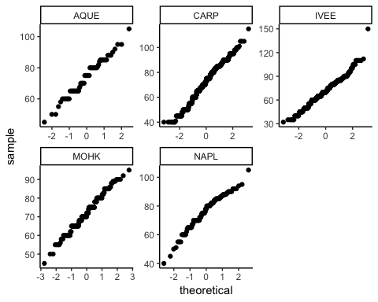

# Question: Is there a significant difference in mean lobster size between the five sites?  
  
# H0: There is no significant difference in mean lobster size between the five sites  
# HA: There is a significant difference in mean lobster size between the five sites  
  
  
  
# Levene's Test   
  
# H0: There are no differences in varance across groups (variances are equal)  
# HA: There are differences in variances across groups (variances are not equal)  
  
lobster_levene <- leveneTest(SIZE ~ SITE, data = size_2017)  
lobster_levene

## Levene's Test for Homogeneity of Variance (center = median)  
## Df F value Pr(>F)   
## group 4 8.3893 1.065e-06 ***  
## 1663   
## ---  
## Signif. codes: 0 '***' 0.001 '**' 0.01 '*' 0.05 '.' 0.1 ' ' 1

# p < 0.05. Reject the null hypothesis. Our variances are differenct (Variances are not equal)  
  
  
  
# What are the actual variances?  
  
variances <- size_2017 %>%   
 group_by(SITE) %>%   
 summarize(  
 mean = mean(SIZE),  
 sd = sd(SIZE),  
 variance = var(SIZE)  
 )  
  
# Our largest variance is less than 4x larger than our smallest variance  
  
  
  
# ONE-WAY ANOVA:  
  
lobster_aov <- aov(SIZE ~ SITE, data = size_2017)  
lobster_sum_aov <- summary(lobster_aov)  
lobster_sum_aov

## Df Sum Sq Mean Sq F value Pr(>F)   
## SITE 4 2355 588.6 3.424 0.0085 **  
## Residuals 1663 285871 171.9   
## ---  
## Signif. codes: 0 '***' 0.001 '**' 0.01 '*' 0.05 '.' 0.1 ' ' 1

lobster_ph <- TukeyHSD(lobster_aov)  
lobster_ph

## Tukey multiple comparisons of means  
## 95% family-wise confidence level  
##   
## Fit: aov(formula = SIZE ~ SITE, data = size_2017)  
##   
## $SITE  
## diff lwr upr p adj  
## CARP-AQUE -1.6657352 -6.24294710 2.911477 0.8582355  
## IVEE-AQUE -2.4433772 -7.05292315 2.166169 0.5968998  
## MOHK-AQUE -1.8955224 -7.02720717 3.236162 0.8514711  
## NAPL-AQUE 2.3366205 -3.19311600 7.866357 0.7775633  
## IVEE-CARP -0.7776420 -2.76097123 1.205687 0.8216104  
## MOHK-CARP -0.2297872 -3.23309697 2.773523 0.9995765  
## NAPL-CARP 4.0023556 0.36042398 7.644287 0.0228728  
## MOHK-IVEE 0.5478548 -2.50450730 3.600217 0.9882889  
## NAPL-IVEE 4.7799976 1.09751057 8.462485 0.0037001  
## NAPL-MOHK 4.2321429 -0.08607271 8.550358 0.0579286

# Box and whisker  
  
lobster_box <- ggplot(size_2017, aes(x = SITE, y = SIZE)) +  
 geom_boxplot(aes(fill = SITE, colour = SITE), alpha = 0.5, show.legend = FALSE) +  
 ylab("Mean Lobster Size (mm)") +  
 ggtitle("Lobster Sizes by Site (2017)") +  
 theme(plot.title = element_text(hjust = 0.5)) +  
 xlab("Site") +  
 theme(panel.grid.major = element_blank(), panel.grid.minor = element_blank(),  
 panel.background = element_blank(), axis.line = element_line(colour = "black"))  
lobster_box # Need to add a way to indicate significance

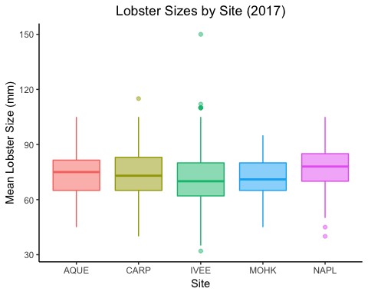

# Column graph of means   
  
lobster_col <- ggplot(variances, aes (x = SITE, y = mean)) +  
 geom_col() +  
 scale_y_continuous()  
lobster_col

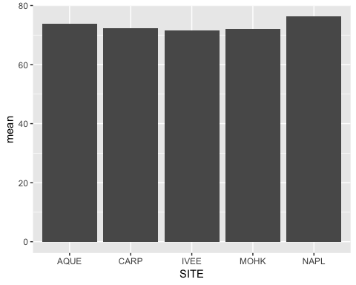

# New data frame for year 2012  
  
size_2012 <- lobster_abundance %>%   
 filter(YEAR == 2012) %>%   
 select(SITE, SIZE)   
  
  
  
# Data exploration  
  
#Histograms  
  
size_2012_hist <- ggplot(size_2012, aes(x = SIZE)) +  
 geom_histogram(bins = 12) +  
 facet_wrap(~ SITE, scale = "free") + # Create a histogram, split graphic visualization by site. Give each histogram its own y-axis scale  
 theme_classic()  
size_2012_hist

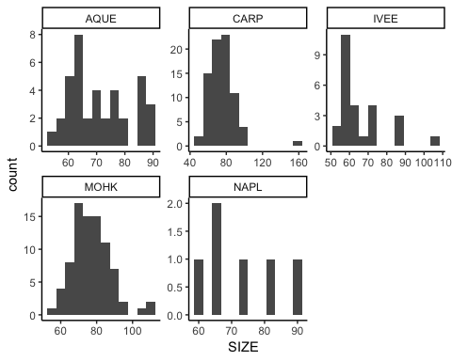

# QQ-Plots  
  
  
  
  
  
# Add the second data set (traps)  
abundance_traps_line <- abundance_traps_line + geom_line(aes(y = TRAPS, color = SITE), show.legend = FALSE) +   
 geom_point(aes(y = TRAPS, color = SITE), show.legend = FALSE)  
abundance_traps_line

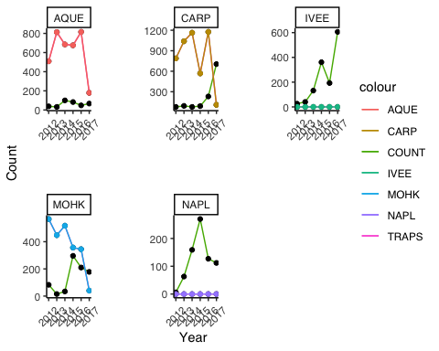

size_2012_qq <- ggplot(size_2012, aes(sample = SIZE)) +  
 geom_qq() +  
 facet_wrap(~ SITE, scale = "free") + # Create a Q-Q plot, split graphic visualization by site. Give each Q-Q Plot its own y-axis scale  
 theme_classic()  
size_2012_qq

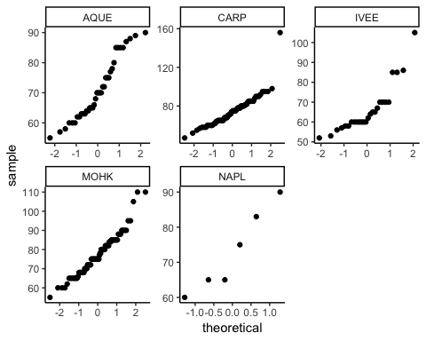

# Question: How do lobster sizes in 2012 and 2017 compare?  
  
# H0: There is no difference in mean lobster size in 2012 and 2017  
# HA: There is a difference in mean lobster size in 2012 and 2017  
  
# New dataframes with only MPA sites for 2012 and 2017  
  
MPA_2012 <- size_2012 %>%  
 filter(SITE == "IVEE" | SITE == "NAPL")  
MPA_2012

## SITE SIZE  
## 1 IVEE 70  
## 2 IVEE 60  
## 3 IVEE 65  
## 4 IVEE 70  
## 5 IVEE 85  
## 6 IVEE 60  
## 7 IVEE 65  
## 8 IVEE 67  
## 9 IVEE 70  
## 10 IVEE 85  
## 11 IVEE 52  
## 12 IVEE 60  
## 13 IVEE 64  
## 14 IVEE 70  
## 15 IVEE 58  
## 16 IVEE 60  
## 17 IVEE 60  
## 18 IVEE 62  
## 19 IVEE 86  
## 20 IVEE 105  
## 21 IVEE 57  
## 22 IVEE 60  
## 23 IVEE 53  
## 24 IVEE 56  
## 25 IVEE 58  
## 26 IVEE 60  
## 27 NAPL 83  
## 28 NAPL 75  
## 29 NAPL 60  
## 30 NAPL 65  
## 31 NAPL 65  
## 32 NAPL 90

MPA_2017 <- size_2017 %>%  
 filter(SITE == "IVEE" | SITE == "NAPL")  
MPA_2017

## SITE SIZE  
## 1 IVEE 80  
## 2 IVEE 80  
## 3 IVEE 65  
## 4 IVEE 50  
## 5 IVEE 57  
## 6 IVEE 58  
## 7 IVEE 58  
## 8 IVEE 60  
## 9 IVEE 62  
## 10 IVEE 65  
## 11 IVEE 72  
## 12 IVEE 75  
## 13 IVEE 80  
## 14 IVEE 80  
## 15 IVEE 85  
## 16 IVEE 75  
## 17 IVEE 82  
## 18 IVEE 63  
## 19 IVEE 70  
## 20 IVEE 76  
## 21 IVEE 82  
## 22 IVEE 85  
## 23 IVEE 85  
## 24 IVEE 87  
## 25 IVEE 90  
## 26 IVEE 60  
## 27 IVEE 61  
## 28 IVEE 62  
## 29 IVEE 65  
## 30 IVEE 65  
## 31 IVEE 70  
## 32 IVEE 70  
## 33 IVEE 72  
## 34 IVEE 74  
## 35 IVEE 75  
## 36 IVEE 76  
## 37 IVEE 76  
## 38 IVEE 80  
## 39 IVEE 80  
## 40 IVEE 84  
## 41 IVEE 87  
## 42 IVEE 88  
## 43 IVEE 35  
## 44 IVEE 62  
## 45 IVEE 65  
## 46 IVEE 68  
## 47 IVEE 70  
## 48 IVEE 72  
## 49 IVEE 72  
## 50 IVEE 85  
## 51 IVEE 61  
## 52 IVEE 63  
## 53 IVEE 65  
## 54 IVEE 65  
## 55 IVEE 65  
## 56 IVEE 65  
## 57 IVEE 67  
## 58 IVEE 67  
## 59 IVEE 68  
## 60 IVEE 70  
## 61 IVEE 70  
## 62 IVEE 70  
## 63 IVEE 71  
## 64 IVEE 71  
## 65 IVEE 72  
## 66 IVEE 72  
## 67 IVEE 75  
## 68 IVEE 76  
## 69 IVEE 77  
## 70 IVEE 78  
## 71 IVEE 80  
## 72 IVEE 80  
## 73 IVEE 80  
## 74 IVEE 81  
## 75 IVEE 82  
## 76 IVEE 82  
## 77 IVEE 83  
## 78 IVEE 85  
## 79 IVEE 85  
## 80 IVEE 85  
## 81 IVEE 85  
## 82 IVEE 86  
## 83 IVEE 87  
## 84 IVEE 87  
## 85 IVEE 90  
## 86 IVEE 91  
## 87 IVEE 105  
## 88 IVEE 63  
## 89 IVEE 63  
## 90 IVEE 64  
## 91 IVEE 65  
## 92 IVEE 65  
## 93 IVEE 66  
## 94 IVEE 67  
## 95 IVEE 69  
## 96 IVEE 70  
## 97 IVEE 70  
## 98 IVEE 76  
## 99 IVEE 78  
## 100 IVEE 80  
## 101 IVEE 81  
## 102 IVEE 85  
## 103 IVEE 87  
## 104 IVEE 88  
## 105 IVEE 90  
## 106 IVEE 35  
## 107 IVEE 45  
## 108 IVEE 45  
## 109 IVEE 45  
## 110 IVEE 50  
## 111 IVEE 55  
## 112 IVEE 60  
## 113 IVEE 68  
## 114 IVEE 69  
## 115 IVEE 70  
## 116 IVEE 70  
## 117 IVEE 70  
## 118 IVEE 70  
## 119 IVEE 70  
## 120 IVEE 70  
## 121 IVEE 78  
## 122 IVEE 80  
## 123 IVEE 80  
## 124 IVEE 82  
## 125 IVEE 83  
## 126 IVEE 84  
## 127 IVEE 40  
## 128 IVEE 45  
## 129 IVEE 45  
## 130 IVEE 50  
## 131 IVEE 50  
## 132 IVEE 50  
## 133 IVEE 55  
## 134 IVEE 60  
## 135 IVEE 60  
## 136 IVEE 60  
## 137 IVEE 60  
## 138 IVEE 60  
## 139 IVEE 60  
## 140 IVEE 62  
## 141 IVEE 62  
## 142 IVEE 64  
## 143 IVEE 65  
## 144 IVEE 65  
## 145 IVEE 70  
## 146 IVEE 70  
## 147 IVEE 70  
## 148 IVEE 70  
## 149 IVEE 70  
## 150 IVEE 72  
## 151 IVEE 73  
## 152 IVEE 75  
## 153 IVEE 75  
## 154 IVEE 75  
## 155 IVEE 80  
## 156 IVEE 80  
## 157 IVEE 80  
## 158 IVEE 80  
## 159 IVEE 82  
## 160 IVEE 85  
## 161 IVEE 85  
## 162 IVEE 85  
## 163 IVEE 86  
## 164 IVEE 86  
## 165 IVEE 90  
## 166 IVEE 58  
## 167 IVEE 60  
## 168 IVEE 60  
## 169 IVEE 62  
## 170 IVEE 62  
## 171 IVEE 63  
## 172 IVEE 65  
## 173 IVEE 65  
## 174 IVEE 65  
## 175 IVEE 65  
## 176 IVEE 65  
## 177 IVEE 65  
## 178 IVEE 65  
## 179 IVEE 65  
## 180 IVEE 66  
## 181 IVEE 67  
## 182 IVEE 68  
## 183 IVEE 68  
## 184 IVEE 68  
## 185 IVEE 70  
## 186 IVEE 70  
## 187 IVEE 70  
## 188 IVEE 70  
## 189 IVEE 70  
## 190 IVEE 70  
## 191 IVEE 70  
## 192 IVEE 71  
## 193 IVEE 71  
## 194 IVEE 72  
## 195 IVEE 72  
## 196 IVEE 72  
## 197 IVEE 75  
## 198 IVEE 75  
## 199 IVEE 75  
## 200 IVEE 75  
## 201 IVEE 75  
## 202 IVEE 75  
## 203 IVEE 75  
## 204 IVEE 76  
## 205 IVEE 76  
## 206 IVEE 77  
## 207 IVEE 77  
## 208 IVEE 78  
## 209 IVEE 78  
## 210 IVEE 79  
## 211 IVEE 80  
## 212 IVEE 80  
## 213 IVEE 80  
## 214 IVEE 80  
## 215 IVEE 80  
## 216 IVEE 80  
## 217 IVEE 80  
## 218 IVEE 80  
## 219 IVEE 80  
## 220 IVEE 80  
## 221 IVEE 80  
## 222 IVEE 80  
## 223 IVEE 81  
## 224 IVEE 81  
## 225 IVEE 82  
## 226 IVEE 82  
## 227 IVEE 82  
## 228 IVEE 82  
## 229 IVEE 83  
## 230 IVEE 83  
## 231 IVEE 85  
## 232 IVEE 85  
## 233 IVEE 85  
## 234 IVEE 85  
## 235 IVEE 85  
## 236 IVEE 85  
## 237 IVEE 87  
## 238 IVEE 87  
## 239 IVEE 88  
## 240 IVEE 88  
## 241 IVEE 89  
## 242 IVEE 90  
## 243 IVEE 90  
## 244 IVEE 90  
## 245 IVEE 91  
## 246 IVEE 94  
## 247 IVEE 95  
## 248 IVEE 100  
## 249 IVEE 100  
## 250 IVEE 102  
## 251 IVEE 105  
## 252 IVEE 110  
## 253 IVEE 110  
## 254 IVEE 32  
## 255 IVEE 55  
## 256 IVEE 59  
## 257 IVEE 60  
## 258 IVEE 61  
## 259 IVEE 63  
## 260 IVEE 63  
## 261 IVEE 63  
## 262 IVEE 64  
## 263 IVEE 65  
## 264 IVEE 65  
## 265 IVEE 65  
## 266 IVEE 67  
## 267 IVEE 70  
## 268 IVEE 70  
## 269 IVEE 70  
## 270 IVEE 70  
## 271 IVEE 70  
## 272 IVEE 70  
## 273 IVEE 72  
## 274 IVEE 72  
## 275 IVEE 75  
## 276 IVEE 75  
## 277 IVEE 76  
## 278 IVEE 78  
## 279 IVEE 79  
## 280 IVEE 80  
## 281 IVEE 82  
## 282 IVEE 83  
## 283 IVEE 85  
## 284 IVEE 85  
## 285 IVEE 85  
## 286 IVEE 85  
## 287 IVEE 85  
## 288 IVEE 86  
## 289 IVEE 87  
## 290 IVEE 87  
## 291 IVEE 88  
## 292 IVEE 88  
## 293 IVEE 90  
## 294 IVEE 90  
## 295 IVEE 90  
## 296 IVEE 91  
## 297 IVEE 92  
## 298 IVEE 92  
## 299 IVEE 96  
## 300 IVEE 100  
## 301 IVEE 105  
## 302 IVEE 110  
## 303 IVEE 110  
## 304 IVEE 112  
## 305 IVEE 35  
## 306 IVEE 40  
## 307 IVEE 45  
## 308 IVEE 45  
## 309 IVEE 46  
## 310 IVEE 50  
## 311 IVEE 50  
## 312 IVEE 50  
## 313 IVEE 50  
## 314 IVEE 50  
## 315 IVEE 50  
## 316 IVEE 50  
## 317 IVEE 50  
## 318 IVEE 50  
## 319 IVEE 50  
## 320 IVEE 50  
## 321 IVEE 51  
## 322 IVEE 52  
## 323 IVEE 52  
## 324 IVEE 55  
## 325 IVEE 55  
## 326 IVEE 55  
## 327 IVEE 58  
## 328 IVEE 60  
## 329 IVEE 60  
## 330 IVEE 60  
## 331 IVEE 60  
## 332 IVEE 60  
## 333 IVEE 60  
## 334 IVEE 60  
## 335 IVEE 60  
## 336 IVEE 60  
## 337 IVEE 62  
## 338 IVEE 63  
## 339 IVEE 65  
## 340 IVEE 65  
## 341 IVEE 65  
## 342 IVEE 68  
## 343 IVEE 70  
## 344 IVEE 70  
## 345 IVEE 70  
## 346 IVEE 70  
## 347 IVEE 72  
## 348 IVEE 72  
## 349 IVEE 80  
## 350 IVEE 80  
## 351 IVEE 82  
## 352 IVEE 84  
## 353 IVEE 85  
## 354 IVEE 98  
## 355 IVEE 35  
## 356 IVEE 40  
## 357 IVEE 40  
## 358 IVEE 40  
## 359 IVEE 43  
## 360 IVEE 45  
## 361 IVEE 45  
## 362 IVEE 45  
## 363 IVEE 50  
## 364 IVEE 55  
## 365 IVEE 55  
## 366 IVEE 55  
## 367 IVEE 55  
## 368 IVEE 56  
## 369 IVEE 60  
## 370 IVEE 60  
## 371 IVEE 60  
## 372 IVEE 60  
## 373 IVEE 60  
## 374 IVEE 60  
## 375 IVEE 60  
## 376 IVEE 60  
## 377 IVEE 60  
## 378 IVEE 60  
## 379 IVEE 63  
## 380 IVEE 70  
## 381 IVEE 70  
## 382 IVEE 70  
## 383 IVEE 70  
## 384 IVEE 70  
## 385 IVEE 70  
## 386 IVEE 70  
## 387 IVEE 70  
## 388 IVEE 70  
## 389 IVEE 72  
## 390 IVEE 72  
## 391 IVEE 72  
## 392 IVEE 72  
## 393 IVEE 75  
## 394 IVEE 75  
## 395 IVEE 75  
## 396 IVEE 80  
## 397 IVEE 80  
## 398 IVEE 80  
## 399 IVEE 80  
## 400 IVEE 83  
## 401 IVEE 83  
## 402 IVEE 84  
## 403 IVEE 85  
## 404 IVEE 85  
## 405 IVEE 88  
## 406 IVEE 90  
## 407 IVEE 90  
## 408 IVEE 95  
## 409 IVEE 95  
## 410 IVEE 97  
## 411 IVEE 100  
## 412 IVEE 55  
## 413 IVEE 58  
## 414 IVEE 62  
## 415 IVEE 65  
## 416 IVEE 65  
## 417 IVEE 75  
## 418 IVEE 78  
## 419 IVEE 48  
## 420 IVEE 50  
## 421 IVEE 55  
## 422 IVEE 58  
## 423 IVEE 60  
## 424 IVEE 62  
## 425 IVEE 63  
## 426 IVEE 65  
## 427 IVEE 65  
## 428 IVEE 65  
## 429 IVEE 65  
## 430 IVEE 65  
## 431 IVEE 67  
## 432 IVEE 68  
## 433 IVEE 68  
## 434 IVEE 68  
## 435 IVEE 80  
## 436 IVEE 85  
## 437 IVEE 85  
## 438 IVEE 90  
## 439 IVEE 95  
## 440 IVEE 60  
## 441 IVEE 60  
## 442 IVEE 60  
## 443 IVEE 60  
## 444 IVEE 65  
## 445 IVEE 68  
## 446 IVEE 70  
## 447 IVEE 70  
## 448 IVEE 75  
## 449 IVEE 78  
## 450 IVEE 80  
## 451 IVEE 90  
## 452 IVEE 55  
## 453 IVEE 55  
## 454 IVEE 60  
## 455 IVEE 60  
## 456 IVEE 60  
## 457 IVEE 61  
## 458 IVEE 62  
## 459 IVEE 65  
## 460 IVEE 65  
## 461 IVEE 65  
## 462 IVEE 65  
## 463 IVEE 65  
## 464 IVEE 70  
## 465 IVEE 70  
## 466 IVEE 72  
## 467 IVEE 78  
## 468 IVEE 80  
## 469 IVEE 80  
## 470 IVEE 82  
## 471 IVEE 85  
## 472 IVEE 90  
## 473 IVEE 95  
## 474 IVEE 105  
## 475 IVEE 40  
## 476 IVEE 50  
## 477 IVEE 55  
## 478 IVEE 60  
## 479 IVEE 60  
## 480 IVEE 65  
## 481 IVEE 65  
## 482 IVEE 68  
## 483 IVEE 75  
## 484 IVEE 78  
## 485 IVEE 78  
## 486 IVEE 80  
## 487 IVEE 80  
## 488 IVEE 83  
## 489 IVEE 83  
## 490 IVEE 85  
## 491 IVEE 85  
## 492 IVEE 89  
## 493 IVEE 50  
## 494 IVEE 56  
## 495 IVEE 58  
## 496 IVEE 60  
## 497 IVEE 62  
## 498 IVEE 62  
## 499 IVEE 63  
## 500 IVEE 65  
## 501 IVEE 65  
## 502 IVEE 65  
## 503 IVEE 68  
## 504 IVEE 70  
## 505 IVEE 74  
## 506 IVEE 76  
## 507 IVEE 78  
## 508 IVEE 79  
## 509 IVEE 82  
## 510 IVEE 83  
## 511 IVEE 84  
## 512 IVEE 84  
## 513 IVEE 86  
## 514 IVEE 90  
## 515 IVEE 105  
## 516 IVEE 35  
## 517 IVEE 40  
## 518 IVEE 45  
## 519 IVEE 45  
## 520 IVEE 48  
## 521 IVEE 55  
## 522 IVEE 65  
## 523 IVEE 67  
## 524 IVEE 68  
## 525 IVEE 70  
## 526 IVEE 72  
## 527 IVEE 75  
## 528 IVEE 75  
## 529 IVEE 78  
## 530 IVEE 78  
## 531 IVEE 78  
## 532 IVEE 78  
## 533 IVEE 78  
## 534 IVEE 79  
## 535 IVEE 80  
## 536 IVEE 81  
## 537 IVEE 82  
## 538 IVEE 83  
## 539 IVEE 83  
## 540 IVEE 84  
## 541 IVEE 85  
## 542 IVEE 90  
## 543 IVEE 90  
## 544 IVEE 92  
## 545 IVEE 95  
## 546 IVEE 110  
## 547 IVEE 110  
## 548 IVEE 40  
## 549 IVEE 47  
## 550 IVEE 48  
## 551 IVEE 49  
## 552 IVEE 49  
## 553 IVEE 50  
## 554 IVEE 50  
## 555 IVEE 50  
## 556 IVEE 55  
## 557 IVEE 55  
## 558 IVEE 60  
## 559 IVEE 60  
## 560 IVEE 60  
## 561 IVEE 65  
## 562 IVEE 65  
## 563 IVEE 70  
## 564 IVEE 70  
## 565 IVEE 72  
## 566 IVEE 75  
## 567 IVEE 75  
## 568 IVEE 75  
## 569 IVEE 78  
## 570 IVEE 78  
## 571 IVEE 80  
## 572 IVEE 85  
## 573 IVEE 150  
## 574 IVEE 70  
## 575 IVEE 70  
## 576 IVEE 75  
## 577 IVEE 65  
## 578 IVEE 70  
## 579 IVEE 90  
## 580 IVEE 62  
## 581 IVEE 65  
## 582 IVEE 65  
## 583 IVEE 65  
## 584 IVEE 70  
## 585 IVEE 70  
## 586 IVEE 70  
## 587 IVEE 75  
## 588 IVEE 75  
## 589 IVEE 78  
## 590 IVEE 50  
## 591 IVEE 55  
## 592 IVEE 65  
## 593 IVEE 70  
## 594 IVEE 85  
## 595 IVEE 50  
## 596 IVEE 68  
## 597 IVEE 75  
## 598 IVEE 75  
## 599 IVEE 78  
## 600 IVEE 80  
## 601 IVEE 82  
## 602 IVEE 71  
## 603 IVEE 85  
## 604 IVEE 65  
## 605 IVEE 70  
## 606 IVEE 79  
## 607 NAPL 76  
## 608 NAPL 82  
## 609 NAPL 60  
## 610 NAPL 62  
## 611 NAPL 64  
## 612 NAPL 65  
## 613 NAPL 70  
## 614 NAPL 72  
## 615 NAPL 73  
## 616 NAPL 75  
## 617 NAPL 75  
## 618 NAPL 78  
## 619 NAPL 80  
## 620 NAPL 80  
## 621 NAPL 82  
## 622 NAPL 83  
## 623 NAPL 85  
## 624 NAPL 94  
## 625 NAPL 76  
## 626 NAPL 80  
## 627 NAPL 80  
## 628 NAPL 85  
## 629 NAPL 82  
## 630 NAPL 83  
## 631 NAPL 86  
## 632 NAPL 86  
## 633 NAPL 55  
## 634 NAPL 78  
## 635 NAPL 84  
## 636 NAPL 88  
## 637 NAPL 70  
## 638 NAPL 72  
## 639 NAPL 74  
## 640 NAPL 75  
## 641 NAPL 80  
## 642 NAPL 85  
## 643 NAPL 90  
## 644 NAPL 40  
## 645 NAPL 45  
## 646 NAPL 50  
## 647 NAPL 51  
## 648 NAPL 60  
## 649 NAPL 70  
## 650 NAPL 70  
## 651 NAPL 78  
## 652 NAPL 80  
## 653 NAPL 85  
## 654 NAPL 88  
## 655 NAPL 90  
## 656 NAPL 92  
## 657 NAPL 105  
## 658 NAPL 65  
## 659 NAPL 70  
## 660 NAPL 72  
## 661 NAPL 81  
## 662 NAPL 82  
## 663 NAPL 70  
## 664 NAPL 85  
## 665 NAPL 90  
## 666 NAPL 75  
## 667 NAPL 95  
## 668 NAPL 68  
## 669 NAPL 70  
## 670 NAPL 80  
## 671 NAPL 82  
## 672 NAPL 84  
## 673 NAPL 88  
## 674 NAPL 65  
## 675 NAPL 80  
## 676 NAPL 80  
## 677 NAPL 84  
## 678 NAPL 85  
## 679 NAPL 86  
## 680 NAPL 87  
## 681 NAPL 89  
## 682 NAPL 89  
## 683 NAPL 70  
## 684 NAPL 75  
## 685 NAPL 88  
## 686 NAPL 55  
## 687 NAPL 55  
## 688 NAPL 60  
## 689 NAPL 60  
## 690 NAPL 60  
## 691 NAPL 65  
## 692 NAPL 65  
## 693 NAPL 65  
## 694 NAPL 65  
## 695 NAPL 70  
## 696 NAPL 70  
## 697 NAPL 70  
## 698 NAPL 70  
## 699 NAPL 75  
## 700 NAPL 80  
## 701 NAPL 88  
## 702 NAPL 67  
## 703 NAPL 67  
## 704 NAPL 70  
## 705 NAPL 70  
## 706 NAPL 72  
## 707 NAPL 84  
## 708 NAPL 85  
## 709 NAPL 87  
## 710 NAPL 87  
## 711 NAPL 75  
## 712 NAPL 85  
## 713 NAPL 90  
## 714 NAPL 92  
## 715 NAPL 75  
## 716 NAPL 92  
## 717 NAPL 82  
## 718 NAPL 81

# F-test for equal variances:  
  
# H0: Variances are equal  
# HA: Variances are not equal  
  
f_test <- var.test(MPA_2012$SIZE, MPA_2017$SIZE)  
  
f_test

##   
## F test to compare two variances  
##   
## data: MPA_2012$SIZE and MPA_2017$SIZE  
## F = 0.75323, num df = 31, denom df = 717, p-value = 0.3346  
## alternative hypothesis: true ratio of variances is not equal to 1  
## 95 percent confidence interval:  
## 0.477719 1.341900  
## sample estimates:  
## ratio of variances   
## 0.7532319

# p = 0.33, retain the null. Variacnes are equal.  
  
  
  
# Two-sided t-test  
  
MPA_ttest <- t.test(MPA_2012$SIZE, MPA_2017$SIZE, var.equal = TRUE)  
MPA_ttest

##   
## Two Sample t-test  
##   
## data: MPA_2012$SIZE and MPA_2017$SIZE  
## t = -1.9159, df = 748, p-value = 0.05576  
## alternative hypothesis: true difference in means is not equal to 0  
## 95 percent confidence interval:  
## -9.7644724 0.1189292  
## sample estimates:  
## mean of x mean of y   
## 67.37500 72.19777

#

```