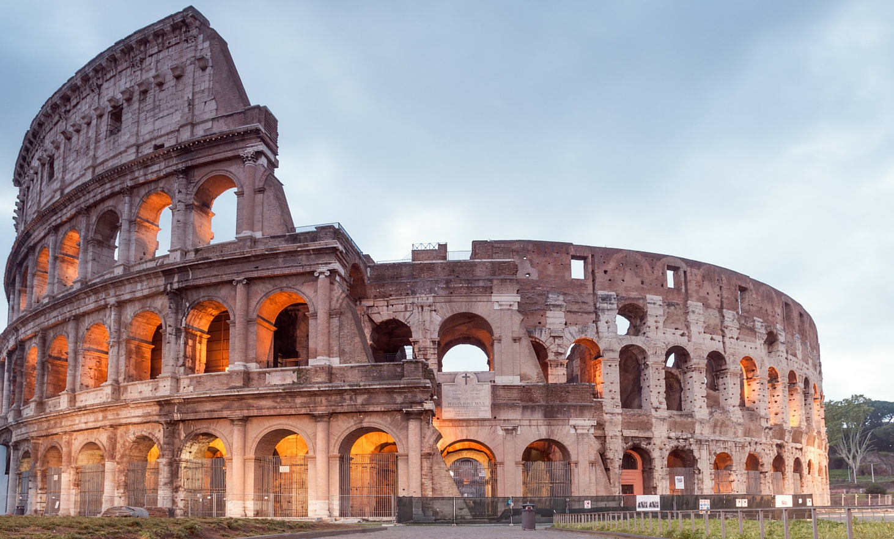

Judah Chairo A. Barlos BSCpE

B

**Forum of Rome**

Display

**Stone or Metal**

Carved

Called

**Roman Acta Diruna**

The first newspaper was created by Julius Caesar

**Newspaper**

**Mass-spectator sporting events**

**Music Concerts**

**Cinemas**

**Cinemas**

**Theatres**

**Mass Entertainment**

**Drainage**

**Irrigation**

**Seed Selection**

**Grafting**

**Crop rotation**

**Pruning**

Techniques

**Agriculture**

**Aqueducts**

**Triumphal Arch**

**Roman Roads**

**Roman Arches**

**Concrete**

**Architecture**

**Romans**