Frontend Challenge
Coriyon Arrington
February 13th, 2020

Up to this point, I have been working on the Frontend Challenge for 23.5 hours approximately. I believe about 80 percent of that time was spent searching Google! Honestly, it was a great project and I really enjoyed working on it. There were so many challenges to overcome though.

The first challenge was figuring out where to start coding. I looked at my final version of the visual fundamental which can be seen below and tried to break it down. I figured the easiest part would be getting the images in there and then adding in the text.
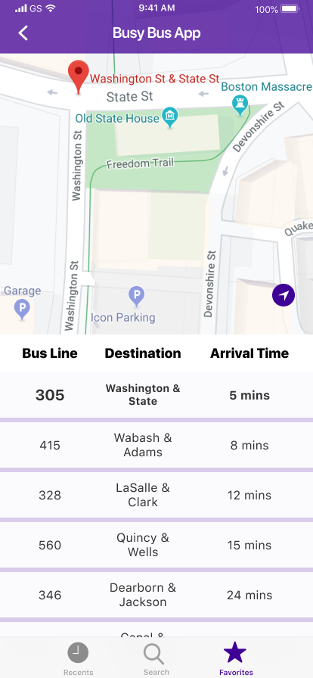
Thankfully, I had learned a lot from the Box Model checkpoint in which we created the restaurant list so I knew that it would be doing something somewhat similar. The main difference would be the styling, which leads to the overarching challenges that I faced.

I had a significantly harder time trying to position the text the same way that I designed it. Originally, in my HTML file I created a bunch of unordered lists and lists tags. With that, I tried using several different functions to align them such as display: inline-block and text-align center but it was not turning out well. Through overcoming this challenge, in particular, I learned that there are endless functions out there and figuring out which ones to use sometimes comes down to a matter of preference and how the code is completed.

I eventually decided to change the HTML from a bunch of lists to div instead because I realized that it might be easier to manipulate the text while being positioned inside of a div container. Once I did that, I learned how to use the display: flex function through some online forums and Flexbox beginner tutorials. This really helped!

From there, I at least had the containers with the text somewhat together and the images pulling in (although it did not look very great)

This brings me to the next styling challenge which was figuring out how to align the containers and get the paddings and margins correct. Needless to say, this was much harder than expected!

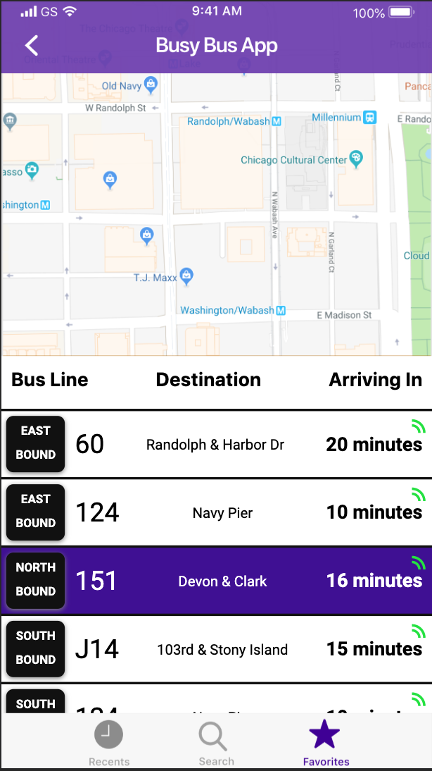
At this point, I decided to visit one of Bloc’s Q&A workshops to get some insight. This really helped also because it reinforced that even full-time developers have these same challenges and issues.

My last major challenge with style was figuring out how to make the content scrollable the way that I wanted. I wanted to keep the status bar, map, and tab bar fixed while making only the bus routes scroll. This proved to be much harder than anticipated. I learned some new functions such as fixed and overflow and that helped in theory but in practice was tough. I met up with a friend who is frontend developer and she gave me some tips on how to do it but honestly the solution was still not ideal because I had to set some styles on the HTML code and set fixed heights in places that would cause the design to be unresponsive in certain areas.

My final outcome can be seen to the left. Despite all of those challenges, I am quite happy with what I was able to complete! I learned some key things that I will always keep in mind.

CSS is crucial and not that easy! Often times when I would use products at work, and I would say I wish they would just put a box here; I see it’s really not that simple. As I design in the future, I’ll definitely keep that top of mind. Another takeaway was learning the ins and out of the inspect tool. At the beginning of the project I was not using it that much but by the end I knew exactly how to manipulate it and edit my code accordingly.

Lastly, the most important thing I learned was how to overcome being stuck! I would work on this for hours only to make a small amount of progress. Then I would take a break and come back to it later that day or the next and much four times as much progress in only two hours.

