**Introduction**

Miriam is writing this

**Methods**

Model Structure

We simulate the infection dynamics of a nursing home case study using a spatially explicit stochastic agent-based model. The nursing home of study is located in Los Angeles County, California, with 172 residents and 170 staff. Three residents are assigned to a single room and 5 rooms are assigned for quarantine and for residents with frequent visits to receive outside care such as dialysis treatment (**Figure 1**). Agents in the model include residents and staff only, as visitors have not been allowed in these facilities throughout this pandemic. Residents interact with residents of shared room and with staff, which can be one of three types, Certified Nurse (CN), Registered Nurse (RN), and Licensed Practical Nurse (LPN). Residents do not currently interact in communal space and meals are taken in rooms. Depending on the type of staff, each staff agent will have different number of contacts with the residents. The contact rates for each staff type were parametrized based on the average number of residents contacts occur during a regular day. We assumed CNA staffing level of 2.9 hours per resident day, 1.2 hours of per resident for LN, and 1.40 hours per resident days for RN.

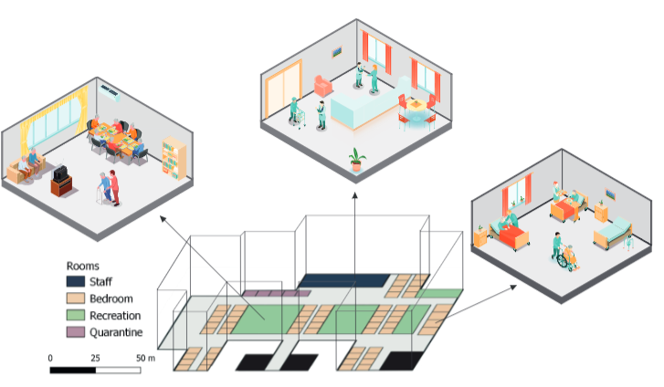

**Figure 1 Caption**. Case study of a nursing home in Los Angeles, CA, with 172 residents and 170 staff. The simplified floor map for the facility describe location of bedrooms with capacity of 3 residents, 5 quarantine room reserved for residents with frequent outside traffic and/or capacity to quarantine exposed residents, recreation areas which are currently off limits to resident and staff interactions, and rooms for staff (Yury – we need to fix this figure to reflect the reality of these homes – I am sorry that I did not catch this before. Recreation rooms need to reflect that no residents are there, only staff.)

Staff agents are assigned to one of three different work schedules, morning (7am-3pm), afternoon (3pm-11pm), and evening (11pm-7am). We assume that 40% of the staff will be working on the morning turn, 40% in the afternoon, and 20% in the evening. (Pablo we need to describe how these schedule are assumed in your multinomial distribution, what do the assumed parameters translate into layman terms). Staff spend on average 8 hours inside the nursing home and the rest of the time on an average day outside in the community. Staff are modeled only during their time spend inside a nursing home, and we assume that while outside they have the same probability of contacting other people. Contact rates and staff schedule distribution assumptions are presented in Table 1. We define the interactions between residents and different types of staff according to the following probability distributions: A CN has a 0.7 chance to have 0 contacts and 0.3 chance to have 1 contact with a resident. LPN have a 0.15 chance of having 0 contacts, 0.2 of two constants, 0.25 chance of having 3 contacts, and so on (**Table 1**). Here I will describe the types of activities that each of these staff members do with residents. To this end, Pablo did you assume that certain staff spend more time with residents and therefore have increased risk of transmission to them? Also, this end, something that comes to mind that may be relevant to keep in mind regarding our results and why we assumed different type of staff. It is clearly important to assume a model that it is as close to reality as possible. But when a virus get introduced, does it matter if it was a RN or LPN that brought it in? Given that all staff mingle together or not? Also, all residents get a fair share of interactions with all staff, so does it even matter that we included 3 types of staff??

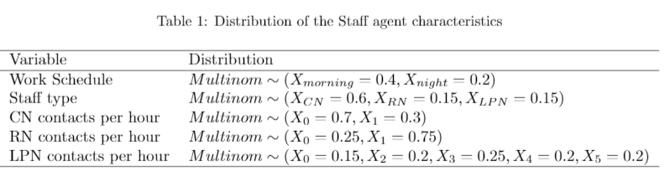

Note: Yury and Pablo. We need to present this table with an additional column where we can include specific hours per resident per day that these staff provide, at least roughly, averages. Otherwise, the reader has to try to figure out what these must be?

Disease Dynamics

At a simulation time step of a day, each resident and staff is in one of seven epidemiological classes: susceptible agents who have not been exposed to the disease (S), exposed individuals that have contracted the virus but are not yet symptomatic (E), infected individuals not yet exhibiting symptoms of illness (Ia), infectious individuals exhibiting symptoms of illness (Is), individuals that have recovered and can no longer infect others (R), symptomatic and infected individuals requiring hospitalization (H), and individuals that succumbed to the disease (D) (**Figure 2**). The model assumes no new inflow of residents and staff exposed to virus are replaced by new staff confirmed negative for SARS-CoV-2 during the period of simulation.

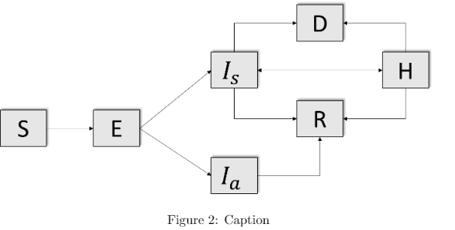

**Figure 2 Caption**. Resident and staff agents transition between seven epidemiological classes according to a spatially explicit stochastic agent-based model. Regular testing of all staff takes place weekly, while weekly testing of residents is rotated among each of the three individuals residing in each room. Monitoring of temperature and symptoms is conducted at the start of each staff shift and staff with concerning symptoms and/or possible community exposure are not allowed in a facility and are replaced by healthy staff and compensated through paid overtime.

Disease transmission between resident and staff agents inside a nursing home depends on the probability that a specific agent will shed the virus and that another agent will be infected with the virus. Transmission rates represent the probability that two given individuals are in the same room for one hour will shed or get infected by the virus depending on their epidemiological state (was this assumption based on data from nursing homes?). The parametrization of the transmission parameters was based on observed outbreaks in California nursing homes (can we provide some formal presentation of this process in the supplemental materials?). This framework of disease transmission was assumed to facilitate the investigation of specific intervention scenarios targeted specific subgroups of the population. Given that the vast majority of nursing homes in the United States have continued to implement strict restrictions to visits, our model assumes that a virus introduction to the nursing home is primarily through contacts with staff. We assume that the introduction from the community to the facility depends on the probability pI, which corresponds to approximate levels of community prevalence (is this true? or how did you come up with p value here; if so we need to report the specific community prevalence at the time when we interviewed which reflects your assumption; this has clearly changed to the present).

Viral load and infectiousness (or some similar description)

Staff and resident agents are assumed susceptible at the initialization of the simulations and after 1 day, a staff is assumed exposed. We then follow-up for 150 days or until the disease has been absent for more than 14 days of simulation. Upon transmission between an infectious and susceptible agent, susceptible agents become exposed and remain in a latency period modeled with a lognormal distribution (Table 2). An agent becomes infectious after an average number of # days, which can be either symptomatic and asymptomatic, remains infectious during an average of 15 days and then transitioned into recovered. Infectious agents may transition into the class of hospitalization at a fix rate of 20% (reference hospitalization rates among nursing home residents). Once agents have recovered they acquire immunity for re-infection that lasts for 120 days.

Interventions (this section is very confusing to me when I read what you wrote, please let’s clarify and walk the reader through all the details. We should start by describing the different interventions that we considered. First PPE and testing – these are considered as they aligned with current CDC recommendations and are part of all scenarios you ran. Then you add improved testing efforts and vaccination, correct.)

We propose a combination of infection control strategies, testing and vaccination efforts to curtail the impact of SARS-CoV-2 in a nursing home. We simulated # scenarios that combine these interventions and documented the impact of infections, hospitalizations, and death. All scenarios assume infection control measures (e.g. PPE and symptoms monitoring upon facility entry) that are in alignment with current CDC recommendations to reduce virus cross-infection within a nursing home. All scenarios also assume immediate implementation of weekly testing of residents and staff (are we assuming PCR testing or rapid testing; depending on which one, we need to give details about this here). Each week, one of the three residents sharing a room gets tested, taking turns with other two in future weeks. We further assume the implementation of vaccination by specifying the proportion of residents and staff that received vaccination, and a fixed interval of time of 120 days between treatment with the first and second dose. After the first dose, we assume that agents confer a 60% vaccine protection and upon the receipt of the second dose agent will attained 100% (why 100%, should be lower for residents than staff? Here you also need to be explicit about these immunity assumptions for staff and residents) immunity. Then the vaccination immunity will have a decay of 120 days and the individual will no longer have the vaccination immunity protective effect (THIS IS CONCERNING? WHY IS THIS? I DON”T think that this is true, individuals don’t lose immunity after 120 days? I believe that vaccine protects us for good; among elderly people, it is true that it is uncertain but they will be protected largerly; otherwise, how are we ever getting past this pandemic if vaccine only work of 120 days?) After we have discussed all the interventions that we will be considering, then we can talk about how all of them come in to play and are encompassed in the probability, pT. Interventions considered have an impact on disease transmission according to specific assumptions and are summarized in a probability of transmission (pT). I will have to do that very soon.

HERE WE NEED TO DESCRIBE HOW MANY SCENARIOS YOU ARE RUNNING.

Baseline Scenario: describe what it entails, in English, as well as, in terms of parameter assumptions (Table needed with parameters and explain of what is assumed). Second Scenario: describe what it entails, in English, as well as, in terms of parameter assumptions. Third Scenario: describe what it entails, in English, as well as, in terms of parameter assumptions. We need a table that describes these scenarios very clearly please. Yury can you help with this. Like the PNAS paper we put together. Here is the example to follow Pablo and Yury.

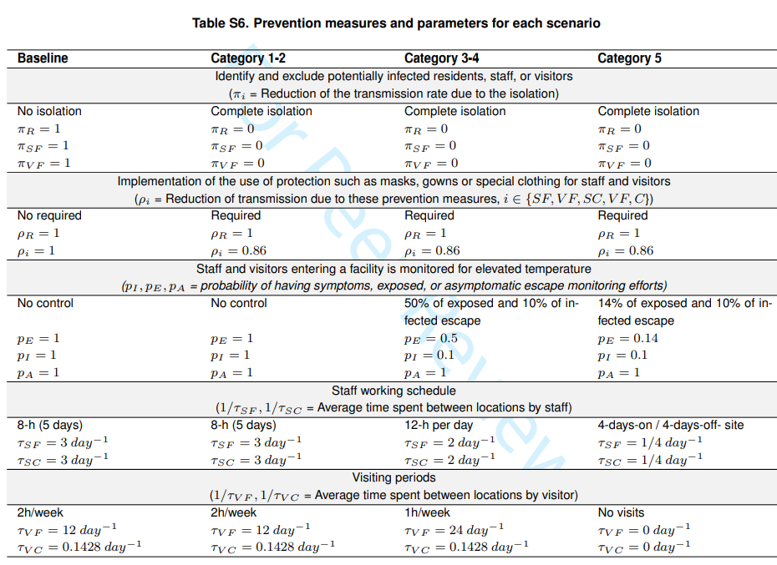

Sensitivity Analyses

Miriam is writing this

Results

Need results to be finalized to write this.

Discussion

Will be driven largely by results.

Figure 1Table for the distribution of contacts