**Cormac Buckley 15534413 CT331 Assignment 2**

Github: <https://github.com/CormacBuckley/ct331_assignment2>

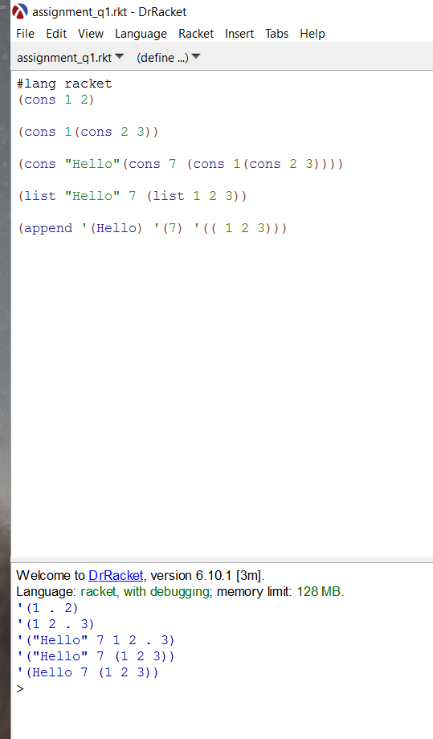Q1.

B)

Cons is the constructor for all pairs. Append is a procedure that uses cons to make a list with all the elements of the argument lists left to right. As I discovered in my assignment, cons accepts strings whereas append does not.

Q2.

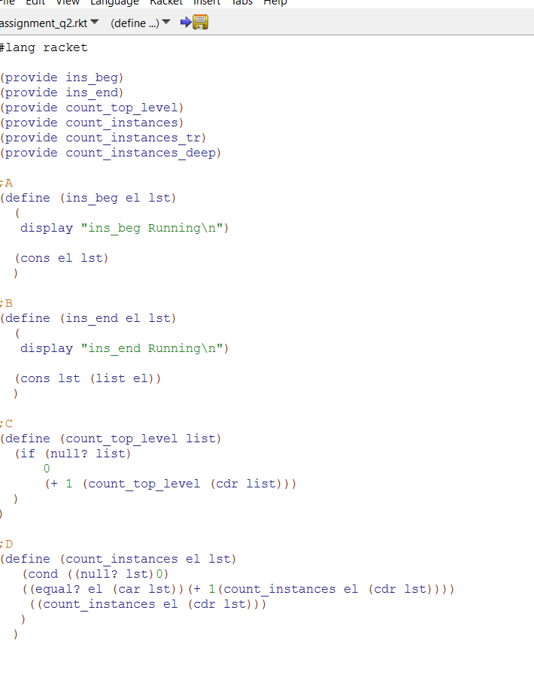

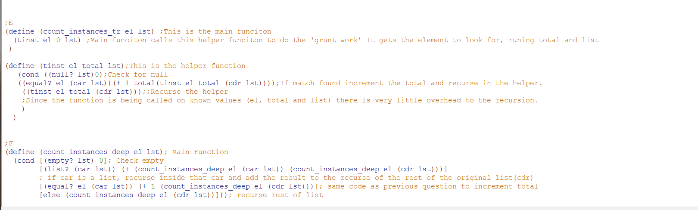

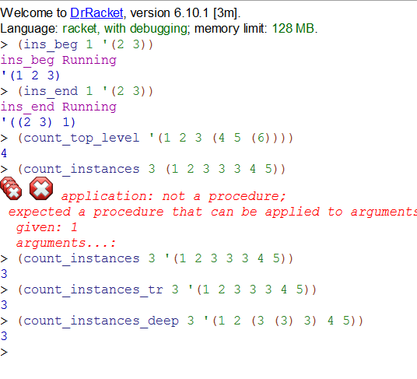

Q3.

