Mobile Applications Development Project: Year 4

Christian Olim - G00334621

Super Mario Bros.

# Project Overview:

The outline­ of this project is to develop a mobile game using the Unity engine. This mobile application will be a 2D platform game. The game I chose for the developer to design is an original version of Super Mario Bros. The reason I selected this game is not only because of how successful it became but primarily it’s the first video game I was introduced to. This mobile application must be completed and uploaded to your GitHub Repository by the given deadline for examination.

# Requirements/Task(s):

* Front End: When the user opens the game, they should be greeted with an opening screen. This can include the name of the game, some designs of Mario and Luigi. Possibly the In-Game Background and music. Here the user will be instructed to click enter where they will be brought to the main menu. The main menu will include these four options:

1. Play Game.
2. How to Play. This screen should consist of the in-game keys that will allow the user to control their character. I also want you to include an overview of the game – Tell the user what’s happening at that specific time, background of the characters/ story and what the objective is.
3. Difficulty. Here we will have three options – easy, medium or hard. This could be designed with a Tick Box or Switch mechanism. By increasing the difficulty, I want you to increase the number of enemies and pits.
4. Settings. This screen should have an option to turn on/ off music and/or sound separately. Here the user will also have the option to choose between Mario’s or Luigi’s character model.

* In-Game Menus: The in-game menu should have the option to enter the settings menu (same as the Front-End menu without the character choice setting) with an option to restart or exit the game. By restarting, the user’s character will be brought back to their original position of the level. If the user clicks the exit menu, they will be transferred to the Front-End menu.
* Control Mechanisms: The control mechanism for Super Mario Bros is quite limited with the character’s actions consisting of running and jumping. These actions I want controlled using the arrow keys.
* The Game: Mario or Luigi will start the game in a set position. As he moves, the camera angle should be set central to the character. Each level will have a set number of enemies and pits for the user to encounter. As the difficulty increases – so will the number of potential hazards.

# Game Background:

# Super Mario Bros is set in a fantasy location called the Mushroom Kingdom. A group of turtle-like creatures called the Koopa Troopas attack the kingdom and turn the inhabitants into Mushroom People using magic. The King, Bowser, kidnaps Princess Toadstool who is the only character able to reverse Bowser’s spells. It’s Mario’s objective to save Princess Toadstool and the Mushroom Kingdom.

# Research:

# A platform is a genre of video game where the gameplay is centered around the users controlling a character that is capable of movements such as: running, jumping or climbing between platforms while trying to maneuver past potentially harmful obstacles.

Super Mario Bros. is a platform game created by [Nintendo](https://en.wikipedia.org/wiki/Nintendo) in 1985 for the Nintendo Entertainment System (NES). Users control the character Mario as he travels through the Mushroom Kingdom in the pursuit of rescuing Princess Toadstool. Mario must overcome being killed by enemies and falling into pits.

Super Mario Bros. is widely regarded as one of the greatest and most prolific video games of all time. It is also one of the best-selling video games with more than 40 million copies sold. The simplicity of the game has helped gain a larger audience. Player ages ranged anywhere between eight years old to forty years old. This game has also appealed to both males and females.

# Controls:

* Move Player: Left & Right Arrow Keys
* Jump Player: Up Arrow Key
* Navigate Menu: Numerical Keys

# Music:

* This Super Mario Bro game I think should be developed using the original song, officially known as the "Ground Theme". Similar to the game, the music should play in a loop from when you open the application until you exit.
* There should be sound effects for actions such as:
* Jumping.
* Navigating through menus.
* When the character dies or when the timer runs out in game.

# Platforms:

# Super Mario Bros will be developed for both the Android and iOS operating systems.

# Game Mechanics:

* The design will contain an introduction screen, in-game menu, a difficulty choice, character choice and a game over screen if the user’s character dies or if the timer runs out.
* The character will be controlled using the arrow keys.
* Super Mario Bros should be a single player game.
* Gameplay will include platforms, pits, coins, mushroom people and pipes.
* The character’s only form of attack is jumping onto their opponent’s head. If the user successfully completes this act then the enemy should rotate and fall off the screen. The user should get one hundred points per kill.
* Enemies will move from right to left repeatedly until they’re killed.
* The character will have a set height limit when they jump.
* The player will have five minutes to complete the level.
* The user will have three lives when they begin the level. One idea for the hard difficulty could be: set the lives to two on medium difficulty and one life on hard difficulty. You could also reduce the timer based off of the difficulty.
* During gameplay, at the top of the screen there should be a counter that includes data such as the number of lives you have left, how many coins you collected, a timer and how many points you have.
* The game over screen will display a summary of the user’s performance.
* If the user completes the level you could present a congratulations screen and a Mario sound effect of him speaking.

# Resources:

<https://en.wikipedia.org/wiki/Platform_game>

<https://en.wikipedia.org/wiki/Super_Mario_Bros.>

<https://www.fanfreegames.com/game/mario-mod>

<https://www.makeuseof.com/tag/origins-history-mario-geek-history-lessons/>

<https://www.idtech.com/blog/10-types-of-platforms-in-platform-video-games>

<https://en.wikipedia.org/wiki/Super_Mario_Bros._theme>

<https://www.youtube.com/watch?v=iNmspUm9hU4>

<https://supermariobros.io/>

# Sketches:

# *Brainstorm for In-Game Menus*

*Characters of Mario and Luigi*

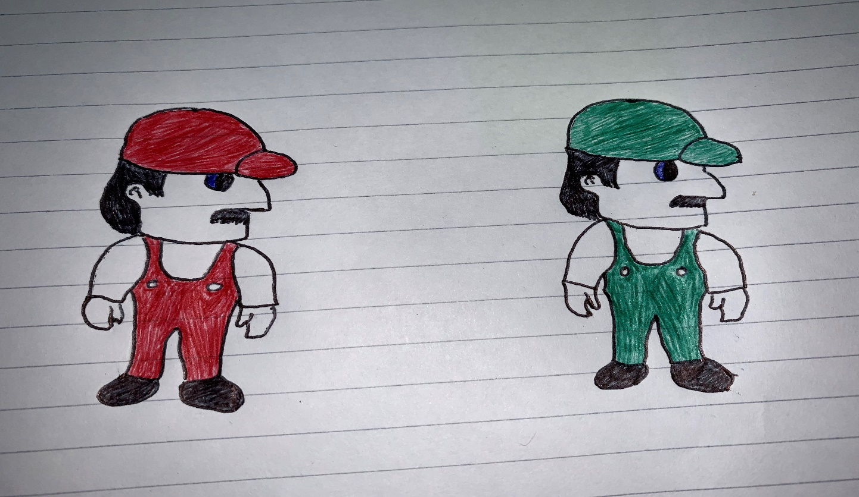

*In-Game Extra: Pipe*

*

*