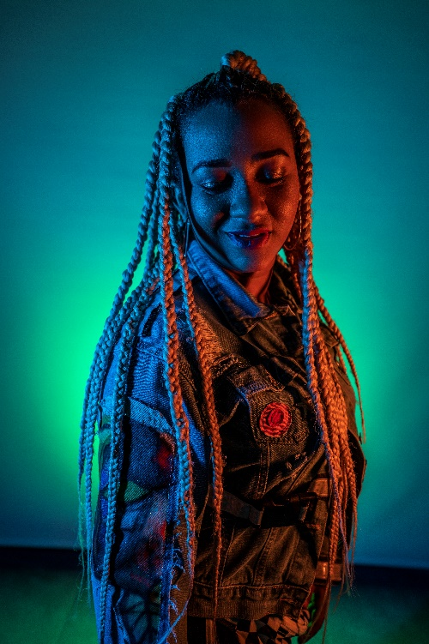**Sindy Mariedis Ruiz Zambrano - MERY LIONZ**

[**www.facebook.com/merylionz**](http://www.facebook.com/merylionz)

[**www.youtube.com/merylionz**](http://www.youtube.com/merylionz)

[**www.instagram.com/merylionz**](http://www.instagram.com/merylionz)

[**https://www.youtube.com/watch?v=UAh9j7Sk-3U**](https://www.youtube.com/watch?v=UAh9j7Sk-3U)

[**https://www.youtube.com/watch?v=ufrH_WSLQHw**](https://www.youtube.com/watch?v=ufrH_WSLQHw)

[**https://www.youtube.com/watch?v=cc0k2tnSNwc**](https://www.youtube.com/watch?v=cc0k2tnSNwc)

[**https://www.youtube.com/watch?v=0PT1UNQbHk8**](https://www.youtube.com/watch?v=0PT1UNQbHk8)