**Data Visualization Project Report**

**[General Instructions: Remove before submitting]**

* Submit this report as a PDF.
* Name your file according to the convention: group number + "*report*" + version. For example, "group15_report_design.pdf".
* File Name: group27_report_design.pdf

**Part 1. Metadata - All**

**Version:** [Choose one: "design" (due 25/3/2024) / "implementation" (due 10/5/2024)]

**Students:**

* Student 1: Corné du Plooy, r1002664, KU Leuven
* Student 2: [Name, Student Number, KU Leuven]
* Student 3: Xinwen Yuan, r0968294, KU Leuven

**Group Number:** 27

**Dataset:** SunCharge

**Part 2. Project Description - Keziah**

**Short Description:** Our project investigates the manufacturing and distribution of eco-friendly car and home batteries by SunCharge. We focus on enhancing time efficiency from order placement to delivery. The anomalies in production and shipping delays present a unique challenge that we aim to understand and mitigate.

**Main Features:** The dataset's intriguing aspects include production times, shipping delays, and in-plant inventory, particularly their impact on the overall door-to-door efficiency. These elements are vital for understanding the temporal and spatial dimensions of SunCharge's production and distribution processes.

**Guiding Questions: - Review these questions based on our final designs**

1. How can we minimize the time from order placement to delivery to the customer's door (door-to-door efficiency)?
2. What factors influence the efficiency of production at different plants and for various products?
3. Why do the longest distribution times occur, and what factors (spatial or otherwise) influence these delays?

Through these questions, we aim to dissect the nuances of production and distribution efficiency, ensuring a comprehensive analysis that covers both the micro and macro aspects of SunCharge's operational framework.

**Part 3. Visual Design**

**Design Process Description: - Keziah**

Our design process transitioned from individual explorations to collective synthesis, emphasizing efficiency in production and distribution. Utilizing tools like Miro and WhatsApp facilitated communication and collaborative ideation. In our initial meeting, team members shared personal insights and sketches, setting a unified direction. Following this, we applied the 'diverge-emerge-converge' methodology from our course, critically evaluating and categorizing each design into themes like spatial/maps, time, and forecasting, which align with our project's focus on supply chain efficiency.

In later sessions, we focused on integrating the best elements from selected themes to craft comprehensive visuals that accurately represent SunCharge's operational efficiency. This collective brainstorming honed our designs to emphasize maps for spatial understanding, time for process duration insights, and forecasting for predictive analytics, ensuring a clear depiction of how these elements affect the overall efficiency of production and distribution.

**Sketches Overview:**

The first figure illustrates the diverge phase's high-level view, where each member presented various visualizations, followed by explanations, note-taking, and clarifying questions to identify key aspects.

Diverge Sketch of everyone’s design

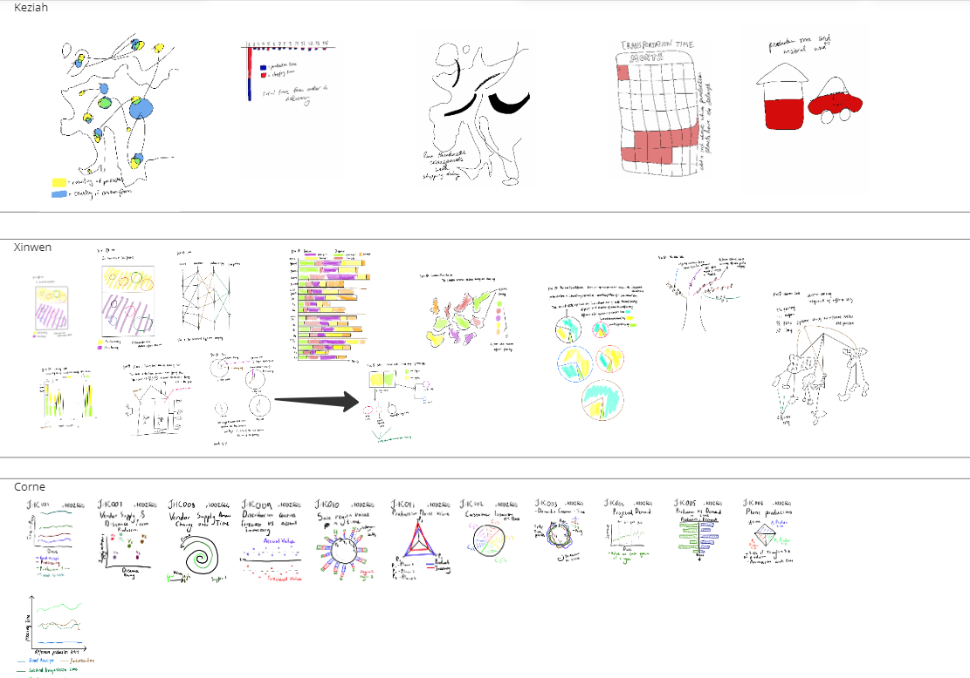

We then identified the main categories from the 27 diverged graph ideas. Seven main categories emerged from the emergence phase. The first group is Map, Time, Category Breakdown and Forecasting, as seen below:

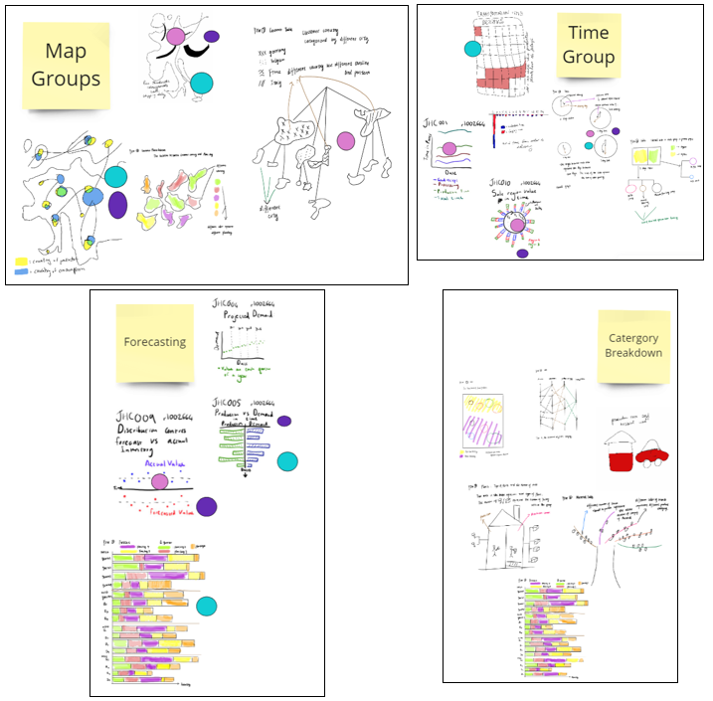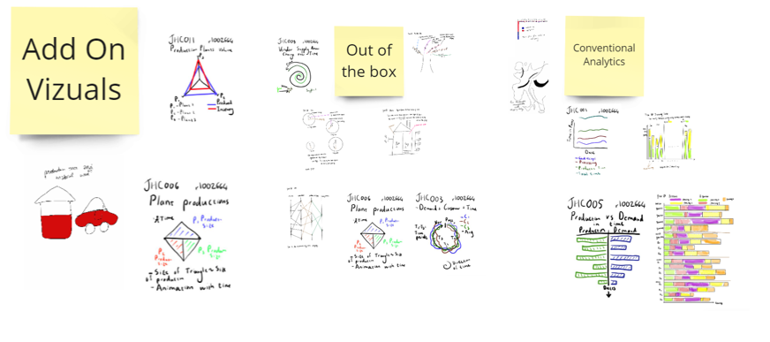

**Chosen Sketches**

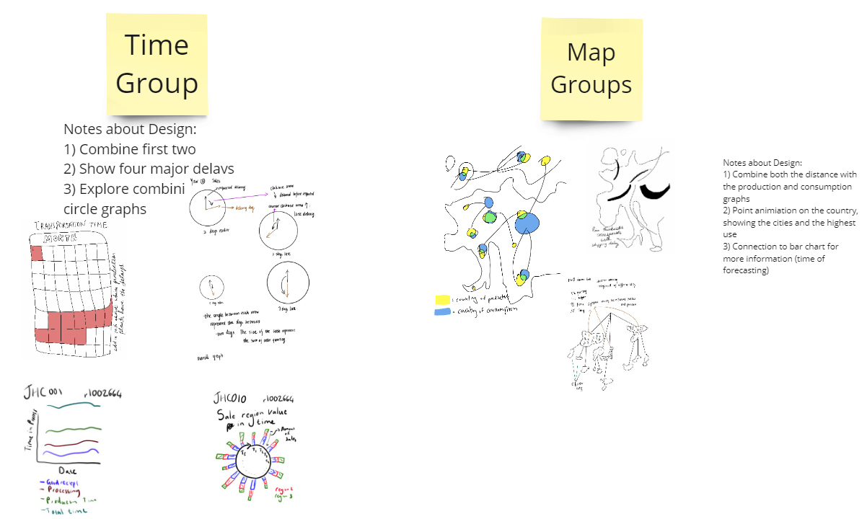

The final sketches were chosen by giving each of the three designers six colored tokens which they placed on the most interesting visuals. The visuals were then grouped together and brainstormed on how they could be combined. These final reworked sketches are explained next.

**Reworked Sketches for Implementation:**

**Map of Production, Consumption and Distribution of Goods:**

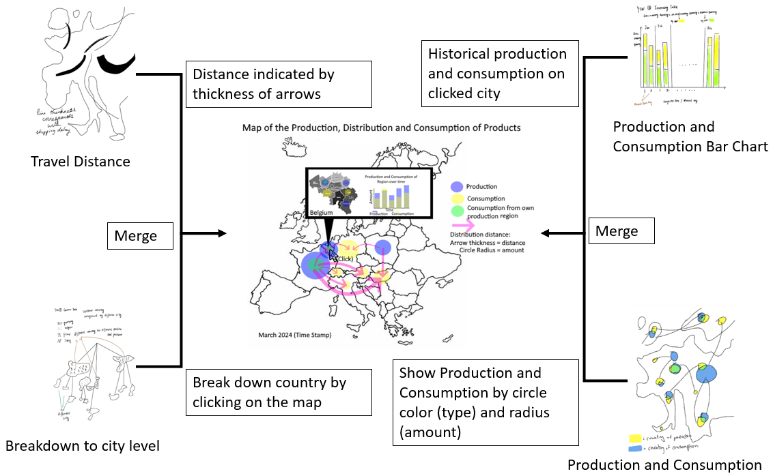

The first visual is a combination of four different visuals:

* **Travel distance**: Shows the distance between produce and consumer by the thickness of lines
* **City Breakdown**: Each country breaks down into cities and shows the biggest consumer/producer cities in the country
* **Bar Chart**: Show the historical production and consumption of goods
* **Production and Consumption**: Show the size (radius) of the production and consumption of each country

The final combined visual is seen below. Visual Encodings: The circles show the production (blue) and consumption (yellow) of products by the size of each circle. Furthermore, it shows the travel distance by the thickness of the opaque pink arrows. When clicking on a country, it shows the cities in the country and the history of the countries’ production and consumption on a bar chart.

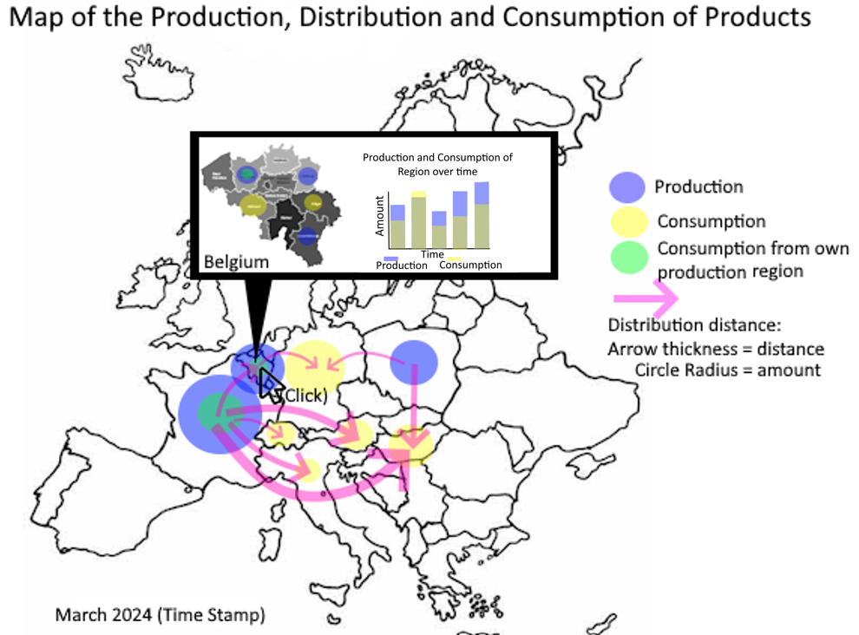

The visual above allows us to understand how physical distance and different countries influence our production and consumption efficiencies.

**Calendar Graph:**

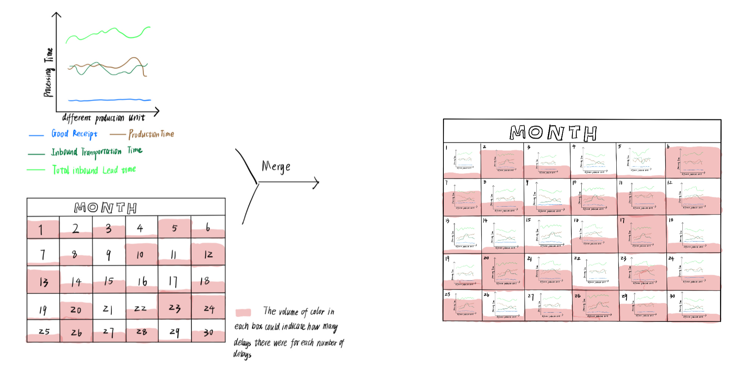

visual encoding:

1) Calendar here represents delays. Each number in the calendar represents the same days of delays.

2) The volume of colored space within each grid on the calendar represents the frequency of specific-day delays. The larger the volume, the more frequent the occurrence. For example, if in a grid with number 1, there is no color, which means one day of delays never occurred. If in a grid with number 30, the color takes up all space, then the frequency of 30-days delays should be quite high.

3) The line chart inside each grid is a representation of the processing time per production unit. The different color indicates various processing time types. The blue lines represent good receipt time. The brown lines represent production time. The dark green lines represent inbound transportation time. The light green lines represent total inbound lead time.

interaction:

1) The grid can be clicked. Clicking on the grid will pop up a new page listing several line graphs regarding relevant products included in this grid.

2) Moving the mouse pointer to the colored space in each grid, the actual frequency of specified delays will pop up.

How it addresses the questions:

This graph can give an overall situation regarding the delays. Users can easily know the details of the delayed product and recognize the most severe ones. This can aid users to notice some “outstanding” product, and analyze through the detailed information to tell the bottle neck.

**Clock Visualization:**

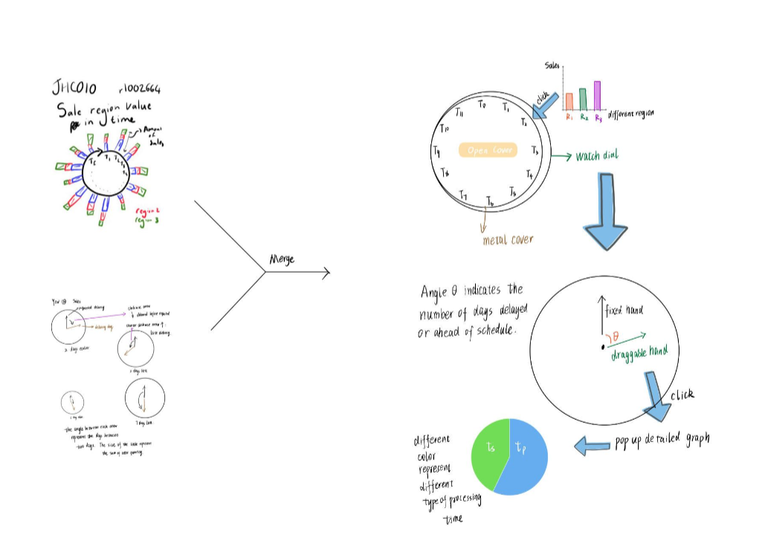

visual encoding:

1) The pocket watch with a metal cover, the cover shows information about sales, while the inner watch dial shows information regarding the performance of the delivery.

2) The blue arrows indicate what would show when clicking.

3) On the metal cover, different numbers represent different time periods. As the number goes up, time passes.

4) Clicking on each number on the cover will pop up bar charts of sales from different locations (or any other interesting attributes we focus

4) In the pop up bar chart, different color indicates different location, which the height of the bar indicates the sales

5) Clicking the 'Open Cover' button in the middle of the cover will reveal a new dial. The hands on the dial are draggable, allowing clockwise and counterclockwise movements. Dragging the hands clockwise will display the quantity of orders delivered ahead of planned date, while dragging counterclockwise will show the number of orders being shipped delayed.

6) The magnitude of the angle dragged is linearly correlated with the number of days ahead or behind schedule. Clicking on the hand, multipe pie charts will appear, which records different type of processing time of different product along with the quantity when hand points to specified number.

interaction:

2) We want to resketch a pocket watch with a metal cover, which is interactive.

how it addresses the questions:

**Appendix A. Sketches Overview**

**Complete Overview:**

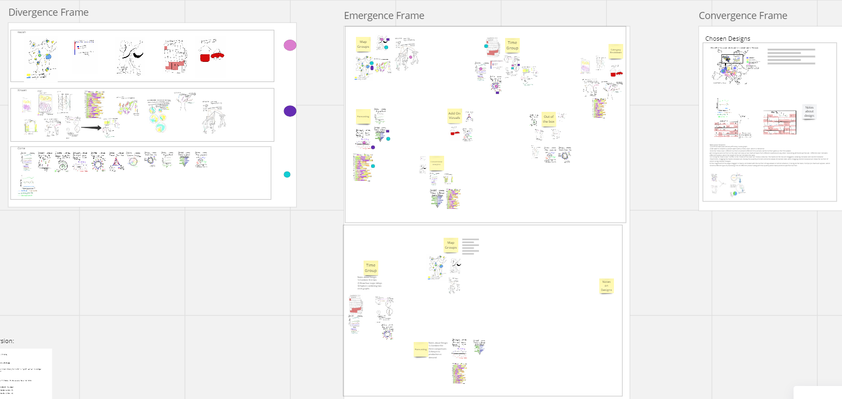

The diagram above shows our Divergence, Emergence and Convergence frames from each phase of the visualization process

**External Resources:**

Invitation link to the Miro board: <https://miro.com/welcomeonboard/Q1QzQW45ZVFxd3N3c2lSbkdzUjJ5Z3lrRmszcm0yaXI0Q1NzT3BsMmFqYlVjSGFMMjA0T1hlMmFVUWV6dlNGS3wzNDU4NzY0NTgwNjg4MzI0NjUzfDI=?share_link_id=475329337199>