Detection of network intrusion in Software defined networks using Artificial Intelligence

Kouam Kamdem Iii, Josimar  Masters Student,  Electrical and Computer Engineering  Carleton University  Ottawa, Canada  JosimarKouamKamdemIi@cmail.carleton.ca | Dharshini Vasudevan  Masters Student,  Electrical and Computer engineering  University of Ottawa  Ottawa, Canada  dvasu076@uottawa.ca | Ahmed Raoof  Professor,  Electrical and computer engineering  Carleton university  Ottawa, Canada  AhmedRaoof@cmail.carleton.ca

Abstract— One of the potential ideas for the future Internet has recently appeared, and it is called Software Defined Networking (SDN). We have the potential to improve our network security thanks to SDN's logical controller centralization and global network awareness. SDN does, however, also offer a rise in possible dangers. In this study, we use deep learning and machine learning methods to identify flow-based anomalies in an SDN setting. For an intrusion detection system, we create a Neural Network model and train it using the NSLKDD Dataset. We have developed two Deep Neural Networks for Network Intrusion Detection System (NIDS). One model detects if the attack is normal traffic or a mallicious attack. Another model detects the attack and categorises it into the major classes of attacks in SDN. Both model has better accuracy.
Keywords—Software defined network, NSLKDD dataset, Deep Neural Network, Accuracy.

Introduction
Software defined network (SDN) is a new way of network management to improve network performance and monitoring by enabling dynamic, programmatically efficient network configuration over traditional network management. SDN disassociates the forwarding process of network packets from the routing process to make the network a centralized network intelligence. The centralization has its own effects on security. The first standard communication interface established between the control and forwarding layers of SDN architecture is Open flow protocol [1]. OpenFlow uses the concept of flow to identify network traffic and record its information by counters.
The separation of the control and data planes opens up new attack opportunities, therefore SDN itself may become the target of some attacks even while its features make it simple to detect and respond to network intrusions. Seven danger vectors have been identified by Kreutz et al. as present in SDN [8]. The controller, the control-data interface, and the control-application interface are three of them that are unique to SDN.
A network is guarded against malicious software attacks by a network intrusion detection system (NIDS). According to methods used to find network threats, there are often two different forms of NIDS. The first, known as signature-based detection, evaluates fresh data against a database of previously detected intrusions. Although this method cannot detect fresh intrusions, it is still the most often used method in commercial intrusion detection systems. The second method, known as anomaly-based detection, uses machine learning to identify anomalies when fresh data significantly deviates from a model of typical user behaviour. This method can identify zero-day assaults that have never been witnessed before. In NIDSs, the technique to anomaly-based detection is typically paired with flow-based traffic monitoring [8]. Flow-based NIDSs must manage far less data than payload-based NIDSs since flow-based monitoring relies on data from packet headers. In several branches of computer science, such as face recognition and speech recognition, machine learning is successfully applied; nevertheless, intrusion detection is not one of them. Numerous aspects that influence the usage of machine learning in network intrusion detection were discussed by Robin Sommer and Vern Paxson [9]. Deep learning and machine learning have recently made a comeback and experienced significant success. These techniques have so far been commonly applied in computer science for the recognition of voices, faces, and images. Deep learning and machine learning are approaches that have promise for the future generation of intrusion detection since they can automatically discover correlation in the data. We can achieve a high detection rate by effectively detecting zero-day assaults using them.

Previous work
Flow-based intrusion detection is now the subject of substantial study. The authors of [11] propose a multi-layer perceptron and gravitational wave based flow-based anomaly detection system.
The search algorithm. The system has a very high accuracy rate for classifying benign and harmful traffic. In [12], the authors suggested an NIDS and obtained a low false alarm rate utilising a one-class support vector machine for their study. In contrast to previous research, the system is trained on a hostile network dataset. It is possible to use intrusion detection algorithms from conventional networks in SDN. Numerous anomaly detection methods have also been created in the SDN environment to safeguard the OpenFlow network.
The authors of [13] demonstrate how a programmable home network router may offer the best platform and placement in the network for identifying security issues in a SOHO (Small Office/Home Office) network by utilising the programmability of SDN. Rate limitation, maximum entropy detector, threshold random walk with credit based rate restriction, and NETAD are four well-known traffic anomaly detection methods that are implemented in an SDN environment utilising OpenFlow compliant switches and a NOX controller. The anomaly detector may operate at line rates without adding any additional performance overhead for the home network traffic, according to experiments, and is substantially more accurate than the ISP (Internet Service Provider) in identifying harmful activity in the SOHO network.
The SDN architecture is a target for a variety of attacks, and the SDN platform has potential Distributed Denial of Service (DDoS) attack vulnerabilities. DDoS attacks aim to block intended users from accessing a computer or network resource. DDoS assaults are sent by two or more individuals or automated systems. In order to execute DDoS attacks against the control layer, the infrastructure layer plane, and the application layer of SDN, for instance, an attacker might use SDN's features. DDoS assaults are simple to conduct but challenging to thwart. DDoS is rapidly expanding as a result of the advent of the Internet. The introduction and growth of botnets, or networks made up of computers infected with malware, is one important factor.
DDoS assaults grew by 125.36% in Q1 2016 compared to Q1 2015, according to Akamai's Q1 2016 "State of the Internet Security" report [14].
The extraction of six tuple features, including the average of packets per flow (APf), average of bytes per flow (ABf), average of duration per flow (ADf), percentage of pair-flows (PPf), growth of single-flows (GSf), and growth of different ports, is presented in [15] as a simple method for DDoS attack detection based on traffic flow features (GDP). The categorization approach makes use of Self Organizing Maps (SOMs).
Trung et almethod .'s [17] combines fuzzy inference system (FIS) and hard thresholds of detection to identify the likelihood of DDoS assaults based on real traffic characteristics in both normal and attack stages. Distribution of Interarrival Time, Distribution of Packet Quantity per Flow, and Flow Quantity to a Server are the three characteristics selected for identifying the assault. To improve detection accuracy, other researchers employ a variety of feature selection techniques.
In this paper, we have used all the feature of the dataset to train the Deep Neural Network that is used to detect the type of attack. We have done two parts of work; one categorises if the attack is normal or malicious and the other part is identifying what type of attack it is. The major difference between our paper and others is we have considered all types of attacks and identified the intrusion.

Methodology

Deep learning Approach
In traditional machine learning, significant input features are created by hand, and the algorithm automatically figures out how to translate the characteristics to an output. Deep learning involves a variety of different degrees of characteristics These characteristics are automatically identified, and they are combined at several levels to create outputs. Each level represents newly found abstract features that are derived from the traits shown in the level before. Our model initiation parameters are setup with 10 for the batch size and 100 for the epoch. The learning rate is 0.001.
As shown in Figure 1 & 2, we built a two Deep Neural Network (DNN) for our experiment. The first one for categorizing the normal and malicious attacks, had an input layer, three hidden layers, and an output layer. The dimensions of the input are unknown and the output is two. There are accordingly fifty, thirty and fifty neurons in the buried layers. The second one which is used to detect the categories of the attack, had an input layer, four hidden layer and an output layer. The dimension of input is unknown and output is 5. There are accordingly forty-one, hundred, eighty and thirty-two neurons in the buried layers.
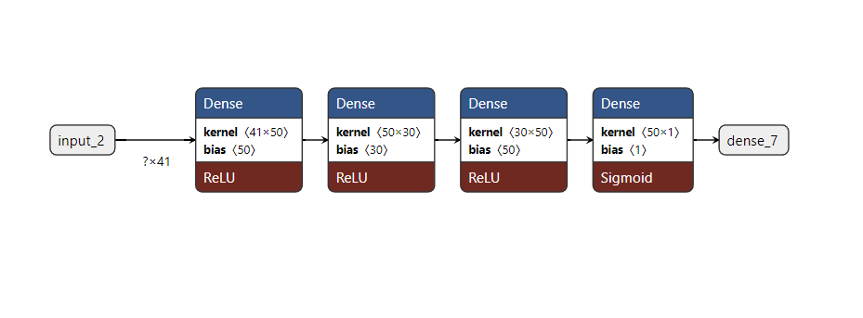
Figure 1: DNN to identify normal and malicious attacks

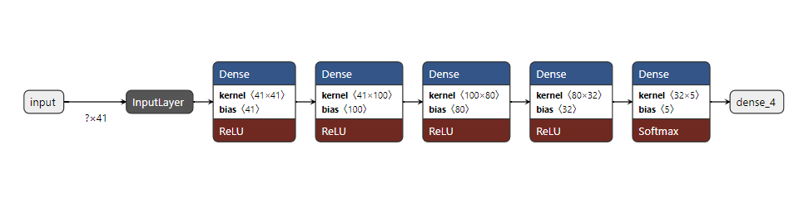
Figure 2: DNN for detecting the attacks

Dataset
The premier data mining competition in the world is the KDD Cup. A solution for several built-in issues with the KDD Cup 1999 Dataset was offered as the NSL-KDD Dataset [18].
It is still a suitable benchmark to use when comparing the NIDS models, despite being very outdated and not being a perfect representation of real-world networks. Numerous studies have utilised it in the past to assess NIDS performance, therefore there are noteworthy performance assessment data for comparison.
The KDDTrain+ Dataset contains 125,973 network traffic samples, whereas the KDDTest+ Dataset has 22,554 network traffic samples. The 41 features in each traffic sample are divided into three categories: fundamental features, content-based features, and traffic-based features. According to their features, attacks in the dataset are divided into four types.
Table I provides a description of each category's specifics.
The training set does not contain some particular attack types seen in the testing set. The detecting task becomes more realistic as a result.
Table 1
Attacks in the NSL-KDD dataset
Category | Training dataset | Testing dataset
DoS | back, land,  neptune, pod,  smurf, teardrop | back, land, neptune, pod, smurf,  teardrop, mailbomb,  processtable, udpstorm,  apache2, worm
R2L | fpt-write,  guess-passwd,  imap, multihop,  phf, spy,  warezclient,  warezmaster | fpt-write, guess-passwd, imap,  multihop, phf, spy, warezmaster,  xlock, xsnoop, snmpguess,  snmpgetattack, httptunnel,  sendmail, named
U2R | buffer-overflow,  loadmodule, perl,  rootkit | buffer-overflow, loadmodule, perl,  rootkit, sqlattack, xterm, ps
Probe | ipsweep, nmap,  portsweep, satan | ipsweep, nmap, portsweep, satan,  mscan, saint

As shown in Figure 3, we propose an NIDS design based on SDN. The controller in this design houses the NIDS module. The NIDS module may benefit from this global network perspective for intrusion detection since the SDN controller can keep an eye on all Open-Flow switches and request any necessary network statistics. Following a predetermined time window, the controller will send an ofp_flow_stats_request message to every OpenFlow switch asking for the network statistic. OpenFlow switches deliver an ofp_flow_stats_reply message including all the statistics back to the controller. To assess and correlate this network feedback, the centralised controller may benefit from the comprehensive network overview provided by the SDN. The NIDS module will then receive all network statistics for analysis and detection of any real-time network intrusion. Once a network anomaly has been discovered and named, the OF protocol can successfully mitigate it by altering the flow table. New security policies can be propagated to switches in order to prevent attacks.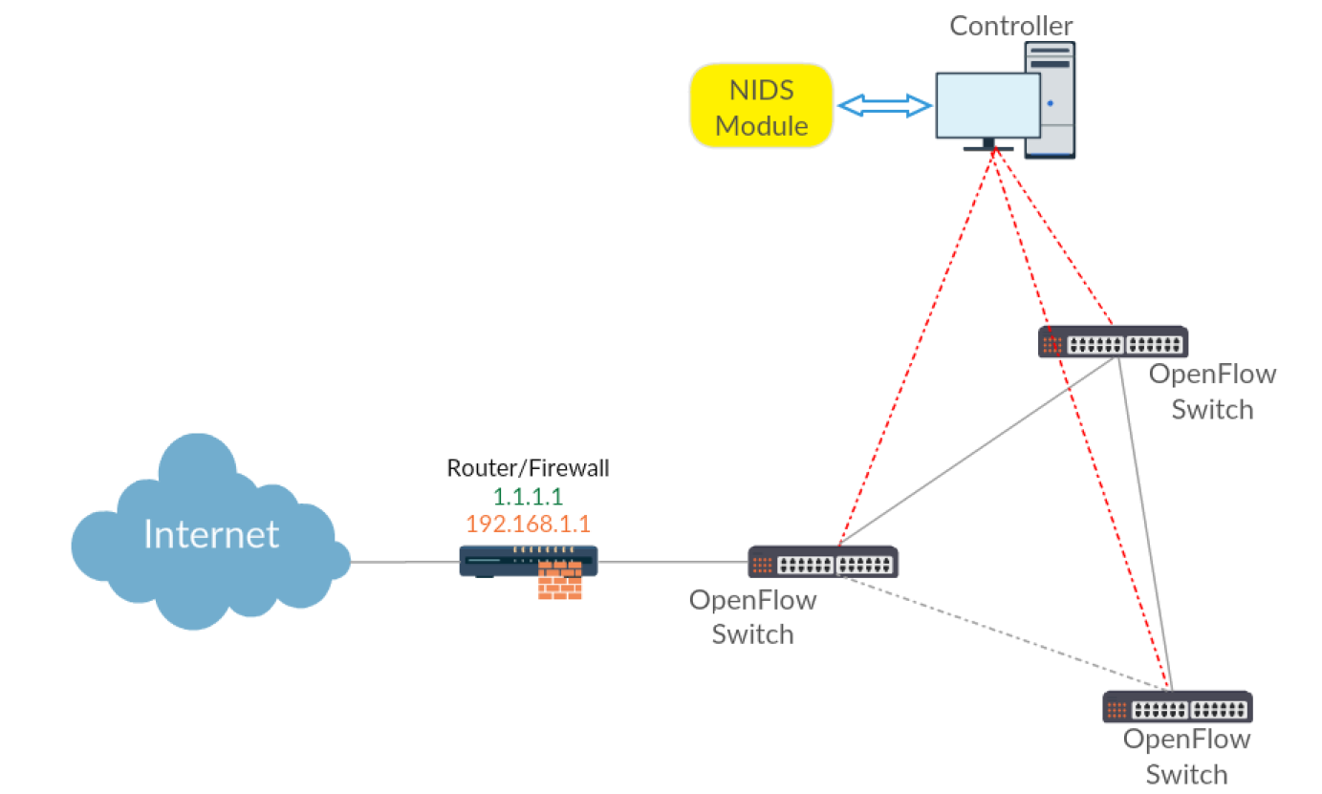
Figure 3: Proposed SDN architecture

PERFORMANCE ANALYSIS

Evaluation Metrics
In general, recall (R), accuracy (AC), precision (P), and F-measure are used to assess how well NIDS function (F).
High precision, high detection rate, and low false alarm rate are necessary for NIDS. These characteristics are computed using a confusion matrix. True Positive (TP) is the number of attack reports that were correctly categorized in the confusion matrix. The number of correctly identified normal data is known as True Negative (TN). The number of typical records that were misclassified is known as false positives (FP). The number of assault records that were wrongly assigned a false negative (FN) value.
- Accuracy (AC): shows the percentage of true detection over total traffic trace:
$$AC=\frac{TP+TN}{TP+TN+FP+FN}$$
- Precision (P): shows how many intrusions predicted by an NIDS are actual intrusions. The higher P is, the lower false alarm is:
$$P=\frac{TP}{TP+FP}$$
- Recall (R): shows the percentage of predicted intrusions versus all intrusion presented. We want a high R value:
$$R=\frac{TP}{TP+FN}$$
- F-measure (F): gives a better measure of the accuracy of an NIDS by considering both the precision (P) and the recal (R). We also aim for a high F value:
$$F=\frac{2}{\frac{1}{P}+\frac{1}{R}}$$

Experimental Results
Firstly, Lets look into the results of the DNN which identifies if the attack or malicious. The model is fed with the training dataset. As we can see in figure 4, the loss decreased and the accuracy kept increasing with epoch.
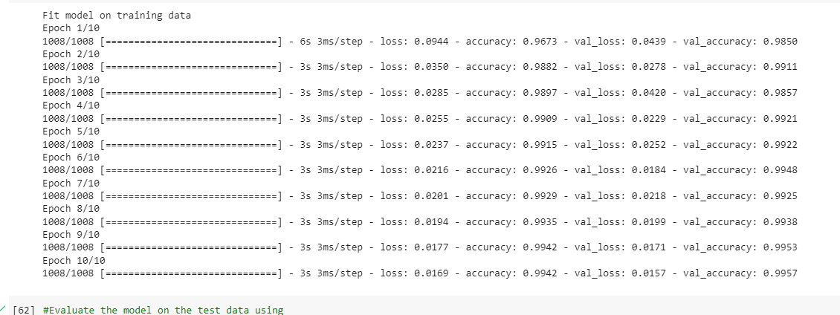
Figure 4: DNN with training dataset
The figure 5 shows the graphical representation of accuracy with each epoch of both training and test dataset. The Blue line represents the training dataset and orange represents the test dataset.

Figure 5: accuracy vs Epoch for training and test dataset
The graphical representation of loss and epoch is shown in figure 6 below. The graph marks the loss in both training and test dataset. As we can see in figure 6, the loss of the model has gone down in each epoch for both training and test data set.

Figure 6: Loss vs Epoch in training and test dataset
The figure 7 below shows the trends of accuracy with iterations. It is clearly visible that the accuracy is increased with each iterations making the model more stable.

Figure 7: Model Accuracy vs Iterations
The graphical representation of loss with iteration is shown in figure 8. The loss drops to negligible with increasing iterations. Thus, the model is reliable.

Figure 8: Model Loss vs Iteration
Now, evaluation metrics of the model for training data is calculated and displayed on the Table 2. the confusion matrix representation of the same is shown in the figure 9. It has the information about the True Positive (TP), True Negative (TN), False Positive (FP) and False Negative (FN) values of the model. Using these values, the metrics are calculated to evaluate the model.
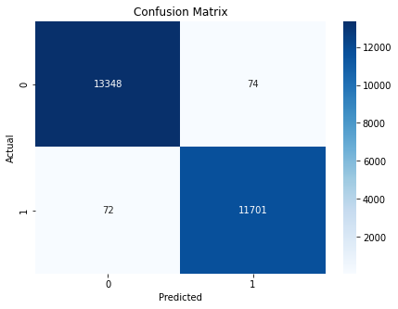
Figure 9: Confusion matrix of DNN with training data set.
Table 2
Evaluation of the model with training dataset
Evaluation metrics | percentage
Accuracy | 99.42
Precision | 99.47
Recall | 99.29
F1-Score | 99.39

Evaluation metrics of the model for test data is calculated and displayed on the Table 3. The confusion matrix representation of the same is shown in the figure 10. Using these values the metrics are calculated to evaluate the model.
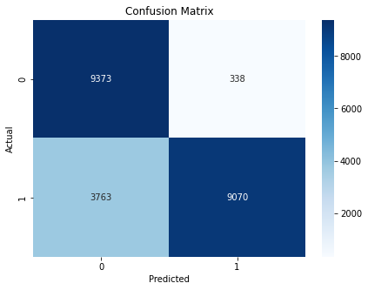
Figure 10: Confusion matrix of DNN with test data set
Table 3
Evaluation of the model with test dataset
Evaluation metrics | percentage
Accuracy | 82
Precision | 96
Recall | 71.3
F1-Score | 81

Secondly, let’s look into the experimental results of the model that detects the category of the attack. The distribution of the different types of attacks in NSL KDD dataset is shown in figure 11. The distribution of the attacks is uneven and makes it complicated to detect rare attacks.
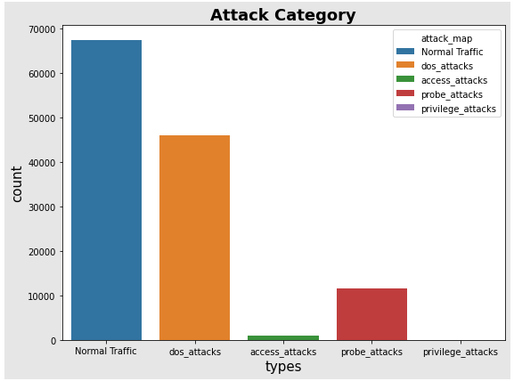
Figure 11: Distribution of attacks in NSL KDD dataset
After the model is applied with training and test dataset, the confusion matrix formed were figure 12 and 13 respectively. Table 4 and 5 shows the evaluation metrics of training and test dataset respectively with the model. The ‘0’ represents normal traffic, ‘1’ is DDoS attack, ‘2’ is access attack, ‘3’ is Probe attack and ‘4’ is privilege attacks.
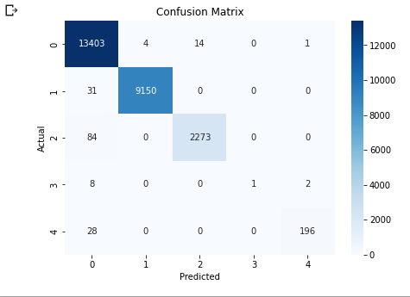
Figure 12: Confusion matrix of DNN with training data
Table 4
Evaluation of the model with training dataset
Evaluation metrics | percentage
Accuracy | 99.34
Precision | 97.98
Recall | 79.54
F1-Score | 81.14

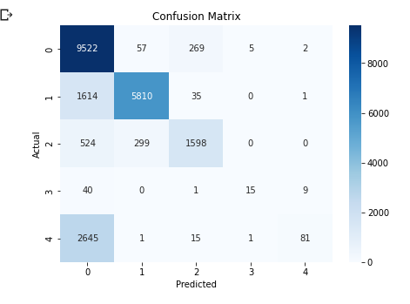
Figure 13: Confusion matrix of DNN with test data

Table 5
Evaluation of the model with test dataset
Evaluation metrics | percentage
Accuracy | 78
Precision | 80
Recall | 77.97
F1-Score | 73.35

CONCLUSION

References
- Tuan A Tang, Lotfi Mhamdi, Des McLernon, Syed Ali Raza Zaidi and Mounir Ghogho “Deep Learning Approach for Network Intrusion Detection in Software Defined Networking” 2016 International Conference on Wireless Networks and Mobile Communications (WINCOM), 2016
- “Software Defined Networking Definition,” Available: https://www.opennetworking.org/sdn-resources/sdn-definition.
- N. McKeown, T. Anderson, H. Balakrishnan, G. Parulkar, L. Peterson, J. Rexford, S. Shenker, and J. Turner, “Openflow: enabling innovation in campus networks,” ACM SIGCOMM Computer Communication Review, vol. 38, no. 2, pp. 69–74, 2008.
- S. Jain, A. Kumar, S. Mandal, J. Ong, L. Poutievski, A. Singh, S. Venkata, J. Wanderer, J. Zhou, M. Zhu et al., “B4: Experience with a globally-deployed software defined wan,” ACM SIGCOMM Computer Communication Review, vol. 43, no. 4, pp. 3–14, 2013.
- C. T. Huawei Press Centre and H. unveil world’s first commercial deployment of SDN in carrier networks, “[online]. available: pr.huawei.com/en/news/hw-332209-sdn.htm.”
- N. Gude, T. Koponen, J. Pettit, B. Pfaff, M. Casado, N. McKeown, and S. Shenker, “Nox: towards an operating system for networks,” ACM SIGCOMM Computer Communication Review, vol. 38, no. 3, pp. 105– 110, 2008.
- “Ryu,” Available: http://http://osrg.github.io/ryu/.
- “Floodlight,”Available: http://www.projectfloodlight.org/.
- D. Kreutz, F. Ramos, and P. Verissimo, “Towards secure and dependable software-defined networks,” in Proceedings of the second ACM SIGCOMM workshop on Hot topics in software defined networking. ACM, 2013, pp. 55–60.
- R. Sommer and V. Paxson, “Outside the closed world: On using machine learning for network intrusion detection,” in 2010 IEEE symposium on security and privacy. IEEE, 2010, pp. 305–316.
- M. Tavallaee, E. Bagheri, W. Lu, and A.-A. Ghorbani, “A detailed analysis of the kdd cup 99 data set,” in Proceedings of the Second IEEE Symposium on Computational Intelligence for Security and Defence Applications, 2009.
- Z. Jadidi, V. Muthukkumarasamy, E. Sithirasenan, and M. Sheikhan, “Flow-based anomaly detection using neural network optimized with gsa algorithm,” in 2013 IEEE 33rd International Conference on Distributed Computing Systems Workshops, 2013, pp. 76–81.
- P. Winter, E. Hermann, and M. Zeilinger, “Inductive intrusion detection in flow-based network data using one-class support vector machines,” in New Technologies, Mobility and Security (NTMS), 2011 4th IFIP International Conference on. IEEE, 2011, pp. 1–5.
- S. A. Mehdi, J. Khalid, and S. A. Khayam, “Revisiting traffic anomaly detection using software defined networking,” in International Workshop on Recent Advances in Intrusion Detection. Springer, 2011, pp. 161– 180.
- “Q1 2016 State of the Internet / Security Report,” Available: https://content.akamai.com/PG6301-SOTI-Security.html, [Accessed 07 Jul. 2016].
- R. Braga, E. Mota, and A. Passito, “Lightweight ddos flooding attack detection using nox/openflow,” in Local Computer Networks (LCN), 2010 IEEE 35th Conference on. IEEE, 2010, pp. 408–415.
- K. Giotis, C. Argyropoulos, G. Androulidakis, D. Kalogeras, and V. Maglaris, “Combining openflow and sflow for an effective and scalable anomaly detection and mitigation mechanism on sdn environments,” Computer Networks, vol. 62, pp. 122–136, 2014.
- P. Van Trung, T. T. Huong, D. Van Tuyen, D. M. Duc, N. H. Thanh, and A. Marshall, “A multi-criteria-based ddos-attack prevention solution using software defined networking,” in Advanced Technologies for Communications (ATC), 2015 International Conference on. IEEE, 2015, pp. 308–313.

