Intrusion Detection in IoT Networks Using Deep Learning Algorithm

Abstract— Significant increase application of IOT that have become integral part of our daily live. This exponential growth of IOT networks has made it more and more difficult to deal with hostile activity they may be subject to. Many approaches have been proposed to address the various security concerns facing IoT, but more effort still have to be done. Amongst those proposed solutions, Machine Learning has emerged as an approach to deal with hostile activities in IoT. In this study, we use deep learning to identify flow-based anomalies in an IoT setting. For an intrusion detection system, we create severals Neural Network models and evaluated them using standard Dataset for evaluation. The goal was classify normal and abnormal flow traffics. Our results showed that machine learnings algorithms could be very efficient for intrusion detection. We obtained an accuracy score of 95% for the DNN and LSTM model respectively and an accuracy of 94% for the MLP and CNN. Furthermore with the ROC curve, we achieved a detection rate above 99% for all our models.
Keywords—Intrusion Detection, IoT, Deep learning Algorithm

Introduction
The IoT has emerged as a revolution in the field of computing in recent years with the aims to significantly transform every aspect of our lives. With the continuously and gradually increasing number of connected devices, IoT application range from connected home, health care, connected cars, supply chain management and much more [1]. A study conducted in [3] predict that close to 38 billion devices will be connected over the internet by the year 2022.
The rise of this live changing technology is however deeply threatened with security and privacy concern [1]. The massive flux connected devices eventually introduced new doors for security attacks. As it wasn’t enough, manufacturer of IoT devices give little if no attention the security aspect of their product when designing them and shipped them without adequate security control in place. Current researches have establish that current IoT devices on the market have serious security flaws and vulnerabilities [4].
If not secured properly, basic Internet of Things (IoT) devices can become a means of attack. In October 2016, this was demonstrated when hacked IoT devices, such as cameras and DVRs, were used to target Dyn, the largest DNS provider. This led to a significant Internet outage, disrupting access to popular websites such as Twitter, Amazon, and Netflix [5].
Despite having certain security measures in place, IoT networks remain susceptible to multiple attacks due to their extensive attack surface. As a result, it is crucial to develop defense mechanisms that can identify and prevent such attacks. Intrusion-detection systems (IDS) are critical security measures for safeguarding vulnerable IoT environments. However, due to their inherent limitations in terms of computational resources, traditional security techniques cannot be readily employed to secure IoT systems.
Most of the current research on intrusion detection for the IoT revolves around rule-based detection techniques [6,7,8]. However, to efficiently detect zero-day threats in emerging IoT environments, anomaly-based detection techniques are indispensable. Moreover, in a highly connected IoT ecosystem where numerous devices generate vast amounts of data, machine learning algorithms can aid in the automated analysis of data and provide valuable insights and predictions about the system. The use of machine learning for IoT security is especially promising in detecting any abnormal activity or outliers in the system. Therefore, we investigate an anomaly-based IDS that employs machine learning techniques to detect known and unknown attacks on IoT devices in real-time.
We aim to create a secure, portable, and easily deployable security system that offers a practical and efficient solution for safeguarding upcoming extensive IoT networks. Numerous techniques and frameworks have been developed to mitigate network attacks. Machine learning and deep learning methods, including both supervised and unsupervised approaches, can assist in monitoring logs, which can reach millions of entries per day on a large network. Many researches have used the knowledge discovery and data (KDD) obtained from the International Knowledge Discovery and Data Mining Tools Competition, the NSL-KDD developed by the Canadian Institute for Cybersecurity at the University of New Brunswick, for IDS. In this paper we will use the BoT-IoT dataset developed by the University of New South Wales (UNSW) Canberra Cyber center, in Australia.

METHODOLOGY

Deep learning approach
In traditional machine learning, significant input features are created by hand, and the algorithm automatically figures out how to translate the characteristics to an output. Deep learning involves a variety of different degrees of characteristics These characteristics are automatically identified, and they are combined at several levels to create outputs. Each level represents newly found abstract features that are derived from the traits shown in the level before.
For my work, I built four neural networks namely: DNN, CNN, LSTM, and MLP each of which has its own structure and in most case, different hyperameters (batch size, epoch, weights initialisation e.g). the approach used to achieved my goals is shown in figure 1.
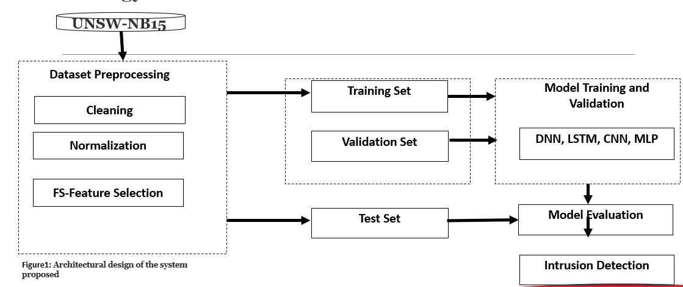

Figure 1: Methodology for implementing NN

Dataset destription
Researchers have employed various types of datasets to evaluate systems. One such dataset used in this study is the BoT-IoT dataset, developed by the UNSW in Canberra, which has multiple datasets. The BoT-IoT dataset was created by combining normal traffic and botnets in an environment built at the Cyber Range Laboratory in the UNSW Canberra Cyber center. The data sources were available in different formats, including original .pcap files containing network data packets, as well as comma-separated values (CSV) files. Pcap files are commonly used by Wireshark programs for network data analysis. The files were categorized based on attack types and subtypes, making the labeling process easier [2].

Dataset Preprocessing
The BoT-IoT dataset is highly imbalance as shown in figure2, where zero represent normal traffic and one represent attacks. To avoid bias in the results, I performed an under sampling technique that manually reduced the size of the majority class. Also, there was a lot of multicollinearities in the dataset and a feature selection were performed to identify those features with higher correlation with our target feature. Then we set a threshold that returned only feature meeting the specified threshold criteria.

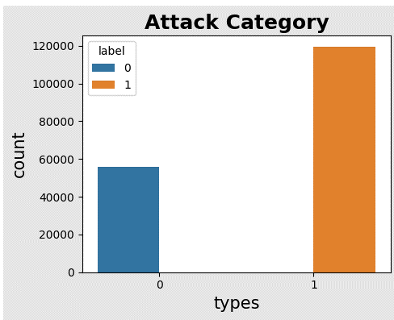

Figuge2: Attack classification

The results of these operations are shown in figure 3 and table1 respectively.
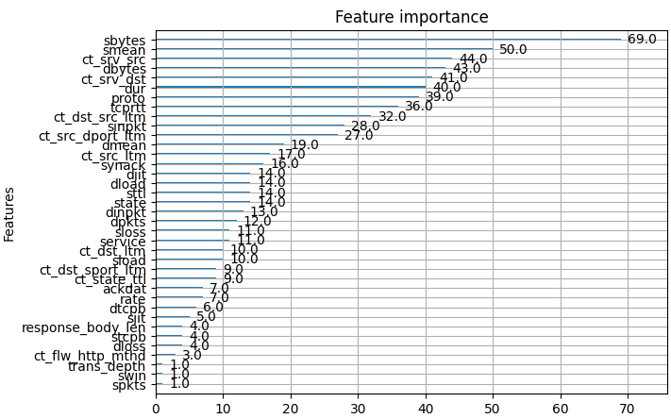

After setting the threshold as previously mentioned, the following 11 features were returned as shown in table (table1)

Features n0 | names
3 | state
6 | sbytes
9 | sttl
13 | sloss
15 | sinpkt
24 | synack
26 | smean
27 | Dmean
28 | trans_depth
35 | ct_dst_src_ltm
40 | ct_srv_dst
Table1: selected features

PERFORMANCE ANALYSIS

Evaluation metrics

The commonly used metrics to evaluate the performance of NIDS are accuracy (AC), precision (P), recall (R), F-measure (F) using a confusion matrix. For classification, it is a good habit to evaluate different model using ROC and the area under the curve(AUC), that provide with the best classification model. Furthermore, it should be pointed out that, when dealing with imbalance dataset, accuracy might not be the best metric to evaluate models. Instead, we can pay more attention on the others previously cited metrics.
- Accuracy (AC): shows the percentage of true detection over total traffic trace:
$$AC=\frac{TP+TN}{TP+TN+FP+FN}$$
- Precision (P): shows how many intrusions predicted by an NIDS are actual intrusions. The higher P is, the lower false alarm is:
$$P=\frac{TP}{TP+FP}$$
- Recall (R): shows the percentage of predicted intrusions versus all intrusion presented. We want a high R value:
$$R=\frac{TP}{TP+FN}$$
- F-measure (F): gives a better measure of the accuracy of an NIDS by considering both the precision (P) and the recall (R). We also aim for a high F value:
$$F=\frac{2}{\frac{1}{P}+\frac{1}{R}}$$

Experimental results
- DNN model
The architectures of the Deep Neural Network is shown in figure 4. It has four hidden layers each with relu as activation function. The activation function at the output layer is sigmoid.
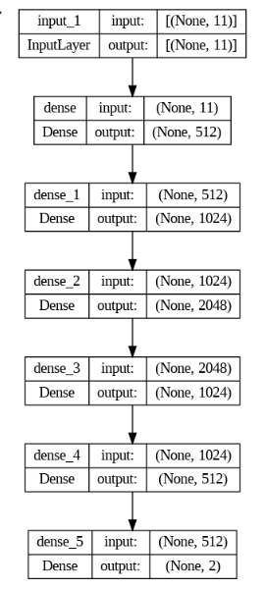

After training the model, the plot accuracy as illustrated in figure 5, shows that the training and validation accuracy increase after five epochs giving an indication that the model is learning fast. This improvement continued until the 100th epoch for the training while the validation seems to stabilise.
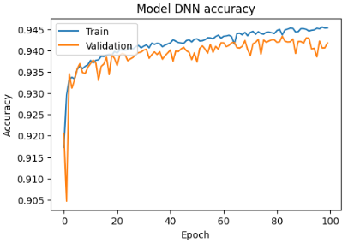

On the other hand, as shown in figure 6, the loss on the training set decreases rapidly for the first few epochs. For the test set, the loss does nor decrease at the same rate and tend to settle at some point. This could be an indication that the model generalises well.
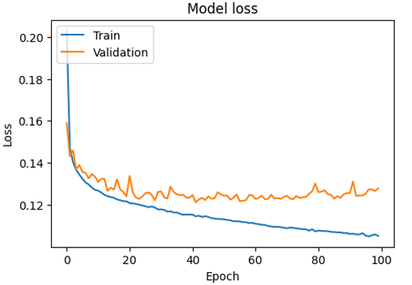

The evaluation of the model with the test data provided us with the confusion matrix represented in figure 7. Table 2 show the score of the evaluation metrics.

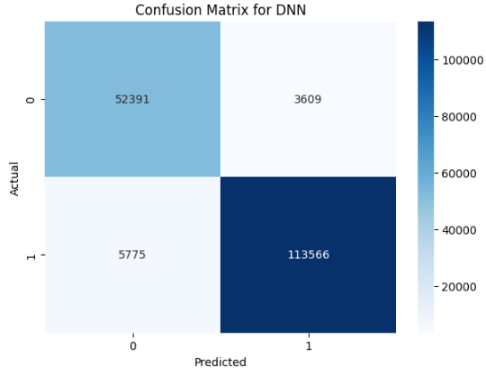

These results shows good performance our DNN with its capability of correctly classify normal and malicious network traffics with a precision score of 94%. The recall is also not bad indicating that the model is capable of identifying false negative rate.
- CNN model
The CNN model is a fully connected neural network (NN) with three hidden layers each of which was associated with a maxpooling layer. The activation function in the hidden layer and output layer are the same as with the DNN. A summary of the model is given in figure 8 bellow.
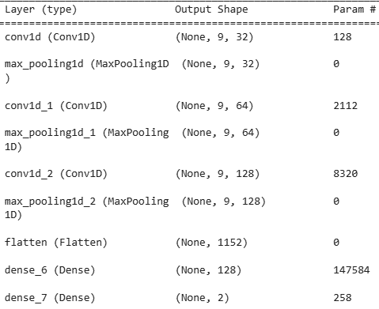

Figure 9 and figure 10 shows the accuracy and the loss of the model. The graphs show that the model is learning fast. After one epoch the accuracy was already above 90% for the training and validation sets. On the other hand, the loss on the training decreases rapidly for the first epoch. For the test set, the loss does not decrease at the same rate as the training set, but does decrease and at some point, remains almost flat for multiple epochs. This means our model is generalizing well to unseen data. The evaluation of the model with the test dataset gave the confusion matrix and the table shown in graph 10 and table 3 respectively. Even if the detection of negative rate is lower than with the DNN, the model still shows a good precision score along with an acceptable f1-score.
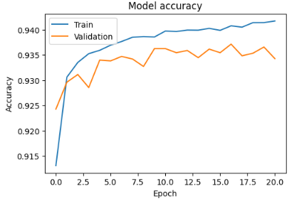

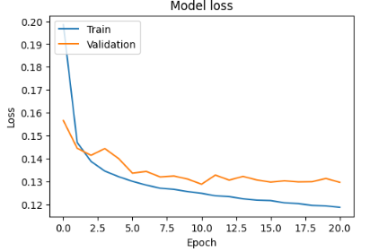

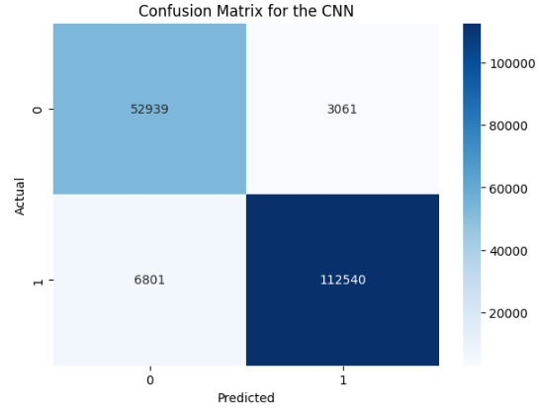

- LSTM model
The summary of the LSTM is shown in figure 11. It is a very simple model.

Evaluation metrics (CNN) | Percentage (%)
Accuracy | 94
Precision | 95
Recall | 89
F1-Score | 91

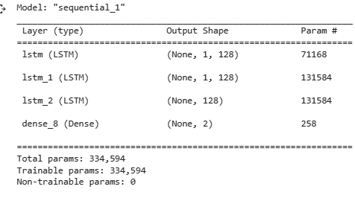

After training the model the graph once again shows that the model is learning fast. At the very first epoch the accuracy on both training and validation were already away above 90% (fig12) below.
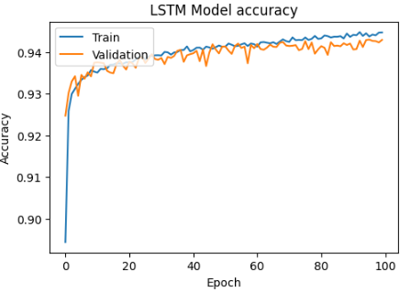

We can clearly see that after 10 epochs both accuracy are still going up. As with our previous models, the loss in the training and test decreased rapidly and seemed to keep on decreasing after the 100th epochs. The evaluation results of the model with the test data are show in fig 14 and table 4.
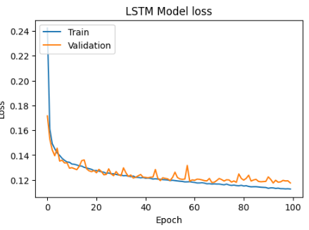

We can see that the false positive rate is better than what was observed with the CNN model but still less good than the DNN model in term of false negative detection.
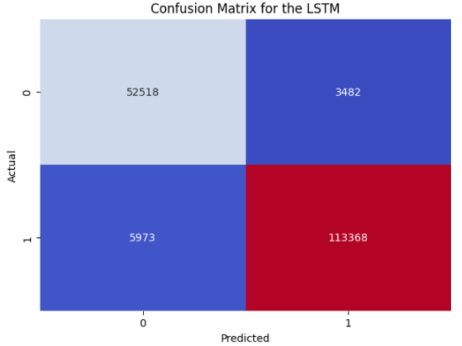

Evaluation metrics (LSTM) | Percentage (%)
Accuracy | 95
Precision | 94
Recall | 90
F1-Score | 92

- Multiple Layer Perceptron (MLP) model
I built a simple MLP model (not a keras). The results of training and evaluation of the model are shown below.

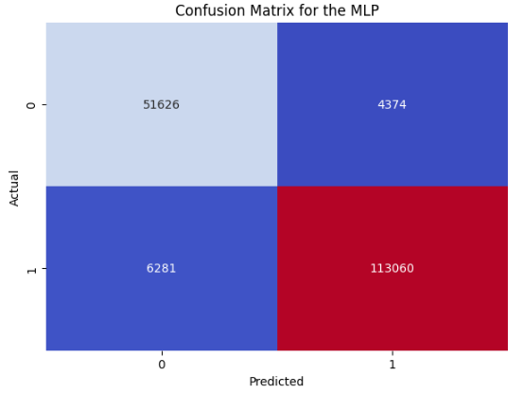

No hyperparameter where done to try to improve the score of this model due to lack of time. Out of the four models presented in this paper, it produced the lowest scores as shown in the table figure below, representing the classification report of the model.
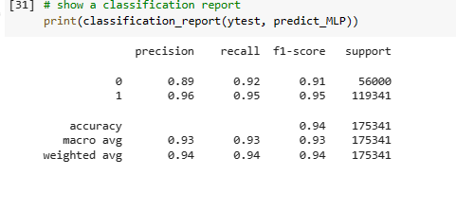
- ROC and AUC for model comparison
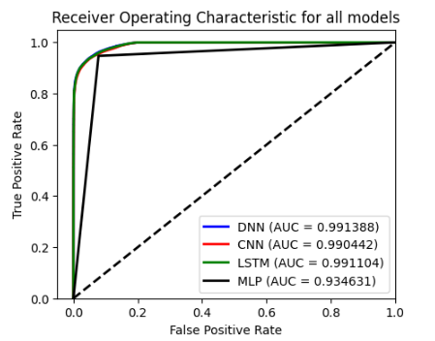
The AUC of the ROC curve determine which model proposes the best classification. The graph below show that the DNN provide the best classification followed by the LSTM, CNN and MLP.

CONCLUSION AND FUTURE WORKS
The goal of this work is to build, train and evaluation several deep learning model in an IoT setting. The results showed that good learning could be very promising in this field. Due to time constraint and the number of models built, it wasn’t possible to dig further into each model thoroughly to obtain a better score. This is what my future work will be based on.

References

- Thamilarasu, Geethapriya, and Shiven Chawla. 2019. "Towards Deep-Learning-Driven Intrusion Detection for the Internet of Things" Sensors 19, no. 9: 1977. https://doi.org/10.3390/s19091977
- N. Moustafa and J. Slay. 2015 . "UNSW-NB15: a comprehensive data set for network intrusion detection systems (UNSW-NB15 network data set), Military Communications and Information Systems Conference (MilCIS), Canberra, ACT, Australia, 2015, pp. 1-6, doi: 10.1109/MilCIS.2015.7348942
- SMITH, S. IoT connected devices to triple to over 38bn units. Juniper Research: Basingstoke, Hampshire, UK, 2015.
- Williams, R., McMahon, E., Samtani, S., Patton, M., & Chen, H. (2017, July). Identifying vulnerabilities of consumer Internet of Things (IoT) devices: A scalable approach. In 2017 IEEE International Conference on Intelligence and Security Informatics (ISI) (pp. 179-181). IEEE.
- Hilton, S. (2016). Dyn analysis summary of friday october 21 attack. Dyn blog https://dyn. com/blog/dyn-analysis-summary-of-friday-october-21-attack..
- Kasinathan, P.; Costamagna, G.; Khaleel, H.; Pastrone, C.; Spirito, M.A. DEMO: An IDS Framework for Internet of Things Empowered by 6LoWPAN. In Proceedings of the 2013 ACM SIGSAC Conference on Computer & Communications Security, Berlin, Germany, 4–8 November 2013.
- Krimmling, J.; Peter, S. Integration and Evaluation of Intrusion Detection for CoAP in smart city applications. In Proceedings of the IEEE Conference on Communications and Network Security (CNS), San Francisco, CA, USA, 29–31 October 2014
- Le, A.; Loo, J.; Lasebae, A.; Aiash, M.; Luo, Y. 6LoWPAN: A study on QoS security threats and countermeasures using intrusion detection system approach. Int. J. Commun. Syst. 2012, 25, 1189–1212
- M. Young, The Technical Writer’s Handbook. Mill Valley, CA: University Science, 1989.

