FunFactory

Hartlauer Sandra, s2510455002@fhooe.at, s2510455002
Langsenlehner Cornelia, s2510455006@fhooe.at, s2510455006
Parzmair Rupert, s2510455013@fhooe.at, s2510455013
Salminger Andreas, s2510455003@fhooe.at, s2510455003
Zellinger Clemens, s2510455019@fhooe.at, s2510455019

Project Idea
The project is a simplified game creation platform inspired by visual programming tools such as Nintendo’s “Game Builder Garage”. The application allows users to create simple games using visual “blueprint-like” logic blocks instead of writing code.
Users can play levels on a grid-based scene and use visual logic blocks to define behaviour such as player movement and pushing chests on the grid. The goal is to provide a beginner-friendly environment where users can experiment with game logic and learn simple programming concepts interactively.
For the first prototype, the system will focus on creating and playing a “Sokoban”-style puzzle game where the player pushes boxes to target positions to solve the level.

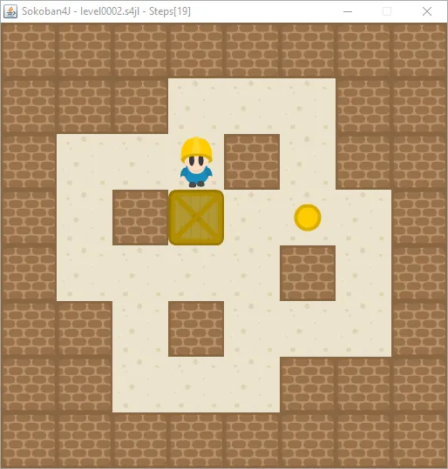  Sokoban Sample Game https://opengameart.org/content/sokoban-pack | 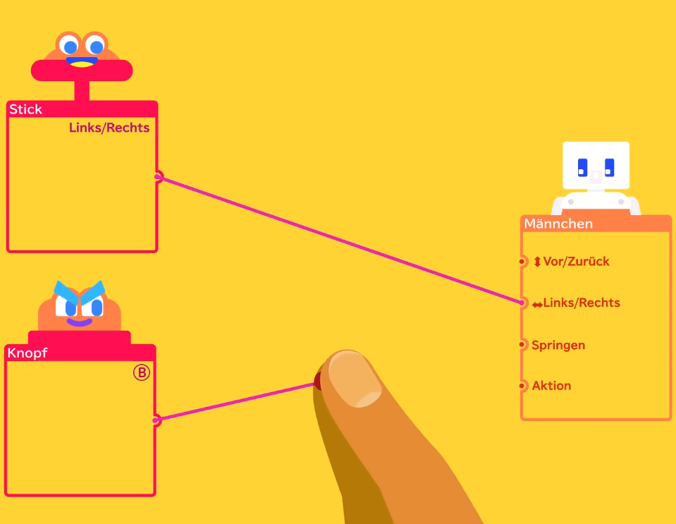  “Game Builder Garage” for Nintendo Switch  https://youtu.be/NENfiwY59N0

Purpose
The purpose of the project is to provide a visual and playful introduction to programming concepts. Instead of traditional code, users interact with graphical logic blocks that represent events and actions.
The project aims to demonstrate how simple programming concepts such as movement actions and conditions (like winning or gameover) combined to control game behaviour.

Motivation
Programming can be difficult for beginners because it requires learning syntax and abstract concepts at the same time. Visual programming environments reduce this barrier by allowing users to focus on logic instead of code.
By building a cross-platform application that works on different (mobile) devices, the project enables users to experiment with game design and programming concepts anywhere, without installing specialized software or acquiring any extra hardware.
The project also demonstrates how modern web technologies can be used to build interactive applications that run on multiple platforms.

Use Cases
A student creates a simple Sokoban level by placing walls, boxes, and target tiles on a grid.
A player connects visual logic blocks to define player movement and interactions.
The player tests the created level directly in the application.
Players experiment with game mechanics to understand basic programming logic.
Teachers or students use the application as a learning tool to demonstrate event-based programming - also perfectly suitable for “Open Days”.

User Stories

As a player, I can solve the predefined levels by moving chests to the target locations.

As a player, I want to move chests using visual logic blocks so that I can define game behaviour without writing code.
As a player, I want to test my game directly in the application so that I can immediately see the results of my changes.
As a player, I want the application to work on different devices so that I can use it on a computer, tablet, or smartphone.
As a player with no experience in programming, I want to learn very basic programming concepts through visual logic blocks so that I can understand how games work.

Target Platforms
The application is designed as a cross-platform system.
Target platforms include:
- Web browsers (desktop)
- Android devices
- iOS devices
Because the application is built using web technologies, it can run on multiple devices without requiring different implementations for each platform.

Target technology and model
The project will be implemented using modern web technologies.
Main technologies:
- Ionic Framework
- Vue.js
- TypeScript
- HTML5 Canvas for rendering the game scene
- Capacitor for cross-platform mobile builds
Architecture model:
- Frontend-based application
- Component-based UI architecture
- JSON-based data model for game levels
- Event-driven logic system for game behaviour (e.g. “Level completed”)

Parts to be implemented (if idea is to big):
Because a full visual game builder with varying game types/simulations would be very large, the project will focus on a limited prototype with the following features:
Core features:
- Basic visual logic blocks for game behaviour
  - Movement
    - Move Player Left
    - Move Player Right
    - Move Player Up
    - Move Player Down
    - Moving the player also possibly moves an adjacent chest
  - Repeat / Loops
    - Repeat other node N times (for example move right 3 times)
    - Repeat Node must not be included in another repeat
  - Conditions / If
    - Winning Condition
    - Losing Condition
- Game preview/play mode
- Simple Sokoban-style puzzle gameplay
Advanced features such as complex physics, multiplayer support, advanced animations, or a large asset system will not be implemented.
The project tasks will be divided among the five students, including:
- UI and editor interface
- Canvas rendering and game runtime
- Logic block system
- Data storage and level serialization
- Cross-platform integration and testing
If applicable possible monetisation options:
Although the project is primarily an educational prototype, possible monetisation options could include:
- Educational licensing for schools or programming courses
- A premium version with advanced game creation tools
- Additional asset packs (sprites, sounds, levels)
The main goal of the project, however, is educational rather than commercial.

