Brainwave
User Guide

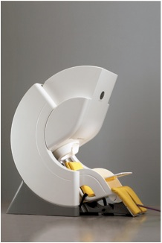
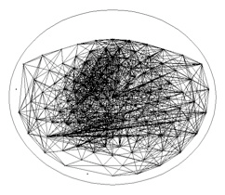
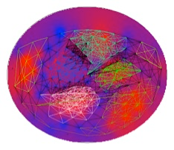
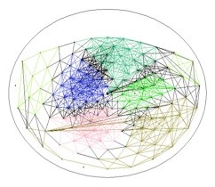
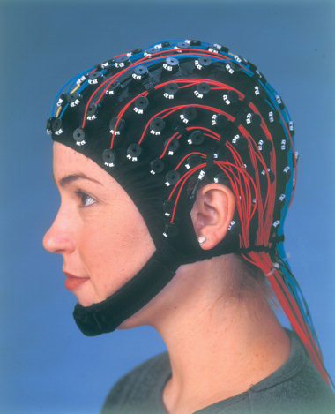
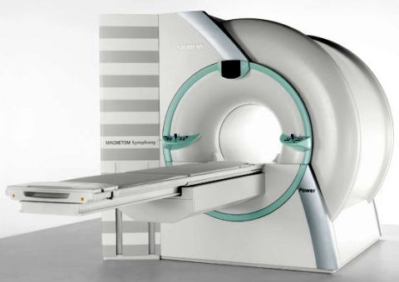
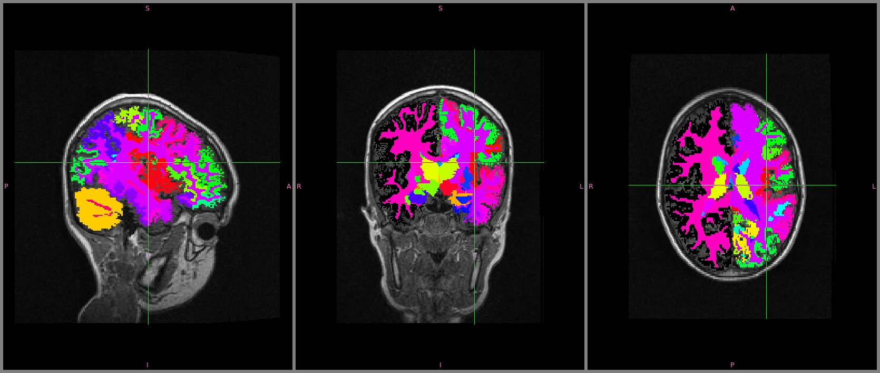
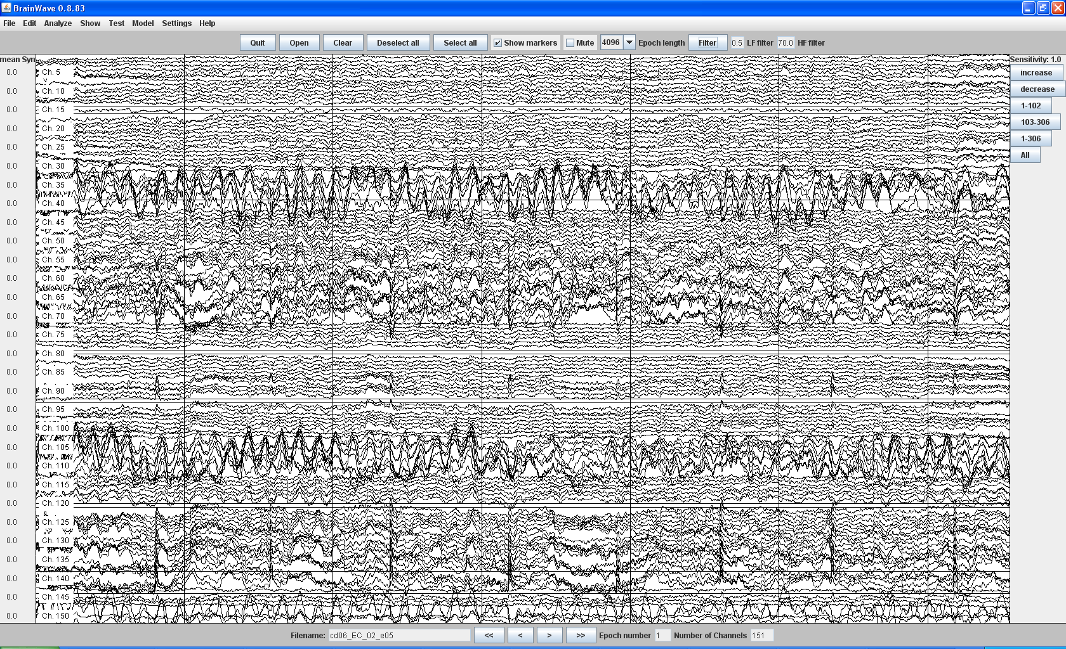
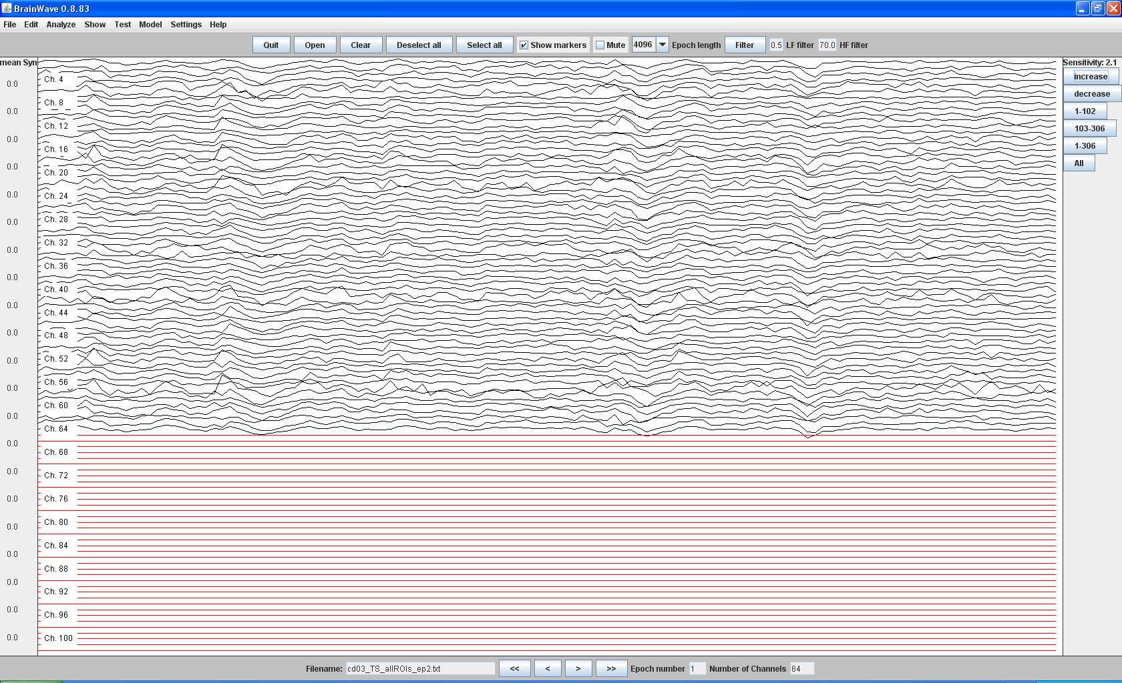

1. Selecting epochs in brainwave

First, you have to open your meg-file with the correct settings for your dataset (in this manual an example of CTF MEG data in children 4-7 years old)

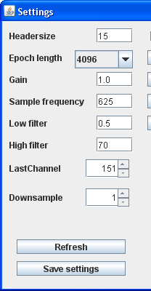
Settings dataset:

Left column:
Headersize = 15 (skips first 15 lines of your dataset, because these lines contain text about your CTF MEG registration, see table 1 at the end of this document)
Epoch length = 4096 (the default number of samples you will select within one epoch. Time in seconds depends on your sample frequency.)
Gain=1.0 (default, to increase or decrease the amplitude of the signals)
Sample frequency = 625 Hz (standard setting of the CTF MEG system)
Low filter = 0.5Hz (default lower border of broad band)
High filter = 70 Hz (default upper border of broad band)
Lastchannel = 151 (standard number of channels in CTF MEG system)
Downsample = 1 (only downsample if you need to increase analysis speed or if you want to compare it with previous measuresments that were downsampled, otherwise use all samples in your meg-scan)

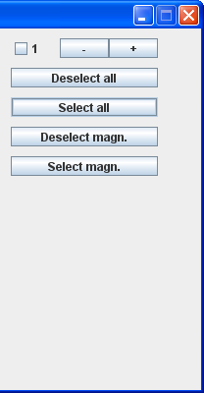
Right column:
> First press button Select all
> use + and – buttons to scroll through 151 MEG channels and deselect channels you want to skip in your analysis because they are filled with artefacts (we additionally deselected channels 14,16, 39, 53, 79, 80, 92, 93, 120, 121, 138 & 144 in child CTF MEG dataset)

!!! press SAVE SETTINGS button before opening dataset!!!

The display of Brainwave now shows the total numbers of MEG channels. The deselected channels are colored red.

  - How to select a MEG epoch in brainwave?

To open your timeseries in Brainwave, make sure you have saved your EEG/MEG/MRI timeseries as ascii files with timeseries per channels/sensors or ROI organized in columns (every time sample a new row). If you deselected artefact channels, these channels will be set to zeros (a flat line) after saving the epoch in Brainwave. Note that for further analyses, you still have to deselect these channels, otherwise you will be looking for power or connectivity in flat lines! Furthermore, it is advisable is to select epochs in the beginning of the registration, since people are in the most optimal awake ‘resting-state’ state. Later in the timeseries, subjects tend to get more drowsy.

The actual selection of the epoch is done by saving the page/epoch you look at on your screen!
Naming your epochs:

Save as: patientgroup_subjectname _experiment_epochnr

2. FFT/ Power Analysis (relative)
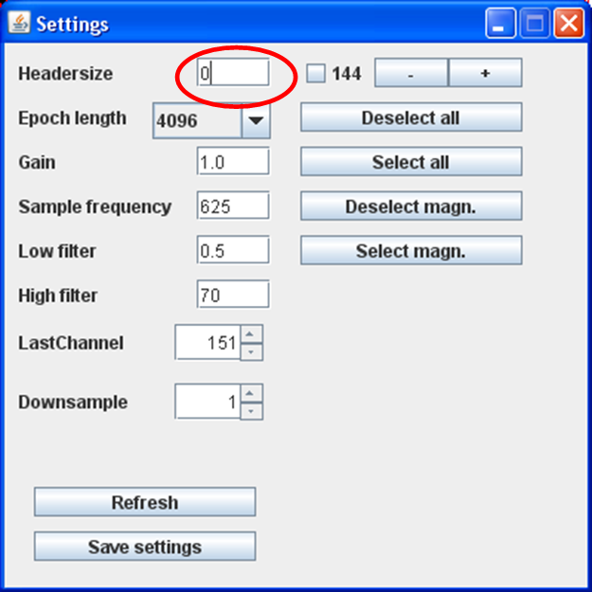
Check if your dataset settings are adjusted to what you want to analyze.
>If headersize = 15 the epoch will skip the first 15 samples of your epoch (by putting it to zeros?) and thus will influence your FFT, connectivity and network analysis. Thus change the setting for headersize (=0) before you start analyzing your epochs.
> Deselect artefact channels to exclude them from analysis

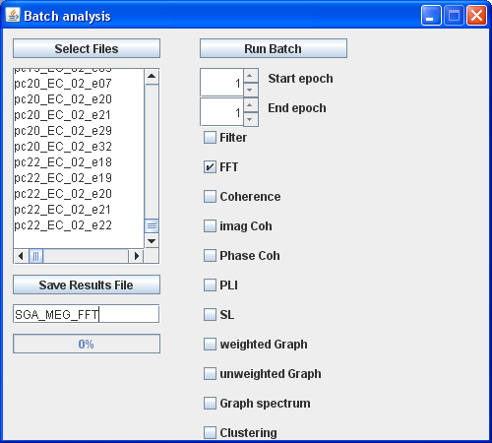
How to do a FFT on all of the epochs of your subjects?:
> analyze
> Batch analysis
> Select Files: all epochs of interest (the same number of epochs in each subject!)
> select box FFT
> Save Results File giving it a good name
> Run Batch

The output is saved in your “saved results file”, wherever you have put it. If opened in excel, the output contains columns that represent the 151 MEG channels. The rows show the 5 default frequency bands per epoch per person.

NOTE: You cannot adjust the frequency bands in FFT analysis.

Definitions of the frequency bands in in Brainwave FFT:
Delta: 0.5- 4 Hz
Theta: 4 - 8 Hz
Alpha: 8-13 Hz
Beta: 13-25 Hz
Gamma: 25-49 Hz

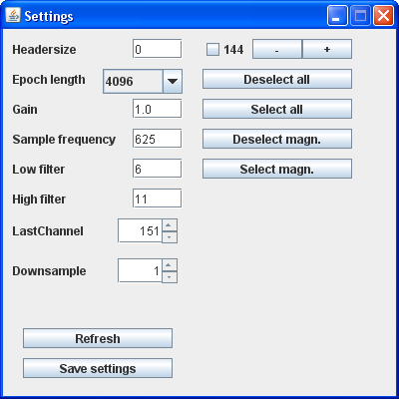
3. Analysis of functional connectivity

Different measures for functional connectivity (FC) can be calculated in Brainwave:
- Coherence
- Imaginary Coherence
- Phase Coherence
- PLI (Phase Lag Index)
- SL (Synchronization Likelihood)

Dataset settings:
> Headersize=0!!
> Select the frequency band of interest:
> deselect artefact channels
> Save settings!!

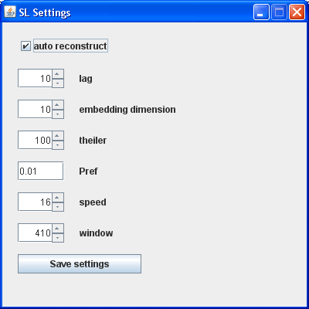
SL settings:
NOTE: If want to calculate SL as a FC measure you have to take in to account a few things.
1. For theta, alpha, beta and gamma bands just use the auto reconstruct option!
2. In delta band (and slower bands, like in fMRI data) you have to deselect auto reconstruct in the SL settings and adjust the values manually:
(See table 2 how to calculate how the parameters shown above!)

For example for rs-fcMRI analysis in children:
> lag = 1
> embedding dimension = 5
> Theiler = 5
> Pref = 0.05
> speed = 1
> window = 128
> !! Save settings!!!
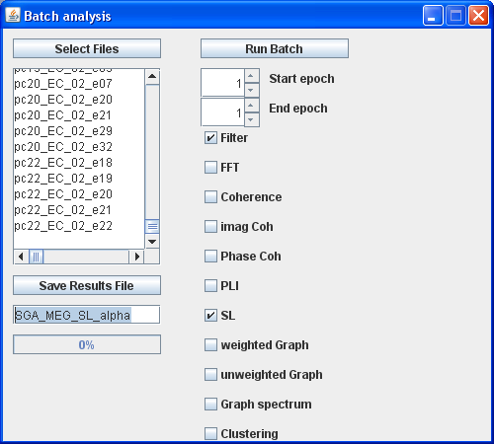
Batch analysis:
> check Filter
> check FC of interest!

Now, if you only are interested in functional connectivity, you can run a batch analysis for FC.

NOTE: If you plan to do graph analysis after FC analysis you can run it in one Batch. The last (lowest) selected FC measure will be used for your network analysis (SL in this example)!
4. Graph Analysis
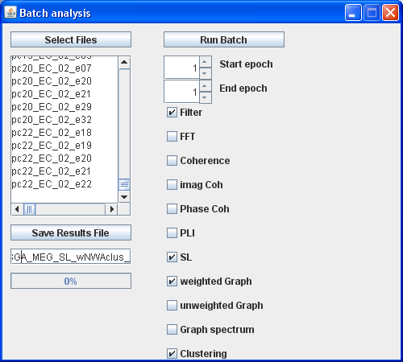
The quickest way to analyze FC , network parameters, clustering/modularity and the graph spectral measures, is running them all simlutaneously in one batch per frequency band. The time required to finish the analyses depends on the number of channels (size of your network), the number of subjects and the speed of your computer.

> Check Filter box
> Think about what FC measure you choose!
> Think about choosing weighted or unweighted graphs, you cannot run both in one batch!
> check clustering/modularity if you are interested in the number of clusters, modularity etc.
> check grpah spectrum
> Run Batch

5. Visualizing the results
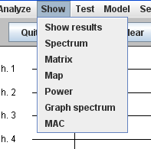
After finishing the batch, you can visualize your results.
Just check the options in the menu show and have a look.

For 21 channel EEG and 151 sensor MEG there is a nice options to visualize modules: see Map and/or Power.
Note that the maps shown are not group maps, but only represent the connections or modules of the last epoch analyzed!

Tables

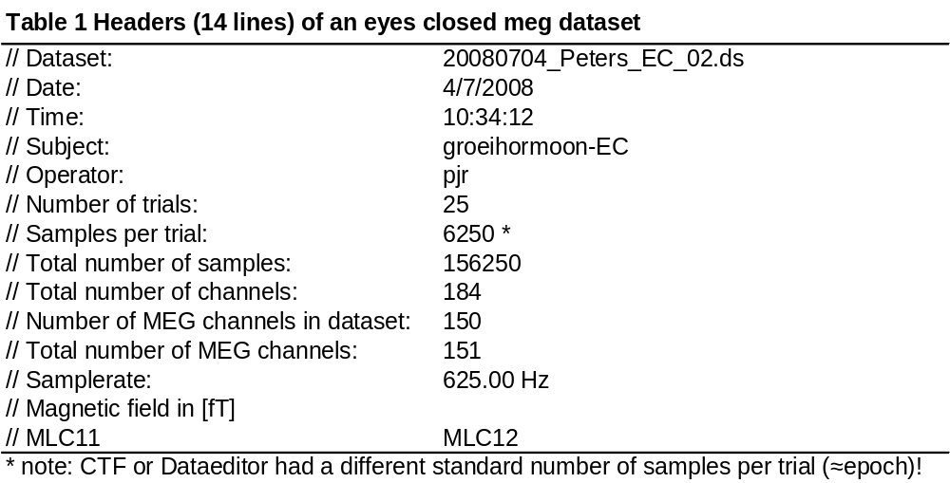

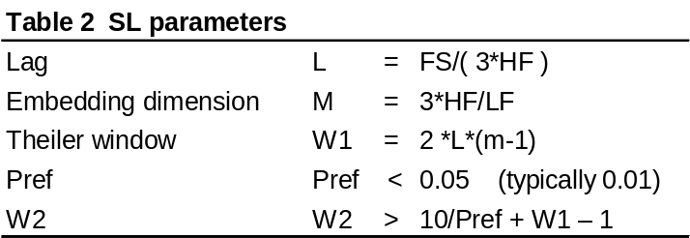
Sometimes large artefacts in single channels can distort selection of epochs in Brainwave. It is advisable to go back to the data in Data-editor (or any other EEG/MEG programm) to preselect artefact free parts of your registration. You can also choose to select epochs there. If you do so, make sure you convert your output to ascii format!

Preprocessing of CTF data in Data-editor

Open vitualbox (right ctrl F and cltr alt backspace to switch between screens):

Check MEG sensors:
→ unzip dataset!!!
→ Dataeditor
→ Display
→ Channel selector: select channels of interest!
→ layout → no overlay (resting state)
→ 5 columns (or 1, to see whole trial)
→ Filter (button upper left) or edit:
→ low pass: 100
→ high pass: 0.7
→ Show: Bad channels
Give it a good thought to before you really switch bad channels off! If you decide to switch them of, save your file with a different name so you won’t overwrite your original file! I prefer to switch off channels in digeeg/brainwave.
(Tip: check in Dataeditor which channels are bad (make a log file) and switch them off in digeeg/brainwave.)

→ left mouse: click channel to select
→ right mouse: click = set good/bad
→ known bad channels: MLF 11, MRC 23 and MRP 34 (in SGA MEG study we found more bad channels: 14, 16, 39, 79, 80/81?, 121, 138, 144)
(Tip: check trials: make one column, than left mouse whole trial)
(TIP: check which channels are switched off: button ‘ch sel’ upper screen, left column shows bad channels that are switched off.)

Check reference channels:

→ Display
→ channel selector → meg-ref
→ change sensitivity to view channels G11 to R23 (select)
(numlock off: check button ‘gain’ selected channels, check selected ch and increase gain)
→ if flat lines, than dataset might not suitable to use for further analysis, check with your supervisor.

