Author

-- this is the author table

CREATE TABLE IF NOT EXISTS authors

(

        id integer NOT NULL GENERATED ALWAYS AS IDENTITY,

    name character varying(255) COLLATE pg_catalog."default" NOT NULL,

    "createdAt" timestamp with time zone NOT NULL,

    "updatedAt" timestamp with time zone NOT NULL,

    CONSTRAINT authors_pkey PRIMARY KEY (id)

)

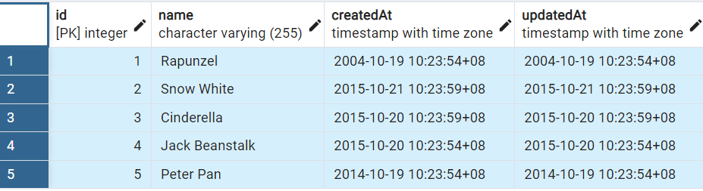

INSERT INTO author (name, "createdAt", "updatedAt")

VALUES

(‘Snow White’, ‘2004-10-19 10:24:54’, ‘2004-10-19 10:24:54’),

(‘Cinderella’, ‘2004-10-19 10:25:54’, ‘2004-10-19 10:25:54’),

(‘Jack Beanstalk’, ‘2004-10-19 10:26:54’, ‘2004-10-19 10:26:54’),

(‘peter pan’, ‘2004-10-19 10:27:54’, ‘2004-10-19 10:27:54’);

Book

--this is the book table

CREATE TABLE IF NOT EXISTS books

(

        id integer NOT NULL GENERATED ALWAYS AS IDENTITY,

    name character varying(255) COLLATE pg_catalog."default" NOT NULL,

    "createdAt" timestamp with time zone NOT NULL,

    "updatedAt" timestamp with time zone NOT NULL,

    CONSTRAINT books_pkey PRIMARY KEY (id)

)

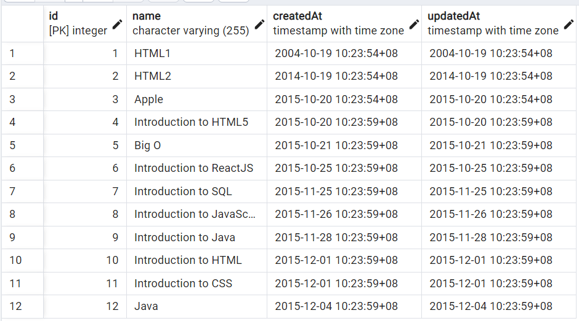

INSERT INTO books(name, "createdAt", "updatedAt")

VALUES(‘Big O’, ‘2004-10-19 10:23:54’, ‘2004-10-19 10:23:54’),

(‘HTML1’, ‘2004-10-19 10:24:54’, ‘2004-10-19 10:24:54’),

(‘HTML2’, ‘2004-10-19 10:25:54’, ‘2004-10-19 10:25:54’),

(‘Apple’, ‘2004-10-19 10:26:54’, ‘2004-10-19 10:26:54’),

(‘introduction to HTML5’, ‘2004-10-19 10:27:54’, ‘2004-10-19 10:27:54’),

(‘Introduction to ReactJS’, ‘2004-10-19 10:28:54’, ‘2004-10-19 10:28:54’),

(‘Introduction to JavaScript’, ‘2004-10-19 10:29:54’, ‘2004-10-19 10:29:54’),

(‘Introduction to Java’, ‘2004-10-19 10:30:54’, ‘2004-10-19 10:30:54’),

(‘Introduction to Java1’, ‘2004-10-19 10:34:54’, ’20 04-10-19 10:34:54’);

Author _books

-- this is the author and book multi to multi relationship table

CREATE TABLE IF NOT EXISTS author_books

(

    "createdAt" timestamp with time zone NOT NULL,

    "updatedAt" timestamp with time zone NOT NULL,

    author_id integer NOT NULL,

    book_id integer NOT NULL,

    CONSTRAINT author_books_pkey PRIMARY KEY (author_id, book_id),

    CONSTRAINT author_books_author_id_fkey FOREIGN KEY (author_id)

        REFERENCES public.authors (id) MATCH SIMPLE

        ON UPDATE CASCADE

        ON DELETE CASCADE,

    CONSTRAINT author_books_book_id_fkey FOREIGN KEY (book_id)

        REFERENCES public.books (id) MATCH SIMPLE

        ON UPDATE CASCADE

        ON DELETE CASCADE

)

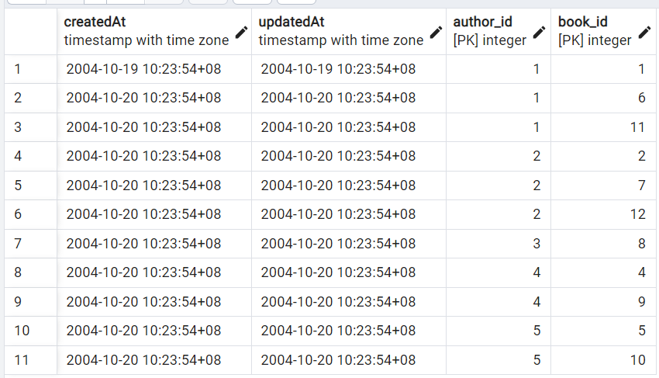

INSERT INTO author_books ("createdAt", "updatedAt", author_id, book_id)

VALUES('2004-10-19 10:23:54', '2004-10-19 10:23:54', 1, 1),

('2004-10-19 10:24:54', '2004-10-19 10:24:54', 2, 2),

('2004-10-19 10:25:54', '2004-10-19 10:25:54', 3, 3),

('2004-10-19 10:26:54', '2004-10-19 10:26:54', 4, 4),

('2004-10-19 10:27:54', '2004-10-19 10:27:54', 5, 5),

('2004-10-19 10:28:54', '2004-10-19 10:28:54', 1, 6),

('2004-10-19 10:29:54', '2004-10-19 10:29:54', 2, 7),

('2004-10-19 10:30:54', '2004-10-19 10:30:54', 3, 8),

('2004-10-19 10:31:54', '2004-10-19 10:31:54', 4, 9),

('2004-10-19 10:32:54', '2004-10-19 10:32:54', 5, 1),

('2004-10-19 10:33:54', '2004-10-19 10:33:54', 1, 2),

('2004-10-19 10:34:54', '2004-10-19 10:34:54', 2, 3);

People

--this is the people table

CREATE TABLE IF NOT EXISTS people

(

id integer NOT NULL GENERATED ALWAYS AS IDENTITY,

name character varying(255) COLLATE pg_catalog."default" NOT NULL,

    "createdAt" timestamp with time zone NOT NULL,

    "updatedAt" timestamp with time zone NOT NULL,

    country_id bigint,

    CONSTRAINT people_pkey PRIMARY KEY (id)

)

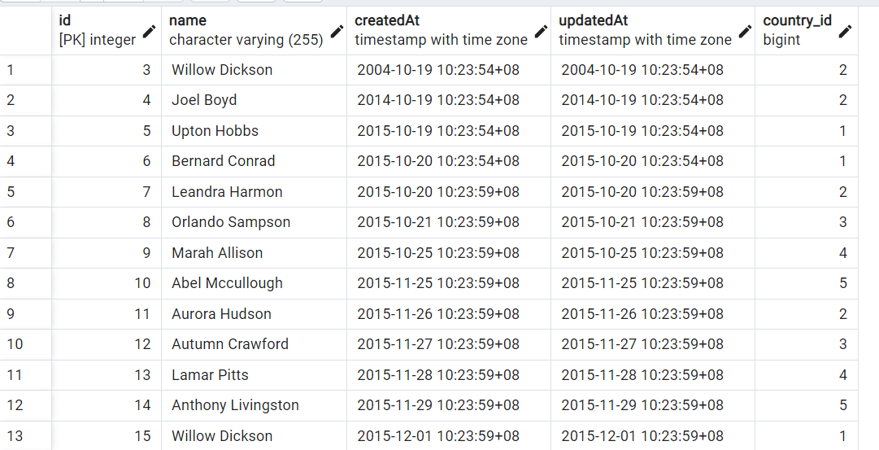

INSERT INTO people (name, "createdAt", "updatedAt")

VALUES(‘Joel Boyd’, ‘2004-10-19 10:23:54’, ‘2004-10-19 10:23:54’),

(‘Willow Dickson’, ‘2004-10-19 10:24:54’, ‘2004-10-19 10:24:54’),

(‘Upton Hobbs’, ‘2004-10-19 10:25:54’, ‘2004-10-19 10:25:54’),

(‘Bernard Conrad’, ‘2004-10-19 10:26:54’, ‘2004-10-19 10:26:54’),

(‘Autumn Crawford’, ‘2004-10-19 10:27:54’, ‘2004-10-19 10:27:54’),

(‘Lamar Pitts’, ‘2004-10-19 10:28:54’, ‘2004-10-19 10:28:54’),

(‘Anthony Livingston’, ‘2004-10-19 10:29:54’, ‘2004-10-19 10:29:54’),

(‘Willow Dickson’, ‘2004-10-19 10:30:54’, ‘2004-10-19 10:30:54’),

(‘Dana Silva’, ‘2004-10-19 10:31:54’, ‘2004-10-19 10:31:54’),

(‘Blythe French’, ‘2004-10-19 10:32:54’, ‘2004-10-19 10:32:54’),

(‘Bernard Conrad’, ‘2004-10-19 10:33:54’, ‘2004-10-19 10:33:54’),

(‘Leandra Harmon’, ‘2004-10-19 10:34:54’, ‘2004-10-19 10:34:54’);

book_rents

--this is the book renting history table

CREATE TABLE IF NOT EXISTS book_rents

(

    person_id bigint NOT NULL,

    book_id bigint NOT NULL,

    "createdAt" time with time zone NOT NULL,

    "updatedAt" time with time zone NOT NULL

)

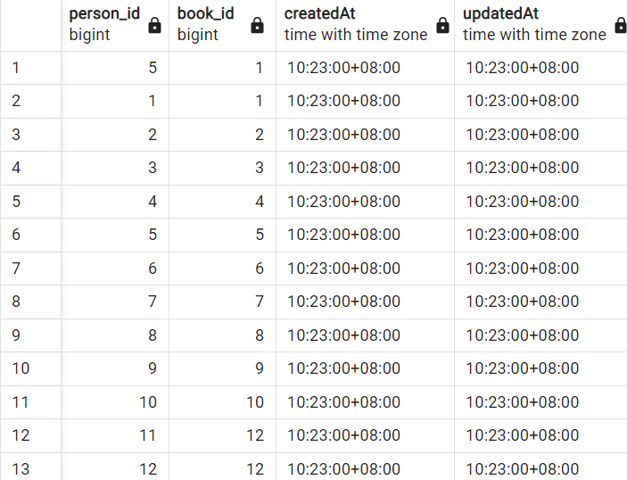

INSERT INTO book_rents(person_id, book_id, "createdAt", "updatedAt")

VALUES( 1, 1, '2004-10-19 10:23:00', '2004-10-19 10:23:00'),

( 2, 2, '2004-10-19 10:24:00', '2004-10-19 10:24:00'),

( 3, 3, '2004-10-19 10:25:00', '2004-10-19 10:25:00'),

( 4, 4, '2004-10-19 10:26:00', '2004-10-19 10:26:00'),

( 5, 5, '2004-10-19 10:27:00', '2004-10-19 10:27:00'),

( 6, 6, '2004-10-19 10:28:00', '2004-10-19 10:28:00'),

( 7, 7, '2004-10-19 10:29:00', '2004-10-19 10:29:00'),

( 8, 8, '2004-10-19 10:30:00', '2004-10-19 10:30:00'),

( 9, 9, '2004-10-19 10:31:00', '2004-10-19 10:31:00'),

( 10, 2, '2004-10-19 10:32:00', '2004-10-19 10:32:00'),

( 11, 1, '2004-10-19 10:33:00', '2004-10-19 10:33:00'),

( 12, 2, '2004-10-19 10:34:00', '2004-10-19 10:34:00'),

( 1, 3, '2004-10-19 10:35:00', '2004-10-19 10:35:00'),

( 2, 4, '2004-10-19 10:36:00', '2004-10-19 10:36:00'),

( 3, 5, '2004-10-19 10:37:00', '2004-10-19 10:37:00'),

( 4, 6, '2004-10-19 10:38:00', '2004-10-19 10:38:00'),

( 5, 7, '2004-10-19 10:39:00', '2004-10-19 10:39:00'),

( 6, 8, '2004-10-19 10:40:00', '2004-10-19 10:40:00'),

( 7, 9, '2004-10-19 10:41:00', '2004-10-19 10:41:00'),

( 8, 3, '2004-10-19 10:42:00', '2004-10-19 10:42:00'),

( 9, 1, '2004-10-19 10:43:00', '2004-10-19 10:43:00'),

( 10, 2, '2004-10-19 10:44:00', '2004-10-19 10:44:00'),

( 11, 3, '2004-10-19 10:45:00', '2004-10-19 10:45:00'),

( 12, 4, '2004-10-19 10:46:00', '2004-10-19 10:46:00'),

( 1, 5, '2004-10-19 10:47:00', '2004-10-19 10:47:00'),

( 2, 6, '2004-10-19 10:48:00', '2004-10-19 10:48:00'),

( 3, 7, '2004-10-19 10:49:00', '2004-10-19 10:49:00'),

( 4, 8, '2004-10-19 10:50:00', '2004-10-19 10:50:00'),

( 5, 9, '2004-10-19 10:51:00', '2004-10-19 10:51:00'),

( 6, 4, '2004-10-19 10:52:00', '2004-10-19 10:52:00'),

( 7, 1, '2004-10-19 10:53:00', '2004-10-19 10:53:00'),

( 8, 2, '2004-10-19 11:23:00', '2004-11-19 10:23:00'),

( 9, 3, '2004-10-19 11:24:00', '2004-11-19 10:24:00'),

( 10, 4, '2004-10-19 11:25:00', '2004-11-19 10:25:00'),

( 11, 5, '2004-10-19 11:26:00', '2004-11-19 10:26:00'),

( 12, 6, '2004-10-19 11:27:00', '2004-11-19 10:27:00'),

( 1, 7, '2004-10-19 11:28:00', '2004-11-19 10:28:00'),

( 2, 8, '2004-10-19 11:29:00', '2004-11-19 10:29:00'),

( 3, 9, '2004-10-19 11:30:00', '2004-11-19 10:30:00'),

( 4, 5, '2004-10-19 11:31:00', '2004-11-19 10:31:00'),

( 5, 1, '2004-10-19 11:32:00', '2004-11-19 10:32:00'),

( 6, 2, '2004-10-19 11:33:00', '2004-11-19 10:33:00'),

( 7, 3, '2004-10-19 11:34:00', '2004-11-19 10:34:00'),

( 8, 4, '2004-10-19 11:35:00', '2004-11-19 10:35:00'),

( 9, 5, '2004-10-19 11:36:00', '2004-11-19 10:36:00'),

( 10, 6, '2004-10-19 11:37:00', '2004-11-19 10:37:00'),

( 11, 7, '2004-10-19 11:38:00', '2004-11-19 10:38:00'),

( 12, 8, '2004-10-19 11:39:00', '2004-11-19 10:39:00'),

( 1, 9, '2004-10-19 11:40:00', '2004-11-19 10:40:00'),

( 2, 6, '2004-10-19 11:41:00', '2004-11-19 10:41:00'),

( 3, 1, '2004-10-19 11:42:00', '2004-11-19 10:42:00'),

( 4, 2, '2004-10-19 11:43:00', '2004-11-19 10:43:00'),

( 5, 3, '2004-10-19 11:44:00', '2004-11-19 10:44:00'),

( 6, 4, '2004-10-19 11:45:00', '2004-11-19 10:45:00'),

( 7, 5, '2004-10-19 11:46:00', '2004-11-19 10:46:00'),

( 8, 6, '2004-10-19 11:47:00', '2004-11-19 10:47:00'),

( 9, 7, '2004-10-19 11:48:00', '2004-11-19 10:48:00'),

( 10, 8, '2004-10-19 11:49:00', '2004-11-19 10:49:00'),

( 11, 9, '2004-10-19 11:50:00', '2004-11-19 10:50:00'),

( 12, 7, '2004-10-19 11:51:00', '2004-11-19 10:51:00'),

( 1, 1, '2004-10-19 11:52:00', '2004-11-19 10:52:00'),

( 2, 2, '2004-10-19 11:53:00', '2004-11-19 10:53:00'),

( 3, 3, '2004-10-19 11:54:00', '2004-10-19 11:54:00');