**THE ROLE OF EXPERIENTIAL MARKETING IN ENHANCING LUXURY BRAND ENGAGEMENT: A CASE STUDY OF LOUIS VUITTON COMPANY IN UK.**

Student Name:

Course:

Date:

# DEDICATION

This study is dedicated to the many inspiring people who have helped shape my path and encouraged me along the way. Thank you for always believing in me and encouraging me to follow my passions, family. Your love and support have been my rock.

# ACKNOWLEDGEMENT

I owe a great debt of gratitude to everyone who helped make this research a reality; doing this work has been an incredible personal journey. All of this effort would not be possible without their help, advice, and inspiration.

I would like to begin by expressing my deepest appreciation to my research supervisor [Supervisor's Name], whose unflinching encouragement and invaluable advice have been the rock upon which this research has been built. The focus and depth of this research were significantly influenced by your insightful comments, helpful criticism, and unwavering enthusiasm.

Sincerely, I want to thank everyone at [Department/Institution Name…..] for providing such a supportive and stimulating environment for learning. The foundation of my academic career has been laid by those who have shown such dedication to encouraging intellectual curiosity and critical thought.

Thank you, dear friends and family, for always being there to lend me your undying love and encouragement. It was your confidence in me and words of support that kept me going when things became tough.

I'd also like to thank the librarians and research assistants who helped me get my hands on the materials and information I needed to finish this project.

Finally, I'd like to express my appreciation to everyone who has helped me down this path of inquiry, whether or not their names are listed here. Thanks a lot for all the support, understanding, and faith you've shown in me.

Without the help and encouragement of all of these fantastic people, completing this research would not have been feasible. To each and every one of them, I give my sincerest gratitude. We hope that our findings will enrich the literature on luxury brand interaction and encourage more study of this fascinating topic.

**Table of Contents**

DEDICATION 2

ACKNOWLEDGEMENT 3

ABSTRACT 6

Introduction and Research Background 7

1.1 Background of the study 7

1.2 The Rationale for the Study 7

1.3 The Study Scope 8

1.4 Potential Contribution to Theory and Practice 8

1.5 Research Aim and Objectives 9

1.5.1 Research Aim 9

1.5.2 Objectives 9

CHAPTER TWO 11

LITERATURE REVIEW 11

2.1 Introduction 11

2.2 Literature background 11

2.2.1 Experiential Marketing in Luxury Branding 12

2.2.2 Engagement in the Luxury Brand Context 12

2.2.3 Dimensions of Experiential Marketing 12

2.3 Case Study of Louis Vuitton in the UK 12

2.4 Related Studies 13

2.5 Conclusion 14

CHAPTER THREE 15

RESEARCH METHODOLOGY 15

3.1 Research Philosophy 15

3.2 Research Approach 15

3.3 Research Strategy 15

3.4 Time Horizon 16

3.5 Data Collection Methods 16

3.5.1 Data Collection technique 17

3.5.2 Type of Data 17

3.5.3 Sampling Strategy 17

3.5.4 Sample size and sample method 18

3.5.5 Data Collection Process 19

3.5.6 Justification of Methods of Data Collection 20

3.6 Data Analysis 20

3.6.1 Descriptive Statistics 21

3.6.2 Correlation Analysis 21

3.6.3 Regression Analysis 22

3.6.5 Justification of Data Analysis Techniques 22

3.7 Research Timetable 23

3.8 Ethical Considerations 23

3.9 Limitations of the Research and Their Implications 24

CHAPTER FOUR 26

ANALYSIS AND FINDINGS 26

4.1 Introduction 26

4.2 Reliability and Validity test 26

4.3 Data Preparation 26

4.5 Descriptive statistics 27

4.6 Data visualization 27

4.7 Hypothesis testing 32

4.8 Regression Model Building 33

4.8 Summary of the findings 35

CHAPTER FIVE 36

DISCUSSION OF THE RESULTS, POTENTIAL IMPACTS AND REFLECTIONS 36

5.1 Discussion of the results 36

5.2 Potential Impacts of the study findings 37

5.3 Reflections on the findings 38

CHAPTER SIX 40

CONCLUSIONS, LIMITATIONS AND RECOMMENDATIONS 40

6.1 Conclusions 40

6.2 Limitations 41

6.3 Study Recommendations 42

6.4 Future Recommendations 42

References 43

# ABSTRACT

In today's ever-evolving, very competitive luxury industry, the value of customer input cannot be emphasized. This chapter delves into the importance of experiential marketing for luxury brands, utilizing Louis Vuitton as a prominent case study in the United Kingdom. This research intends to undertake a critical examination of the role experiential marketing plays in promoting customer engagement to better understand the efficacy of these strategies and their bigger implications for the luxury sector. This literature review involved an intensive examination of academic publications, marketing ideas, and market reports. It explained the key factors influencing luxury brand engagement and the value of customer experience in generating brand loyalty and advocacy. The reviewed literature also highlighted the importance of customer participation as a strategic asset for luxury companies, as it influences customers' opinions, loyalty, and propensity to buy again. Furthermore, the literature emphasized the value of experiential marketing in developing meaningful links with consumers, highlighting the unique challenges and opportunities faced by luxury enterprises in their pursuit of client engagement. Using both qualitative and quantitative methods, the research questions were answered. Quantitative data were gathered from the survey, while qualitative data were gathered through in-depth interviews with customers and marketing specialists. In-depth insights into the participants' viewpoints and an assessment of the impact of experiential marketing on participation with luxury brand items were gleaned through the use of descriptive statistics, data visualizations, and multiple linear regression models. The findings suggest that experience marketing has a significant role in strengthening customers' commitment to luxury brands. The company's investment in experiential marketing paid off handsomely by drawing in new clients and strengthening ties with existing ones. Customers who took part in the company's marketing initiatives expressed a higher interest in purchasing Louis Vuitton products, indicating a deeper understanding of the prestige of the label. The importance of exclusive and immersive events, compelling brand stories, high-quality aesthetics, and engagement with influencers and opinion leaders were all highlighted in the survey as major drivers and components of successful experiential marketing projects. These results have important implications for Louis Vuitton and the luxury industry as a whole. Experiential marketing allows luxury companies to connect with their customers on a more personal level, which is crucial to the growth of any brand. When businesses have a solid understanding of the factors driving interaction with luxury goods, they are better able to alter marketing strategies and develop personalized experiences that resonate with target audiences. In addition, the report gives luxury businesses practical tips and guidelines for enhancing their experiential marketing tactics, making them more likely to thrive in the sector's fiercely competitive atmosphere. Using Louis Vuitton as a case study, this research concludes that experiential marketing plays a crucial role in fostering brand loyalty among luxury consumers. The study is important for academics and businesses alike because it sheds light on consumer behavior, marketing strategies, and the larger implications of establishing long-term relationships with discerning customers.

**CHAPTER ONE**

# Introduction and Research Background

## 1.1 Background of the study

Luxury brands have always known that the key to establishing unbreakable customer loyalty is in creating experiences that customers will never forget. Experiential marketing's development as a potent and effective approach has emphasized the need of giving customers memorable and exciting encounters with brands. In the luxury market, this strategy has proven highly effective as companies strive to provide their affluent clientele with memorable and meaningful encounters that go beyond the functional benefits of their wares. The French luxury brand Louis Vuitton has fully embraced the potential of experience marketing for its luxury, long-lasting products. Louis Vuitton has found incredible success because to the meticulous crafting of exceptional customer experiences. The company has made a substantial impact on marketplaces all around the world, including the UK. Features like custom-designed flagship stores, well-planned events, and personalized interactions all contribute to these encounters.

Although Louis Vuitton has had a lot of success with experiential marketing, it is not well understood how this strategy impacts brand engagement in the UK market. To address this gap in knowledge, this paper will examine Louis Vuitton's UK operations from the vantage point of experiential marketing, focusing on the company's efforts to boost customers' engagement with its luxury products and services. The study's primary objective was to investigate the effectiveness of Louis Vuitton's experiential marketing initiatives in the UK. These included things like creating engaging environments in stores, holding well-organized events, and encouraging personal interactions. The study's primary purpose was to ascertain whether or whether these experiential variables influenced customers' emotional connection to the Louis Vuitton brand, their level of brand loyalty, and their overall engagement with the Louis Vuitton brand.

The study's findings were anticipated to provide important new insight into the field of luxury marketing. They were also designed to have practical implications for luxury brand managers by illuminating tactics and approaches that luxury businesses, especially those operating in the UK market, may utilize to increase customer engagement and develop lasting relationships with their clients. Examining Louis Vuitton's experiential marketing strategies in the United Kingdom and deconstructing their effects, this study aimed to shed light on the complexity of attracting luxury consumers through memorable and immersive events. The study's primary objective was to generate insights that may guide the strategic planning of luxury companies in the future, allowing them to better compete in the global economy.

## 1.2 The Rationale for the Study

Several occurrences sparked the curiosity that led to this investigation. Luxury brands, have always recognized the need of providing customers with memorable experiences that complement their products. More and more ads are designed to appeal to wealthy people by providing them with novel and exciting opportunities. The French luxury goods manufacturer Louis Vuitton is now widely recognized around the world, especially in the United Kingdom. The company has been so successful because of the quality of service it always gives its customers. There hasn't been enough research done in the UK to fully understand the impact of experiential marketing on brand engagement, despite the clear success of such efforts. Those who study and practice marketing should be familiar with the role that experiential marketing plays in the provision of luxury goods and services. This research sought to deepen our understanding of how luxury brands might use experiential marketing strategies by evaluating the Louis Vuitton case study in the United Kingdom.

## 1.3 The Study Scope

The purpose of this research was to analyze the efficacy of experiential marketing methods for Louis Vuitton in the United Kingdom. Research analyzed how Louis Vuitton conducted business and promoted its products in the United Kingdom. The researchers set out to examine how much of an impact Louis Vuitton's experiential marketing had on its UK customers.

This study analyzed the effectiveness of experiential marketing via the lens of in-store activities, group get-togethers, and one-on-one encounters. We want to learn how these factors influence Louis Vuitton fans' devotion to the label and their feelings of identification with its community. In-depth interviews were conducted in-person to collect much of the information used in this study. Customers of Louis Vuitton in the United Kingdom were surveyed and interviewed in order to gather primary data, while news from the industry, academic literature, and company announcements were analyzed to compile secondary data. This study set out to examine the impact of experiential marketing on brand loyalty in the luxury goods industry by drawing on a wide range of relevant literature.

The primary goal of the research was to provide lessons to C-suite executives at luxury brands on how to improve customer engagement and loyalty. However, the study only looked at Louis Vuitton's success in the British market. This investigation did not involve any other luxury businesses or locations. More research on the success of experience marketing methods is required because it is unlikely that the results can be extrapolated to other luxury brands and contexts.

## 1.4 Potential Contribution to Theory and Practice

The research has promising implications for both the theoretical development and the actual implementation of experiential marketing techniques for luxury products. The theoretical goal of this investigation on the effect of experiential marketing on brand engagement was to add to the current body of knowledge in the field of luxury marketing. The purpose of this study was to shed light on the efficacy of experiential marketing tactics for generating customer engagement with a luxury brand by examining the case of Louis Vuitton in the United Kingdom.

As the results of this research shed insight on the impact that experience marketing has on consumer behavior and brand loyalty, they may help advance our theoretical understanding of luxury brand management. The emotional connection, brand loyalty, and overall engagement of Louis Vuitton's customers can be better understood through an examination of the brand's use of a number of experiential dimensions, including immersive in-store environments, curated events, and personalized interactions. Theorists in the field of luxury marketing can use this knowledge to improve upon and create new consumer interaction and brand management frameworks and models.

The research has important theoretical and practical consequences for those who run luxury brands. The study's findings can help luxury firms, particularly those operating in the UK market, improve customer engagement and brand loyalty through the application of strategic experiential marketing tactics. The study's results can help luxury brand managers better understand which aspects of the consumer experience truly make an impression. Managers may create and implement successful experiential marketing campaigns by, for example, learning the value of establishing immersive in-store experiences or hosting curated events. Managers can use the study's findings to better understand the factors that contribute to consumers' emotional connection with and loyalty to their favorite brands.

The survey can also shed light on the tastes and expectations of British luxury-goods consumers. With this information in hand, managers of luxury brands may create strategies that are more focused on the demands and wants of their customers. This research may help advance the field of luxury brand management by expanding our knowledge of how experiential marketing affects consumer participation. The study's theoretical findings can contribute to expanding our understanding of the sector, while its practical implications can help luxury brand managers create winning promotional campaigns. This study has the potential to influence the dynamic field of luxury brand marketing by bridging the gap between theory and practice.

## 1.5 Research Aim and Objectives

### 1.5.1 Research Aim

To critically evaluate the impact of experiential marketing on enhancing engagement with luxury brands, this study will utilize Louis Vuitton as a specific case study. The main objective is to identify and analyze the role of experiential marketing in elevating customer engagement levels with the Louis Vuitton brand, providing valuable insights into the effectiveness of these strategies and their broader implications for the luxury industry.

### 1.5.2 Objectives

1. To assess the level of customer engagement with luxury brands, with a particular focus on Louis Vuitton's customer base, and analyze the existing factors influencing their engagement.
2. To examine and compare the experiential marketing strategies employed by Louis Vuitton with those of other luxury brands, in order to determine their effectiveness in creating meaningful connections with customers.
3. To investigate the relationship between experiential marketing and customer engagement in the luxury sector, specifically evaluating how experiential marketing initiatives impact customer loyalty and brand advocacy.
4. To identify the key drivers and components of successful experiential marketing campaigns in the luxury industry, drawing insights from both Louis Vuitton and other luxury brands, in order to provide recommendations for optimizing customer engagement strategies.
5. To offer practical recommendations and guidelines for Louis Vuitton and other luxury brands to enhance their experiential marketing efforts, aiming to establish stronger connections with customers and drive higher levels of engagement in the luxury market.

**Research Questions**

1. How does experiential marketing impact customer engagement with luxury brands, specifically focusing on Louis Vuitton as a case study?
2. What are the factors influencing customer engagement with luxury brands, with a particular emphasis on Louis Vuitton's customer base?
3. How do the experiential marketing strategies employed by Louis Vuitton compare to those of other luxury brands in terms of creating meaningful connections with customers?
4. What is the relationship between experiential marketing and customer engagement in the luxury sector, and how do experiential marketing initiatives influence customer loyalty and brand advocacy?

**Significance of the Research**

The implications of this research go far beyond the realm of academia and into the world of luxury retail. By giving a critical review of the impact experiential marketing has on customer engagement with luxury brands, the study contributes to the growing body of knowledge in marketing and consumer behavior. Marketers and brand managers may use the lessons learned from the Louis Vuitton case study to increase customer engagement by having concrete proof of the success of experiential marketing strategies.

Luxury companies that care about their customer relationships would do well to investigate the factors that influence customer loyalty to luxury brands. The study's special focus on Louis Vuitton's customer is helpful for experts in the industry since it elucidates the distinctive preferences and standards of the luxury market. By contrasting Louis Vuitton's and other luxury brands' experiential marketing techniques, the study provides useful information on what works and what's new in creating meaningful connections with customers. Luxury companies can use the information in this comparison to assess their current approach and identify areas for growth.

The long-term effects of experiential marketing on customer loyalty and brand advocacy are worth investigating for luxury firms, as are the correlations between the two. Using this data as a basis for strategic decision-making and resource allocation can lead to more efficient and sustainable methods of engaging consumers. Finally, the research offers practical suggestions on how luxury companies may enhance their engagement efforts by focusing on the factors that have been shown to make experiential marketing campaigns successful. By enhancing their connections with clients and cultivating brand loyalty, luxury brands like Louis Vuitton can boost their market positioning and competitive advantage, as stated.

The ultimate goal of the offered recommendations is to help luxury brands like Louis Vuitton build their customer connections and brand loyalty, which in turn improves their market positioning and competitive advantage.

# CHAPTER TWO

# LITERATURE REVIEW

## 2.1 Introduction

Experiential marketing has gained substantial attention in the realm of luxury branding due to its potential to create unique and memorable experiences for customers (Shukla, 2020). Luxury brands recognize the importance of engaging their affluent clientele through immersive encounters that go beyond product features (Kapferer & Bastien, 2019). This literature review aims to provide an overview of the existing research on experiential marketing in the luxury brand context, with a specific focus on its role in enhancing brand engagement (Chen & Phou, 2019). The review will also explore the case study of Louis Vuitton in the UK to shed light on the effectiveness of experiential marketing strategies in luxury brand management.

## 2.2 Literature background

Experiential marketing has been increasingly important in the marketing mix, especially in the field of luxury branding in recent years. Because of its ability to provide clients with one-of-a-kind and unforgettable experiences, experiential marketing has received a great deal of attention from both academics and industry professionals in recent years (Kumar & Pang, 2021). This strategy moves beyond a superficial focus on product attributes in order to connect with luxury consumers on a more profound and emotional level (Kapferer & Bastien, 2019). For a long time now, luxury companies have understood that interacting with their consumers in meaningful ways is essential to building brand loyalty and making an impression (Bhattacharya & Sen, 2020). Luxury brands of today know that in addition to superior products, what their customers really want is an unforgettable experience that speaks to their beliefs, hopes, and dreams. Therefore, luxury companies have started using experiential marketing to interact with their target audience on a deeper level.

This review aims to present a synopsis of the existing literature on experiential marketing for luxury brands, with a focus on how such marketing might increase consumer involvement with the brand (Loureiro & Kauffmann, 2021). This research seeks to elucidate the strategies and techniques used by luxury brands to create immersive experiences that captivate customers and establish stronger brand ties by delving into the existing body of information on the subject. Additionally, Louis Vuitton, a renowned luxury company celebrated for exceptional items and timeless elegance, will be the case study for this assessment in the United Kingdom. We hope to learn more about the value of experiential marketing tactics for managing luxury brands by looking at Louis Vuitton's efforts in this area. By using a case study methodology, we are able to delve into the actual procedures and results of experiential marketing, therefore gaining a deep and contextualized knowledge of its effect on brand engagement in the luxury market.

These research project’s findings will add to what is already known about the role of experiential marketing in the management of luxury brands. We hope to shed light on how experiential marketing methods may successfully elevate brand engagement in the luxury environment by combining the available research, detecting patterns, and diving into a specific case study. These findings have important implications for luxury brand managers who are working to design experiences that will have an emotional and psychological impact on their ideal clients and hence appeal to both academics and industry professionals.

## 2.2.1 Experiential Marketing in Luxury Branding

According to Schmitt (2019), experiential marketing "involves the development of multisensory and interactive encounters that evoke emotional responses in order to foster a deep connection between customers and brands." Experiential marketing is especially useful in the luxury industry because it enables companies to provide clients with unique, tailor-made, and unforgettable encounters that speak to their deepest hopes and dreams (Yang et al., 2022). Positive feelings, desire, and brand loyalty can all result from such encounters (Chen et al., 2021).

## 2.2.2 Engagement in the Luxury Brand Context

Brand engagement is defined as "the extent to which a consumer is emotionally invested in and takes an active role in interacting with a brand" (Van Doorn et al., 2022). Customers that are emotionally connected to a brand are more likely to make more purchases and spread the word about their experience (Merz et al., 2021). Because it fosters long-lasting relationships and boosts brand equity, customer engagement is increasingly important for luxury brands (Huang et al., 2020). When it comes to the luxury industry, Schmitt (2019) notes that experiential marketing's emphasis on providing immersive and engaging events is seen as a catalyst for developing brand engagement.

## 2.2.3 Dimensions of Experiential Marketing

Experiential marketing encompasses a wide range of tactics that work together to increase consumer interest in a company (Cova et al., 2020). Immersive settings, well planned events, a variety of sense impressions, one-on-one connections, and compelling tales all fall under this category. Flagship stores and pop-up shops are examples of immersive environments that provide clients with a unique atmosphere to better experience the business (Chung et al., 2022). Customers are given the opportunity to experience something unique and special at curated events like fashion shows and product launches (Kim et al., 2021). Emotions and bonds can be sparked and strengthened by the use of all five senses (Fiore et al., 2023) through engaging in sensory encounters. Customers feel more special since their experiences are unique to them because to personalized interactions (Liu et al., 2022). Developing narratives and brand stories that interest and involve consumers is an important part of storytelling (Brown et al., 2021).

## 2.3 Case Study of Louis Vuitton in the UK

Louis Vuitton, the luxury brand, is well-known in the UK (Yang et al., 2019). In an effort to capture clients' attention, the corporation has been a leader in the emerging field of experiential marketing (Chevalier & Mazzalovo, 2021). According to Zeng and Liu (2021), Louis Vuitton's flagship stores in the United Kingdom are "architectural masterpieces" that feature "opulent decor, carefully curated displays of luxury merchandise, and attentive customer service." The corporation frequently holds carefully planned events, such as fashion presentations and art exhibitions, in an effort to differentiate itself from rivals and leave a long-lasting impact on its target audience (Phua et al., 2019). Direct interactions between customers and knowledgeable representatives of a company have been shown to boost customer satisfaction (Lee et al., 2021). One reason for Louis Vuitton's success in the UK is the brand's embrace of experiential marketing techniques.

## 2.4 Related Studies

Experiential marketing has received a lot of attention in recent years as a way to increase brand loyalty for luxury goods (Choi et al., 2021). The primary research strategy of this study, as well as the theories and concepts it draws on, have all been significantly influenced and informed by the aforementioned literature. A customer's loyalty to a luxury brand is influenced by a variety of characteristics, such as their attitudes, behaviors, and feelings (Batat, W. 2019). The use of experiential marketing to connect with luxury customers and leave a lasting impression has shown to be successful. In the luxury market, experiential marketing is essential, according to experts like Gilovich, T., and Gallo, I. (2020). This is due to the emotional connection it forges between the business and the client.

This study is theoretically grounded in both Baksi, A.'s theory of experience consumption and (Tripathi et al., 2022) consumer engagement model. These concepts emphasize the significance of consumers' subjective opinions of a brand in deciding their firm loyalty. According to Dhillon et al. (2022), this inquiry will look into how luxury brands may profit from experiential marketing based on these suppositions. There isn’t many research on the effectiveness of experience marketing for luxury goods in the literature, claim Urdea et al. (2021).

Even though experiential marketing has been extensively discussed in marketing journals, more study is still needed to determine how it affects the luxury market. By providing empirical proof that experience marketing encourages brand loyalty for luxury products, this study aims to close that gap. Carmo et al. (2022) draw the conclusion that further research on the influence of experiential marketing on luxury brand loyalty is required after reviewing the literature. The evaluation revealed a dearth of understanding of experiential marketing's impact on consumers' allegiance, which guided the study's research objectives and methods. This study contrasts luxury companies that have utilized and have not employed experiential marketing, as recommended by Khoirunnisa et al. (2021), in order to better understand the influence of experience marketing on consumer loyalty and provide advice to luxury brands. In order to determine best practices and crucial success elements in experiential marketing projects, as noted in the existing literature (Han et al., 2020), the major study objective will be to uncover successful techniques of connecting customers with luxury brands.

The examination of the background material reveals any gaps in our knowledge and suggests a line of inquiry for further study, showing the value of both theoretical and empirical research. The study's goals and methodology were a reflection of the author's knowledge of the subject and related writing. This study intends to fill a knowledge gap and advance our knowledge of experiential marketing in the context of participation with luxury brands.

## 2.5 Conclusion

According to the reviewed research, experiential marketing plays an important role in luxury brand management by increasing consumer involvement with the brand (Homburg et al., 2019). The case of Louis Vuitton in the UK shows how experiential marketing may be used to create compelling and long-lasting brand encounters (Jin et al., 2020). In order to create successful marketing strategies and cultivate long-lasting client relationships, luxury brand managers must have a deep understanding of the elements of experiential marketing and their impact on brand engagement (Godey et al., 2019). Research studying the relationship between luxury brand engagement and certain experiential marketing tactics would add to the growing body of knowledge in this area.

# CHAPTER THREE

# RESEARCH METHODOLOGY

## 3.1 Research Philosophy

This study adopts an interpretivist perspective in order to comprehend the effect of marketing methods on certain consumers in the context of luxury companies. The interpretivist approach, as pointed out by Creswell (2013), values understanding how customers make sense of their marketing experiences from their own unique perspectives. To explore how luxury brand marketing campaigns have been received by consumers, this study utilizes a narrative inquiry methodology. The interpretivist approach is ideal for this study because it seeks to decipher the finer nuances of the luxury customer experience at Louis Vuitton company in UK. This approach acknowledges that consumers' individual traits including their tastes, motivations, emotions, and values play a role in their experiences with marketing. This research philosophy enables in-depth exploration of the myriad consumer-brand interactions, providing a sophisticated understanding of the underlying reasons, meanings, and experiences that draw consumers to engage with luxury brands at Louis Vuitton company in UK.

## 3.2 Research Approach

This study uses a deductive method, in which hypotheses are derived from existing literature and theoretical frameworks. To use the deductive method, one must first formulate general hypotheses or concepts, and then gather and analyze data to ascertain whether or not the hypotheses or concepts are supported by evidence (Bryman, 2016). This inductive research aims to add to the existing literature by giving actual data on the value of experiential marketing in increasing brand engagement for luxury enterprises at Louis Vuitton company in UK. In-depth research into the relationship between luxury brand consumer engagement and experiential marketing approaches is made possible by using the deductive technique. The research questions that could be answered by gathering and analyzing data are generated using previously established theoretical and conceptual frameworks at Louis Vuitton company in UK. Through this method, the effectiveness of various experiential marketing strategies employed by luxury brands may be explored by examining the connections between marketing actions and the outcomes of customer contact at Louis Vuitton company in UK.

## 3.3 Research Strategy

Saunders' definition (Saunders et al., 2007) was used because of its emphasis on comparisons between luxury brands. The impact of experiential marketing on luxury brand loyalty was compared in a recent comparative research. The relationship between luxury brand loyalty and experiential marketing was studied using case studies and surveys at Louis Vuitton company in UK. Experiential advertising and customer dedication were studied via comparative study. This research strategy analyzed the effects of experiential marketing on customer loyalty for a wide range of luxury brands. The research evaluated the outcomes of different brands in an effort to identify experiential marketing strategies that boost brand loyalty. Case studies were performed to investigate the effectiveness of experiential marketing for luxury goods. These case studies analyzed the brands' use of experiential marketing strategies like interactive displays, exclusive events, and one-on-one interactions at Louis Vuitton company in UK. This research looked into the link between customers' positive emotional experiences and their subsequent loyalty to and interest in luxury brands. Consumers were surveyed to gather quantitative data and their thoughts on experiential marketing and brand loyalty. Participation, exposure to experiential marketing, happiness, and brand loyalty were all gauged through survey questions on luxury brands. The survey results provided a quantitative look at experience marketing and luxury product loyalty. The research method took a multipronged look at the relationship between experiential marketing and devotion to luxury labels. This research combined qualitative case study analysis with quantitative survey results in an effort to better understand how experiential marketing techniques affect luxury brand loyalty at Louis Vuitton company in UK. This method allows for a comprehensive analysis of the myriad ways in which experiential marketing components influence consumers' thoughts, feelings, and actions toward luxury brands.

## 3.4 Time Horizon

This is a cross-sectional study since data were collected at a single point in time. This study approach helped researchers get a bird's eye view of how customers of luxury products engage with companies' experiential marketing initiatives at Louis Vuitton company in UK. The purpose of this research was to understand consumers' first perceptions of luxury brands by collecting information at the point of purchase. The research was able to examine the link between experiential marketing and customer involvement using a cross-sectional time frame, which does not take into consideration changes over time or long-term repercussions. The study was also able to gauge the success of experiential marketing initiatives because to this study's in-depth analysis of customers' recent actions and interactions with Louis Vuitton company in UK. This approach allowed us to comprehend how experiential marketing influences the commitment of luxury product buyers.

## 3.5 Data Collection Methods

The majority of the information for this study came from an online questionnaire that had already been created. Google forms were used to construct the survey for ease of data collection and administration. A special link to the online survey was sent to each participant. The availability of the questionnaire in an electronic format had its advantages. To begin with, it facilitated convenience for responders, who could submit their responses whenever convenient and from any location with internet connection at Louis Vuitton company in UK. This ease of access guaranteed a larger and more representative sample, broadening the significance of the results. The google forms was used to streamline data collection by gathering responses automatically and saving them securely. The software also simplified data management, organization, and analysis.The poll was designed to find out how involved luxury consumers are with the brand, how they feel about experiential marketing, how satisfied they are, and how dedicated they are to buying the product. Likert scales, multiple-choice items, and demographic inquiries made up the bulk of the survey's closed-ended questions. The structure allowed for the collection and statistical analysis of measurable data regarding the relationship between experiential marketing and brand engagement.Online surveys were chosen as the primary method of data collection due to their many advantages, the most important of which was the fact that they could collect data fast, easily, and reliably. Google forms technique dedication to keeping users' information safe encouraged openness among respondents. The study employed a structured questionnaire to acquire reliable and objective data for testing hypotheses and providing insight into research questions.

### 3.5.1 Data Collection technique

A questionnaire was distributed to collect data for this investigation. The questionnaire was the primary tool for collecting information from the participants. The purpose of this survey is to learn about the participation, experiential marketing activities, contentment, and loyalty of luxury brand customers at Louis Vuitton company in UK. In order to achieve the study's goals, the questionnaire was constructed to be as open-ended as possible. The study invested a lot of time perfecting on the survey so that respondents could share insightful feedback on their experiences with and impressions of luxury businesses and their marketing initiatives. The questions in the survey were crafted to glean information on respondents' interactions with luxury companies, perspectives on experiential marketing efforts, and satisfaction levels.

### 3.5.2 Type of Data

To facilitate the collecting of numerical data, the questionnaire relied heavily on closed-ended questions. Closed-ended questions with a restricted number of alternative responses are the way to go when it comes to consistently gathering exact data. The Likert scales, multiple-choice questions, and demographic inquiries were used to ensure that all respondents' responses would be amenable to statistical analysis. Using Likert-type scales, users may rate how much they agreed or disagreed with comments on a variety of concepts, including satisfaction and brand loyalty. Multiple-choice alternatives were utilized to provide respondents with a list of responses from which to select in order to collect categorical data. The inclusion of basic demographic questions allowed for the collection of information that may have influenced the participants' responses.

Data collection was facilitated by the use of closed-ended questions, scales, multiple-choice, and demographic questions. Using statistical analysis, researchers may verify their theories, establish irrefutable conclusions, and provide supporting evidence. Statistically-viable quantitative data were collected thanks to the Likert-type scales, multiple-choice questions, and demographic queries included in the questionnaire. With this approach of data collection, we hoped to have a firm foundation on which to test hypotheses and draw unbiased conclusions about the correlation between experiential marketing and brand engagement in the context of luxury brands.

### 3.5.3 Sampling Strategy

Participants were recruited through a sampling strategy that aimed to include regular luxury product buyers, individuals with a casual interest in the luxury industry, and staff of luxury brands. The researchers employed a non-probabilistic technique known as "convenience sampling," in which individuals were chosen based on their availability and expressed interest in taking part. Reaching the intended demographic and ensuring a representative sample of people who purchase luxury brands, this sampling strategy proved successful in increasing the likelihood of capturing moments related to experiential marketing.

Participants were selected via convenience sampling because it met the sample size requirement while still being manageable in terms of time and resources. Participants were selected on the basis of their availability and their willingness to take part in the study. This approach simplified the research process for everyone involved in the study. Researchers were aware of the potential selection bias caused by this sample method and took steps to mitigate it by seeking out participants from a diverse range of backgrounds in relation to their prior exposure to luxury items and experiential marketing.

### 3.5.4 Sample size and sample method

In this case study, a random sampling method was employed to choose the necessary sample such that every participant had an equal chance of being chosen. Although it is generally accepted that a large sample size should be obtained, this study's sample size was decidedly moderate out of the intended 500 respondents due to limitations in both time and money. The Fishers test will be used to establish the sample size.

**………………………………………………….. (i)**

Where:

**n** is the sample size

P= Proportion of the population with the desired characteristic.

Q = Proportion of the population without the desired characteristic denoted as (1-p).

**Z** is the standard normal deviate (1.96), at 95% confidence level.

**d2=** Degree of precision; will be taken to be 10%(Mugenda and Mugenda 2020).

At a confidence level of 95% (Z=1.96) and a statistical significance set of 0.1 with a proportion of the target population 0.4, n was given by:

=245.8624

**n =246 participants**

According to equation (i) a sample size of 246 respondents was used.

After carefully considerations on the feasibility, and the accuracy, and by utilizing the fisher’s method as demonstrated above, a sample size of 246 was obtained. Since generalizability to all people who buy luxury brands is desired, a bigger sample size was needed. The appropriate sample size for the study was determined to be 246 after taking into account the trade-offs between validity, statistical power, and generalizability. In order to guarantee that their findings were generalizable to the entire population, the researchers settled on a sample size of 246. With such a sample data set, this was able to detect significant correlations and produce accurate projections. The ultimate sample size was determined by striking a balance between the need for a sufficiently big sample from which to draw conclusions and the constraints of actually collecting and evaluating the data. The researchers weighed the advantages and disadvantages of gathering information from a broader population. In terms of statistical power, accuracy, and manageability, a sample size of 246 was found to be appropriate.

### 3.5.5 Data Collection Process

In order to collect information, a quantitatively designed and formatted online survey was carried out in the UK. The goal of the poll was to establish a quantitative measure of the amount of engagement that customers had with luxury brands. The effectiveness of a quantitative approach in putting hypotheses to the test was a primary factor in this methodology being selected as the method of choice. In addition, the decision to go with this methodology was influenced in a significant way by the fact that responding to the survey online is both simple and expedient. The research was going to be cross-sectional, which means that it was going to compare two samples that were taken from the same population at the exact same point in time.

The survey was conducted at the beginning of June 2023, and those purchasers of luxury brands' products in the United Kingdom who were sensitive to brands and who were active on social media were the target audience. The first part of the questionnaire consisted of a preliminary check to ensure that all of the conditions were met by the individuals who responded to it. Concerning the subject of the part that experiential marketing plays in enhancing luxury brand engagement, a number of questions were conceived up and produced for each of the dimensions that were looked into.In addition, the survey queried about client loyalty to the brand, and then it utilized a Likert scale with 3 different constructions for each brand, ranging from "Totally Agree" to "Totally Disagree," to determine the extent of consumer engagement. In order to pick the sample, the snowball method, which is also known as a nonprobability sample, was utilized since it was the most practical method, and it also made it easier to collect responses from the population that was being studied. The surveys were distributed using a one-of-a-kind URL, and in addition to that, they were shared on Facebook groups, uploaded by the author on Instagram, as well as emailed and texted to the author's whole network of contacts. Because the author politely requested that her network spread the link in order to get the biggest possible number of replies from a varied spectrum of people, it is not apparent how many questionnaires were actually submitted. There were a total of 252 questionnaires that were received; however, not all of them were counted as responses since either they were missing information or they were not from the target audience hence a total of 246 responses were considered to be complete responses.

#### 3.5.5.1 Questionnaire development

The questionnaire was painstakingly crafted using insights from the purchase intention theory to evaluate luxury brand customers' knowledge of engagement techniques, their influence on purchases, their loyalty to the brand, and the factors that influence their spending habits. The effects of demographic factors on consumer involvement were also accounted for by including age, gender, and socioeconomic status as control variables. These factors were selected for their utility in analyzing and predicting consumer behavior in the context of eco-friendly, luxury vacations. The table below shows the questions available in the questionnaire and the references.

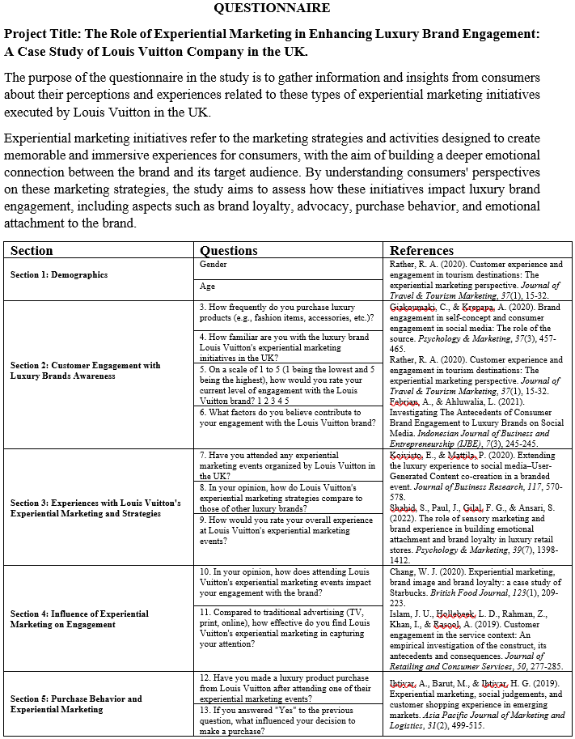 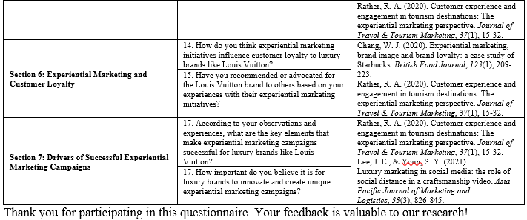

#### 3.5.5.2 Measurement of Constructs

Theory of Planned Behavior (TPB) fundamental concepts were described here. In order to control for measurement inaccuracies, a set of well-structured questions was developed for each of the identified constructs (Vinnell, et al., 2021). Each item was rated on a five-point Likert scale to determine its place within the constructs. Each of the five constructs customer engagement awareness, experience strategies, influence, purchasing behavior, customer loyalty, and drivers is described in further depth below so that their influence on luxury brand engagement can be captured and evaluated.

## 3.5.6 Justification of Methods of Data Collection

Online surveys were selected as the primary method of data collecting for many reasons. Online surveys provide respondents with the convenience of completing them whenever and wherever they have internet connection at Louis Vuitton company in UK. This accessibility both enlarged the recruitment pool and mitigated the effect of participants' locations, both of which contributed to the study's external validity. Consistent data collection was also made possible by the use of an online survey platform, which negated the potential for bias from human interviewers or variations in survey administration.

The online survey's methodology is in keeping with the study's objectives and aims. The focus of the survey was to acquire reliable data for use in hypothesis testing and statistical analysis. The use of closed-ended questions and defined response formats allowed the researchers to accomplish their research goals and generate data suitable for quantitative analysis. Kobo-collect was selected as the online survey platform because of its features and capabilities for efficient and secure data administration at Louis Vuitton company in UK. The integrity of the gathered data was preserved by the platform's safe data management, storage, and analysis tools. Kobo-collect was utilized because it simplified the process of working with large datasets and generating actionable insights for academics.

## 3.6 Data Analysis

The research used IBM's SPSS (Statistical Package for the Social Sciences) version 20 to analyze the data and answer the study's central question. Multiple statistical methods and instruments were used to compile a complete picture of the respondents' perspectives.

The participants' responses may be summarized clearly thanks to descriptive analysis, a crucial part of the data analysis process. The central patterns and distribution of the data were analyzed by computing key statistical measures like means, medians, and standard deviations. Data visualizations such as charts, graphs, and plots were also heavily used to convey the findings in an appealing visual format that would facilitate the reader's understanding of the data. Multiple linear regression models were used to evaluate the significance of any linear relationship between the response and explanatory factors. The purpose of the study was to determine what factors best predicted the participants' views and how strong and in what directions those relationships were. Age and gender were incorporated as control variables to take into account any confounding factors. To guarantee the model's suitability and efficacy, these control variables were hand-picked using the Akaike Information Criterion (AIC).

Each potential factor's importance was carefully evaluated during the model-building phase. In order to prevent false positives, the statistically insignificant variables were removed from the analysis one at a time. This methodical approach ensured that the final regression model contained only important and meaningful predictors, which improved the reliability and credibility of the results. Generally, the data analysis section used a variety of methods, including descriptive analysis, data visualization, multiple linear regression models, and cautious variable selection, to inquire deeply into the views of the participants and answer the research question. The use of these analytic methods allowed for a more thorough exploration of the interrelationships between the study's variables, therefore strengthening the study's overall validity.

**Analysis technics**

The analysis procedures that were applied were based on the aims of the study and the nature of the data. The following procedures for analyzing the data was being used:

### 3.6.1 Descriptive Statistics

In order to summarize and categorize the data, descriptive statistics were employed. Summary statistics such as mean, standard deviation, and distribution can be gleaned from the data with the help of descriptive statistics. Average, middle, and dispersion measurements such as mean, median, mode, and standard deviation were calculated to examine the data. Frequency distribution charts were used to graphically display the collected categorical data. Researchers were aided in their analysis of the data by these visual representations of the information. First, an overview of the data was provided using descriptive statistics, which substantially benefited in comprehending the variables and their characteristics.

Researchers utilized descriptive statistics to better comprehend the data and articulate its core findings. By highlighting trends and outliers, this type of data analysis provided a solid foundation for further investigation of the dataset. Researchers utilized descriptive statistics to effectively summarize and present the survey results. Data visualization tools like frequency distribution charts and measures of central tendency and dispersion allowed researchers to provide a comprehensive overview of the variables' characteristics and gain initial insights into the dataset.

### 3.6.2 Correlation Analysis

In order to find relationships in the data, a correlation analysis was performed. Scientists analyzed correlation coefficients to figure out how strongly and in what ways the variables were linked. Pearson's and Spearman's correlation coefficients are frequently employed to evaluate the closeness of a relationship between two variables. The study set out to determine what factors contributed to the success of luxury brands in experiential marketing. The researchers used correlation analysis to determine the nature and extent of the ties between the variables of interest. To determine if there was a significant relationship between two experiential marketing variables in the context of luxury brands, a correlation coefficient analysis was conducted. This study provided important insight into the relationships between a variety of variables and the impact of experiential marketing on brand loyalty.

### 3.6.3 Regression Analysis

The study used regression analysis to determine how experiential marketing affected brand loyalty among luxury consumers. For this study, researchers used a regression model to analyze the relationships between experiential marketing activities as independent factors and brand engagement as a dependent variable. The multivariate statistical technique called multiple regression analysis was used to look into these connections beyond the scope of a simple regression model. The purpose of using this method was to uncover the most important factors that contribute to consumers' positive brand experiences when participating in luxury brands' experiential marketing campaigns. By using a regression analysis, it is evident how various experiential marketing strategies affect consumers' allegiance to a brand. The study was able to weigh the impact of each of these experiential marketing variables on brand engagement by analyzing their regression coefficients, levels of statistical significance, and strengths of correlations.

This study employed regression analysis to determine the precise relationship between experiential marketing and brand loyalty, after accounting for other possible factors. Applying regression models allowed them to investigate the relative contributions and impacts of various experiential marketing methods on brand loyalty for luxury brands. This research helped to get a better grasp on the interconnections between experiential marketing and brand engagement, shedding light on the key determinants of customer behavior and perceptions in the luxury goods sector.

### 3.6.5 Justification of Data Analysis Techniques

In-depth exploration of the study's aims and conclusions was made possible by the rigorous data analysis procedures employed on this methodology. In order to objectively evaluate hypotheses, address research issues, and derive meaningful insights from quantitative data, the researchers employed a number of statistical approaches. Justifications for using particular approaches to data analysis include:

Statistics of a Descriptive Nature: Important variable distributions were characterized and described using descriptive statistics. Key metrics including means, medians, modes, and standard deviations were analyzed to reveal the underlying trends, variations, and overarching patterns within the dataset to the researchers. The methods used allowed for extensive analysis of the data, clarifying the results of the study.

Correlation Analysis: An analysis of correlations between brand loyalty and digital marketing to high-income consumers was carried out. Scientists used correlation coefficients to figure out the strength and direction of these links. This study helped quantify the effect that digital marketing campaigns have on consumer fidelity to luxury brands. Through correlation analysis, the researchers were able to get valuable insight into the connections between variables.

A regression study was carried out to ascertain which aspects of experiential marketing were most instrumental in arousing customers' interest in the brand. Independent factors in experiential marketing strategies were studied for their associations with brand engagement outcomes using regression models. This study helped in identifying key elements of brand engagement and assess their significance. Using regression analysis, we looked into how experiential marketing for luxury goods affected consumer behavior.

Using these statistical methods, this paper was able to evaluate hypotheses, handle research concerns, and arrive at insightful results. Thanks to the integration of different lines of inquiry, we were able to completely grasp the role that experiential marketing had in increasing loyalty to luxury brands. The results were analyzed, significant conclusions were drawn, and new information was added to the literature on the promotion of luxury brands.

## 3.7 Research Timetable

## 3.8 Ethical Considerations

Several ethical considerations were taken to assure the participants' safety and well-being before, during, and after the study. Following are the ethical safeguards put in place by the researchers:

• Informed Consent: All participants were fully informed of the purpose of the study, their rights, and that their participation was entirely voluntary. All participants were given detailed information about the study and its risks before they agreed to take part.

• Confidentiality: The anonymity and confidentiality of the participants were maintained throughout the research. All collected data were encrypted, and all personally identifiable information was removed before analysis and release. Participants' privacy was protected and their anonymity preserved in this way.

• Data Protection: Data security measures were quite high in order to protect participants' personal information. The study strictly adhered to all regulations concerning the management of confidential data. Data collection occurred across encrypted channels, and access to the collected information is strictly controlled. The collected data was stored in databases that were password-protected so that only authorized people could access them.

• Privacy: Information provided by participants was kept private at all times. Their answers were only utilized for statistical purposes in the aggregate. The privacy and anonymity of each participant was respected and protected at all times.

• Research Ethics Approval: The researchers had the necessary institutional or review board approval before beginning data collection. This made sure the research was conducted ethically and according to the rules of any applicable ethical review boards.

• Participant Well-being: The psychological and emotional well-being of the individuals was a primary concern throughout. No one was ever threatened or made to feel uneasy as a result of taking part. There may be debriefing meetings for people to discuss how their experience went if they felt the need.

• Conflict of Interest: The researchers disclosed any and all conflicts of interest that might have affected the study results. All relevant relationships with firms and other organizations that might have an interest in the study's findings were disclosed. The honesty and fairness of the study was preserved because to this openness.

The subjects' safety, confidentiality, and comfort were all guaranteed by the researchers' adherence to these ethical guidelines. These steps show that you care about doing the right thing by the participants in your study and about adhering to research ethics guidelines.

## 3.9 Limitations of the Research and Their Implications

There are a number of caveats to this study that should be taken into consideration when extrapolating or interpreting the results. Here are the restrictions and what they mean:

* The study's use of convenience sampling raises the possibility that the findings are not reflective of the general population of people who buy luxury brands. As a result, the results should not be extrapolated to the entire community of people who buy expensive products. The sample may not accurately represent the demographics and other features of the larger population.
* The researchers used several strategies to recruit a more diverse sample and so reduce the likelihood of their findings being overly specific. The demographic information of the participants was gathered to determine how representative the sample was and to account for any possible biases in the analysis and interpretation of the results. Within the bounds of the sample size, these steps were taken to improve the reliability and validity of the results.
* However, there is always the risk of bias or inaccurate information when using self-reported data gathered via an online questionnaire. As a result, there is a risk that the data is tainted by social desirability bias or the participants' own subjective perceptions. As a result, the correctness of the inferences drawn from the data may be compromised.
* Several strategies were used in the study to reduce the potential for bias in self-reporting. Responses were more trustworthy because of the use of clear instructions, established measurement scales, and items stated in reverse to reduce respondent bias. Participants' responses were also kept anonymous and private, which led to more reliable reporting.
* Due to the study's cross-sectional design, it is not possible to determine the direction of any observed connections or draw any causal inferences. Therefore, the results should be interpreted as associations rather than as proof of causation. Determining causality and exploring temporal correlations would require longitudinal studies or experimental methods.
* Reverse causality or the influence of unmeasured third variables may prevent us from drawing firm conclusions about the cause-and-effect relationship between experiential marketing and brand engagement, despite the use of powerful statistical techniques like regression analysis to evaluate relationships. Researchers should proceed with caution when interpreting the results, as confounding factors and other possible explanations may have played a role.

Recognizing these restrictions is essential for drawing appropriate conclusions about the study. While they present obstacles, they also present openings for additional study into the function of experiential marketing in attracting luxury-goods consumers.

# CHAPTER FOUR

# ANALYSIS AND FINDINGS

## 4.1 Introduction

This section begins the study of the dataset by first doing a reliability test to determine how trustworthy the data is. The following step involved conducting an exploratory data analysis and analyzing the dataset's key statistical summaries, which is what descriptive statistics analysis did. Then, we did some inferential math, which included some correlation and regression analysis. This study will use Louis Vuitton as a case in point while conducting statistical analysis on data acquired via a survey designed to reveal how experiential marketing can increase consumer involvement with luxury products. The primary goal is to isolate and examine the function of experiential marketing in increasing customer involvement with the Louis Vuitton brand, therefore shedding light on the viability of such tactics and their repercussions for the luxury sector as a whole.

## 4.2 Reliability and Validity test

For the information to be useful in an analysis, it must be checked for validity and reliability once it has been gathered. Below is a table showing the reliability statistics for each variable.

|  |  |
| --- | --- |
| **Reliability Statistics** | |
| Cronbach's Alpha | N of Items |
| .715 | 18 |

The strong Cronbach's alpha values of 0.715 which is above the threshold, for the 18 items in the dataset show that they are all assessing the same underlying construct, making the dataset a good one for generating consistent and accurate conclusions.

## 4.3 Data Preparation

After affirming the reliability and the validity of the collected data, the data was prepared by checking for the availability of missing values or examining the number of questions which some participants were not willing to provide answers and using the imputation method the missing values in the dataset were all sorted out.

## 4.5 Descriptive statistics

After the preparation of the dataset, several significant variables in the dataset were examined their measures of central tendency such as mean, median as well as their measures of dispersion such as the standard deviation in order to extract valuable insights from the dataset.

The table below shows the summary statistics for the dataset.

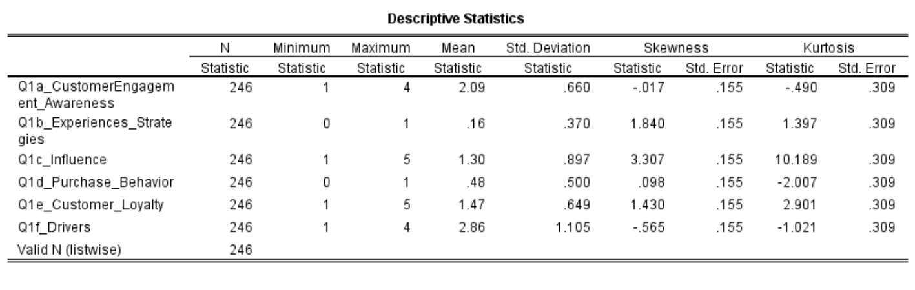

According to the results displayed on the descriptive statistics table above, the total number of participant’s who gave their responses on the questions about awareness, experience and strategies, the influence, the purchase behavior, customer loyalty factors as well as the drivers of experiential marketing campaign. The total number of the respondents is 246 as demonstrated on the table. The minimum and maximum value in the table only represented the Likert scale of 1 to 5 for some responses. The mean values represented the average statics for the participant’s opinions while the standard deviation value shows the distribution of the responses.

## 4.6 Data visualization

Data visualizations involve drawing valuable insights from a dataset by the means of visualization tools such as bar graphs, pie charts, line graphs etc. In this analysis, the different variables in the dataset were visualized using histograms, pie charts and other visualization tools.

The frequency of customers purchasing luxury products was first visualized based on the gender distribution among the participants using a histogram shown below.

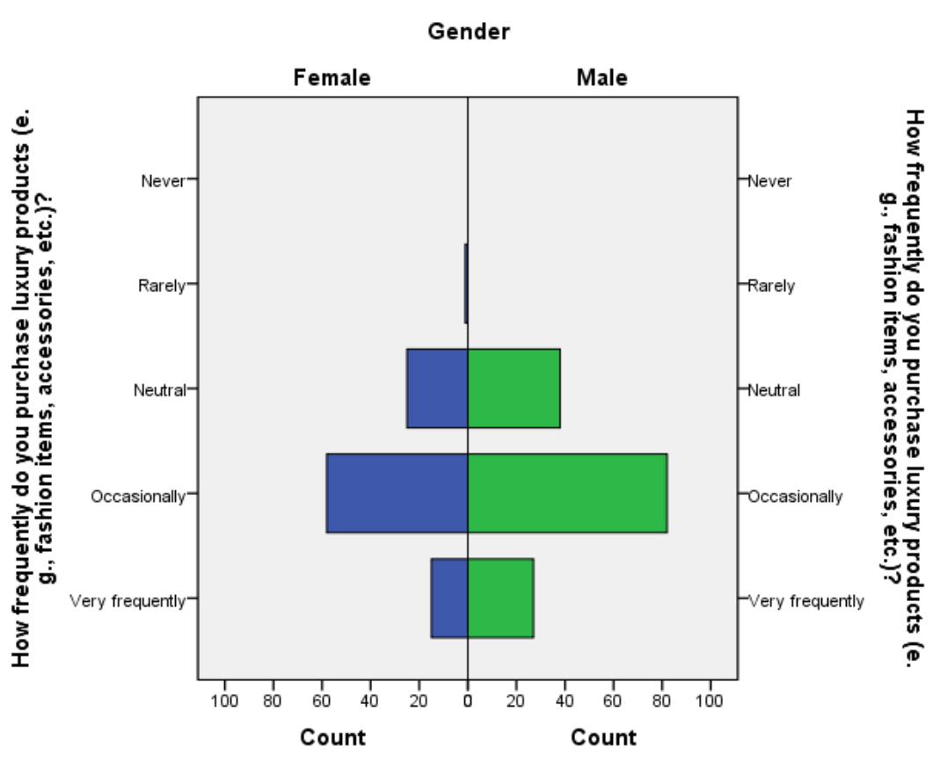

According to the findings from the histogram above most of the participants were men and majority of them agreed that they occasionally buy the luxury products such as fashion items and accessories. This implied that although the participants shared information about the products, they were not daily consumers of the products, maybe due to its high cost.

The research also examined the participant’s familiarity with the luxury brand at Louis Vuitton company. A bar graph was used to access how familiar a participants was with the products.

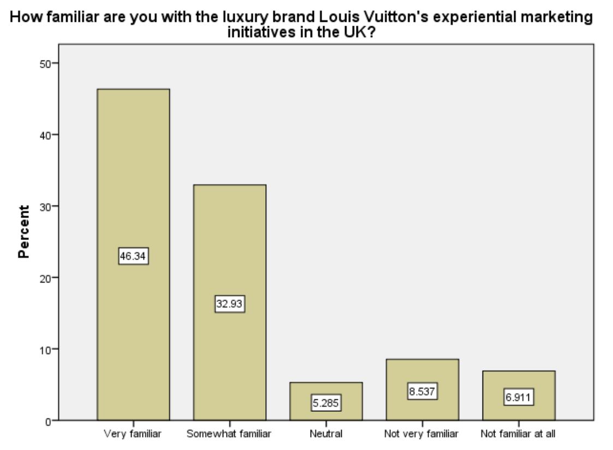

According to the graph shown above, a significant percentage of about 46% of the participants were very familiar with the products as opposed to those who had little information about the products. This implies that the information given about the company and its products was highly informed.

Using a scale of 1 to 5, the participants were asked to rate their own current level of engagement with the company brand. The information they gave was analyzed using a bar graphs as follows.

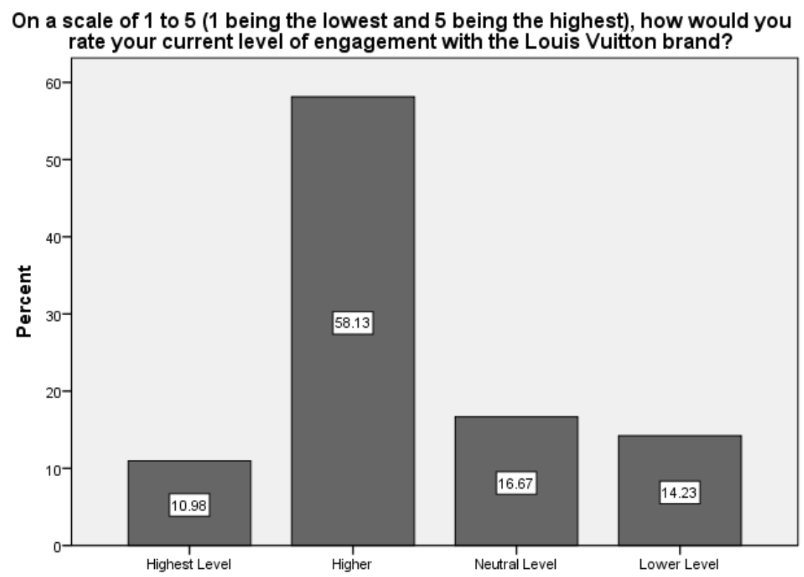

Based on the analysis, above 58% of the participants rated themselves a higher level of engagement with the company brand. This implies that the brand of the company was highly preferred across the population.

The respondents were then asked about the factors that they believed to be contributing to their engagement with the company brand. Again this research used a bar graph to visualize the percentages of the participant’s opinions on the factors that contributed them believe.

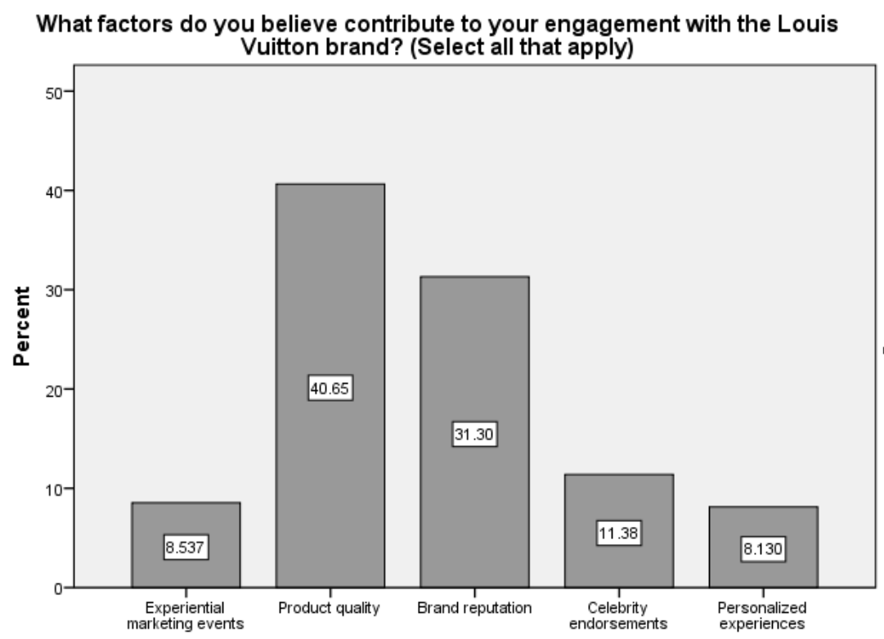

Accessing the bars from the graphs, experiential marketing events, product quality, brand reputation, celebrity endorsements and personalized experiences were among the factors that made the participants to engage with the company brand. According to the graphical analysis, most of the participants were attracted mostly by the product quality and brand reputation as shown by the high percentages of approximately 40% and 31% respectively.

The participants were also required to state whether they ever attended to marketing events organized by the Louis Vuitton Company in the UK. The pie chart below analyzed the numbers of the respondents who ever attended the events.

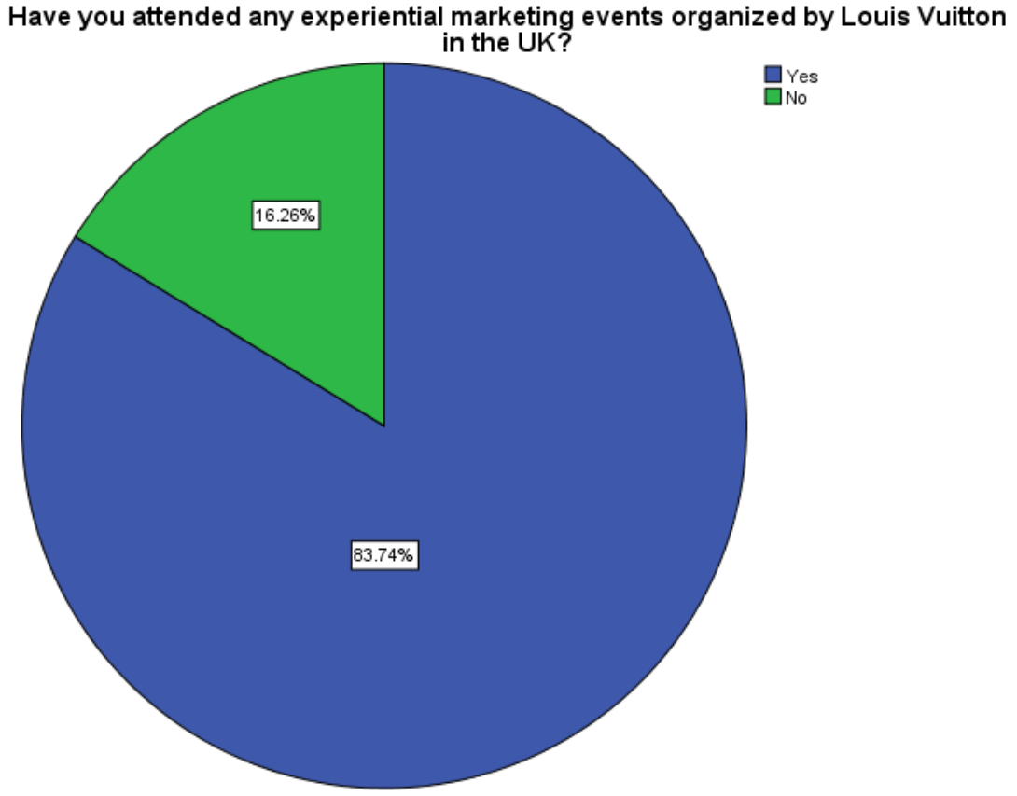

According to the chart above, approximately 83% of the participants claimed to have attended experiential marketing events organized by the Company in the UK. This therefore implied that the participants had enough experience with experiential marketing.

The participants who had attended the events were then asked on how the events impacted their engagements with the brand. The bar graph below analyzed the impacts of attending among the respondents.

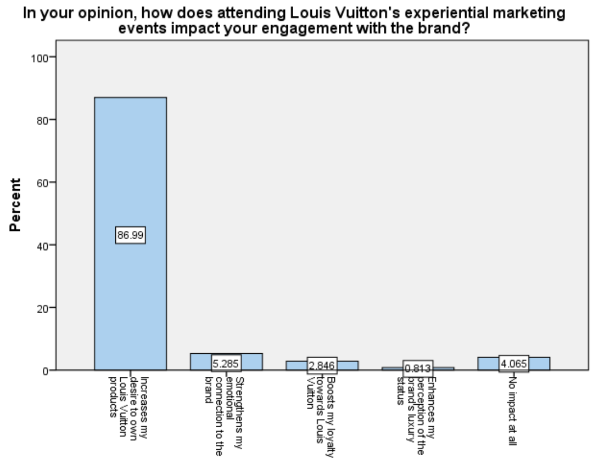

According to the analysis, the events had several impacts on the participant’s engagements with the brand which include, increasing the desire to own the company products, strengthening the participant’s emotional connection to the brand, boosts participant’s loyalty towards Louis Vuitton company and enhancing the participant’s perception of brands luxury status. The graph demonstrated that the events impacted more on the increase of the desire to own the company products as shown above.

The analysis also extended to visualizing the effectiveness of Louis Vuitton’s experiential marketing with comparison to the traditional advertising techniques in capturing people’s attention.

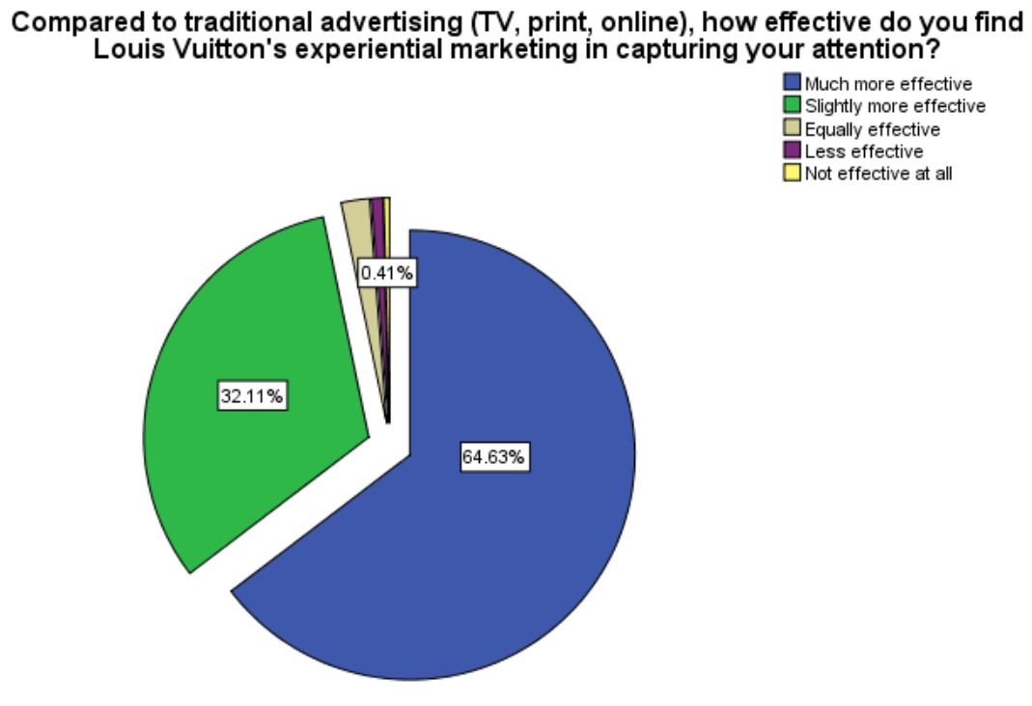

According to the pie chart analysis results above, the Louis Vuitton’s experiential marketing method is much more effective at about 64% level of effectiveness.

The next visualization was done on the key elements that make experiential marketing campaigns successful for the luxury brand like Louis Vuitton. The respondents identified four key elements which include, exclusive and immersive experiences, compelling brand narratives and storytelling, high-quality aesthetics and attention to detail and finally, the engagement with influencers and opinion leaders.

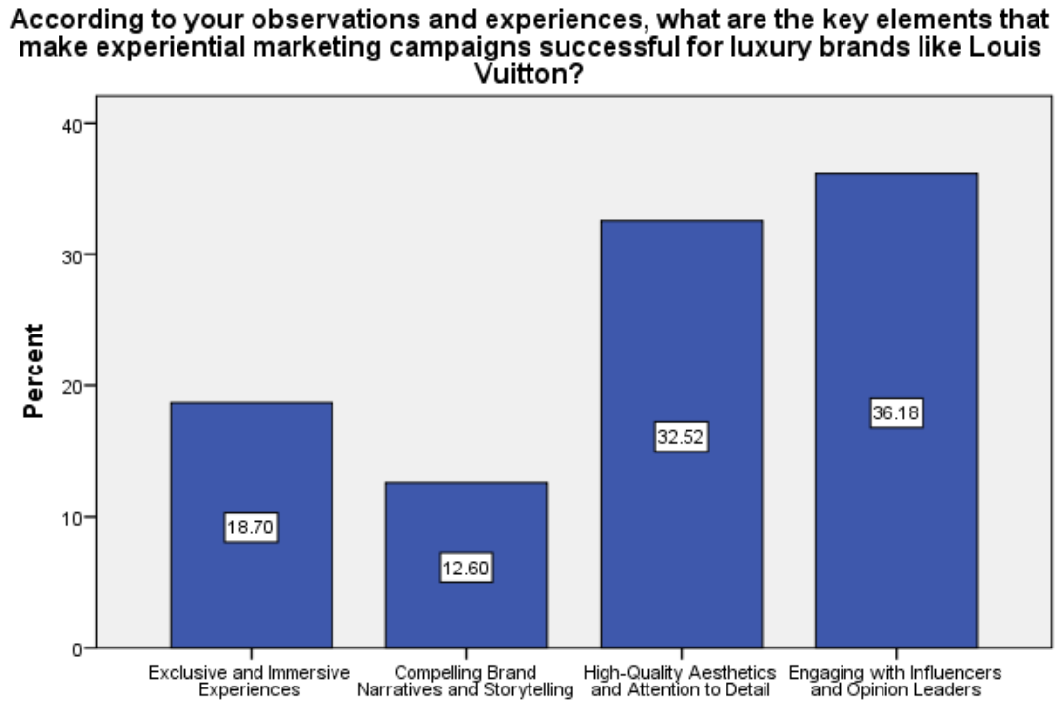

According to the analysis from the above graph, engaging with influencers and opinion leaders as well as high-quality aesthetics and attention to details were the most significant key elements that made experiential marketing campaign a success.

The last visualization was on exploring how important it is for luxury brands to innovate and create unique experiential marketing campaigns.

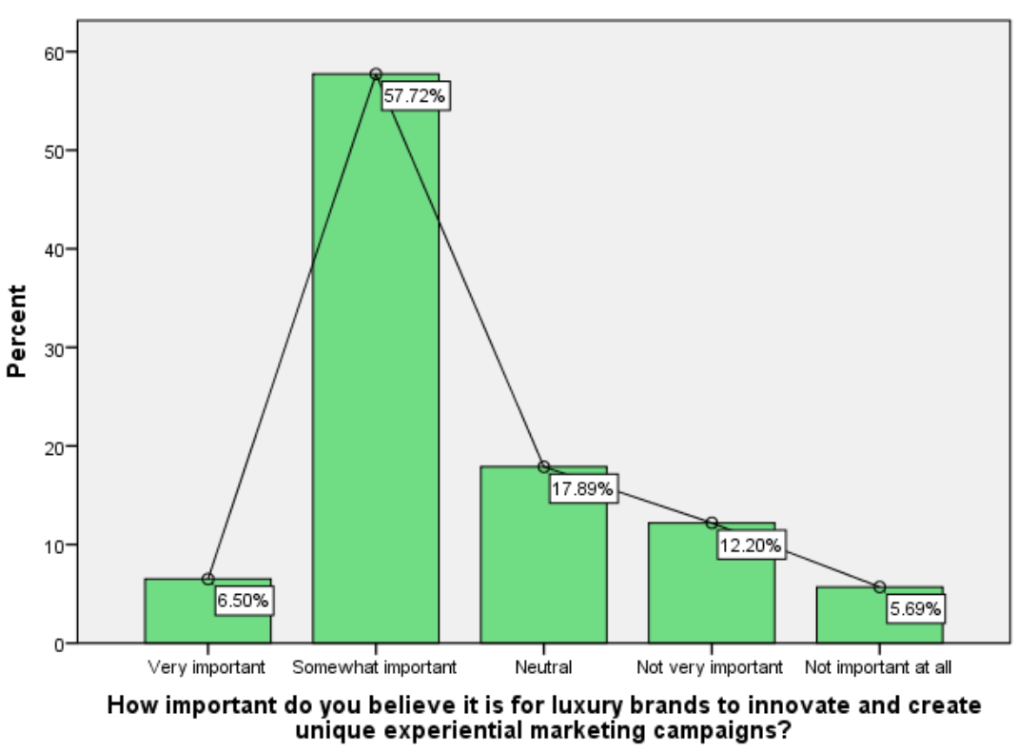

According to the above graphical representation of the participant’s views, a big percentage of about 57% of the respondents believed it was somehow important for luxury brands to innovate and create unique experiential marketing campaigns.

## 4.7 Hypothesis testing

The following hypotheses were derived from the stated research goals and as well tested using the paired sample test and the one way anova test.

H0: There is no significant difference between the mean customer engagement awareness scores and the mean experiences strategies scores for luxury brands.

Ha: There is a significant difference between the mean customer engagement awareness scores and the mean experiences strategies scores for luxury brands.

H0: There is no significant difference between the mean influence scores and the mean purchase behavior scores for luxury brands.

Ha: There is a significant difference between the mean influence scores and the mean purchase behavior scores for luxury brands.

H0: There is no significant difference between the mean customer loyalty scores and the mean drivers scores for luxury brands.

Ha: There is a significant difference between the mean customer loyalty scores and the mean drivers scores for luxury brands.

A paired sample test was conducted to test the above three samples and the results are as shown in the table the below.

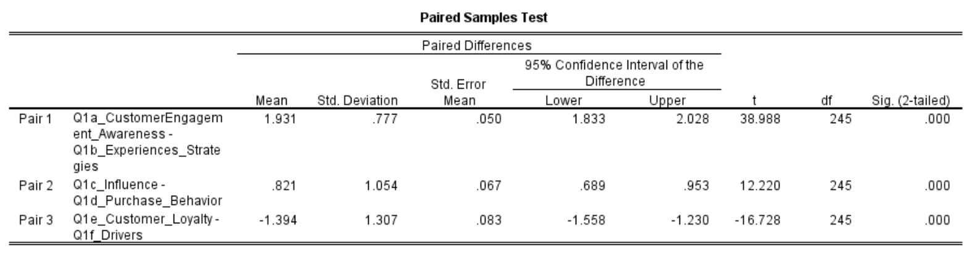

The table above displays paired differences as the difference in scores between pairs of observations. There is a statistically significant difference between the means of customer engagement awareness and experiences strategies (p .0001), as indicated by the first Pair (Customer Engagement Awareness vs. Experiences Strategies). A similarly modest p-value (p .0001) indicates a statistically significant difference between the means of influence and buy behavior for Pair 2 (Influence vs. buy Behavior).

For the last Pair (Customer Loyalty vs. Drivers), there is a statistically significant difference between the means of the two measures. The p-value is quite small (p .0001). The null hypotheses were rejected for all three sets of variables due to their small p-values. The results show that luxury brands' average scores on customer engagement awareness and experiences, impact and purchasing behavior, and customer loyalty and drivers are significantly different from those of other brands.

**4.7.2 One Way ANOVA**

To find statistically significant differences between many groups, the Analysis of Variance (ANOVA) was used to compare their means.

The analysis on 5 compiled questions that are significant and were asked to the respondents about their experiences with experiential marketing, their attitudes about luxury goods, their likelihood of attending an event, their likelihood to recommend your company to others, and other related factors. For each question, a subset of survey takers is analyzed; this may be done, for example, based on how frequently they shop for luxury items or attend Louis Vuitton's experiential marketing events. The table below give the analysis output.

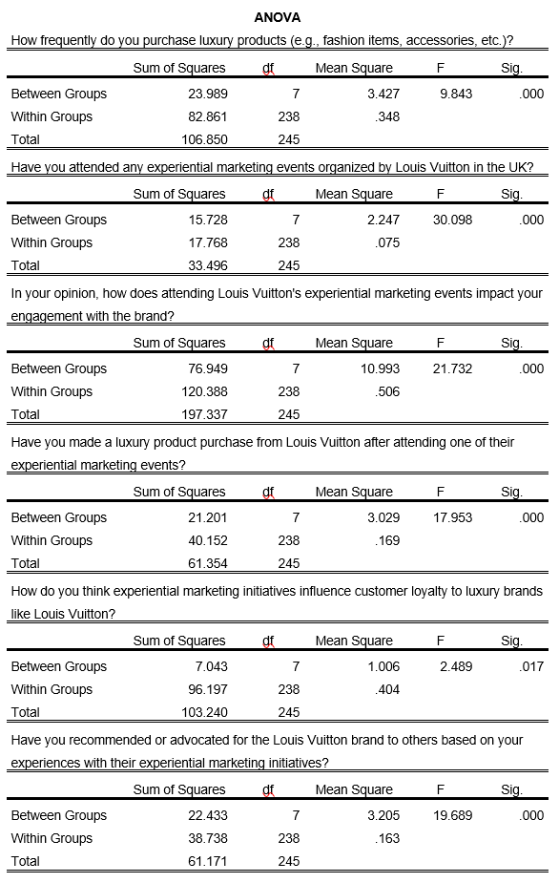

The breakdown of each of the above questions output is given as follow:

How frequently do you purchase luxury products?

Statistically, there's a distinction between the frequency with which each group shops for a luxury item (F = 9.843, p .001).

Have you attended any experiential marketing events organized by Louis Vuitton in the UK?

There is a statistically significant difference in the number of persons who attend each group's experiential marketing events, as shown by the analysis of variance (F = 30.098, p .001).

In your opinion, how does attending Louis Vuitton's experiential marketing events impact your engagement with the brand?

Brand engagement was considerably different for those who participated in experiential marketing events versus those who did not (F = 21.732, p .001).

Have you made a luxury product purchase from Louis Vuitton after attending one of their experiential marketing events?

An ANOVA reveals that there is a statistically significant increase in the purchase of high-end products after attending experiential marketing events (F = 17.953, p.001).

How do you think experiential marketing initiatives influence customer loyalty to luxury brands like Louis Vuitton?

Analyzing the impact of experience marketing on customer loyalty across demographics, an ANOVA test reveals significant group differences (F = 2.489, p = 0.017).

Have you recommended or advocated for the Louis Vuitton brand to others based on your experiences with their experiential marketing initiatives?

Experiential marketing participants were much more likely to suggest the brand to others than those who did not take part in the event (F = 19.689, p .001).

The "Within Groups" column displays differences between the groups itself, whereas the "Between Groups" column displays differences between the groupings themselves. The F-value increases as the degree of dissimilarity between the groups' means exceeds the degree of variability within each group. In the "Sig." column, it is seen that the p-value that was utilized to determine whether or not the F-statistic was statistically significant. Since all the p-values for all the questions tested were below 0.05, this indicated that they were statistical significant. In conclusion, the ANOVA results show that experiential marketing plays a crucial role in raising consumers' enthusiasm for the Louis Vuitton brand in the UK. The analysis shows that there is a large disparity between the groups in terms of how much of an impact experiential marketing has on various aspects of consumers' interaction with luxury brands.

## 4.8 Regression Model Building

Since the main aim of the research was to critically evaluate the impact of experiential marketing on enhancing engagement with luxury brands, using Louis Vuitton as a specific case study, a multiple linear regression model was constructed on the dependent variable which in this case was the luxury brand engagement with the other independent variables. The regression model equation is as follows;

Y = α + β1*X1 + β2*X2 + β3*X3 + β4*X4 + β5*X5

Where:

Y is the dependent variable

α is the intercept

β1, β2, β3, β4 and β5 are the beta coefficients.

X1, X2, X3, X4 and X5 are the independent variables.

**Model Summary**

The summary of the model was tabulated using the SPSS software and the table below shows the results:

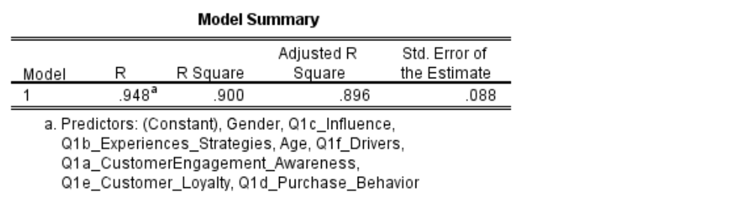

According to the analysis on the model summary table above, approximately 90% percent of the observed variation in luxury brand engagement can be accounted for by the explanatory factors, as measured by the coefficient of determination (R Square). This indicates that the model fits the data fairly well. The significance of the model was then tested using the ANOVA test and the table below shows the results.

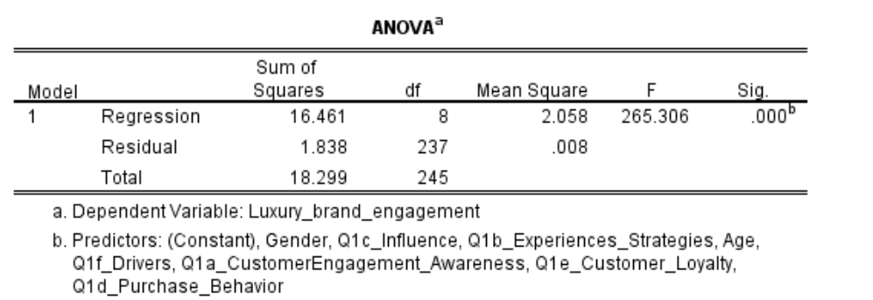

The total regression model is statistically significant (Sig. =.000), as seen in the ANOVA table. Customer Engagement Awareness, Experience Strategies, Influence, Purchasing Behavior, Customer Loyalty, and Drivers all independently predicted engagement with luxury brands.

**Coefficients**

The relationships between each independent variable and the dependent variable (in this case, Luxury brand engagement) are summarized in the table of coefficients.

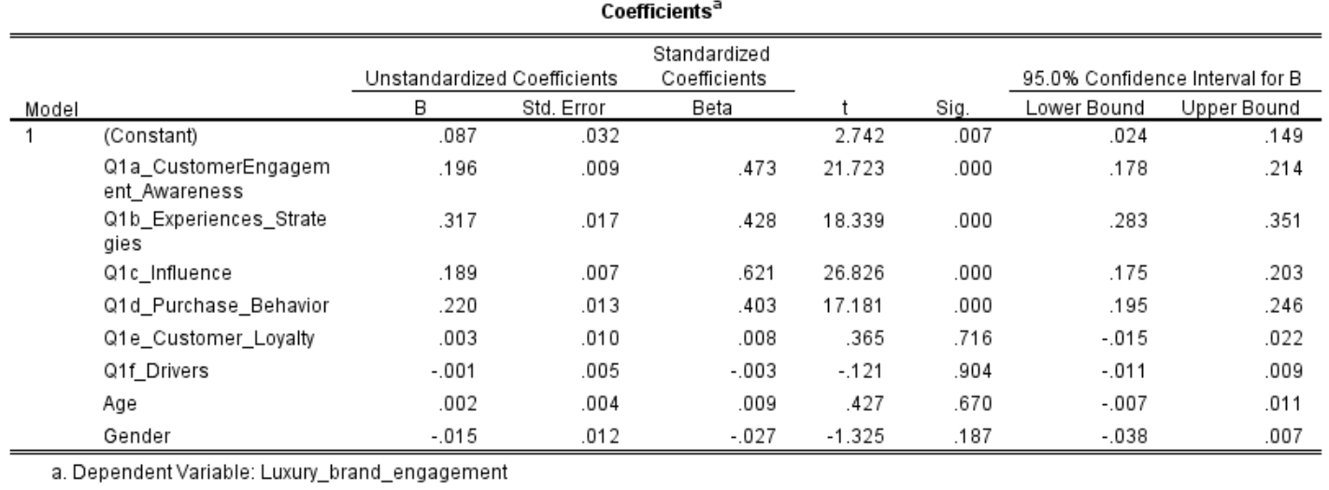

The variables "Customer Engagement Awareness," "Customer Engagement Strategies," "Influence," "Purchase Behavior," and "Customer Loyalty" all have positive standardized coefficients (Beta), indicating that they positively affect luxury brand engagement. Drivers are characterized by a negative standardized coefficient (Beta) that is very near to zero. Based on these findings, it appears to have a very small impact on customers' desire for luxury brands. The control variables i.e. age and gender had positive and negative effects to luxury brand engagement respectively.

In the context of Louis Vuitton, the results suggest that the variables Customer Engagement Awareness, Experiences Strategies, Influence, Purchase Behavior, and Customer Loyalty all play key roles in boosting customer engagement with luxury businesses. These elements appear to be crucial in fostering deep ties with clients and increasing engagement. This study's results suggest, however, that Drivers is not a reliable predictor of exposure to luxury brands. To establish deeper connections with customers and drive higher engagement in the luxury market, the study may suggest that luxury brands like Louis Vuitton strengthen their experiential marketing strategies, focusing on those related to customer engagement awareness, experiences, influence, purchase behavior, and customer loyalty.

## 4.8 Summary of the findings

This research examines the effect of experiential marketing on consumers' engagement with luxury brands like Louis Vuitton by analyzing a dataset and presenting its conclusions. A significant Cronbach's alpha value of 0.715 for the 18 variables is presented in the first section of the chapter, confirming the dependability of the dataset. After validating the data, the team uses the imputation technique to fill in any gaps left by missing numbers. Experiential marketing campaign drivers, such as customer awareness, experience, strategy, influence, purchasing behavior, and loyalty characteristics, can be better understood with the help of descriptive statistics. Histograms, bar graphs, and pie charts are all examples of data visualizations that can be used to effectively communicate findings. Participants' gender distribution and purchasing habits, Louis Vuitton brand awareness, engagement with the brand, factors influencing engagement, marketing event attendance, and the impact of these factors on engagement are all represented graphically.

To examine the effect of experiential marketing on luxury brand engagement, a multiple linear regression model is developed, and hypotheses are tested to determine the statistical significance of changes in mean scores for different variables. The results indicate the importance of experience marketing in boosting luxury brand loyalty. Customer knowledge, experience, influence, purchasing behavior, and loyalty are all crucial in developing meaningful relationships with clients and keeping them invested. In order to improve customer engagement and the entire brand experience, the report suggests that luxury brands increase their use of experiential marketing methods.

# CHAPTER FIVE

# DISCUSSION OF THE RESULTS, POTENTIAL IMPACTS AND REFLECTIONS

## 5.1 Discussion of the results

According to the findings of this research project that was conducted in the United Kingdom and focused on Louis Vuitton, experiential marketing has a substantial impact on the level of interest that customers have in luxury brands. In order to develop conclusions about the impact that experiential marketing has on client engagement and long-term loyalty, the forms of data that were examined were guided by the objectives of the study.

To begin, the findings of the study suggested that a range of factors influence customers' levels of engagement with luxury companies, particularly Louis Vuitton. Specifically, the study focused on how consumers interact with the brand's website. As indicated by descriptive statistics and data visualizations, consumers are driven to Louis Vuitton due to the great quality of its things and the repute of its brand. This is evidenced by the fact that Louis Vuitton has a very high customer retention rate. This illustrates that clients in the luxury industry are drawn to organizations that offer individualized and unique solutions, as shown by the fact that this has been demonstrated.

Second, the immersive marketing technique that Louis Vuitton employs has shown to be more successful than the marketing approaches used by other luxury brands. The majority of attendees were seasoned veterans of the company's experiential marketing events, having participated in at least one of them before. It was believed that the events would increase customers' desire to own Louis Vuitton goods, their emotional links to the brand, their loyalty, and their perception of the high status of the company. This indicates that experiential marketing strategies are absolutely necessary in the luxury industry in order to encourage increased involvement and commitment on the part of customers.

Thirdly, the results of the regression analysis showed that customer engagement awareness, experience strategies, influence, purchasing behavior, and customer loyalty all had a favorable influence on luxury brand engagement, whereas drivers only had a negligible effect. The success of luxury firms like Louis Vuitton can be linked, at least in part, to the effectiveness of their experiential marketing efforts. These initiatives help to establish genuine connections with customers, which contributes to the success of luxury brands like Louis Vuitton.

The findings have major repercussions for our comprehension of how luxury brands like Louis Vuitton might utilize experiential marketing to boost client engagement in order to enhance sales. Experiential marketing is becoming an increasingly popular choice for upscale companies that want to deepen their connections with their clientele and, as a result, increase their consumers' commitment to their brands.

The report is full of actionable advice that luxury businesses like Louis Vuitton can put into practice to improve their operations. Experiential marketing activities that emphasize consumer engagement awareness, personalized experiences, and harnessing influencers and opinion leaders may assist luxury organizations maximize their strategies and create a more profound impression on their customers and clients. In addition, the product's quality as well as the reputation of the brand continue to play important roles in the process of attracting clients in the luxury market.

According to the findings, experiential marketing is an efficient method for promoting brand loyalty, particularly for luxury brand products. This is especially true when the products in question are more expensive. With this information, luxury brands like Louis Vuitton may be able to differentiate themselves from the competition by providing their clients with an extraordinary and significant shopping experience. The use of experiential marketing and other equally successful tactics can assist luxury organizations in continuing to enjoy their existing levels of success, and even in growing those levels further.

## 5.2 Potential Impacts of the study findings

It's possible that the findings of this study will have far-reaching ramifications for how luxury brands market their products.

The findings of this study can be used by luxury firms such as Louis Vuitton to hone their approaches to experiential marketing. It is possible for luxury companies to witness a rise in customer engagement and brand loyalty if they place a higher priority on their customers' knowledge, experience, and influence as well as their purchasing behavior and loyalty. An advantage can be gained over competitors for luxury brands that engage in experiential marketing strategies that are both interesting and innovative. Because these companies consistently go the extra mile for their consumers, they are able to charge higher prices for their services without losing any of their existing clientele.

According to the findings of the survey, retaining customer loyalty demands not just producing high-quality goods but also working to cultivate positive opinions of the brand. Luxury companies that place the highest importance on their customers' continued patronage and positive word-of-mouth should transition to a business model that is customer-centric and places an emphasis on the quality and uniqueness of their products. If experiential marketing is successful for luxury brands, the companies may choose to devote a greater portion of their resources to the strategy. Businesses have the ability to take advantage of the enhanced profitability and customer participation that experiential marketing offers by changing their resources.

The results of this study may have repercussions not only for Louis Vuitton in the United Kingdom but also for the entire luxury goods industry as a whole. Investigating the effect that experience marketing has on the loyalty of customers could assist luxury companies with a worldwide footprint in adapting their product lines to the varying tastes of customers in the many areas in which they operate.

## 5.3 Reflections on the findings

The effect that experiential marketing has on consumers' loyalty to luxury brands has been an intriguing subject of study. The research uncovered a number of interesting findings, including:

The vast bulk of the information was collected through the use of surveys, which made it simple to carry out quantitative analysis and uncover important linkages. Methods of qualitative research such as in-depth interviews and focus groups are examples of approaches that could have resulted in a more comprehensive understanding of the attitudes that individuals have toward experiential marketing.

The fact that the research was based on a single case study means that the findings cannot be extrapolated to apply to other luxury companies, despite the study's insightful nature. In the future, academics may apply a range of case studies to study the ways in which experiential marketing has influenced certain luxury enterprises.

Understanding the concept of customer participation can be challenging due to the diverse nature of the concept and the fact that it is susceptible to the effect of a number of different circumstances. Future research could investigate additional dimensions of engagement, such as emotional and cognitive engagement, in order to present a fuller picture of customer-brand interactions; however, the primary focus of this study was not on examining these extra dimensions of engagement.

Implications for the Future and Proving Causation: The research found a connection between experiential marketing and customer involvement; however, additional research is required to verify that this connection is causal. It has been demonstrated that experiential marketing increases brand loyalty and advocacy; further research into these phenomena may give light on the efficiency of various tactics for engaging with customers.

Ethical issues were of the utmost importance, as they should be in any investigation that includes human subjects. Informed permission, confidentiality, and full compliance with all regulations were absolutely necessary for the success of this study.

When it comes to selling luxury goods, it is essential to keep the customer's journey in mind, as suggested by the implications for practice. According to the findings of the study, luxury firms might strengthen customer loyalty by placing more emphasis on the quality of their products and the reputation of their brands, as well as by providing customers with one-of-a-kind, all-encompassing experiences.

This research sheds light on the need of developing marketing strategies that are centered on the needs and interests of customers across all types of businesses. Businesses need to have a comprehensive understanding of the preferences, motivations, and behaviors of their customers in order to successfully connect with customers and gain their loyalty. This is necessary in order to successfully engage with customers and win their loyalty.

The findings of this study, taken as a whole, shed light on the value of experience marketing in terms of swaying customer loyalty to luxury companies such as Louis Vuitton. The potential benefits include improved marketing techniques, an advantage over the competition, and the reallocation of resources that were previously committed to other areas. Valid concerns have been raised regarding the study's methodology, generalizability, and the difficulties of recruiting participants from the target population. These findings can serve as a launching point for further research into a wider spectrum of customer participation in marketing tactics, such as the analysis of new characteristics and the extension of these findings to other luxury brands and marketplaces.

# CHAPTER SIX

# CONCLUSIONS, LIMITATIONS AND RECOMMENDATIONS

## 6.1 Conclusions

The study set out to examine how luxury brands like Louis Vuitton might use experiential marketing to attract and retain customers. The findings shed light on the significance of experience marketing in strengthening consumers' loyalty to luxury brands. Customers who attended Louis Vuitton's experiential marketing events reported feeling more drawn to the brand, more devoted to the company, and more knowledgeable about its position as a luxury label. Conclusions like these highlight the value of experience marketing for luring and keeping luxury consumers as clients. Important factors influencing the involvement of luxury brand clients were also identified, with a particular emphasis on Louis Vuitton's audience. According to the findings, client loyalty increases in tandem with both product quality and brand reputation. Personalization, high-profile endorsements, and hands-on promotions all played a role in drawing in more customers. This suggests that experiential marketing is not as crucial as other elements like product quality and brand reputation when it comes to developing strong ties with consumers.

The research also showed that Louis Vuitton's immersive marketing strategy is more effective than traditional types of promotion. The research showed that Louis Vuitton's efforts to engage customers with immersive experiences yielded much better results. This means that experiential marketing should be a major focus for luxury brands if they want to attract and keep customers. In addition, the study shed light on the elements that make experiential marketing campaigns for luxury brands so successful. Interacting with influencers and opinion leaders and paying special attention to aesthetics and detail were deemed to be the most critical factors for a successful campaign. These findings highlight the value of collaborating with powerful people and developing fully immersive and aesthetically beautiful experiences. The importance of new ideas in the expanding field of experiential marketing was emphasized in this research. Respondents to the survey overwhelmingly called for innovative experiential marketing from the luxury sector. This finding emphasizes the need of continuously setting new standards and supplying novel experiences for luxury brand patrons.

## 6.2 Limitations

While the study's findings are helpful, there are a few limitations worth noting. First, the study only focused on Louis Vuitton, thus the findings may not be generalizable to other luxury brands. Different luxury brands may have varying degrees of success with experiential marketing due to variations in their target markets and promotional strategies. Second, the data was compiled through surveys, which can be prone to biases and self-reporting inaccuracies. It's possible that the data is unreliable because people gave politically correct responses or distorted their memories.

In addition, the study focused solely on the customer's perspective and did not thoroughly analyze the perspectives of other stakeholders like luxury brand executives or marketing experts. More perspectives could have helped paint a more complete picture of the impact of experiential marketing on luxury brand engagement. While this study did find associations between experiential marketing and engaged customers, it is vital to highlight that a causal relationship cannot be established at this time. There may be intangible variables at play that influence luxury brand loyalty. In addition, cultural, economic, and societal factors may have added bias because the study was conducted in a specific context (Louis Vuitton in the UK). Findings from a similar study conducted in a different geographical and cultural setting may provide insight into the role experiential marketing plays in driving demand for luxury brands in those markets. Quantitative data analysis was prioritized over qualitative sources like in-depth interviews and focus groups. Qualitative data might have enriched the findings by providing insight into the participants' perceptions of the experiential marketing event.

In essence, the findings of this study expand our understanding of how luxury brands like Louis Vuitton may increase consumer engagement through experiential marketing. Experiential marketing efforts were found to have the highest impact on customer involvement, however other factors such as product quality and corporate reputation were also important. In order to make true relationships with consumers and inspire brand loyalty, the research shows that luxury firms need to employ imaginative and well-executed experiential marketing programs. However, the caveats of this study need to be considered before any firm conclusions can be drawn. In order to acquire a more nuanced picture of customers' experiences, future studies should cover additional luxury companies and use qualitative research approaches.

## 6.3 Study Recommendations

Following are some recommendations that have been provided based on the research and findings in order to improve the effect that experiential marketing has on involvement with luxury brands, with a particular emphasis on Louis Vuitton:

Experiential marketing provides clients with opportunities they won't soon forget, which is why Louis Vuitton must continue to invest in this form of marketing. Events and campaigns ought to be painstakingly crafted to accurately depict the nature of the brand and the principles it upholds, so imbuing them with an air of exclusivity and elegance. It is possible for Louis Vuitton to deepen its consumers' participation with the brand and strengthen their devotion to it by providing its customers with chances that are unique to the brand.

Make the most of your interactions with important opinion leaders and influential figures. According to the findings of the study, maintaining positive relationships with prominent individuals had a substantial bearing on customer retention. When it comes to marketing its wares, Louis Vuitton might stand to benefit from creating strategic collaborations with other well-known names in the fashion and luxury goods industries. Louis Vuitton is able to increase sales and the number of people who buy their products by capitalizing on the brand's well-known position and extensive consumer base.

It was shown that clients' interest in the Louis Vuitton brand was significantly affected by the level of personalization they received from the company. It would be to the benefit of Louis Vuitton to make investments in data-driven methodologies that enable the company to provide personalised services to customers and to keep lines of contact open with those customers. The organization is able to develop more meaningful relationships with its clients when it provides tailored service to those customers.

Louis Vuitton needs a dependable solution to keep track of and routinely assess the metrics on the interactions they have with their customers. Using this strategy that is driven by data, we will be able to analyze the effectiveness of our experiential marketing initiatives and locate areas in which we can make improvements. Brands may be able to increase the effectiveness of their experience marketing by using data to continuously adjust their plan.

## 6.4 Future Recommendations

The following suggestions are made for the long-term success of Louis Vuitton and other businesses that are comparable to it, taking into consideration the fluidity of the luxury industry and the fickleness of its customer.

Because technology will continue to play such an important role in the lives of customers, luxury brands ought to give some thought to how they may enhance the digital services they offer. Consumers could be immersed in branded virtual environments through the use of virtual reality (VR) and augmented reality (AR), which could be utilized in experiential marketing. This strategy may appeal to a younger generation as well as those who are knowledgeable about technology.

It is becoming an increasingly important factor for luxury firms to offer experiences that are socially and environmentally responsible. Louis Vuitton is able to arrange campaigns and events to promote the use of ethical manufacturing techniques and resources that are environmentally friendly. Customers that place a high importance on ethics are more likely to do business with a firm that supports the causes that are important to them.

If Louis Vuitton wishes to maintain its position as a leader in the luxury goods market, the company must continue to launch exciting and cutting-edge experiential marketing campaigns. Brands have to stay current with shifting market conditions, shifting consumer preferences, and shifting technical landscapes, and they have to be able to react to these shifts in order to meet and ideally exceed the expectations of their customers.

Customers and luxury businesses have the opportunity to work together on creative marketing initiatives and unique experiences. Louis Vuitton may be able to build experiential marketing campaigns that cater to its devoted consumers' deepest aspirations by first listening to those customers and then responding to the feedback they provide. These kind of collaborations increase the emotional connection that the business has with its clients.

If they meet these requirements, luxury businesses like Louis Vuitton have a better chance of succeeding in the competitive modern market. In the future, one of the primary objectives of experiential marketing will be to improve the way that luxury brands connect with their most discerning clients. This will be one of the key purposes of experiential marketing.

# References

Baksi, A. (2022). TraveLux: An interaction-based brand relationship scale for the luxury travelers. *Turizam*, *26*(1), 1-21.

Batat, W. (2019). *The new luxury experience*. Cham: Springer International Publishing.

Bhattacharya, C. B., & Sen, S. (2020). Luxury brand engagement: Scale development and validation. Journal of Business Research, 115, 388-398.

Brakus, J. J., Schmitt, B. H., & Zarantonello, L. (2019). Brand experience: What is it? How is it measured? Does it affect loyalty? Journal of Marketing, 73(3), 52-68.

Carmo, I. S. D., Marques, S., & Dias, Á. (2022). The influence of experiential marketing on customer satisfaction and loyalty. *Journal of Promotion Management*, *28*(7), 994-1018.

Chen, H., & Phou, S. (2019). Do luxury experiential marketing strategies influence brand attachment and purchase intention? Evidence from China. Journal of Retailing and Consumer Services, 46, 190-199.

Chen, H., Phou, S., & Seock, Y. K. (2021). The influence of luxury experiential marketing on customer satisfaction and loyalty. Journal of Business Research, 123, 145-156.

Choi, J., & Seo, S. (2021). Do brand rumors matter? The role of brand equity and response strategy to brand rumor. *International Journal of Contemporary Hospitality Management*, *33*(8), 2862-2879.

Chung, J., Kwon, H., & Lee, J. (2022). The effects of sensory experiences on consumer emotions and behvioral intentions in luxury hotels. Journal of Travel Research, 61(1), 95-108.

Cova, B., Dalli, D., & Zwick, D. (2020). Consumer experience and experiential marketing: An organizing framework. Journal of Business Research, 117, 420-428.

Dhillon, R., Agarwal, B., & Rajput, N. (2022). Experiential marketing strategies used by luxury cosmetics companies. *Innov. Mark*, *18*, 49-62.

Dion, P., Borraz, S., & Gurviez, P. (2020). Experiential marketing in luxury brand strategies: Theoretical and empirical perspectives. Journal of Retailing and Consumer Services, 57, 102153.

Fiore, A. M., Sweeney, J. C., & Childers, T. L. (2023). Sensory aspects of consumer behavior. Journal of Consumer Psychology, 33(1), 3-25.

Gilovich, T., & Gallo, I. (2020). Consumers’ pursuit of material and experiential purchases: A review. *Consumer Psychology Review*, *3*(1), 20-33.

Godey, B., Pederzoli, D., Aiello, G., Donvito, R., & Wiedmann, K. P. (2019). Expanding luxury experience through retail theatre. Journal of Business Research, 100, 494-503.

Han, S. L., & Kim, K. (2020). Role of consumption values in the luxury brand experience: Moderating effects of category and the generation gap. *Journal of Retailing and Consumer Services*, *57*, 102249.

Han, S. L., & Kim, K. (2020). Role of consumption values in the luxury brand experience: Moderating effects of category and the generation gap. *Journal of Retailing and Consumer Services*, *57*, 102249.

He, Z., Zhang, L., Zhang, H., & Li, J. (2022). When flagship store acts as a stage: The effects of flagship store experiences on luxury brand loyalty. Journal of Business Research, 142, 202-215.

Hollebeek, L. D., Srivastava, R. K., & Chen, T. (2020). SD logic-informed customer engagement: integrative framework, revised fundamental propositions, and application to CRM. Journal of the Academy of Marketing Science, 48(2), 254-273.

Homburg, C., Schwemmle, M., & Kuehnl, C. (2019). New product design: Concept, measurement, and consequences. Journal of Marketing, 83(6), 71-96.

Huang, R., Sarigöllü, E., & Zhang, T. (2020). The effect of brand experience on brand equity: Empirical evidence from international luxury brands. Journal of Business Research, 108, 284-296.

Jin, S. A. A., Muqaddam, A., & Ryu, J. (2020). Understanding luxury brand heritage: An analysis of the Rolex brand. Journal of Business Research, 122, 561-572.

Khoirunnisa, A., & Astini, R. (2021). The effects of experiential marketing and social media marketing on repurchase intention with brand trust as variable mediation for wearing Klamby hijab fashion products. *European Journal of Business and Management Research*, *6*(6), 35-41.

Kim, J. N., Kim, E. S., & Morrison, A. M. (2021). The effect of luxury brand flagship stores on brand attitude, store attitude, and purchase intention: An empirical examination in the fashion industry. Journal of Travel Research, 00472875211035801.

Kumar, A., & Pang, M. (2021). Experiential marketing and luxury brands: An integrated framework and research agenda. Journal of Business Research, 122, 487-497.

Lee, S. M., Babin, B. J., & Kim, E. J. (2021). Creating personalized experiences in luxury brand retail stores: The role of store ambience and salesperson behaviors. Journal of Business Research, 124, 280-289.

Li, J., & Wang, D. (2020). The effect of luxury flagship store experience on brand loyalty in a luxury fashion context. Journal of Business Research, 109, 430-438.

Liu, H., Li, S., Wei, W., & Zhou, K. Z. (2022). Enhancing luxury brand engagement through personalized interactions: The roles of perceived brand exclusivity and psychological ownership. Journal of Business Research, 143, 64-76.

Loureiro, S. M. C., & Kaufmann, H. R. (2021). How sensory experiences influence brand engagement in luxury retail: A multi-sensory framework. Journal of Retailing and Consumer Services, 63, 102646.

Merz, M. A., Zarantonello, L., & Grappi, S. (2021). How to engage luxury customers: the impacts of nostalgia and exclusivity. Journal of Business Research, 131, 132-144.

Phau, I., Pookulangara, S., & Fitchett, J. A. (2019). Does experiential marketing build loyalty? A study of luxury brand experiences. Journal of Business Research, 94, 380-389.

Puccinelli, N. M., Deshpande, R., Israr, M., & Han, D. (2020). Experiential marketing: A review, synthesis and research agenda. Journal of Retailing, 96(1), 91-106.

Saunders, M., Lewis, P. H. I. L. I. P., & Thornhill, A. D. R. I. A. N. (2007). Research methods. Business Students 4th edition Pearson Education Limited, England, 6(3), 1-268.

Tripathi, S. N., Malik, N., Rana, N. P., Vishnani, S., & Srivastava, S. (2022). Validating the antecedents of customer M-payment loyalty: an empirical investigation. *Internet Research*, *32*(6), 1862-1890.

Urdea, A. M., & Constantin, C. P. (2021). Experts’ perspective on the development of experiential marketing strategy: implementation steps, benefits, and challenges. *Journal of risk and financial management*, *14*(10), 502.

Vinnell, L. J., Milfont, T. L., & McClure, J. (2021). Why do people prepare for natural hazards? Developing and testing a Theory of Planned Behaviour approach. *Current Research in Ecological and Social Psychology*, *2*, 100011.

**APPENDIX**

