
United States
Deloitte Consulting LLP

  In this issue:
  What is New
  Cover Story
  Get Social
  Campus News
  Recent Event
  A Peek At 2010
  Quick Links
  About Deloitte
  About Consulting
  About Recruiting
  Campus Communication
  Issue 3.1
  November 2009
  What’s New
  Cover Story
  Deloitte takes the top spot on BusinessWeek’s 2009 list
  In September, BusinessWeek named Deloitte the #1 Place to Launch a Career. Deloitte Insiders is a podcast series that explores why Deloitte is a great place to work in the words of the people who know best — our employees. The content is driven by questions submitted by our listeners and your peers. Let us know what you think!
  http://careers.deloitte.com/united-states/students/csc_general.aspx?CountryContentID=16018
  Read More
  back to top
  Get Social
  Find Out Your Future At Deloitte!
  Click the icons below to check out why Deloitte is the best place to launch a career.
  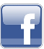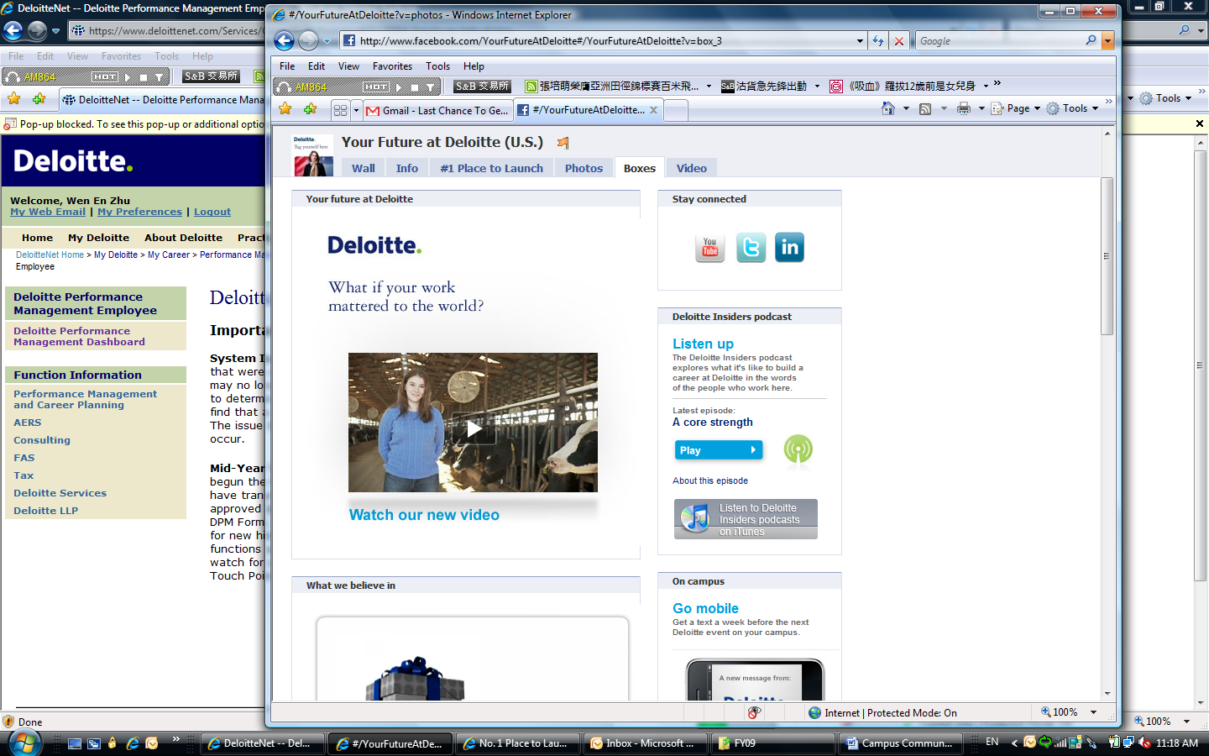
  back to top
  Campus News
  Recent Event
  Deloitte On Campus
  Business Case Competition
  
  
  It’s that time again! For the past four semesters, we have worked with Professor Dan Cohen and his Business Strategy class from the ILR School to host a Deloitte sponsored Business Case Competition. Students in his Business Consulting class form teams of 4-6 people and are given a business case scenario with a “client issue”. At the end of the semester, the students present their findings, recommendations, and solution to a panel of 4-5 Deloitte practitioners. After all the presentations are finished, Deloitte judges rank 1st, 2nd, and 3rd place groups based on criteria provided by Professor Dan Cohen and prizes are awarded.
  This semester’s Business Case Competition will be held on Thursday, 3-Dec 2009 from 7:30am - 5pm in the ILR Conference Center. We are very excited to be working with Professor Dan Cohen again this semester and are eagerly looking forward to the presentations!
  back to top
  A Peek At 2010
  Internship Recruiting in 2010
  Deloitte will resume its recruiting on-campus at Cornell in January 2010 with Summer Scholar (internship) recruiting!
  Please keep an eye next month for the following job postings on Experience:
  - Business Analyst Summer Scholar
  - Business Technology Analyst Summer Scholar
  - Business Technology Analyst Summer Scholar (Sophomore Program)
  - Human Capital Analyst Summer Scholar
  - Human Capital Analyst Summer Scholar (Actuarial)
  The positions listed above are for Summer 2010 internships, and are open to Sophomores and Juniors (with the exception of the Business Analyst Summer Scholar, which is open to Juniors only).
  We plan to hold our Information Session in late January once you return to campus from winter break. Please check with Career Services for the exact date.
  back to top
  Deloitte.com | Security | Legal | Privacy
  1633 Broadway
  New York, NY 10019-6754
  United States
  
  Copyright 2009 Deloitte Development LLC. All rights reserved. Member of Deloitte Touche Tohmatsu

