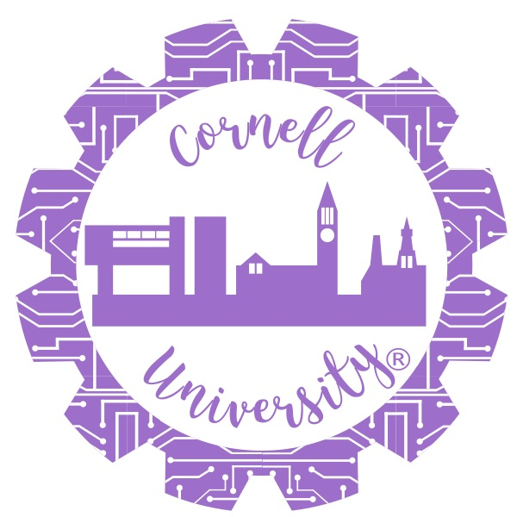

Cornell University Society of Women Engineers

Spring 2019 Committee Member Application

**Due Monday, Jan 7th at 11:59pm**

Please submit your completed application titled “lastname_firstname_committeeapp” to [presidents.cornellswe@gmail.com](mailto:presidents.cornellswe@gmail.com) with the subject line “Lastname_CommitteeApp.”

*Welcome to the Society of Women Engineers at Cornell! We are proud to grow our students through our extensive networking, professional development, outreach, and social events. We encourage leadership and teamwork at all levels and provide our members with the opportunity to take on projects with real impact. We could not have the effect on and off campus that we have without our incredible army of chairs and team leaders who ensure our events are executed well and in an impactful way. Thank you for interest in SWE!*

Please note:

* There will be a Mandatory Committee Member Training that will be set up by your directors at the end of January or beginning of February.
* All committee members are expected to attend General Body Meetings on the first Monday of every month from 4:30 - 5:30 pm (locations to be announced via SWEMail and on Facebook).
* Committee members are expected to sign-up for a [SWE National Membership](http://societyofwomenengineers.swe.org/membership/benefits-a-discounts). For only $50, you can get a 5 year, Collegiate to Career (C2C) membership that covers all of your undergraduate career as well as the first year after graduation. If purchasing a membership places a financial burden on you or your family, please email the co-Presidents, Haley Antoine (hla37@cornell.edu) and Madeline Dubelier (mrd237@cornell.edu).

All attendance conflicts should be addressed to your directors once you are assigned a position.

PERSONAL INFORMATION:

Name:

NetID (the letters and numbers before @cornell.edu in your email address):

Cell Phone Number:

Major (Intended Major if Freshman):

Graduation Year:

QUESTIONS:

1. Do you have any experience with SWE? If so, please talk about any events you have been involved in. If you have not been involved with SWE yet, please tell us how you found out about us and why you’d like to be involved in the organization.

1. Why do you want to hold a SWE leadership position? Why do you think you would make an effective SWE committee member?

1. Describe any relevant leadership experiences you have held.

1. Pick one word to describe yourself.
2. What ideas do you have for the position(s) to which you are applying?

1. What does being a part of a community of women in STEM mean to you?

Apply for as few/many positions as you’d like! Please note that Corporate Relations Liaisons require a separate application -- you can be BOTH a committee member and a liaison!

|  |  |  |
| --- | --- | --- |
| Rank | Committee Member Position | Directorship |
| 1 |  |  |
| 2 |  |  |
| 3 |  |  |
| 4 |  |  |
| 5 |  |  |

The following directorships are accepting committee members for the Spring of 2019 semester. For more information on all the SWE Directorships, check out our [website](https://swe.cornell.edu/), [Facebook](https://www.facebook.com/CornellSwe/), or [Instagram](https://www.instagram.com/swecornell/)! If you have any questions regarding a specific position, please email the directors listed below.

**COMMUNICATIONS**    Naseem Dabiran (nd378) and Nicole Wang (new45)

We’re looking to start fresh with our group of committee members this year. But if you were a Communications team member last year and would like to continue to be one, please be sure to mention it in your application!

**Alumni Relations (2)**: These committee members will be responsible for networking with alumni, planning and executing student-alumni events during occasions such as career fair, reunion, lunches, etc., updating a database of alumni, and creating a student-alumni networking and communications interface with a mentoring program. This has previously been an underdeveloped position and is ideal for individuals looking to make a huge impact on SWE. You will be working closely with the Communications directors, the Office of Alumni Affairs and of course, alumni. This position is ideal for gaining experience in creating innovative event ideas and making these ideas come to life! This position requires someone who is very passionate, comfortable interacting with alumni, a team player, organized and proactive.  (2-3 hrs/week)

**Faculty Relations (2)**: These committee members will be responsible for planning one large-scale social event per semester with the engineering faculty and students to enhance student-faculty interaction. As the organizer of this event, your responsibilities include: finding and confirming a reservation for a venue, creating invitations and contacting faculty, creating a menu and ordering the dinner, as well as dealing with financial concerns and effectively communicating with the different directorships within SWE. This is ideal for someone who is comfortable and willing to interact with faculty, student leaders, and other staff members, and it is a good opportunity to exercise your project management skills! We are looking for innovative, proactive, organized and team-oriented chairs. (2-3 hrs/week)

**General Publicity (1)**: This committee will work together closely to promote SWE events effectively on campus by creating designs for posters/quarter-cards/cover photos for social media. Another main responsibility is to go around campus postering, quarter-carding, chalking and  making invitations, etc. Each publicity team member will lead the publicity of specific events by coming up with creative ideas, but all committee members will still work as a team for door-to-door publicity of major events. If you like design, art and/or marketing, this may be the position for you! (although of course no art or design experience/skill necessary). This position is extremely important to Public Relations, so we are looking for innovative students who will honor their commitment throughout the year.  In addition, each member will be responsible in assisting and helping coordinate events with the other committees if needed.(2-3 hrs/week)

**FUNDRAISING**          Jaye Ren (jr853) and Anjali Patel (anp48)

**Fundraising Committee Members:** The fundraising directorship focuses on raising money to fund the SWE National Conference, as well as the many other events our section holds. We are seeking FIVE enthusiastic, creative, and hard-working members to help us brainstorm and organize fundraising events on campus, and reach out to company sponsors throughout to year to form partnerships. Committee members will also help sell SWE apparel during monthly Gbody meetings. In the weeks leading up to fundraising events, the time commitment will be about 1 hour a week. Otherwise, we will hold meetings as seen fit. This position is very important to SWE as a whole, so we are looking for students who will honor this commitment.

**OUTREACH:** Catherine Gurecky (ceg226) and Tracy Goldman (tag96)

**Time commitments for these positions entail meetings with other committee members and directors, shopping for supplies, and volunteering on the day of the event**

**Girl Scout Day: Brownie:** This committee is responsible for planning two one-day events for local Brownie Girl Scout Troops. Tasks include choosing a badge, planning the associated activities, working with local Girl Scout coordinator, reaching out to local GS troops, coordinating volunteers, and running the event on the day of. (Spring Semester: ~20 hours)

**Girl Scout Day: Junior:** This committee is responsible for planning two one-day events for local Junior Girl Scout Troops. Tasks include choosing a badge, planning the associated activities, working with local Girl Scout coordinator, reaching out to local GS troops, coordinating volunteers, and running the event on the day of. (Spring Semester: ~20 hours)

**Community Outreach:** This committee is responsible for coordinating a series of one-day volunteer events throughout the year. Committee will work with SWE and other engineering organizations to coordinate a variety of events. Events include activities at the Ithaca Sciencenter, STEM events at the public library, Into the Streets, working with Habitat for Humanity, etc. This committee is also encouraged to look for new outreach opportunities with Cornell and the greater Ithaca community. (Spring Semester: ~20 hours)

**Elementary School Outreach:** This committee is responsible for designing interesting, hands-on projects and coordinating volunteers to go to local elementary schools after school or during classroom time to teach children about engineering and science. This committee is also responsible for coordinating SWENext K-12 initiatives at the local elementary schools. (Spring Semester: ~15 hours)

**Middles School Outreach:** This committee is responsible for designing interesting, hands-on projects and coordinating volunteers to go to local middle schools after school or during classroom time to teach children about engineering and science. This committee is also responsible for coordinating SWENext K-12 initiatives at the local middle schools. (Spring Semester: ~15 hours)

**High School Outreach:** This committee is responsible for planning events for the high school mentorship program. Activities throughout the year are meant to introduce high school women to STEM majors and instill an interest in becoming involved in STEM activities. Committee will organize Cornell research lab visits, panels, and hands-on activities. This committee is also responsible for coordinating SWENext K-12 initiatives at the local high schools. (Spring Semester: ~20 hours)

**Campus Outreach:** This committee is responsible for planning events that increase SWE’s presence on campus. Activities will include working with other Diversity Programs in Engineering clubs (SHPE, WICC, ASME, etc) to plan socials across engineering groups and work to reduce minority stereotyping in STEM. This committee will also work closely with engineering admissions & engineering advising to promote SWE to incoming freshmen. (Spring Semester: ~15 hours)

**HeForSWE:** HeForSWE is a nationwide movement to include male students in SWE as active participants in our organization’s activities. This committee is only 1 year old, so the HeForSWE committee will work with their coordinator to design new programming to promote the goal of an inclusive environment, free of gender stereotypes, for all engineering students. Events may include photo campaigns, ice-skating socials, activities aimed towards guys’ interests at g-body meetings, etc. (Spring Semester: ~10 hours)

**STUDENT SERVICES** Liz Pizzonia (ep467) and Erica Lee (el559)

Student Services focuses on connecting SWE members, facilitating social events, and integrating SWE into the greater Cornell and Ithaca communities. The directorship is responsible for organizing general body meetings, apparel sales, and the internal mentorship program. In conjunction with the other directorships, Student Services aims to support women so they can excel academically and professionally in STEM fields. All committee positions are for the entirety of the academic year:

**Membership Chair:** Committee members will maintain attendance records from General Body meetings, networking events, and volunteer opportunities and promote membership growth and retention. Who you are: Love spreadsheets, people, and helping SWE grow!

**Mentorship Chair:** Committee members will assist and improve the existing mentorship program, match under- and upperclassmen to create mentor/mentee pairs, plan fun events that will help mentors and mentees bond, and connect with Membership Committee to keep track of the attendance at mentorship events. Who you are: Love meeting new people, planning events (and going to them!), and helping new SWE members find their place at Cornell!

**Social Chair:** Committee members will plan social events throughout the year for SWE members, help directors (and the directorship as a whole, it’s a team effort!) create awesome apparel to show off our passion for SWE, and connect with Membership Committee in order to keep track of attendance of social events. Who you are: Love creating fun events for everyone in SWE and want to help design some great apparel!

**General Body Meeting Chairs:** Committee will help directors plan monthly general body meetings by communicating with professors, companies, graduate students, etc. to come and give talks during the meetings and decide what food to serve during meetings. Who you are: Love reaching out to professors/companies and willing to form relationships that SWE can benefit from in years to come!