Technical Configuration Document
Template V0.1
27 May 2026
Project Name: | Standard User SOE on Azure Virtual Desktop
Document Owner: | Shaun Struik
Contact Details: | shaun.struik@apm.net.au
Program Name: | Standard Operating Environment Program
Division/Unit: | Digital Workplace
Document Status: | Draft - for build
Document Version: | V1.0
Product ID: | N/A

FOR INTERNAL USE ONLY
Commercial in confidence
© APM

Document control
Version History
Version | Date | Author | Key changes
V1.0 | 23/09/2026 | Shaun Struik | Initial issue.

Consultation
Name | Position title | Date

References and Derivation
Version # | Document Title | Reference Location

SDA Approval
Name | Role/Group | Signature | Date

Confidentiality & Disclaimer
This document is provided by Advanced Personnel Management International Pty Ltd and / or its related entities (APM) on a confidential basis. This document is subject to approval of the APM Board and does not constitute an offer capable of acceptance. No agreement binding APM or its related companies in respect of this document is intended or proposed unless and until the terms and conditions between APM or its related entities are agreed in writing in a formal agreement with the named Company or Prospective Client.
APM will not be bound by any pricing or any other material contained in this response until the above has taken place.
Photography
Photographs used in this document are for illustration only
and should not be interpreted to mean that any person or organisation whose assets are shown in them endorses this document.
APM Contact
Communications regarding
this document should be forwarded to:
Head of Digital Operations
Head of Product Development
P 08 XXXX XXXX
M 08 XXXX XXXX
E Leah.Brenton@apm.net.au
E Michael.Barker@apm.net.au

Contents
1. Introduction 8
1.1 Background 8
1.2 Purpose 8
1.2 Audience 8
2. Overview 9
2.1 Scope 9
2.2 Systems Impacted 9
2.3 Constraints, Assumptions, Dependencies and Risks 9
2.3.1 Constraints 9
2.3.2 Assumptions 9
2.3.3 Dependencies 10
2.3.4 Risks 10
2.4 Business requirement traceability matrix 10
2.4.1 Functional Requirements Validation 10
2.4.2 Non-Functional Requirements Validation 10
4. Solution Design 10
4.1 Solution Overview 11
4.2 Solution/Product Component Inventory 11
4.3 Detailed Solution Interface Diagram 11
4.4 Solution/Product Interface catalogue 11
5. Technology Architecture 11
5.1 Technology Component Standards 12
5.2 Network & Infrastructure Standards & Patterns 12
6. Infrastructure Overview 13
6.1 Network and Firewall Specifications 13
6.1.1Network Communications Diagram 13
6.1.2 IP Addressing 13
6.1.3 DNS Information 14
6.1.4 Load Balancing Specification 14
6.1.5 NAT Rules 15
6.1.6 Firewall Rules 15
7. Database Specification 16
7.1 IaaS 16
7.1.1 Hosting 16
7.2 PaaS 16
7.1.2 Hosting 16
8. Compute Specifications 17
8.1 On-Prem – Virtual 17
8.2 On-Prem – Physical 17
8.3 Azure 18
9. PaaS Specification 18
10. Information & Data Architecture 19
10.1 Information Model 19
10.2 Information Classification 19
10.3 Analytics and reporting Patterns 19
11. Cyber & Security Architecture 19
11.1 Data Security 19
11.2 RBAC Specification 19
11.2.1 Application Roles 19
11.2.2 Local Groups 19
11.2.3 Active Directory Groups 20
11.2.4 Azure Active Directory Groups 20
11.3 Accounts 20
11.3.1 Service Accounts 20
11.3.2 Shared Accounts 21
11.4 Authentication 21
11.4.1 Authentication Requirements 21
11.4.2 Conditional Access Rules 21
11.5 IDP Specification 21
11.5.1 Azure AD 22
11.5.2 ADFS 22
11.6 Authentication Specification 22
11.6.1 Integrated 22
11.6.2 LDAP 22
11.6.3 SAML 22
12. Threat Management 23
12.1 Endpoint Protection & Antivirus 23
12.1.1 Antivirus Exclusions 23
12.2 DNS 23
12.3 Logging 23
12.4 Monitoring 23
12.5 NTP 24
12.6 Patching 24
12.7 PKI 24
12.7.1 Certificate Authority 24
12.7.2 Certificates 24
12.8 SMTP 24
13. Disaster Recovery 24
13.1 RPO and RTO 25
13.2 Backup Specification 25
13.3 Restore Specification 25
13.3.1 <Component> 25
13.4 Disaster Recovery and Business Continuity 25
14 Build, Test and Release Management 25
14.1 Repository and Devops Tools 25
14.1.1 Repository and change management 25
14.1.2 Build Tool 25
14.1.3 Monitoring Tool 25
14.2 Pipeline Management 25
14.2.1 Environmental management 25
14.2.2 Naming Convention 25
14.2.3 Code Review and Release Management 26
14.2.4 Access Control: RBAC via GitHub Teams 26
14.3 Test Management 26
14.3.1 Test Strategy/Plan 26
14.3.2 Test Tool sets 26
14.3.3 Test Data Management 26
14.4 Security & Compliance 26
14.4.1 Code Scanning 26
14.4.2 Secrets Management 26
15 Capacity Planning 26
15.1 On-Prem – Virtual 26
15.1.1 Storage 26
15.1.2 Compute 26
15.1.3 Memory 26
15.2 On-Prem – Physical 26
15.2.1 Storage – Local 26
15.2.2 Storage – SAN 27
15.2.3 Compute 27
15.2.4 Memory 27
15.3 Azure 27
15.3.1 Compute 27
15.3.2 Storage – Machine 27
15.3.3 Storage – as a Service 28
16. Service Management 28

1. Introduction

1.1 Background
This Technical Configuration Document is the build specification for the Standard User SOE on Azure Virtual Desktop. It is the companion to the Standard User SOE on AVD Detail Design Document V1.5, which holds the architecture, the decisions and the risk position. Where the two differ, the Detail Design Document is authoritative.
Section references written as "DDD" followed by a number point into the Detail Design Document. Every other section reference points into this document.

1.2 Purpose
This document specifies every Azure, Nerdio, Intune, Entra ID and Zscaler object the solution creates, the value of every setting, the order they are built in, and the tests that must pass before production. An engineer builds the solution from this document in the order it is written.

1.3 Audience
Role | Uses this document to
APM AVD Build Engineer | Build the spoke, the image, the host pool, the Intune objects and the Zscaler components in the order in 4.5 Build Sequence
APM Network Management | Create the spoke network objects in 6.1 Network and Firewall Specifications and the hub firewall rules in 6.1.6 Firewall Rules
APM Cyber Security | Create CA-210 and the session host exclusions in 11.4.2 Conditional Access Rules, confirm the Zscaler tenant configuration, and approve the pilot result
Digital Operations | Run the test plan in 14.3.1 Test Strategy/Plan and accept the service
EUC Team | Create the application assignment groups in 4.5.6.1 Application groups, and validate the compliance policy and configuration profiles in 4.5.6.2 Compliance policy validation and 4.5.6.3 Configuration profile validation

2. Overview

2.1 Scope
In scope. The AVD spoke network and its hub-side changes, the profile and App Attach storage, the Compute Gallery and golden image, the host pool, workspace and application groups in Nerdio Manager for Enterprise, the session host Intune objects, CA-210 and the session host exclusion on two existing Conditional Access policies, Zscaler Client Connector for VDI and the Zscaler Cloud Connector pair, and the pre-production test plan.
Out of scope. The landing zone platform, the hub firewall build, the Nerdio Manager platform itself, the existing thick client SOE policies (assigned unchanged, DDD 7), and the test environment build in DDD Appendix B.

2.2 Systems Impacted
System | Impact | Change
Azure landing zone, aus-sub-avd-controlled-001 | New | Spoke virtual network, four subnets, four network security groups, one route table, two private endpoints, two storage accounts, a Compute Gallery and the Cloud Connector virtual machines
Hub, aus-sub-connectivity | Modify | Spoke peering, a return route to 10.40.90.0/23, and the firewall rules in 6.1.6 Firewall Rules
Nerdio Manager for Enterprise | Modify | One host pool, one workspace, two desktop application groups, one validation pool
Microsoft Intune | Modify | One compliance policy and seven configuration profiles. Session hosts join the inherited thick client policy set
Microsoft Entra ID | Modify | Seven security groups, one new Conditional Access policy (CA-210), and a device filter exclusion on two existing policies
Zscaler | Modify | Client Connector for VDI enabled on the tenant; a VDI group, VDI template and VDI forwarding profile; a Cloud Connector group

2.3 Constraints, Assumptions, Dependencies and Risks

2.3.1 Constraints
Constraint | Effect on the build
Landing zone forced tunnel | Every spoke subnet takes 0.0.0.0/0 to the hub firewall. No public IP address and no NAT Gateway in the spoke
Zscaler Client Connector supports one user session per host | The standard agent is not installed. Zscaler Client Connector for VDI is the agent on every session host
Session hosts are Entra ID joined | No domain join step, no domain controller reachability, no ADFS
Every new spoke object is instance 002 | The 001 instance of each name is already in use

2.3.2 Assumptions
As DDD 2.3. No assumption is added by this document.

2.3.3 Dependencies
ID | Dependency | Blocks
DEP-01 | Zscaler Support enables Client Connector for VDI on the tenant and the tunnel ports are recorded (DDD G-10) | 4.5.8 Phase 8 - Zscaler, and the port values in 6.1.6 Firewall Rules
DEP-02 | Network Management confirms auea-snet-avd-ctrl-zscc-002 at 10.40.91.64/26 (DDD G-11) | 4.5.2 Phase 2 - Spoke network, 4.5.8 Phase 8 - Zscaler
DEP-03 | The mapped network drive back end is recorded (DDD G-01) | Conditional forwarding in 6.1.3 DNS Information and test T-16
DEP-04 | The staff SOE application and desktop definitions are supplied (DDD G-08) | The image application list and two profiles in 4.5.6 Phase 6 - Intune objects
DEP-05 | The print mechanism is chosen (DDD G-09) | Test T-17
DEP-06 | CA-210 is confirmed unused in the tenant, and Cyber Security confirms the two points in 11.4.2 Conditional Access Rules (DDD G-12) | 4.5.7 Phase 7 - Conditional Access
DEP-07 | Session host size and users per host are fixed at the end of the pilot (DDD G-06) | Production scaling in 8. Compute Specifications

Phases 1 and 2 of 4.5 Build Sequence are prerequisites for every later phase.

2.3.4 Risks
The risk register is DDD 7. Build-order risks:
Risk | Control in this build
The session host exclusion is added after the first host is provisioned, so Microsoft 365 fails in the first sessions | The exclusion is added in 4.5.7 Phase 7 - Conditional Access, before any user signs in
The profile container does not mount under the enforced policy set | T-15 proves the mount on a host carrying the full inherited policy set

2.4 Business Requirement Traceability Matrix

2.4.1 Functional Requirements Validation
Requirement | Built by | Proven by
BR-01 | 4.5.5 Phase 5 - Host pool | T-01, T-03
BR-03 | 4.5.7 Phase 7 - Conditional Access, 11.4.2 Conditional Access Rules | T-09
BR-04 | 4.5.3 Phase 3 - Storage, 4.5.6 Phase 6 - Intune objects | T-03, T-04
BR-05 | 4.5.4 Phase 4 - Golden image | T-05, T-06
BR-06 | 6.1.3 DNS Information | T-16
BR-07 | DEP-05 | T-17
BR-08 | 11.1 Data Security | T-07, T-08
BR-09 | 4.5.5 Phase 5 - Host pool | T-12
BR-13 | 6.1.6 Firewall Rules | T-18
BR-14 | 4.5.4 Phase 4 - Golden image | T-13

2.4.2 Non-Functional Requirements Validation
Requirement | Built by | Proven by
BR-02 | 4.5.6 Phase 6 - Intune objects, 12.1 Endpoint Protection &amp; Antivirus | T-02, T-11
BR-10 | 4.5.5 Phase 5 - Host pool | T-13
BR-11 | 16. Service Management | T-14
BR-12 | 4.5.6 Phase 6 - Intune objects, 12.1 Endpoint Protection &amp; Antivirus | T-02, T-11, T-19

4. Solution Design

4.1 Solution Overview
Users reach a pooled Windows 11 Enterprise multi-session desktop through the Windows App. Session hosts are built from a golden image in the Compute Gallery, provisioned and scaled by Nerdio, Entra ID joined and Intune managed, and hold each user's profile in an FSLogix container on Azure Files Premium. Web traffic from each user session is tunnelled by Zscaler Client Connector for VDI to a Zscaler Cloud Connector pair in the spoke. All spoke egress is forced to the hub firewall. The architecture is in DDD 4 and DDD 5.

4.2 Solution/Product Component Inventory
Component | Built in
Spoke virtual network, subnets, network security groups, route table | 4.5.2 Phase 2 - Spoke network, values in 6.1 Network and Firewall Specifications
Profile and App Attach storage, private endpoints | 4.5.3 Phase 3 - Storage, values in 9. PaaS Specification
Compute Gallery and golden image | 4.5.4 Phase 4 - Golden image
Host pool, workspace, application groups | 4.5.5 Phase 5 - Host pool
Compliance policy and seven configuration profiles | 4.5.6 Phase 6 - Intune objects
CA-210 and the session host exclusions | 4.5.7 Phase 7 - Conditional Access, values in 11.4.2 Conditional Access Rules
Zscaler Client Connector for VDI and Cloud Connector | 4.5.8 Phase 8 - Zscaler

4.3 Detailed Solution Interface Diagram
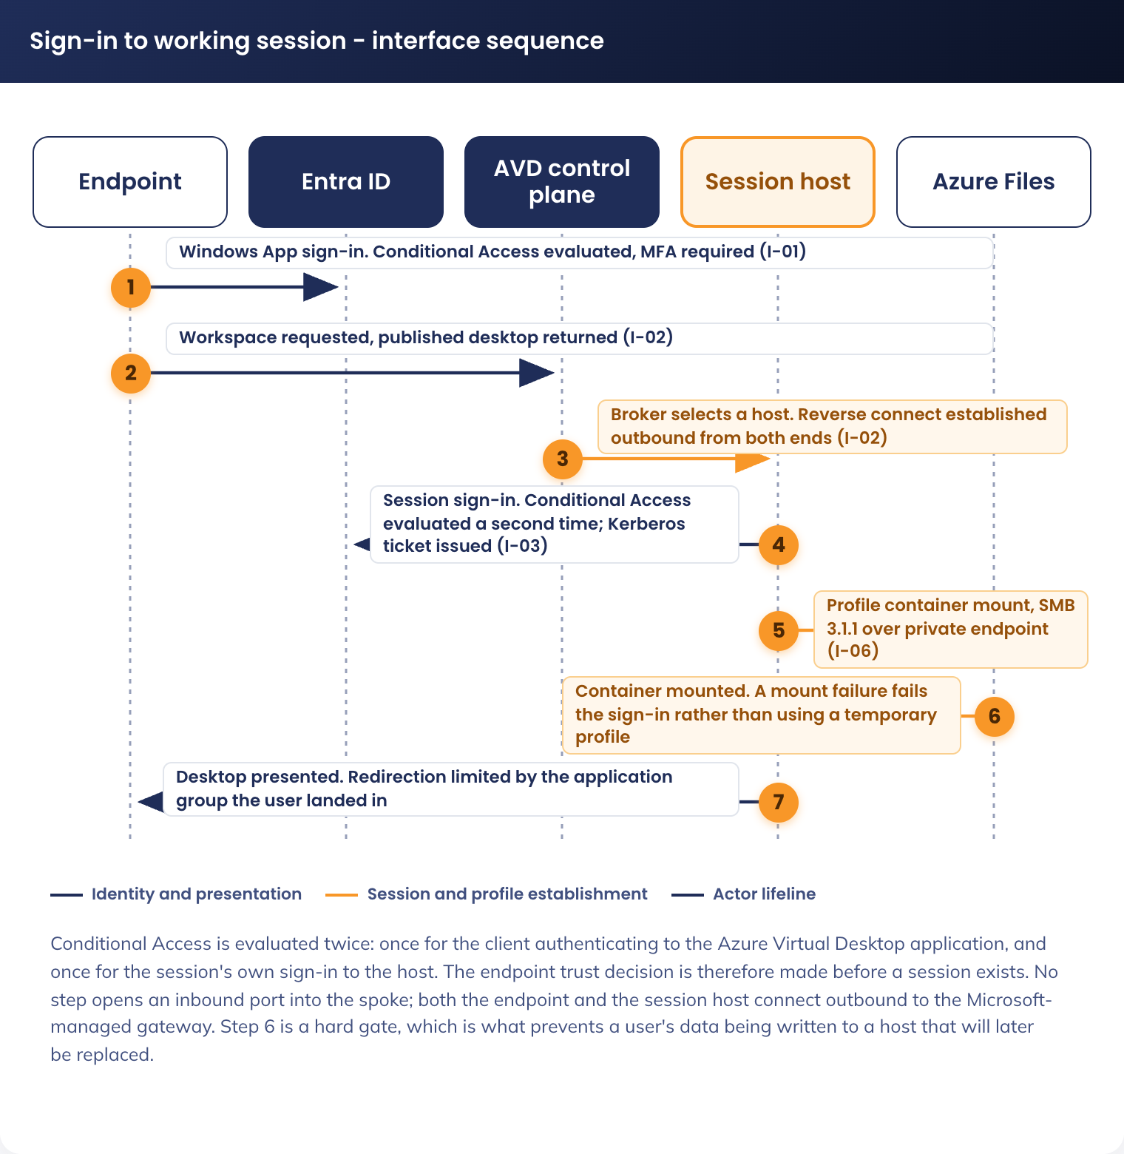
Figure 1. Sign-in to working session - interface sequence

4.4 Solution/Product Interface Catalogue
The interface catalogue is DDD 4.4. The ports each interface uses are in 6.1.6 Firewall Rules.

4.5 Build Sequence
Build in this order. Each phase depends on the one before it.

4.5.1 Phase 1 - Identity groups and estate exclusions
1. Entra admin centre > Groups > New group. Create the groups in 11.2.4 Azure Active Directory Groups with the type and membership shown there
2. Intune admin centre > Devices > Compliance > Staff-Windows-Compliance-Policy > Properties > Assignments > Exclude > Add group. Add sg-dyn-dvc-avd-session-hosts. It is replaced by AVD-W11-COM-Session Host-P-1.0 in 4.5.6 Phase 6 - Intune objects
3. Assign the 11 inherited thick client policies to sg-dyn-dvc-avd-session-hosts unchanged. The list is DDD 7
4. Intune admin centre > Devices > Windows > Update rings for Windows 10 and later > [each ring] > Properties > Assignments > Exclude > Add group. Add sg-dyn-dvc-avd-session-hosts to each estate ring: [ring names to be confirmed]
5. Exclude sg-dyn-dvc-avd-session-hosts from the estate Windows Autopatch groups [group names to be confirmed, or not used] and from the Patch My PC published application assignments [assignments to be confirmed]. Session hosts are updated by image replacement only (14.1.1 Image update cycle)

4.5.2 Phase 2 - Spoke network
1. Azure portal > Virtual networks > Create. Subscription aus-sub-avd-controlled-001, region Australia East, name auea-vnet-avd-ctrl-002, address space 10.40.90.0/23
2. Create the four subnets in 6.1.2 IP Addressing. Enable private endpoint network policies on auea-snet-avd-ctrl-avdpe-002
3. Azure portal > Network security groups > Create. Create the four groups in 6.1.6 Firewall Rules and associate each to its subnet
4. Azure portal > Route tables > Create. Create auea-rt-avd-ctrl-002 with the route and settings in 6.1.2 IP Addressing, and associate it to all four subnets
5. Azure portal > auea-vnet-avd-ctrl-002 > Peerings > Add. Peer to auea-vnet-connectivity-001. Gateway transit disabled, use remote gateways disabled
6. APM Network Management adds the return route to 10.40.90.0/23 on the hub side and the firewall rules in 6.1.6 Firewall Rules
7. Link privatelink.file.core.windows.net to auea-vnet-avd-ctrl-002 from the connectivity subscription (6.1.3 DNS Information)

4.5.3 Phase 3 - Storage
1. Azure portal > Storage accounts > Create. Create aestacfslogix001 and aestacappattach001 with the settings in 9. PaaS Specification
2. Create the private endpoint for each in auea-snet-avd-ctrl-avdpe-002, named auea-pep-avd-ctrl-fslogix-002 and auea-pep-avd-ctrl-appattach-002. Disable public network access on both accounts
3. Enable Microsoft Entra Kerberos authentication on aestacfslogix001, and grant sg-stc-usr-avd-standard-user the share-level role in 9. PaaS Specification

4.5.4 Phase 4 - Golden image
1. Azure portal > Azure compute galleries > Create. Create aegalacstaff001 and the image definition auea-img-avd-ctrl-w11ms-002
2. Build the image on a virtual machine in auea-snet-avd-ctrl-avdbuild-002 with the components in 8. Compute Specifications. Do not enrol Zscaler Client Connector for VDI on the build virtual machine
3. Capture the image as version 1.0.0 in the gallery. Write access is limited to sg-stc-usr-avd-image-builders

4.5.5 Phase 5 - Host pool
1. Nerdio Manager for Enterprise, host pool creation. Create auea-avdhp-avd-ctrl-staff-002 with the settings in 8. Compute Specifications, hosts in auea-snet-avd-ctrl-avdhosts-002, VM name prefix aevmacstd
2. Create the workspace auea-avdws-avd-ctrl-staff-002 and the application groups auea-avdag-avd-ctrl-staff-managed-002 and auea-avdag-avd-ctrl-staff-unmanaged-002. Assign sg-stc-usr-avd-desktop-managed and sg-stc-usr-avd-desktop-unmanaged respectively
3. Set the RDP properties of each application group per 11.1 Data Security
4. Create the validation pool on the same image definition

4.5.6 Phase 6 - Intune objects
Owner: EUC Team. Every object is assigned to sg-stc-dvc-avd-session-hosts-ring1 first and extended to sg-dyn-dvc-avd-session-hosts in 4.5.9 Phase 9 - Pilot, enforce, release.
1. Intune admin centre > Devices > Compliance > Create policy > Windows 10 and later. Create AVD-W11-COM-Session Host-P-1.0 with the settings in 4.5.6.2 Compliance policy validation
2. Intune admin centre > Devices > Configuration > Create > Settings catalog. Create the seven profiles in 11.3 Accounts
3. Create AVD-W11-CFG-Defender-P-1.0 with the values in 12.1 Endpoint Protection &amp; Antivirus
4. Create the application assignment groups and assign the applications in 4.5.6.1 Application groups

4.5.6.1 Application groups
Entra admin centre > Groups > New group, then Intune admin centre > Apps > Windows > [application] > Properties > Assignments > Required > Add group. Microsoft 365 Apps, Teams, OneDrive and Edge are in the image and take no assignment.
Application | Delivery | Assignment group | Assignment | Source
[Application name] | [MSIX App Attach or Intune Win32] | [sg-stc-dvc-avd-app-[name]] | Required | DDD G-08
[Application name] | [MSIX App Attach or Intune Win32] | [sg-stc-dvc-avd-app-[name]] | Required | DDD G-08

4.5.6.2 Compliance policy validation
AVD-W11-COM-Session Host-P-1.0. Validate each value on a ring 1 host under Intune admin centre > Devices > [host] > Device compliance.
Setting | Value | Validated | Date
BitLocker | Not required (DDD SOE-02). [Disk encryption at rest for session hosts, to be confirmed] | [Name] | [Date]
Secure Boot | [Require, to be confirmed] | [Name] | [Date]
Code integrity | [Require, to be confirmed] | [Name] | [Date]
Minimum OS version | [Build number, DDD G-05] | [Name] | [Date]
Microsoft Defender Antimalware | [Require, to be confirmed] | [Name] | [Date]
Real-time protection | Require | [Name] | [Date]
Firewall | [Require, to be confirmed] | [Name] | [Date]
Device threat level (Defender for Endpoint) | [Value to be confirmed] | [Name] | [Date]
Actions for noncompliance | [Mark noncompliant after N days, to be confirmed] | [Name] | [Date]

4.5.6.3 Configuration profile validation
Validate each profile on a ring 1 host under Intune admin centre > Devices > [host] > Device configuration. A profile passes when it reports Succeeded with no conflicting setting.
Profile | Expected state | Validated | Date
AVD-W11-CFG-FSLogix Profile-P-1.0 | Succeeded | [Name] | [Date]
AVD-W11-CFG-Session Time Limits-P-1.0 | Succeeded | [Name] | [Date]
AVD-W11-CFG-Multi-Session Host-P-1.0 | Succeeded | [Name] | [Date]
AVD-W11-CFG-Desktop Branding-P-1.0 | Succeeded | [Name] | [Date]
AVD-W11-CFG-Edge Configuration-P-1.0 | Succeeded | [Name] | [Date]
AVD-W11-CFG-Defender-P-1.0 | Succeeded | [Name] | [Date]
The 11 inherited thick client policies | Succeeded, or Not applicable for DDD SOE-01 to SOE-05 only (T-02) | [Name] | [Date]

4.5.7 Phase 7 - Conditional Access
1. Confirm DEP-06 is closed
2. Entra admin centre > Protection > Conditional Access > Create new policy. Create CA-210 with the values in 11.4.2 Conditional Access Rules, state Report-only
3. Entra admin centre > Protection > Conditional Access > AllUsers_Office365_DeviceRequired > Conditions > Filter for devices > Exclude. Enter the rule in 11.4.2 Conditional Access Rules. Repeat on AllUsers_Sharepoint_DeviceRequired
4. Set CA-210 to On in the same change as the two exclusions, so no session host is ever outside both

4.5.8 Phase 8 - Zscaler
1. Confirm DEP-01 is closed and the tunnel ports are recorded in 6.1.6 Firewall Rules
2. Zscaler Admin Console > Infrastructure > Client Connector > App Store for VDI. Download the 64-bit MSI and add it to the golden image as a new image version
3. Deploy the Cloud Connector pair into auea-snet-avd-ctrl-zscc-002, then create the VDI group for the host pool, the VDI template and the VDI forwarding profile in the Zscaler Admin Console
4. Add the Defender exclusions and App Control allowances for the Client Connector for VDI processes in 12.1 Endpoint Protection &amp; Antivirus

4.5.9 Phase 9 - Pilot, enforce, release
1. Provision the pilot on sg-stc-dvc-avd-session-hosts-ring1 and run every test in 14.3.1 Test Strategy/Plan
2. When every test passes, extend the entitlement group from the pilot users to the full user population
3. Extend the Intune profile assignments from the ring 1 group to sg-dyn-dvc-avd-session-hosts, and reimage the production pool from the validated image version by drain mode

5. Technology Architecture

5.1 Technology Component Standards
Component standards and the naming convention are DDD 5.1. Every object name in this document is resolved in full from that convention.

5.2 Network & Infrastructure Standards & Patterns
The network pattern is DDD 5.3. The values are in 6.1 Network and Firewall Specifications.

6. Infrastructure Overview
All network objects are in aus-sub-avd-controlled-001, Australia East, except where a row names the hub.

6.1 Network and Firewall Specifications

6.1.1 Network Communications Diagram
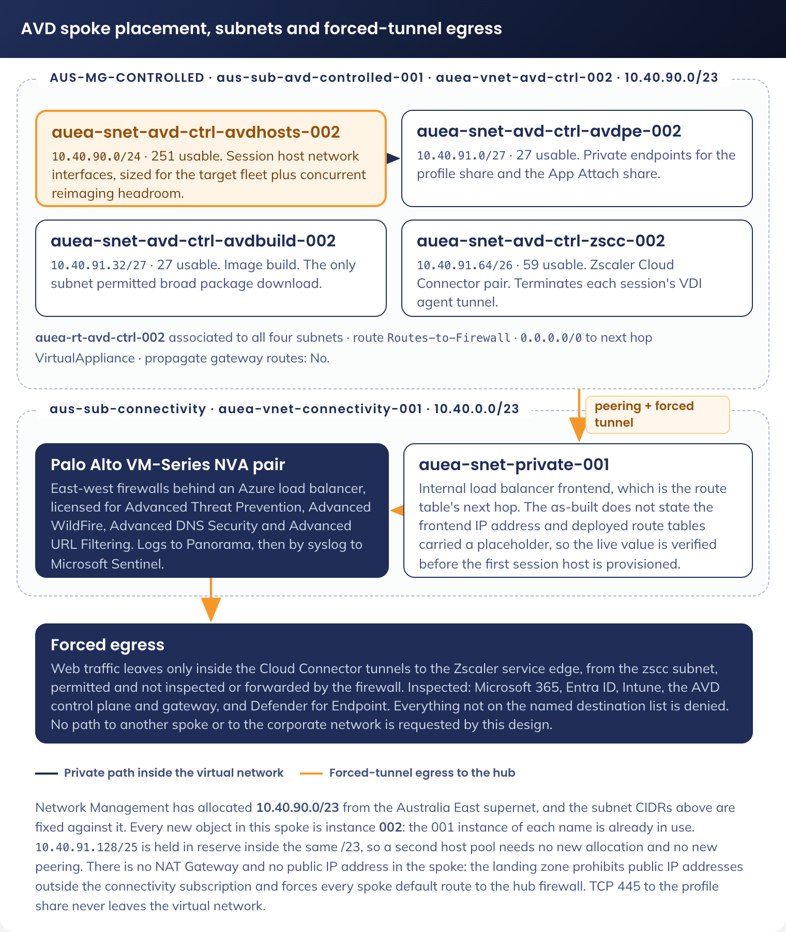
Figure 2. AVD spoke, subnet plan and forced tunnel egress

6.1.2 IP Addressing
Virtual network auea-vnet-avd-ctrl-002, address space 10.40.90.0/23, allocated by APM Network Management.
Subnet | CIDR | Usable | Purpose
auea-snet-avd-ctrl-avdhosts-002 | 10.40.90.0/24 | 251 | Session host network interfaces. Sized for the target fleet plus concurrent reimaging
auea-snet-avd-ctrl-avdpe-002 | 10.40.91.0/27 | 27 | Private endpoints for the profile share and the App Attach share
auea-snet-avd-ctrl-avdbuild-002 | 10.40.91.32/27 | 27 | Image build. The only subnet permitted broad package download
auea-snet-avd-ctrl-zscc-002 | 10.40.91.64/26 | 59 | Zscaler Cloud Connector management and service interfaces (DEP-02)
Reserved | 10.40.91.128/25 | - | Held for a second host pool or a personal desktop pool

Five addresses per subnet are reserved by Azure and are excluded from the usable counts.
Route name | Prefix | Next hop type | Next hop address
Routes-to-Firewall | 0.0.0.0/0 | Virtual appliance | The internal load balancer frontend in auea-snet-private-001, fronting the east-west firewall backend pool. Verify the live frontend IP address before the first host is provisioned

Route table setting | Value
Name | auea-rt-avd-ctrl-002
Propagate gateway routes | Disabled
Subnet associations | All four subnets above

The hub route table carries a return route to 10.40.90.0/23. Private endpoint traffic stays inside the virtual network and does not follow the default route.

6.1.3 DNS Information
Item | Value
Resolver for session hosts | Azure-provided DNS in the spoke
Private DNS zones | privatelink.file.core.windows.net, linked from the connectivity subscription. Records are created by the private endpoints
Public name resolution | Forwarded by the platform resolver. No custom DNS server in the spoke
Conditional forwarding to on-premises | Only if DEP-03 resolves to an on-premises file server

6.1.4 Load Balancing Specification
No load balancer is created in the spoke. The route table next hop is the existing hub internal load balancer in 6.1.2 IP Addressing. Session load balancing is breadth-first in the host pool (8. Compute Specifications).

6.1.5 NAT Rules
N/A. The spoke has no NAT Gateway and no public IP address.

6.1.6 Firewall Rules
Full firewall and routing connectivity requirements are in Std AVD FW and NSG Connectivity Requirements v0.1.xlsx.
Network security groups.
Network security group | Inbound | Outbound | Note
auea-nsg-avd-ctrl-avdhosts-002 | Deny all inbound from the internet. Allow intra-virtual-network | Allow HTTPS to the AVD, Entra, Intune and Defender service tags. Allow SMB 445 to the avdpe subnet only. Allow the VDI agent tunnel ports to the zscc subnet only | No inbound rule is needed for session traffic. Reverse connect is outbound
auea-nsg-avd-ctrl-avdpe-002 | Allow SMB 445 from the avdhosts and avdbuild subnets | Deny all outbound to the internet | Private endpoint subnet
auea-nsg-avd-ctrl-avdbuild-002 | Deny all inbound from the internet | Allow HTTPS to Windows Update, the Microsoft CDN and the image package sources | Broad download is permitted here and nowhere else
auea-nsg-avd-ctrl-zscc-002 | Allow the VDI agent tunnel ports from the avdhosts subnet only. Deny all inbound from the internet | Allow the Zscaler service edge ports to the hub firewall | No other source reaches it

The VDI agent tunnel ports and the Zscaler service edge ports are recorded here when DEP-01 closes. Until then, no rule referencing them is created.
Hub firewall, permitted egress from the AVD spoke. Any destination not listed is denied and the denial is logged.
Destination | Source subnet | Note
Azure Virtual Desktop service tag | avdhosts | Agent registration, brokering and diagnostics
Entra ID and Microsoft Intune endpoints | avdhosts, avdbuild | Device join, token issue and policy channel
Microsoft 365 optimise and allow endpoints | avdhosts | Exchange Online, SharePoint Online, OneDrive, Teams signalling and Graph
Microsoft Defender for Endpoint endpoints | avdhosts | Detection and vulnerability telemetry
Zscaler service edge | zscc only | Cloud Connector tunnels. Permitted and not inspected. The firewall does not forward AVD spoke traffic over its own Zscaler tunnels
Windows Update and the Microsoft CDN | avdbuild only | Image build

7. Database Specification
N/A. The solution creates no database.

8. Compute Specifications
Item | Value
Host pool | auea-avdhp-avd-ctrl-staff-002, pooled, breadth-first load balancing
Session host image | auea-img-avd-ctrl-w11ms-002, Windows 11 Enterprise multi-session
Session host SKU and users per host | Fixed at the end of the pilot (DEP-07)
Availability zones | Hosts distributed across the three Australia East zones
Auto-scale | Nerdio dynamic auto-scale on active session count, with a working-hours minimum and an out-of-hours floor
Session limits | Idle disconnect at 1 hour, disconnected sign-out at 4 hours, active session limit not set. Delivered by AVD-W11-CFG-Session Time Limits-P-1.0
Image contents | Microsoft 365 Apps with shared computer activation, Teams with AVD media optimisation, OneDrive, Edge, FSLogix agent, AVD agents, Defender for Endpoint onboarding, Zscaler Client Connector for VDI, and the line-of-business set from DEP-04
Cloud Connector | A pair of Zscaler Cloud Connector virtual machines in auea-snet-avd-ctrl-zscc-002. Size set under DEP-02

9. PaaS Specification
Item | Value
aestacfslogix001 | Azure Files Premium. FSLogix profile containers, VHDX, one per user. Microsoft Entra Kerberos. Public network access disabled. sg-stc-usr-avd-standard-user holds Storage File Data SMB Share Contributor on the profile share
aestacappattach001 | Azure Files Premium. MSIX App Attach packages. Public network access disabled
aegalacstaff001 | Azure Compute Gallery holding auea-img-avd-ctrl-w11ms-002
AVD control plane | auea-avdws-avd-ctrl-staff-002 and the two application groups in 4.5.5 Phase 5 - Host pool

10. Information & Data Architecture
N/A. The information model is DDD 6.

11. Cyber & Security Architecture

11.1 Data Security
Redirection | Managed endpoint | Unmanaged endpoint
Clipboard | Both directions | Disabled
Drive | Disabled | Disabled
Printer | Disabled. Printing is from the session host (DEP-05) | Disabled
Camera and microphone | Enabled | Enabled
USB device | Disabled | Disabled

11.2 RBAC Specification

11.2.4 Azure Active Directory Groups
Group | Type | Membership and use
sg-dyn-dvc-avd-session-hosts | Dynamic device | Session host name prefix aevmacstd and Entra ID join type. Production policy target
sg-stc-dvc-avd-session-hosts-ring1 | Assigned device | Pilot hosts. Policy and image changes land here first
sg-stc-usr-avd-standard-user | Assigned user | AVD entitlement and profile share access
sg-stc-usr-avd-desktop-managed | Assigned user | Managed endpoint desktop application group
sg-stc-usr-avd-desktop-unmanaged | Assigned user | Unmanaged endpoint desktop application group
sg-stc-usr-avd-operators | Assigned user | Nerdio and host pool operational access
sg-stc-usr-avd-image-builders | Assigned user | Write access to aegalacstaff001

11.3 Accounts
No account is created by this build. The seven Intune configuration profiles are listed here for the build in 4.5.6 Phase 6 - Intune objects.
Profile | Contents
AVD-W11-CFG-FSLogix Profile-P-1.0 | Profile container path on aestacfslogix001, size, redirections, fail closed, CloudKerberosTicketRetrievalEnabled
AVD-W11-CFG-Session Time Limits-P-1.0 | Idle disconnect 1 hour, disconnected sign-out 4 hours, active session limit not set
AVD-W11-CFG-Multi-Session Host-P-1.0 | Per-user Windows Search index, Teams optimisation, time zone redirection
AVD-W11-CFG-Desktop Branding-P-1.0 | Desktop and lock screen image by local path, Start and taskbar layout, first sign-in prompts suppressed (DEP-04)
AVD-W11-CFG-Edge Configuration-P-1.0 | Managed favourites, homepage, start-up behaviour, new tab page (DEP-04). Sets no security key
AVD-W11-CFG-Defender-P-1.0 | Scan model and exclusions in 12.1 Endpoint Protection &amp; Antivirus
AVD-W11-COM-Session Host-P-1.0 | Compliance policy for session hosts

11.4 Authentication

11.4.2 Conditional Access Rules
Six policies apply to the AVD channel: five existing enforced policies and CA-210, which is created. The existing policies apply unchanged, except for the session host exclusion on the two hybrid-only grants.
Policy | Effect on this solution
AllUsers_WVDApp_MFAtimeout | Existing. All users, the Azure Virtual Desktop application. Multi-factor authentication at session start
AllUsers_AllAccess_DeviceRequired | Existing. All users, all apps. Compliant or hybrid joined device. Blocks an unmanaged endpoint from Microsoft 365 directly. A session host satisfies it
CA-102 - All Users & Guests - All Apps - Locations exc. AU, Corporate - Block | Existing. Blocks sign-in from outside Australia and the corporate locations
AllUsers_Office365_DeviceRequired | Existing. Office 365, hybrid joined device only. Session hosts excluded below
AllUsers_Sharepoint_DeviceRequired | Existing. SharePoint Online, hybrid joined device only. Session hosts excluded below
CA-210 - Org Users - Microsoft 365 - AVD Session Hosts - Allow - Require MFA and Compliant Device | New. Replaces the two hybrid-only grants for session hosts

CA-210 - Org Users - Microsoft 365 - AVD Session Hosts - Allow - Require MFA and Compliant Device.
Setting | Value
Users, include | sg-stc-usr-avd-standard-user
Users, exclude | The two tenant emergency access accounts
Target resources | Office 365
Conditions > Filter for devices | Include filtered devices: device.displayName -startsWith "aevmacstd" -and device.trustType -eq "AzureAD" -and device.isCompliant -eq True
Grant | Grant access. Require multi-factor authentication and Require device to be marked as compliant. For multiple controls: Require all the selected controls
Session | Not configured
State | Report-only at creation, then On in the same change as the exclusions below

Session host exclusion, added to AllUsers_Office365_DeviceRequired and AllUsers_Sharepoint_DeviceRequired:
Setting | Value
Conditions > Filter for devices | Exclude filtered devices: device.displayName -startsWith "aevmacstd" -and device.trustType -eq "AzureAD" -and device.isCompliant -eq True

The exclusion and the CA-210 inclusion use the identical rule, so every device excluded from the two hybrid-only grants is required to present multi-factor authentication and a compliant state instead.
Two points confirmed by Cyber Security before the build (DEP-06). AllUsers_AllAccess_DeviceRequired excludes the Azure Virtual Desktop application, or an unmanaged endpoint is refused the session. The grant in AllUsers_WVDApp_MFAtimeout is multi-factor authentication or a managed device, not all of them, or an unmanaged endpoint cannot start a session. The existing administrator policies AdminAccounts_WVD_DomainDevice and CA-404 target the same application and do not apply to sg-stc-usr-avd-standard-user.

11.5 IDP Specification
Microsoft Entra ID is the identity provider for session sign-in, Conditional Access and Azure Files. Zscaler Client Connector for VDI authenticates the signed-in user against the existing Zscaler tenant identity provider configuration.

12. Threat Management

12.1 Endpoint Protection & Antivirus
AVD-W11-CFG-Defender-P-1.0, scan settings.
Setting | Value
Real-time protection, on-access scanning | Enabled
Scheduled quick scan | Disabled
Scheduled full scan | Disabled
Catch-up scans | Disabled
Cloud-delivered protection and sample submission | Enabled

Exclusions.
Exclusion | Type
Profile share VHDX and VHD files on the aestacfslogix001 share path | Path
App Attach share VHDX files on the aestacappattach001 share path | Path
%ProgramData%\FSLogix\Cache and %ProgramData%\FSLogix\Proxy VHD and VHDX files | Path
%TEMP% and %Windir%\Temp VHD and VHDX files | Path
frxdrv.sys, frxdrvvt.sys, frxccd.sys under the FSLogix install folder | Path
frxccd.exe, frxccds.exe, frxsvc.exe, frxrobocopy.exe | Process
%ProgramData%\ZCCVDI | Path
ZCCVDIService, ZCCVDIHelper, ZCCVDIUI and the ZCCVDI executable | Process

The share paths are fixed when the storage accounts are created in 4.5.3 Phase 3 - Storage. No user data path, application folder or download location is excluded. The Zscaler Client Connector for VDI processes are also allowed in App Control for Business.

13. Disaster Recovery
Recovery of a failed image is a drain-mode reimage to the previous gallery version, proven by T-13. The disaster recovery position is DDD 8.3.

14 Build, Test and Release Management

14.1 Repository and DevOps Tools

14.1.1 Image update cycle
Session hosts are updated by image replacement only. No Windows Update ring, Autopatch group or Patch My PC assignment applies to them (4.5.1 Phase 1 - Identity groups and estate exclusions).
Step | Action
1. Build | New image version on a virtual machine in auea-snet-avd-ctrl-avdbuild-002 with the current cumulative update, Microsoft 365 Apps, Edge, Defender platform and application versions
2. Capture | Capture to auea-img-avd-ctrl-w11ms-002 as the next version. Retain the previous two versions
3. Validate | Provision the validation pool from the new version and run 14.3.1 Test Strategy/Plan
4. Release | Drain and reimage the production pool from the new version in Nerdio
Cadence | Monthly. Out-of-cycle for a critical security update. Build day [Patch Tuesday plus N days, to be confirmed]

Images are versioned in aegalacstaff001. Host pools are built and reimaged through Nerdio Manager for Enterprise. Intune changes land on sg-stc-dvc-avd-session-hosts-ring1 before sg-dyn-dvc-avd-session-hosts.

14.3 Test Management

14.3.1 Test Strategy/Plan
All 20 tests pass before the user population is extended in 4.5.9 Phase 9 - Pilot, enforce, release, and the set is re-run for every new image version and policy change.
ID | Test | Pass criterion
T-01 | Provision a session host from the shared gallery image | The host joins Entra ID, enrols in Intune, appears in the device group and reports compliant, with no manual step
T-02 | Apply the 11 inherited policies | All 11 report as applied. The controls reporting not applicable match DDD SOE-01 to SOE-05 and nothing else
T-03 | Sign in a test user | The profile container is created and mounted, and the desktop presents the published application set
T-04 | Remove the test user's permission on the profile share, then sign in | Sign-in fails. No temporary profile is created and no user data is written to the host
T-05 | Sign in a second user concurrently to the same host | Microsoft 365 Apps activate for both users through shared computer activation, and neither session is refused
T-06 | Place a Teams call | The call reports as optimised, and processor use on the session host stays at idle levels
T-07 | From the managed desktop, copy text into and out of the session, then attempt drive redirection | Clipboard succeeds in both directions. No endpoint drive is presented in the session
T-08 | From the unmanaged desktop, attempt the same | Clipboard and drive redirection both fail. Camera and microphone still work
T-09 | From a device that is neither compliant nor Entra ID joined, attempt Outlook on the web, SharePoint, Teams web and Graph | All are blocked by AllUsers_AllAccess_DeviceRequired. The Windows App to AVD succeeds with multi-factor authentication under AllUsers_WVDApp_MFAtimeout
T-10 | Reach a destination not on the permitted egress list, then one on it | The first is denied at the hub firewall and the denial is visible in the log. The second succeeds
T-11 | Run an unsigned test binary | App Control blocks execution and the block appears in Defender for Endpoint
T-12 | Leave the pool idle past the session limits, then trigger scale-in | An idle session disconnects at 1 hour, a disconnected session signs out at 4 hours, the container dismounts, and the emptied host is removed by auto-scale
T-13 | Reimage a host to the previous gallery version | The host returns to service on the previous version and a user signs in
T-14 | Check the telemetry destinations | Host pool connection events, session host events, FSLogix mount events and Nerdio audit events are all queryable in the workspaces named in DDD 9.2
T-15 | Sign in on a host carrying the complete inherited policy set, with the enforced Conditional Access set and the session host exclusion in place, and open Outlook and SharePoint in the session | The profile container mounts, and Outlook and SharePoint open. The sign-in log shows CA-210 applied and satisfied, and AllUsers_Office365_DeviceRequired not applied
T-16 | Reach the mapped drive from a session | The drive mounts and a file opens and saves
T-17 | Print to an APM site printer from a session | A test page prints through the mechanism chosen under DEP-05, with no printer redirected from the endpoint
T-18 | Block all traffic from the avdhosts subnet to the on-premises address ranges, then sign in and work a full session | Sign-in, profile mount, Microsoft 365, browsing and printing all succeed
T-19 | Two test users sign in to the same session host and each browses to a different site | The Zscaler Internet Access log shows each request under the signed-in user who made it, not under the host
T-20 | On a session host, confirm the Zscaler Client Connector for VDI service is running in each session and that web traffic leaves through the Cloud Connector | The hub firewall log shows web connections from the zscc subnet only, and none from the avdhosts subnet

T-04, T-08, T-09, T-10, T-13, T-15 and T-18 prove a control rather than a feature. T-15 cannot be substituted by T-03.

15 Capacity Planning
Session host SKU, users per host and auto-scale thresholds are fixed from pilot measurement (DEP-07).

16. Service Management
The service management and monitoring model is DDD 9. No additional service management configuration is created by this build.

Appendix A: Terms & Abbreviations
Term | Meaning
AVD | Azure Virtual Desktop
FSLogix | The Microsoft profile container technology used for user profiles on pooled hosts
Cloud Connector | The Zscaler virtual appliance that terminates Client Connector for VDI tunnels and forwards traffic to Zscaler Internet Access
NSG | Network security group
SOE | Standard Operating Environment

