Detail Design Document
Template V0.1

Project Name: | YubiKey Phishing-Resistant Authentication
Document Owner: | Samit Chandra,  Head of Digital Transformation & Architecture
Contact Details: | Samit.Chandra@apm.net.au
Program Name: | Digital Workplace — AVD Program
Division/Unit: | Digital
Document Status: | Draft — for Cyber Security review
Document Version: | V0.1
Product ID:

FOR INTERNAL USE ONLY
Commercial in confidence
© APM

Document control
Version History
Version | Date | Author | Key changes
V0.1

Consultation
Name | Position title | Date

References and Derivation
Version # | Document Title | Reference Location

SDA Approval
Name | Role/Group | Signature | Date
 | 24 July 2026 | Shaun Struik (Twiki Corp) | Initial draft for APM Cyber Security review

Confidentiality & Disclaimer
This document is provided by Advanced Personnel Management International Pty Ltd and / or its related entities (APM) on a confidential basis. This document is subject to approval of the APM Board and does not constitute an offer capable of acceptance. No agreement binding APM or its related companies in respect of this document is intended or proposed unless and until the terms and conditions between APM or its related entities are agreed in writing in a formal agreement with the named Company or Prospective Client.
APM will not be bound by any pricing or any other material contained in this response until the above has taken place.
Photography
Photographs used in this document are for illustration only
and should not be interpreted to mean that any person or organisation whose assets are shown in them endorses this document.
APM Contact
Communications regarding
this document should be forwarded to:
Head of Digital Transformation & Architecture
P 08 XXXX XXXX
M 08 XXXX XXXX
E samit.chandra@apm.net.au

Contents
1. Introduction 6
1.1 Purpose 6
1.2 Audience 6
2. Overview 7
2.1 Scope 7
2.2 Guiding Principles 7
2.3 Assumptions 7
3. Business Architecture 8
3.1 Business Reference architecture 8
3.2 Business Requirements 9
3.3 Gap treatment 9
4. Application Architecture 9
4.1 System Context Diagram 10
4.2 Solution/Product Component Inventory 10
4.3 Solution Interface Diagram 10
4.4 Solution/Product Interface catalogue 10
5. Technology Architecture 10
5.1 Technology Component Standards 11
5.2 Integration standards and patterns 11
5.3 Network & Infrastructure Standards & Patterns 12
5.4 Technology component Deployment Patterns 12
6. Information & Data Architecture 12
6.1 Information Model 12
6.2 Information Classification 13
6.3 Analytics and reporting Patterns 13
7. Cyber & Security Architecture 13
8. Service Availability and Disaster Recovery 13
8.1 Business Service Tiering 13
8.2 Service Availability 13
8.2 Disaster recovery & Resilience 13
9. Service Management 14
9.1 Service Management principles 14
9.2 Monitoring, Logging, Reporting and Alerting 14

1. Introduction

1.1 Purpose
This document defines the detailed design for the deployment of YubiKey 5C NFC FIPS hardware security keys as the phishing-resistant authentication method for privileged and high-privileged access across APM. It specifies the Microsoft Entra ID configuration, Conditional Access policies, Privileged Identity Management (PIM) model, endpoint and Azure Virtual Desktop (AVD) session settings, key lifecycle processes, risks and compensating controls required to enable the solution.
The design enables the project team and APM administrators to authenticate to high-privilege (xy) and privileged (zz) accounts, jump boxes, virtual machines, the privileged AVD image, Windows App, the Azure Portal and Microsoft 365 admin portals using a FIPS-validated hardware-bound passkey — from both corporate-managed and personal devices — without a password being used or exposed at any step.
This document is submitted to APM Cyber Security for review and approval. On approval it forms the basis of the build and the Technical Design/runbook artefacts for implementation.

1.2 Audience
The primary audience is APM Cyber Security, Digital Transformation & Architecture, Digital Operations and the Digital Workplace / AVD project team. This includes:
• Cyber Security (approver of the privileged access and authentication model)
• Head of Digital Transformation & Architecture (design authority)
• CTO / CISO (accountable authority for privileged access)
• Digital Operations and End User Compute (build and operate)
• IT Service Lead / Service Desk (issuance, verification and support processes)
• Twiki Corp project team (design and build delivery)

2. Overview
APM's Digital Workplace program is standardising end-user computing on Azure Virtual Desktop (AVD), managed through Nerdio Manager for Enterprise, Microsoft Intune and Microsoft Entra ID. The Privileged Access use case introduces a hardened, Privileged Access Workstation (PAW)-style AVD image as the only path to production systems, operated at two tiers: Priv (account prefix zz) and High-Priv (account prefix xy).
Passwords — even with app-based MFA — remain phishable: a proxied (adversary-in-the-middle) login page can capture both the password and the approval. For accounts that can change tenant configuration or reach production, APM requires authentication that cannot be phished, replayed or exported. The YubiKey 5C NFC FIPS provides this: a FIPS 140-2 / FIPS 140-3 validated hardware authenticator implementing FIDO2/WebAuthn, where the private key is generated and held in tamper-resistant hardware, bound to the legitimate sign-in origin, and only usable with the holder's PIN plus a physical touch.
The solution is deliberately simple for users: the key arrives, the user signs in once with a Temporary Access Pass, Entra ID prompts them to register the key at login, they set a PIN and touch the key. From then on, sign-in is PIN + touch. Registration is native Entra ID functionality — no third-party software, agents or portals are introduced.

2.1 Scope
In scope
• Passkey (FIDO2) authentication in Microsoft Entra ID for privileged (zz) and high-privileged (xy) accounts, restricted to YubiKey 5C NFC FIPS hardware only
• Sign-in surfaces: Windows App and AVD web client into the privileged AVD image; Azure Portal, Microsoft 365 / Entra admin portals; Nerdio Manager; Windows 11 device sign-in (FIDO2 at the lock screen) on corporate devices; in-session WebAuthn redirection to jump boxes and virtual machines from AVD sessions
• Access from corporate (Intune-managed) devices and from personal (unmanaged, BYOD) devices, with the Entra ID + AVD boundary as the trust boundary for personal devices
• macOS endpoints (corporate and personal) via browser and Windows App WebAuthn
• Conditional Access policies, authentication strengths, authentication methods policy, Temporary Access Pass configuration and PIM role settings
• Key issuance (including postal issuance), registration, rotation, revocation and break-glass processes
• Extension path: staged rollout of passkeys to standard user accounts (passwordless for all staff) using the same configuration pattern
Out of scope
• Smart card (PIV) certificate authentication and macOS local (login window) authentication with the YubiKey — noted as a future option in section 5.4.4
• The privileged AVD image build itself (covered by the Privileged Access detailed design)
• SSH FIDO2 keys for Linux workloads (future option)
• Third-party (non-Microsoft) application federation — applications authenticate via Entra ID SSO and inherit this design

2.2 Guiding Principles
• Phishing-resistant by default — privileged accounts never use a password or phishable MFA method; the credential is origin-bound and hardware-bound
• Assume endpoint compromise — the design must remain safe when the endpoint is untrusted; the credential and the production environment must both survive a compromised device
• The trust boundary is Entra ID + the privileged AVD image, not the endpoint — personal devices gain no standing, data never lands on them
• Least privilege, just-in-time — no standing admin rights; PIM activation per tier with time-boxed, audited elevation
• Native platform capability only — Entra ID passkey registration at sign-in; no third-party middleware, no custom portals
• Operable at APM scale — issuance by post is supported with verification controls, because privileged staff are distributed nationally
• RFFR alignment — controls map to the ASD Essential Eight (MFA at Maturity Level 3 characteristics; Restrict Administrative Privileges) and ISM guidance for privileged access

2.3 Assumptions
• A-01: Entra ID P2 licensing is in place for privileged users (PIM, Identity Protection, Conditional Access authentication strengths)
• A-02: YubiKey 5C NFC FIPS stock procured through SoftwareOne is firmware 5.7.4 (FIPS 140-3 certified); existing firmware 5.4.3 (FIPS 140-2) keys remain acceptable during transition
• A-03: The privileged AVD image and host pool (Privileged Access use case) are delivered by the parallel workstream; this design supplies its authentication and session-entry controls
• A-04: zz and xy accounts are cloud-native Entra ID accounts (no AD DS dependency), consistent with APM's modern-management-only posture
• A-05: Endpoint hardware supports USB-C or NFC; users without a compatible port are issued a USB-C to USB-A adapter with the key
• A-06: The APM ServiceNow instance is available for issuance tickets, the key register and support workflows
• A-07: Two break-glass emergency access accounts exist, are excluded from Conditional Access, and are governed under existing Cyber procedures

3. Business Architecture

3.1 Business Reference architecture
The solution uplifts APM's Identity & Access Management and Cyber Security capabilities and underpins every business capability that depends on production systems: employment services delivery, allied health, corporate services and the Digital platforms that support them. It directly supports APM's obligations as a DEWR-contracted provider under Right Fit For Risk (RFFR), which requires demonstrable maturity against the ASD Essential Eight — including multi-factor authentication and restriction of administrative privileges.

3.2 Business Requirements
ID | Requirement | Met by
BR-01 | Privileged (zz) and high-privileged (xy) accounts must authenticate with phishing-resistant MFA for all access | Passkey (FIDO2) on YubiKey 5C NFC FIPS enforced via Conditional Access authentication strength (§5.2)
BR-02 | Only APM-issued, FIPS-validated authenticators may be registered | Attestation enforcement + AAGUID allow-list in the authentication methods policy (§5.1)
BR-03 | The team must be able to work from corporate devices and personal devices without weakening the production boundary | Entra ID + privileged AVD trust boundary; BYOD session controls (§5.4, §7.2)
BR-04 | Sign-in must work across Windows App, AVD web client, admin portals, Windows lock screen, and in-session to jump boxes and VMs | WebAuthn support matrix and session redirection design (§4.4, §5.4)
BR-05 | No standing privileged access; elevation is just-in-time, approved and audited | Entra PIM per tier (§5.3)
BR-06 | Registration must be simple enough to complete unassisted after receiving a key by post | Temporary Access Pass + Entra ID registration prompt at sign-in (§5.1.3, §9.1)
BR-07 | Loss of a key must not lock out an administrator or force a fallback to phishable methods | Spare-key policy, TAP re-issuance process, break-glass accounts (§8)
BR-08 | The pattern must extend to standard user accounts for a staged move to passwordless | Phase 2 rollout path (§2.1, §5.1.5)

3.3 Gap treatment
All business requirements are met by the recommended solution. One capability gap is carried: macOS local (login window) sign-in cannot use FIDO2 natively; macOS users authenticate to Entra ID, AVD and portals with the YubiKey via WebAuthn in the browser and Windows App, while local Mac login continues to use the local account credential. Treatment options (PIV smart-card login, Platform SSO) are recorded in §5.4.4 as future work and do not weaken the production path, which always terminates in the privileged AVD image.

4. Application Architecture

4.1 System Context Diagram
Figure 1 shows the solution context: users and their endpoints on the left, the Entra ID identity control plane in the centre, and the target resources — admin portals, the privileged AVD image and production systems — on the right.
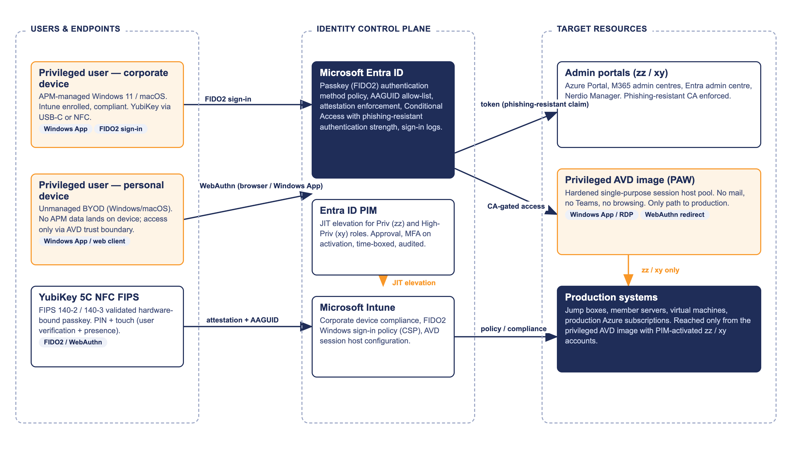
Figure 1 — System context: YubiKey-authenticated privileged access

4.2 Solution/Product Component Inventory
Component | Role in the solution | Version / licensing
YubiKey 5C NFC FIPS | Hardware-bound FIDO2 passkey; PIN + touch user verification. USB-C and NFC interfaces | Firmware 5.7.4 (FIPS 140-3, certified 22 May 2026) preferred; firmware 5.4.3 (FIPS 140-2) accepted. One-time purchase via SoftwareOne
Microsoft Entra ID | Identity provider; passkey registration, attestation validation, AAGUID restriction, token issuance, sign-in logging | Entra ID P2 (existing) for privileged users
Entra ID Conditional Access | Enforces phishing-resistant authentication strength, session controls and BYOD constraints | Included in P1/P2 (existing)
Entra ID PIM | Just-in-time role activation for zz / xy tiers with approval and audit | Entra ID P2 (existing)
Temporary Access Pass (TAP) | Time-limited, one-time bootstrap credential for first registration and recovery | Native Entra ID feature (no additional licence)
Windows App / AVD web client | Client entry point to the privileged AVD image from corporate and personal devices; performs WebAuthn | Current evergreen releases (Windows, macOS, web)
Azure Virtual Desktop — privileged image | Hardened PAW-style session host pool; the only path to production | Per the Privileged Access detailed design
Microsoft Intune | Corporate device compliance; FIDO2 Windows sign-in policy; AVD session host configuration | Existing Intune licensing
Microsoft Sentinel / Defender for Endpoint | Monitoring, detection and alerting for registration, sign-in and elevation events | Existing platform
ServiceNow (APM) | Issuance workflow, identity verification records, key register, support runbooks | Existing platform

4.3 Solution Interface Diagram
Figure 2 shows the end-to-end authentication sequence from key to production, including the in-session WebAuthn redirection used to satisfy authentication prompts on jump boxes and virtual machines from inside the AVD session. No password is used at any step.
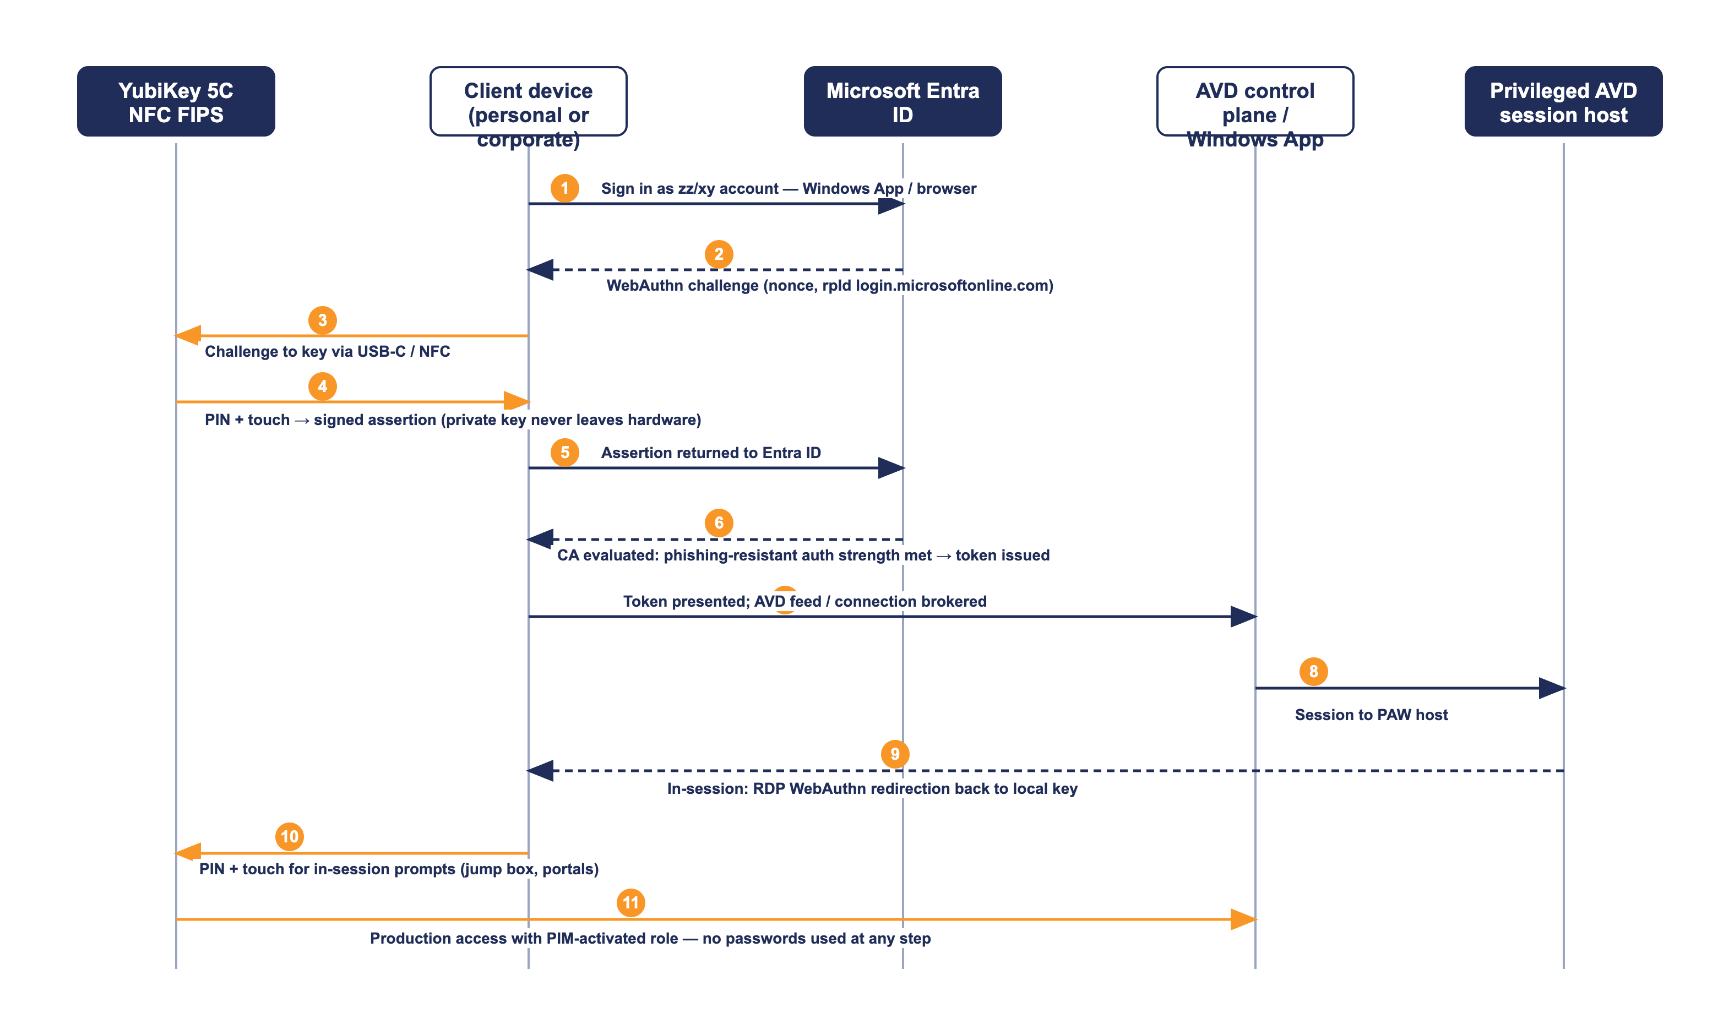
Figure 2 — Authentication flow: YubiKey to Entra ID to AVD to production

4.4 Solution/Product Interface catalogue
Interface | Pattern / protocol | Notes
YubiKey ↔ client device | CTAP2 over USB-C or NFC | PIN + touch (user verification and user presence). Private key never leaves the key
Client ↔ Entra ID | FIDO2 / WebAuthn over TLS (login.microsoftonline.com) | Origin binding defeats adversary-in-the-middle proxies; supported in Edge, Chrome, Safari and Windows App
Client ↔ AVD control plane | Windows App / HTML5 web client, reverse-connect over TLS 443 | Entra ID token carries the phishing-resistant authentication claim
AVD session ↔ YubiKey | RDP WebAuthn redirection (redirectwebauthn:i:1) | In-session passkey prompts (portals, jump boxes) redirect to the key attached to the local endpoint
AVD session ↔ jump boxes / VMs | RDP / SSH inside the production network | Reached only from the privileged AVD image with a PIM-activated role
Entra ID ↔ Sentinel | Diagnostic settings / log export | Sign-in, audit, provisioning and PIM logs streamed for analytics and alerting

5. Technology Architecture
This section specifies the configuration to be applied, in the order it should be built: authentication methods policy, Conditional Access, PIM, then endpoint and session settings.

5.1 Entra ID authentication configuration

5.1.1 Passkey (FIDO2) authentication methods policy
Entra admin centre → Protection → Authentication methods → Passkey (FIDO2).
Setting | Value | Rationale
Enable | Yes | Enables passkey registration and sign-in
Target | Include group SEC-MFA-FIDO2-Privileged (all zz and xy accounts). Phase 2: SEC-MFA-FIDO2-Staff | Scoped rollout; group-driven so no per-user administration
Allow self-service set up | Yes | Permits registration from My Security Info and the sign-in registration prompt — the core of the simple enrolment flow
Enforce attestation | Yes | Entra validates the Yubico attestation certificate at registration; a software or counterfeit authenticator cannot register
Enforce key restrictions | Yes | Activates the AAGUID allow-list below
Restrict specific keys | Allow (allow-list mode) | Only the listed authenticator models can register — all other passkeys (phones, software passkeys, non-FIPS keys) are rejected
Microsoft Authenticator passkeys | Not targeted for privileged accounts | Privileged tiers use hardware keys only; phone-held passkeys are excluded

AAGUID allow-list. The Authenticator Attestation GUID identifies the exact authenticator model at registration. The allow-list is restricted to the YubiKey 5 FIPS Series with NFC — the series the YubiKey 5C NFC FIPS belongs to:
Authenticator model | Firmware / validation | AAGUID
YubiKey 5 FIPS Series with NFC (includes YubiKey 5C NFC FIPS) | 5.4.3 — FIPS 140-2 (Overall L1/L2, Physical Security L3) | c1f9a0bc-1dd2-404a-b27f-8e29047a43fd
YubiKey 5 FIPS Series with NFC (includes YubiKey 5C NFC FIPS) | 5.7.4 — FIPS 140-3 (Overall L2, Physical Security L3), NIST-certified 22 May 2026 | Confirm from the Yubico AAGUID register / FIDO MDS at build time (build task V-01)

Verification task V-01: Yubico publishes AAGUIDs in its "YubiKey hardware FIDO2 AAGUIDs" register and the FIDO Metadata Service. The firmware 5.7.4 FIPS AAGUID must be taken from that register when the first 5.7.4 key is enrolled in the pilot, and this table updated. Registration of a pilot key is itself the definitive test: a key whose AAGUID is not on the list cannot register.

5.1.2 FIDO2 PIN and hardware behaviour (firmware 5.7.4)
Property | Behaviour
PIN length | Minimum 8 characters, complexity enforced by the key firmware (common/simple PINs blocked at hardware level, per NIST SP 800-63B)
PIN attempts | Eight consecutive failures permanently blocks the FIDO2 application; credentials are destroyed and the key must be reset and re-registered
User presence | Physical touch required for every authentication — malware cannot silently invoke the key
Credential storage | Discoverable credentials generated and stored on-key (up to 100 on 5.7.4); private keys are not exportable by any interface
Assurance level | Meets NIST SP 800-63B AAL3 (hardware-based, verifier-impersonation-resistant)
U2F application | Permanently disabled on 5.7.4 (does not meet FIPS 140-3); FIDO2 is the only WebAuthn application, as this design requires

5.1.3 Temporary Access Pass (bootstrap credential)
Entra admin centre → Protection → Authentication methods → Temporary Access Pass.
Setting | Value | Rationale
Enable / Target | Yes — SEC-MFA-FIDO2-Privileged (and later staff group) | TAP is issued only when a key is being registered or recovered
Minimum lifetime | 1 hour | Enough to complete registration on receipt of the call
Maximum lifetime | 8 hours | Caps exposure if unused
Default lifetime | 1 hour | Issued during the verification call; expires shortly after
One-time use | Yes | A TAP cannot be replayed after the registration sign-in
Length | 12 characters | Default strength retained

5.1.4 Registration flow — native Entra ID prompt at sign-in
Registration uses only built-in Entra ID behaviour, which is the simplest flow available and the easiest to assure: when a user who is targeted for passkeys signs in with a TAP and has no passkey registered, Entra ID interrupts the sign-in and walks them through registering the key (set PIN, touch). The user never visits a separate portal, and the TAP is consumed in the same session. The full issuance procedure, including postal delivery and identity verification, is specified in §9.1 and Figure 5.

5.1.5 Phase 2 — standard user extension
The same policy pattern extends to standard staff accounts by adding the staff group to the passkey policy target and enabling a registration campaign (Authentication methods → Registration campaign) to nudge registration at sign-in. Standard users may use non-FIPS YubiKeys or Microsoft Authenticator passkeys at APM's discretion; that decision belongs to the Standard User workstream and does not alter the privileged design, which remains hardware-FIPS-only via its own group scoping.

5.2 Conditional Access design

5.2.1 Authentication strength
A custom authentication strength restricts privileged sign-in to hardware passkeys only (the built-in "Phishing-resistant MFA" strength also admits Windows Hello for Business and certificate-based authentication, which are not part of the privileged design):
Authentication strength | Definition
APM Phishing-Resistant Hardware Key (custom) | Method: Passkey (FIDO2) only. Advanced options: restrict by AAGUID to the allow-list in §5.1.1 (same two AAGUIDs)

5.2.2 Conditional Access policies
Policy | Configuration | Effect
CA-APM-PRIV-01 Require hardware key | Users: SEC-MFA-FIDO2-Privileged (zz, xy). Cloud apps: All. Exclusions: break-glass accounts only. Grant: require authentication strength "APM Phishing-Resistant Hardware Key" | Every privileged sign-in, from any device, anywhere, requires the YubiKey. Passwords and app MFA cease to grant access even if known
CA-APM-PRIV-02 Session controls | Same scope. Session: sign-in frequency 8 hours; persistent browser sessions disabled | Bounds token lifetime on shared or personal endpoints; re-authentication requires the key again
CA-APM-PRIV-03 Secure registration | User action: register security information. Scope: privileged groups. Grant: require TAP-satisfied authentication (registration only possible in a session established with a TAP or existing passkey) | Prevents an attacker who has only a password from registering their own authenticator
CA-APM-PRIV-04 Constrain BYOD path | Users: privileged groups. Device filter: NOT compliant AND NOT Entra-joined. Cloud apps: All except Azure Virtual Desktop / Windows App (and My Security Info via TAP) | From personal devices, privileged accounts can reach only the AVD entry point — no direct M365, Exchange or Graph access from unmanaged endpoints
CA-APM-PRIV-05 Block legacy/weak paths | Users: privileged groups. Conditions: legacy authentication clients | Legacy protocols that cannot perform WebAuthn are blocked outright

Deployment note: policies are built in report-only mode, validated against pilot sign-in logs for a minimum of one week, then enabled — consistent with the change and Conditional Access governance already agreed with APM Cyber for the AVD program.

5.3 Privileged Identity Management (PIM)
PIM provides just-in-time elevation after the phishing-resistant sign-in. Figure 4 shows the activation flow.
Role setting | Priv tier (zz) | High-Priv tier (xy)
Assignment | Eligible only — no permanent active assignments | Eligible only; assignments reviewed monthly
Activation maximum | 8 hours | 4 hours
On activation | Require authentication context bound to "APM Phishing-Resistant Hardware Key" (key re-asserted); justification required | As zz, plus ticket reference mandatory
Approval | Not required (auto-approve) | Required — Cyber Security Lead or delegate
Notifications | Activation alerts to the security mailbox | Activation and approval alerts to Cyber Security Lead
Access reviews | Quarterly | Monthly

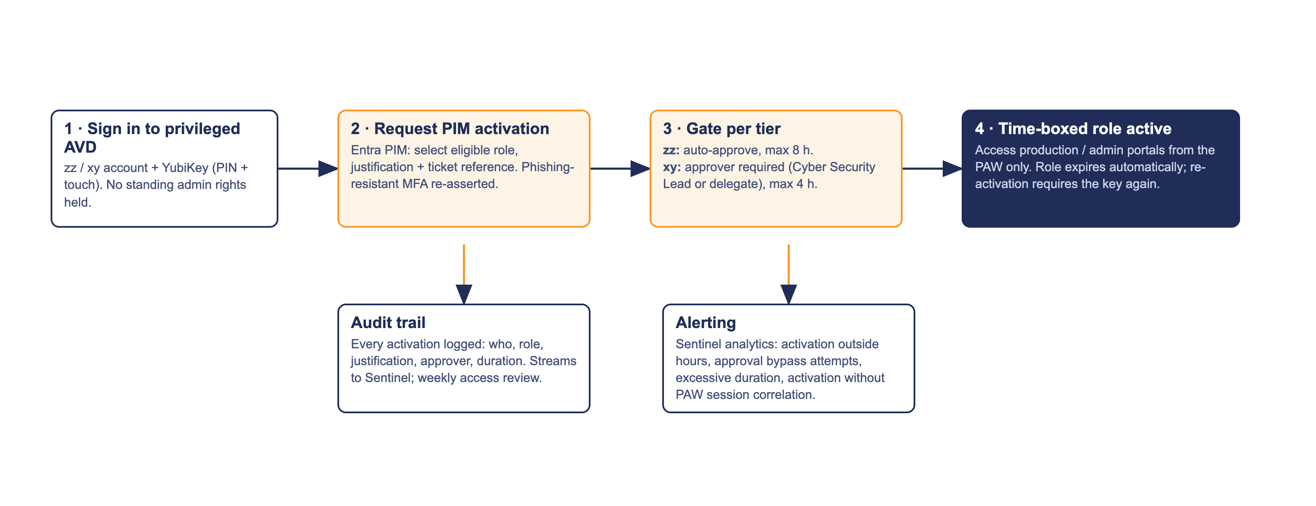
Figure 4 — PIM just-in-time elevation flow (zz / xy tiers)

5.4 Endpoint and session configuration

5.4.1 Corporate Windows devices — FIDO2 sign-in at the lock screen
Intune Settings Catalog policy assigned to corporate Windows 11 devices used by privileged staff:
Setting (Settings Catalog / CSP) | Value
Authentication → Use security key for sign-in (SecurityKey/UseSecurityKeyForSignin) | Enabled — adds the FIDO2 credential provider to the Windows lock screen; the user signs in to the device with the key (PIN + touch), no password
Excluded credential providers | Password provider retained during pilot; removal assessed at steady state

5.4.2 AVD session hosts — WebAuthn redirection
Nerdio Manager host pool RDP properties for the privileged host pool (and any pool from which admin portals are reached):
RDP property | Value
redirectwebauthn:i:1 | In-session WebAuthn calls redirect to the key on the local endpoint — passkey prompts inside the AVD session (Azure Portal, jump box PIM prompts) are satisfied by the physically attached YubiKey
redirectsmartcards:i:0 | Smart card redirection disabled (PIV not in scope)
Drive, clipboard, printer, USB redirection | Disabled on the privileged pool per the PAW design — the WebAuthn channel is the only endpoint capability the session trusts

5.4.3 Jump boxes and virtual machines
Administrative RDP hops from the privileged AVD session to jump boxes and Windows VMs carry the WebAuthn channel through nested redirection where a passkey prompt is raised. Server-side sign-in to production VMs uses the PIM-activated zz/xy account; where a target cannot present a WebAuthn prompt (e.g. legacy console), access is via the jump box which can. Every path originates from the PAW image — there is no direct endpoint-to-production route (Figure 3).

5.4.4 macOS endpoints
macOS (corporate or personal) uses the YubiKey through Safari/Chrome/Edge WebAuthn and the Windows App for macOS — covering AVD, portals and all Entra ID sign-in. Native macOS login-window FIDO2 is not supported by the platform; local Mac login therefore remains a local credential, and privileged work occurs inside the AVD boundary. Future options (not in this design): PIV smart-card login using the same key's PIV applet; Entra Platform SSO for Mac. Neither is required for cyber approval of this design because production access never depends on the Mac's local login.

5.4.5 Personal (BYOD) devices
Personal Windows and macOS devices run only the Windows App or a browser. CA-APM-PRIV-04 confines privileged accounts on these devices to the AVD entry point; the PAW session applies watermarking, disabled redirections and screen-capture protection; and no APM data is stored on the device. The full security argument is made in §7.2.

6. Information & Data Architecture

6.1 Information Model
Data element | Where held | Notes
FIDO2 public key + credential metadata | Entra ID (user object, authentication methods) | Public material only; useless without the physical key
FIDO2 private keys | YubiKey secure element only | Generated on-key; not exportable, not backed up, not escrowed
Key register (serial ↔ user ↔ issue date ↔ status) | ServiceNow asset register | Operational record for issuance, audit and revocation
Identity verification record | ServiceNow ticket | Who verified, how, when; retained per records policy
Sign-in, registration, PIM logs | Entra ID logs → Sentinel workspace | Retention per APM logging standard

6.2 Information Classification
No APM business data is introduced, stored or processed by the solution. The key register and verification records are OFFICIAL: Sensitive (personnel-related operational records). Authentication logs inherit the classification of the existing Entra ID/Sentinel logging platform. The YubiKey itself holds no personal or business data — loss of a key does not constitute a data breach (see R-03).

6.3 Analytics and reporting Patterns
Reporting uses existing platforms: Entra ID authentication methods activity (registration coverage), sign-in logs (method used, surface, failures), and PIM audit history. A monthly privileged-authentication report to Cyber Security covers registration coverage, TAP issuance volume, PIM activations by tier and anomalies (§9.2).

7. Cyber & Security Architecture

7.1 Why FIDO2 on FIPS-validated hardware
• Phishing-resistant by protocol — the WebAuthn assertion is cryptographically bound to the origin (login.microsoftonline.com) and a per-authentication nonce. A proxied fake login page receives an assertion that is invalid for the real origin; there is nothing a user can be tricked into typing, approving or forwarding
• Hardware-bound — private keys are generated in, and never leave, the FIPS-validated secure element. Malware on any endpoint can neither read nor clone the credential
• User verification and presence — every use requires the PIN (something you know) and a physical touch (presence), so a stolen key alone is useless and malware cannot invoke the key silently
• Validated cryptography — YubiKey 5C NFC FIPS firmware 5.7.4 is FIPS 140-3 certified (Overall Level 2, Physical Security Level 3, NIST-certified 22 May 2026); firmware 5.4.3 is FIPS 140-2 certified. Both meet NIST SP 800-63B AAL3. Procurement note: NIST moved FIPS 140-2 certificates to its sunset list in 2026, so new stock is ordered as firmware 5.7.4
• Replay- and export-proof — assertions are single-use; there is no OTP seed, no certificate file and no password hash to steal

7.2 The personal-device question — why BYOD access is safe in this design
Allowing privileged sign-in from personal devices is normally the point of cyber contention, so the argument is made explicitly. The design's position: the endpoint is not trusted and does not need to be trusted, because the credential and the environment are both protected independently of the endpoint.
• The credential cannot be stolen from the device: there is no password to keylog, no session cookie worth stealing beyond its 8-hour bound life, and the private key is in the YubiKey, not the device
• An attacker on the device cannot authenticate: PIN entry plus physical touch defeat remote invocation, and origin binding defeats phishing pages presented to the user
• The device never touches APM data: CA-APM-PRIV-04 restricts personal devices to the AVD entry point; within the PAW session, drive/clipboard/print/USB redirection is disabled, watermarking and screen-capture protection are on, and nothing is written to the endpoint
• What remains is session observation — a fully compromised personal device could screenshot what the administrator sees. This residual risk (R-02) is time-boxed by PIM and session limits, observable in Sentinel, and materially smaller than the risk it replaces (phishable credentials usable from anywhere, invisibly)
• Comparable posture: this is the same boundary argument APM accepts for BYOD access to the Standard User AVD channel, strengthened here by hardware-only authentication, JIT elevation and the PAW image's egress controls
Figure 3 shows the device-posture model and the trust boundary.
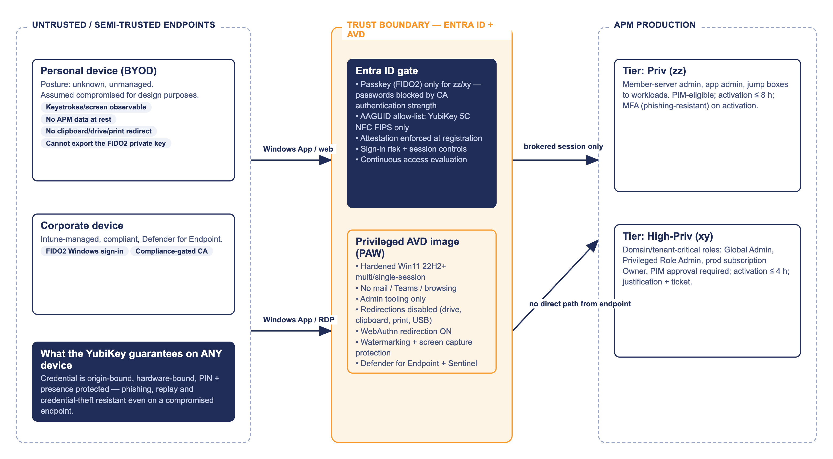
Figure 3 — Trust boundary and device posture: personal vs corporate devices

7.3 Threats and controls
Threat | Control | Residual position
Phishing / adversary-in-the-middle of a privileged account | FIDO2 origin binding; passwords never grant access (CA-APM-PRIV-01) | Effectively eliminated for targeted accounts
Credential theft from endpoint (malware, infostealer) | Private key in hardware; no stored secrets; touch requirement | Eliminated
Rogue authenticator registration by an attacker | Attestation enforcement + AAGUID allow-list + TAP-gated registration (CA-APM-PRIV-03) | Registration requires a verified TAP session and a genuine FIPS YubiKey
Postal interception of a key | Key ships with no credential; registration needs a TAP issued only after live identity verification; serial checked at verification call | Interception yields inert hardware
Stolen key + PIN coercion / shoulder-surf | 8-attempt hardware lockout; immediate revocation path (§9.1); PIM approval still gates xy | Low; bounded by revocation SLA of 1 hour
Service desk social engineering for a TAP | Verification script with video + manager confirmation for privileged accounts; TAP issuance alerting; one-time 1-hour TAP | Low; every TAP is logged and alerted
Compromised personal endpoint | §7.2 controls; session observation is the only residual | Accepted, monitored (R-02)
Break-glass account abuse | Two accounts, excluded from these policies, FIDO2 keys held in safes at two sites, sign-in alerting to Cyber | Existing control, unchanged

7.4 Risk register
ID | Risk | Likelihood | Impact | Treatment
R-01 | A mailed YubiKey is intercepted in transit | Low | Low | Key carries no credential; TAP issued only after identity verification; serial confirmed at the verification call; tracked post. ACCEPT with controls
R-02 | A compromised personal device observes a privileged AVD session (screen scraping) | Low | Medium | PAW egress controls, watermark, 8 h session bound, PIM time-boxing, Sentinel analytics; user obligation in the Privileged Access agreement to use a trusted device where available. ACCEPT — approval sought
R-03 | Key lost or stolen | Medium | Low | Credential useless without PIN; 8-attempt wipe; revocation ≤ 1 h of report; spare-key policy for xy holders. MITIGATE
R-04 | User locked out (lost key, no fallback) delaying production response | Medium | Medium | Spare registered key for xy holders; TAP re-issuance path 24/7 via on-call; break-glass accounts for tenant-level emergencies. MITIGATE
R-05 | Service desk tricked into issuing a TAP to an attacker | Low | High | Mandatory video verification + manager confirmation for privileged TAPs; alert on every privileged TAP creation; one-time 1 h lifetime. MITIGATE
R-06 | FIPS 140-2 (fw 5.4.3) certification sunset reduces compliance standing | Medium | Low | Procure 5.7.4 (FIPS 140-3) stock; existing 5.4.3 keys rotated at natural replacement. MITIGATE
R-07 | A client surface lacks WebAuthn support (edge-case browser/OS) | Low | Medium | Support matrix tested in pilot (T-05..T-08); AVD web client as universal fallback; no password fallback introduced. MITIGATE
R-08 | User friction / PIN forgotten drives support load | Medium | Low | PIN self-reset with existing key possible via re-registration flow; KB articles and issuance walkthrough; pilot feedback loop. MITIGATE
R-09 | AAGUID list gap blocks legitimate new key stock (e.g. future firmware) | Low | Low | AAGUID register check added to procurement runbook; verification task V-01 pattern repeated per firmware change. MITIGATE
R-10 | Attestation enforcement outage at Microsoft blocks registrations (not sign-ins) | Low | Low | Registrations are rare and schedulable; sign-in unaffected. ACCEPT

7.5 Compliance alignment (RFFR / Essential Eight / ISM)
Obligation | How the design satisfies it
Essential Eight — Multi-factor authentication (ML3 characteristics) | Phishing-resistant MFA (FIDO2 hardware keys) enforced for privileged users on every access to systems and data repositories; unphishable by design
Essential Eight — Restrict administrative privileges | No standing privilege; PIM JIT activation with approval at the xy tier; privileged accounts blocked from mail/browsing paths (PAW model); privileged actions from a hardened, dedicated environment
ISM — authentication hardening guidance | Memorised secrets removed from the privileged flow; authenticators are hardware-bound, FIPS-validated (AAL3); authentication events centrally logged
RFFR (DEWR) | Uplift is evidenced by configuration export (policies in §5), the key register, PIM audit history and the monthly privileged-authentication report — auditable artefacts for ISO 27001 / RFFR assessment

8. Service Availability and Disaster Recovery

8.1 Business Service Tiering
Authentication for privileged access is Tier 1: loss of the capability delays incident response and production change. The dependency chain is Entra ID (Microsoft SLA) + the physical key. No new APM-operated infrastructure is introduced, so the solution adds no new availability liability beyond the key itself.

8.2 Service Availability
• Entra ID authentication and AVD availability are inherited from the existing platform design (Australia East hub-spoke)
• Each High-Priv (xy) holder registers two keys (primary + spare); the spare is stored per the holder's site security arrangement. Priv (zz) holders may hold a single key with the 24/7 TAP path as fallback
• TAP re-issuance is available 24/7 through the on-call process with the same verification controls

8.3 Disaster recovery & Resilience
• Break-glass: two cloud-only emergency access accounts, excluded from CA-APM-PRIV-01..05, each with two registered FIDO2 keys held in safes at separate sites; any sign-in raises a Sentinel incident to Cyber Security. Reviewed quarterly
• Tenant-level Entra outage: privileged authentication is unavailable along with everything else; recovery follows the Microsoft major-incident process — no APM-side credential fallback is created, deliberately, to avoid re-introducing a phishable path
• Key fleet failure (batch defect): dual-firmware acceptance (5.4.3 / 5.7.4) means a replacement batch can be sourced and registered within days via the standard lifecycle; break-glass covers the interim

9. Service Management

9.1 Key lifecycle operations
Figure 5 defines the lifecycle. The issuance procedure, including the postal path, is:
• 1. Requester's manager raises the ServiceNow request; Cyber Security approves privileged issuance; key serial assigned from stock and recorded in the register
• 2. Key issued in person where the user is co-located with IT; otherwise sent by tracked post to the user's verified address — the key carries no credential in transit
• 3. On receipt, the user books the verification call. Service desk verifies identity (video call + photo ID or manager attestation per the privileged verification script) and confirms the key serial matches the register
• 4. Service desk issues a one-time Temporary Access Pass (1 h). The user signs in at any Entra sign-in surface with the TAP; Entra ID prompts passkey registration at login — the user inserts the key, sets the PIN (8+ characters, complexity enforced by hardware), touches the key, done
• 5. Entra validates attestation + AAGUID; only a genuine YubiKey 5 FIPS Series key completes. The register is updated to Active; from the next sign-in, CA enforces key-only authentication
• 6. Loss/theft/leaver: report → passkey deleted in Entra within 1 hour (authoritative revocation — the key becomes inert) → register updated → replacement via steps 1–5. Returned keys are FIDO2-reset before restocking
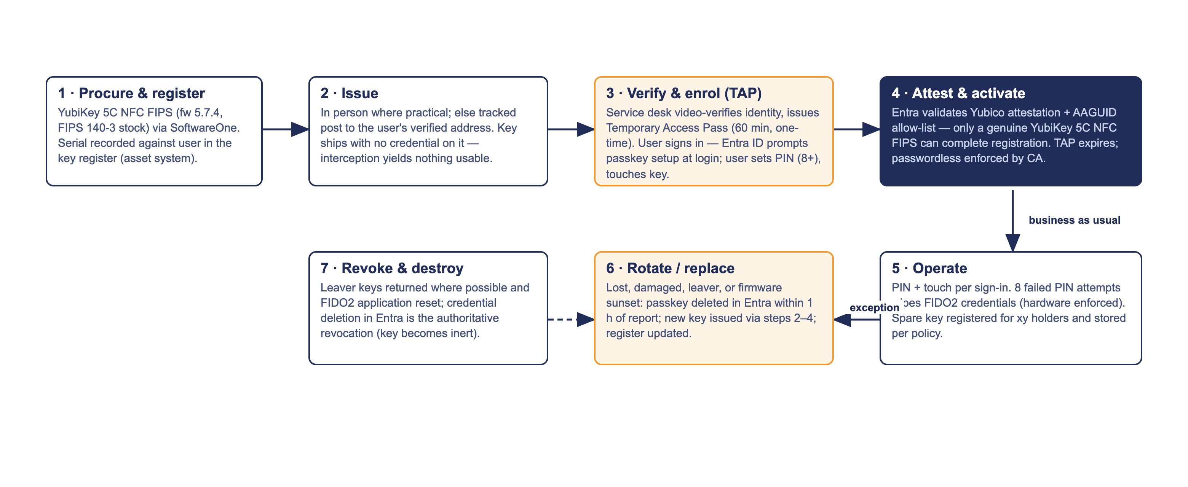
Figure 5 — Key lifecycle: procure, issue, enrol, operate, rotate, revoke

9.2 Monitoring, Logging, Reporting and Alerting
Event | Source | Action
Privileged TAP created | Entra audit log → Sentinel | Alert to Cyber Security in near-real-time; reconciled against ServiceNow verification tickets weekly
Passkey registered / deleted on a privileged account | Entra audit log → Sentinel | Alert; reconcile against key register
Privileged sign-in NOT using FIDO2 (should be impossible) | Sign-in logs → Sentinel analytic | High-severity incident — indicates policy tamper or exclusion drift
Break-glass account sign-in | Sign-in logs → Sentinel | Immediate incident to Cyber Security Lead
PIM activation (xy) / approval outcomes | PIM audit → Sentinel | Daily digest; anomaly rules (out-of-hours, repeated max-duration)
CA policy change to CA-APM-PRIV-* | Entra audit log → Sentinel | Alert to Cyber Security; change must map to an approved RFC
Registration coverage / method usage | Authentication methods activity report | Monthly privileged-authentication report to Cyber Security

9.3 Validation and test plan (pilot exit criteria)
ID | Test | Pass criterion
T-01 | Register key via TAP + sign-in prompt (Windows, corporate device) | Registration completes; attestation validated; register updated
T-02 | Attempt registration with a non-FIPS YubiKey and a phone passkey | Both rejected by key restrictions
T-03 | Privileged sign-in with password + Authenticator app only | Blocked by CA-APM-PRIV-01
T-04 | Windows lock-screen sign-in with key on corporate device | Success, no password used
T-05 | Windows App → privileged AVD from corporate device | Key satisfies sign-in; session established
T-06 | Windows App / web client → privileged AVD from personal Windows device | Key works; CA-APM-PRIV-04 blocks non-AVD apps; no redirections available in session
T-07 | macOS (Safari + Windows App) → portals and AVD | Key works over USB-C and NFC
T-08 | In-session WebAuthn redirect: Azure Portal + jump box prompt inside AVD | Prompt satisfied by local key (redirectwebauthn confirmed)
T-09 | PIM activation zz (auto) and xy (approval) with key re-assertion | Flows complete; audit records present
T-10 | Lost-key drill: revoke passkey, re-issue via TAP | Old key inert ≤ 1 h; new key active; register consistent
T-11 | TAP social-engineering drill against verification script | Request refused without video verification; alert fired on TAP creation
T-12 | Break-glass sign-in test (scheduled) | Access succeeds; Sentinel incident raised

9.4 Support model
Tier-1 (Service Desk): issuance verification calls, TAP issuance under script, lost-key intake, KB-guided registration support. Tier-2 (EUC/Digital Operations): policy exclusion investigation, device-side FIDO2 issues, AVD redirection faults. Tier-3 (project team, then Digital Operations at handover): CA/PIM/authentication-methods policy changes under RFC. Knowledge-base articles for issuance, registration, lost key and PIN reset are delivered with the build and validated through the APM KB workflow before go-live.

How to Document Application Architecture

