Stratus Phase 3

Palo Alto Low-Level Design/As-Built Document
Version V1.0
22 July 2026
Project Name: | Stratus Phase 3
Document Owner: | Oliver Garate
Contact Details: | Oliver.Garate@apm.net.au
Division/Unit: | Digital Operations
Document Status: | Ready to
Document Version: | 1.0
Product ID:

FOR INTERNAL USE ONLY
Commercial in confidence
© APM

Document control
Version History
Version | Date | Author | Key changes
V1.0 | 12/12/2025 | Lewis Kellar | Ready for APM to Review & Endorse

Consultation
Name | Position title | Date
Michael Kruger | Software One - Cyber Security Lead
Oliver Garate | Cloud Product Manager/Program Manager
Michael Kallergis | Senior Infrastructure Engineer
Michael Court | IT Infrastructure Lead
Ugbaad Adani | Senior Cyber Security Architect

Confidentiality & Disclaimer
This document is provided by Advanced Personnel Management International Pty Ltd and / or its related entities (APM) on a confidential basis. This document is subject to approval of the APM Board and does not constitute an offer capable of acceptance. No agreement binding APM or its related companies in respect of this document is intended or proposed unless and until the terms and conditions between APM or its related entities are agreed in writing in a formal agreement with the named Company or Prospective Client.
APM will not be bound by any pricing or any other material contained in this response until the above has taken place.
Photography
Photographs used in this document are for illustration only
and should not be interpreted to mean that any person or organisation whose assets are shown in them endorses this document.
APM Contact
Communications regarding
this document should be forwarded to:
Head of Digital Transformation & Architecture
P 1300 436 432
M 0460 703 384
E samit.chandra@apm.net.au

Contents
1 Introduction 6
1.1 Purpose 6
1.2 Audience 6
2 Overview 6
2.1 Scope 7
2.2 Guiding Principles 8
2.3 Design Assumptions 8
3 Palo Alto Integration Landing Zone Design 11
3.1 Overview of Palo Alto Logical Design within Azure ESLZ: APM 11
3.1.1 Advantages of Integrating Palo Alto within Logical Design of ESLZ 11
3.2 Network Topology and Connectivity 12
3.2.1 Virtual Networks 12
3.2.2 User-Defined Routes 13
3.2.3 Palo Alto Test Cases 14
3.3 Azure Perimeter Protection 15
3.3.1 Palo Alto Firewall 15
4 Reference Network 39
4.1 Traffic Flow Design 39

List of Tables

Table 1-Design Assumptions 11
Table 2- VNet Ranges for Australia East Region 13
Table 3- VNet Ranges for Australia Southeast Region 13
Table 4-Overview of the Subnets (Australia East) 14
Table 5-Overview of the Subnets Planning (Australia Southeast) 14
Table 6- Azure VM-Series Palo Alto Firewall Instances 19
Table 7– Applied Firewall Licensing 20
Table 8 Interface Configurations 28
Table 9 Management Settings 30
Table 10 Services Settings 30
Table 11 Management Interface Settings 31
Table 12 Palo Alto firewall Dynamic Update Settings 31
Table 13 North/South Firewall NAT rule 33
Table 14 East/West Firewall NAT rule 33
Table 15 Deployment Files 34
Table 16 Deployment Dependencies 36

List of Figures
Figure 1-Azure Landing Zone Conceptual Architecture 12
Figure 2 Default System Route 15
Figure 3 Azure Route Table 15
Figure 4-VNET Peering 19
Figure 5 Log Forwarding 20
Figure 6 Panorama Firewall Connected Device Summary 21
Figure 7 Panorama Log Collector Configuration 21
Figure 8 Panorama Primary Instance High Availability Configuration 22
Figure 9 Panorama High Availability Status and General Information 23
Figure 10 Panorama Template Configuration 24
Figure 11 Panorama Device Group Configuration 25
Figure 12 North/South Firewall Interfaces 28
Figure 13 East/West Firewall Interfaces 28
Figure 14 North/South Firewall Zones 28
Figure 15 North/South Firewall Zones 28
Figure North/South Firewalls Virtual Routers 28
Figure North/South Firewalls NS-Public-VR Virtual Router 29
Figure North/South Firewalls NS-Private-VR Virtual Router 29
Figure North/South Firewalls NS-DMZ-VR Virtual Router 29
Figure East/West Firewalls Virtual Router 30
Figure 21 Security Policy 32
Figure 22 Intrazone & Interzone Rules 32
Figure 23 Key vault storage location 36
Figure 24 Australia East test firewall test deployment pipeline logs 38
Figure 25 Australia SouthEast test firewall test deployment pipeline logs 39
Figure 26-Network Traffic Flow 40

Introduction

Purpose

The purpose of this document is to provide a Low-level logical architecture view of the implementation of initiative for Azure Landing Zone Palo Alto Firewall Deployment and related Integration Components and to define any services required which have been implemented to allow satellite systems to integrate and coexist with inherent eco system. Services are also mapped to requirements (Business Use Cases) as part of this document.
This document will form the basis on which Technical Design document (TDD) for each distinct solution component can be prepared.
The aim of this document is to:
1. Align with the business requirements previously highlighted in the TDD
2. Describe the logical architecture to meet those requirements
3. Describe the physical architecture to meet those requirements
4. Describe the solution decisions that have been made with the business requirements in mind and their implications. Though Functional requirements that are partially or fully enabled by solution design (vs tool capabilities) will be considered in this document, Non-functional requirements driven by service tiering and business will be addressed as well.
5. Outline data and cyber security requirements and policies & controls to adhere and meet APM cyber security guidelines and standards

Audience
This document provides an overview of the implemented architecture and resources deployed in Azure for key stakeholders, technical staff, and decision-makers at APM. It recommends advanced knowledge of Azure and Palo Alto NGFW (Next Gen Firewall) cloud technologies or certification in Azure Architecture (305), Azure Security (500), and Azure Networking (700) for a comprehensive understanding, as the content covers detailed technical and operational concepts in these areas.
- The document is primarily for teams managing digital delivery, operations, cybersecurity, information architecture, and Microsoft Azure Landscape specially in Palo Alto Firewalls.
- Business sponsors, partners, and operations staff should also be involved to ensure business requirements are addressed.
- The framework development requires collaboration between business stakeholders and technical teams.

Overview
This design serves as an extension of the Azure Landing Zone Design document; this Palo Alto firewall As-Built document provides an overview of the Palo Alto VM-series firewalls and associated resources deployed in Azure in the Australia East and Australia SouthEast regions.
The implemented Palo Alto Networks VM-series firewalls serve as the central security enforcement point within APM’s Azure Enterprise-Scale Landing Zone (ESLZ). The architecture uses a hub-and-spoke topology, with all North-South (internet and on-premises) and East-West (inter-VNet) traffic routed through dedicated firewall clusters in the hub (Connectivity Subscription). This ensures comprehensive inspection and control of all critical traffic flows.
Firewall clusters are logically separated for North-South and East-West traffic, supporting granular policy enforcement and network segmentation. User-defined routes and VNet peering enforce mandatory traffic inspection. Panorama is deployed in high availability across Australia East and Southeast regions, providing centralised management, configuration consistency, and log aggregation.
The design supports advanced threat protection, intrusion prevention, URL filtering, DDoS mitigation, and strict access controls. Redundancy and disaster recovery are built in at both the firewall and management layers. All design decisions are explicitly documented and confirmed with stakeholders. The solution enforces encryption, compliance, and policy consistency, supporting phased migration from legacy environments and future scalability. This deployment provides a comprehensive, robust, and scalable security foundation for APM’s Azure environment.
In addition, this as-built document describes the deployment of the Palo Alto VM-Series firewall solution into the Microsoft Azure environment using an automated Infrastructure-as-Code (IaC) pipeline based on Azure DevOps and Terraform. The deployment approach was designed to deliver a consistent and repeatable method for provisioning security infrastructure across different regions and for disaster recovery requirements. This deployment forms a core component of APM’s cloud security architecture and establishes a reliable foundation for safeguarding workloads hosted in Azure.

Scope
This deployment focused on reviewing and uplifting the Palo Alto Firewall environment aligned with both the Azure Landing Zone and DevOps practices, intending to improve operational and security measures. The focus is split into two zones:
- Azure Australia East Region:
  - Adding 1 instance of Palo Alto Panorama for centralised management
  - 4 virtual NGFWs with load balancing and redundancy capabilities.
    - 2 x NGFWs for East-West Traffic
    - 2 x NGFWs for North-South Traffic
  - 4x Load Balancers
  - 2x VM Availability Sets
- Azure Australia South-East Region:
  - Adding 1 instance of Palo Alto Panorama to be HA with Australia East Instance.
  - 2 virtual NGFWs with load balancing and redundancy capabilities.
    - 1 x NGFWs for East-West Traffic
    - 1 x NGFWs for North-South Traffic
  - 4x Load Balancers
  - 2x VM Availability Sets
A thorough set of business, functional, and non-functional requirements were evaluated, and decisions were made collaboratively regarding which controls would be incorporated into the original landing zone delivery. This approach ensures that the final solution meets compliance standards for RFFR, ISM, ISO, and APM Policy.
This Palo Alto Firewall uplift will directly impact business capabilities associated with cloud adoption, operational efficiency, and digital delivery. It involves people, processes, and technology across the business units that rely on or are enabled by cloud and network security functions.

Guiding Principles

The Guiding Principles are a set of key statements and ideas that drive how elements of the project will be designed, implemented, and operated. These principles are contextualised, focusing on project delivery that aligns with the project/program success criteria.
- Cloud Native Focus: Palo Alto, while it is mostly a cloud-ready solution, it leverages the use of Azure native cloud tools and services whenever possible to maximise benefits and Policy Compliance: Adherence to established security and architecture policies, ensuring consistent and secure cloud usage.
- Environment Segregation: Use of hub-and-spoke topology and dedicated subnets to minimise risks and enhance security.
- Standardised Operations: Centralised management via Palo Alto Panorama, templates, and modular device groups to unify and simplify operations.
- Secure by Design: All traffic is routed through firewalls for inspection, with advanced threat protection, DDoS mitigation, and strict access rules.
- Reduced Complexity: Unified architecture, centralised management, and automation to streamline operations and reduce manual intervention.
- Resilient Design: High availability and redundancy for firewalls and management, ensuring service continuity and disaster recovery between regions.
- Minimal Customisation: Alignment with Microsoft’s Cloud Adoption Framework and Palo Alto reference architectures, minimising deviations.
- Certification Compliance: Designed to meet compliance requirements for standards such as MCSB, RFFR, ISM, and APM Policy.

Design Assumptions
The following prerequisites were considered essential to enable rapid progress on the project before the start of the deployment:
Reference | Detail
Firewall Specific
AS02 | APM will apply its own enterprise and IT risk processes to integrate the contents of these documents, as it may or may not be implemented in accordance with any strategic decisions APM may make for their improvement.
AS03 | All necessary identities and groups for IAM access management will be established using cloud-based groups within Microsoft Entra ID through the used combination of SAML and Kerberos authentications.
AS04 | Any disaster recovery (DR) activities will be focused on Palo Alto Firewalls and related resources, with scenarios anticipated at either the Availability Zone (AZ) or regional (primary region outage) level. It is important to note that a Business Continuity Plan (BCP) for APM has not been provided.
AS05 | APM will review and provide access to the infrastructure required for SoftwareOne to carry out its activities.
AS06 | APM/SoftwareOne will create required subscriptions and supply CIDR ranges based on ESLZ design principles.
AS07 | All modifications or updates to networks, subnets, network security groups (NSG), application security groups (ASG), route tables, tagging, load balancers and user access must be performed by the designated APM/SoftwareOne Cloud team members.
AS08 | APM turnaround time and architectural signoff are set at a maximum of five (5) days for documentation provided by SoftwareOne as part of the deliverables. If no formal acceptance is received within this period, acceptance will be assumed, and the relevant milestone may be invoiced if applicable.
AS09 | The Firewall Integration has been completed, establishing bidirectional communication among all relevant points within the Primary Region (Australia East), including connectivity from the New Hub to all Spoke Virtual Networks (VNets) and to on-premises resources. Where Source Network Address Translation (SNAT) is necessary, appropriate firewall rules have been implemented to ensure proper handling of return traffic. Additionally, provisions have been made to allow the Application Gateway to operate concurrently with the Firewall.
AS10 | The Landing Zone is equipped to meet the bandwidth, throughput, and security specifications necessary for the migration of all relevant workloads.
AS11 | The Palo Alto Firewalls are the placed in the hub any other Firewall, even in Sandpit will not be implemented between an organisation’s internal networks and public network infrastructure.
AS12 | Subnet allocations are designed to accommodate Azure services that require dedicated subnets, with additional address space reserved for future expansion.
AS13 | The subscriptions and CIDR ranges for network deployment are done in Azure Landing zone build.
AS14 | Firewall integration is completed for bidirectional communication in the primary region, including connectivity from the new hub to all spoke VNets (legacy hub) and to on-premises resources.
AS15 | The landing zone is equipped to meet bandwidth, throughput, and security requirements for migration of all relevant workloads.
AS16 | Disaster recovery activities focus on production and identity resources, with scenarios anticipated at either the Availability Zone or regional level.
AS17 | The Logs from Palo Alto/Panorama will be forward to the SIEM service and Syslog servers created by IMP Projects.
AS18 | All recommendations are tailored to benefit APM, based on Palo Alto design best practices and Security requirements.
AS19 | The Advance Firewall configurations will be performed by APM at in later stage when the ACLs are evaluated and migrated.
Table 1-Design Assumptions

Palo Alto Integration Landing Zone Design

Overview of Palo Alto Logical Design within Azure ESLZ: APM
The deployed Palo Alto architecture forms a part of the overall focused centralised integration for the Azure Enterprise-Scale Landing Zone (ESLZ), serving as a hub for connecting various business units and systems. This approach helps streamline data flow, simplify management, and reduce the need for direct integrations. By adopting DevOps practices, APM can quickly and efficiently integrate newly acquired businesses, ensuring a smooth and rapid onboarding process.
Logical design is presented as a crucial element in mapping business needs to technical architecture, ensuring effective implementation of Palo Alto NGFWs within the Azure Enterprise-Scale Landing Zone (ESLZ). This structured approach lays the foundation for robust, scalable, and secure cloud environments, supporting operational excellence and digital transformation.
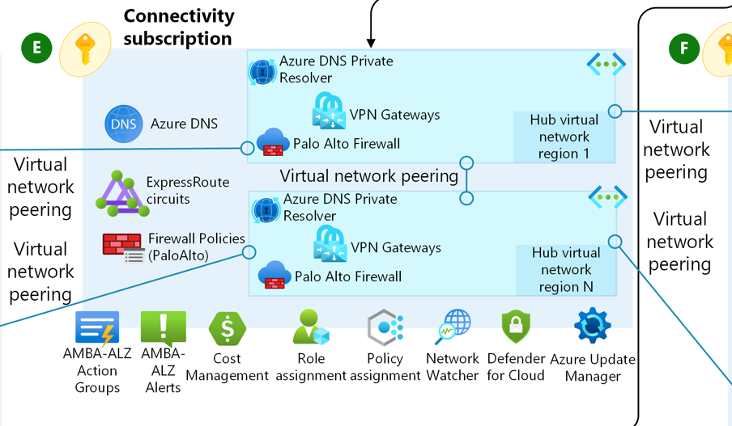
Figure 1-Azure Landing Zone Conceptual Architecture

The Azure landing zone architecture utilises a hub-spoke topology. In this configuration, shared resources and network infrastructure within the hub are overseen by a centralised platform team. The spokes operate under a collaborative ownership arrangement between the platform team and the respective workload teams, leveraging those spoke networks. All hubs are managed within a dedicated "Connectivity" subscription for streamlined administration, whereas spoke virtual networks are distributed across individual application landing zone subscriptions corresponding to specific workloads.

Advantages of Integrating Palo Alto within Logical Design of ESLZ
- Ensures that cloud foundations are aligned with business goals and regulatory requirements from the outset.
- Reduces risk of misconfiguration and security gaps by enforcing consistency across environments.
- Accelerates cloud adoption by removing ambiguity and streamlining deployment processes.
- Enables agility and innovation while maintaining governance and control.

Network Topology and Connectivity

Virtual Networks
A virtual network is a representation of your own network in the cloud. A virtual network is a logical isolation of the Azure cloud environment dedicated to your subscription. You can also establish connectivity between the virtual networks in Azure and the on-premises network. The virtual network needs to have a non-overlapping address space with the on-premises network so that they can be connected.

VNet CIDR’s
The Azure Regions Australia East and Australia Southeast are in use at APM. IP ranges are 10.40.0.0/16 and 10.50.0.0/16. The 10.40.0.0/16 range has been allocated for Australia East, and 10.50.0.0/16 for Australia Southeast.

VNet Subscription and Network Segregation
Critical services, such as Azure Firewall, VPN, Application Gateways, and Active Directory Domain Controllers, should be protected; therefore, these are hosted in the Connectivity and Identity Subscriptions. Access to these services will be limited and will be configured with Resource Locks.
All Spoke VNets connect to the local regional Hub for inter-region and VNet network connectivity. All the VNets are required in both regions, and flexibility provided for future growth.
The Sandbox CIDR is not be allowed to connect to the Hub or other VNets to limit the blast radius. As there might be cases where the CIDR will intentionally overlap with other virtual networks (VNets).

VNet Ranges for Australia East Region:
Subscription | Virtual Network | VNet CIDR | Additional CIDR
aus-sub-connectivity | auea-vnet-connectivity-001 | 10.40.0.0/23 | 10.40.2.0/23
Table 2- VNet Ranges for Australia East Region

VNet Ranges for Australia Southeast Region:
Subscription | Virtual Network | VNet CIDR | Additional CIDR
aus-sub-connectivity | ause-vnet-connectivity-01 | 10.50.0.0/23 | 10.50.2.0/23
Table 3- VNet Ranges for Australia Southeast Region

Subnets
A subnet is a portion of an address space carved out of a virtual network. Subnets provide logical isolation, allowing application workloads to be deployed according to their tier and function. Each landing zone virtual network has been provisioned with predefined subnets to support common services, and additional free IP space has been reserved for growth and service-specific requirements. Certain Azure services require dedicated subnets, and as such IaaS and PaaS workloads will not be hosted in the same subnet.

The Connectivity Subscription hosts the hub virtual networks connecting Palo Alto instances, which include both general-purpose and dedicated subnets such as:
- GatewaySubnet – Reserved for VNet gateways for VPN gateways and expressroute circuits
- auea-snet-mgmt-001 / ause-snet-mgmt-001 – Management subnet for firewall and Panorama management interfaces
- auea-snet-public-001 / ause-snet-public-001 – For the firewall public external internet facing interfaces
- auea-snet-private-001 / ause-snet-private-001 - For the firewall internal facing interfaces
- auea-snet-dmz-001 / ause-snet-dmz-001 - For the firewall DMZ facing interfaces
- auea-snet-vmx-001 / ause-snet-vmx-001 – For the vMX appliance interfaces

These environments are designed for flexibility and ease of onboarding new workloads. Subnet sizing is carefully allocated to support scaling, tier upgrades, and future workloads. Additional CIDRs are reserved for each network to ensure contiguous address space management.

Virtual Network | VNet CIDR | Subnet Name | Subnet CIDR (usable) | Additional Subnet CIDR
auea-vnet-connectivity-001 | 10.40.0.0/23 | GatewaySubnet | 10.40.0.0/27 (dynamic use)
auea-vnet-connectivity-001 | 10.40.0.0/23 | auea-snet-mgmt-001 | 10.40.0.32/27 (27)
auea-vnet-connectivity-001 | 10.40.0.0/23 | auea-snet-public-001 | 10.40.0.64/27 (27)
auea-vnet-connectivity-001 | 10.40.0.0/23 | auea-snet-private-001 | 10.40.0.96/27 (27)
auea-vnet-connectivity-001 | 10.40.0.0/23 | auea-snet-dmz-001 | 10.40.0.128/27 (27)
auea-vnet-connectivity-001 | 10.40.0.0/23 | auea-snet-vmx-001 | 10.40.0.160/27 (27)

Table 4-Overview of the Subnets (Australia East)

Virtual Network | VNet CIDR | Subnet Name | Subnet CIDR (usable) | Additional Subnet CIDR
ause-vnet-connectivity-001 | 10.50.0.0/23 | GatewaySubnet | 10.50.0.0/27 (dynamic use)
ause -vnet-connectivity-001 | 10.50.0.0/23 | ause-snet-mgmt-001 | 10.50.0.32/27 (27)
ause -vnet-connectivity-001 | 10.50.0.0/23 | ause-snet-public-001 | 10.50.0.64/27 (27)
ause -vnet-connectivity-001 | 10.50.0.0/23 | ause-snet-private-001 | 10.50.0.96/27 (27)
ause -vnet-connectivity-001 | 10.50.0.0/23 | ause-snet-dmz-001 | 10.50.0.128/27 (27)
ause -vnet-connectivity-001 | 10.50.0.0/23 | ause-snet-vmx-001 | 10.50.0.160/27 (27)

Table 5-Overview of the Subnets Planning (Australia Southeast)

User-Defined Routes
Azure automatically creates a route table for each subnet within an Azure virtual network and adds system default routes to the table. Azure automatically creates the following default system routes for each subnet within the virtual network:
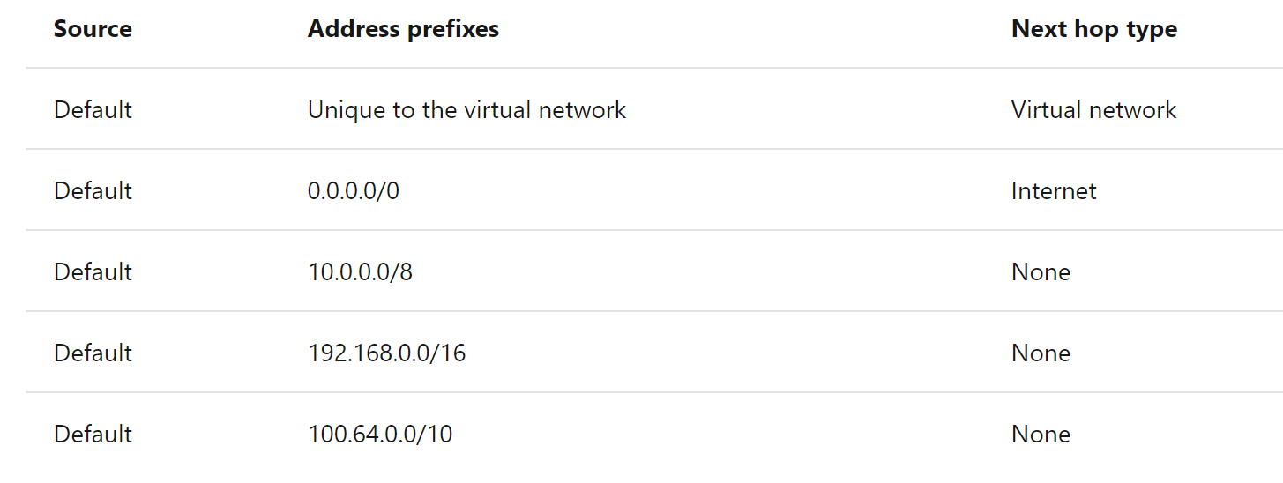
Figure 2 Default System Route

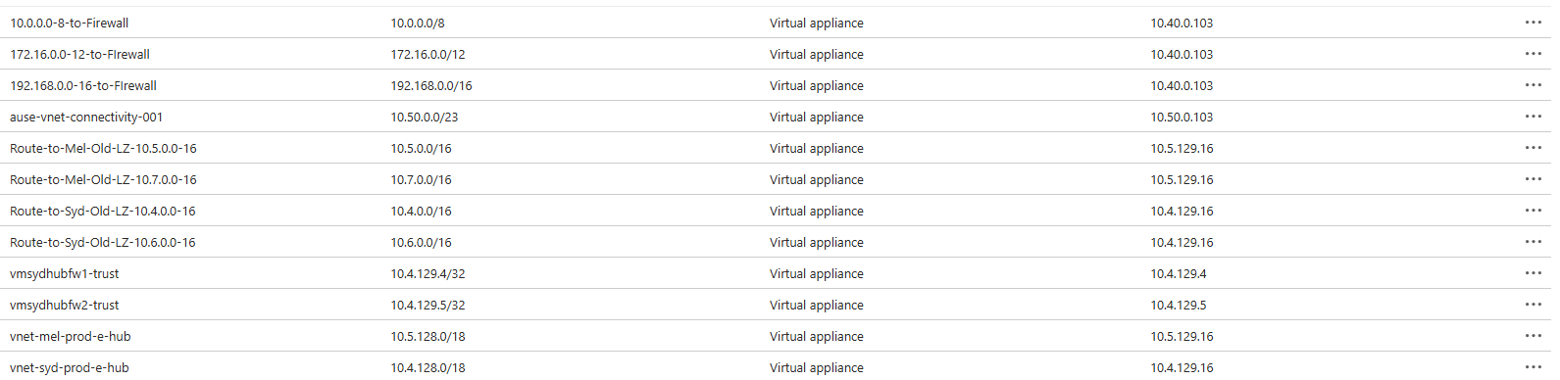
Figure 3 Azure Route Table

If multiple routes contain the same address prefix, Azure selects the route type, based on the following priority:
- User-defined route
- BGP route
- System route

Palo Alto Test Cases
Developing effective test cases for this Palo Alto deployment is crucial to ensuring that all core requirements—such as security, compliance, scalability, and operational readiness—are met from the outset. Developing test cases involves mapping these architectural components to business and regulatory needs.

Identify Palo Alto Components to Test
Following will be tested:
- Network and Firewall connectivity and routing
- Inter Landing zone connectivity of Firewalls and Panorama.
- Cross-region connectivity or HA and Failover.
- Identity integrations (single sign-on, multi-factor authentication)
- Load balancing and traffic distribution
- Monitoring and alerting
- Backup and Restore

Azure Perimeter Protection
Securing the edge in ESLZ cloud architectures is crucial. Perimeter protection involves defending network boundaries—such as virtual networks, gateways, and endpoints—to block unauthorised access and mitigate threats before they reach vital resources.
Palo Alto VM-series firewalls act as perimeter protection in the Azure Landing Zone by:
- Serving as the central enforcement point for all North-South (internet and on-premises) and East-West (inter-VNet) traffic, ensuring that all ingress and egress flows are inspected and controlled.
- Being deployed in the hub (Connectivity Subscription) behind Azure Load Balancers, so all traffic entering or leaving the cloud environment must traverse the firewalls.
- Providing advanced security functions at the perimeter, including intrusion prevention, threat intelligence, URL filtering, DDoS mitigation, and explicit allow-listing of authorized traffic.
- Enforcing deep packet inspection and blocking unauthorized or suspicious traffic at the network and transport layers.
- Integrating with Azure native controls (VNet peering, user-defined routes) to ensure that no traffic bypasses the perimeter firewalls.
- Logging and monitoring all perimeter traffic for compliance and incident response, with logs forwarded to Panorama and SIEM tools.
This design ensures that the Palo Alto firewalls are the mandatory security gateway for all inbound and outbound traffic, fulfilling the perimeter protection role for the Azure environment. No other firewalls are implemented between internal networks and public infrastructure.

Palo Alto Firewall
The deployment of Palo Alto VM-Series firewalls in Azure ensures that APM meets stringent compliance and governance requirements that exceed the capabilities of native Azure security controls. This will ensure compliance with regulatory frameworks requiring advanced inspection, detailed logging, and centralised policy management that cannot be achieved solely with NSGs or ASGs. The Palo Alto VM-Series firewalls provide Layer 7 visibility, intrusion prevention, URL filtering, and threat intelligence integration capabilities essential for demonstrating compliance with data protection and access control standards. They also enable consistent enforcement of corporate security policies, ensuring transparency and accountability. By integrating with Azure’s native services such as Azure Sentinel, and providing centralised management through Panorama, the VM-Series solution supports compliance reporting, policy version control, and end-to-end monitoring. This ensures that the deployment satisfies regulatory and internal audit requirements but also strengthens APM’s overall security posture and risk management framework.
During the design and technical requirements sessions, it was decided to separate the East-West and North-South traffic filtering into separate firewall cluster instances, with one set of two firewalls performing East-West and a second set of two firewalls performing North-South traffic filtering.
There was also consideration for interconnecting networks and resources between the existing landing zone and the new one.
APM team made the following decisions about traffic flows to be inspected in-line with the new VM-Series.
- east-west traffic within the new landing zone
- east-west traffic between the new and legacy landing zones in the same region
- outbound traffic to the internet (including traffic to the Zscaler Cloud Proxy)
- traffic to and from Meraki SDWAN

For the LZ deployment, there is an inbound traffic inspection requirement which is handled by the North-South firewall set. While there will not be inbound traffic initially after the deployment of the firewalls set, the infrastructure is ready to process inbound traffic with the additional deployment of an external Azure Load Balancer and route table.
General Considerations for VM-Series in Azure
There are several unique considerations when deploying Palo Alto Networks VM-Series in public cloud environments such as Azure. These are mostly due to constraints of networking in the provider’s cloud environment and due to the requirement to have a more dynamic or automated deployment.
- VM-Series firewall instances operate independently: For this outbound topology behind the Azure Internal Load Balancer (LB), resiliency is achieved via LB health checks. There is no traditional PAN HA involved in this scenario. This does mean that there is no shared session state between firewalls, so a single firewall failure will require that sessions be reestablished on the other active firewall.
- Generic Configuration: In general, a key design principle is to avoid unique device configurations so that the firewall instances can easily be deployed or scaled with mostly identical configurations. Examples of configuration settings that enable scalability are using DHCP for VM-Series management interfaces and referencing interfaces instead of IP in NAT policies. This is especially important with bootstrapping, as N-number of VMs can join to the same Panorama template stack and device group and automatically retrieve their configurations.
- Zones: In the Azure Transit VNet topology for the East-West firewalls, all traffic coming into the firewalls from either VNets or backhaul connections such as the Meraki vMX appliance will ingress on the same VM-Series interface, and thus the same zone. This means that you will not be able to rely solely on zones for making security policies for traffic between internal resources. Instead, look towards using address objects based on use case (Subnet CIDR ranges, etc), or using dynamic address groups based on VM Labels.

Hub VNet Dual Firewall Sets with Azure load-balancers
With this separation model of different firewall sets for East-West and North-South filtering, there are two pools of two VMs deployed behind Azure Load Balancers.
The Hub VNet model distributes various traffic profiles across resources in multiple VNets and is highly scalable. This design model is composed of a single transit/hub VNet and one or more subscriber/spoke VNets. This hub VNet does not typically contain any virtual computer resources and acts only as a central point for interconnecting the spoke VNets. It provides inbound, outbound, and backhaul access for spoke VNets as a shared service and controls east-west traffic between spokes.
The model requires the establishment of a VNet peering relationship between each spoke VNet and the hub VNet. You cannot use overlapping IP address space for the hub and/or spoke VNets, all connected VNets must use unique IP address space.
Outbound Traffic from Private Subnets
User-defined routes (UDR) on the private subnets direct traffic to the internal load balancer’s front-end IP address, which shares a subnet with the firewall private interfaces. The internal load balancer in the transit VNet distributes traffic to the set of firewalls. Load-balancer rules forward all TCP and UDP ports to the firewalls.
Outbound HTTP and other non-HTTP traffic are forwarded differently. The firewalls establish IPSEC VPN tunnels to Zscaler that are used for the HTTP traffic. For non-HTTP traffic, the firewall translates the source address to its public interface IP. Azure applies second source NAT using the Public IPs (PIPs) directly attached to the VM-Series public interfaces before forwarding to the internet.
The firewall security policy allows appropriate application traffic from the resources in the private networks to the internet. Security policy rules allowing outbound access to the internet are included as part of the firewall security policy rulebase, and traffic not explicitly allowed through is dropped. Security profiles have been implemented to prevent known malware and vulnerabilities from entering the network in return traffic allowed by the security policy. URL filtering, file blocking, and data filtering protect against data exfiltration. All outbound traffic is logged by the firewall. Outbound access is restricted by security policy to only allowed URL categories and applications. Access to proxy-avoidance and anonymizers is blocked and logged by URL filtering category.
East-West Traffic Filtering
For the APM deployment, all East-West traffic between VNets is routed via VM-series. A UDR has been applied to the landing zones subnets to forward traffic to the internal load balancer, and then onto the destination VNet via the firewalls.
Backhaul Traffic from Meraki SD-WAN
All backhaul traffic is sent to the Meraki SD-WAN solution in the legacy landing zone in the Australia East region. The Meraki SD-WAN solution advertises BGP routes into Azure. The traffic inspected by the firewall is forwarded to the active Meraki VM.
Management Traffic
For management traffic from VM-Series that is destined to the internet, traffic will route via the private subnet to the private subnet load balancer to be filtered by the East/West firewall before egress to the internet.
VNet peering
VNet peering can seamlessly connect two different VNets in Azure, enabling connectivity and traffic flow. It can be used to connect two VNets created in different regions and subscriptions.
Both the new and existing workload/spoke VNets will establish VNet peering with the new hub VNet in the same region. Only east-west traffic within the same region is forwarded to the firewall for inspection.
There are also inter-region VNet peerings, but they are only for accessing Panorama and Meraki vMX that reside in Australia East.
The following diagram shows the network topology and traffic flows for both regions, showing the dual firewalls sets in Australia East region and the single firewall instances in Australia SouthEast.
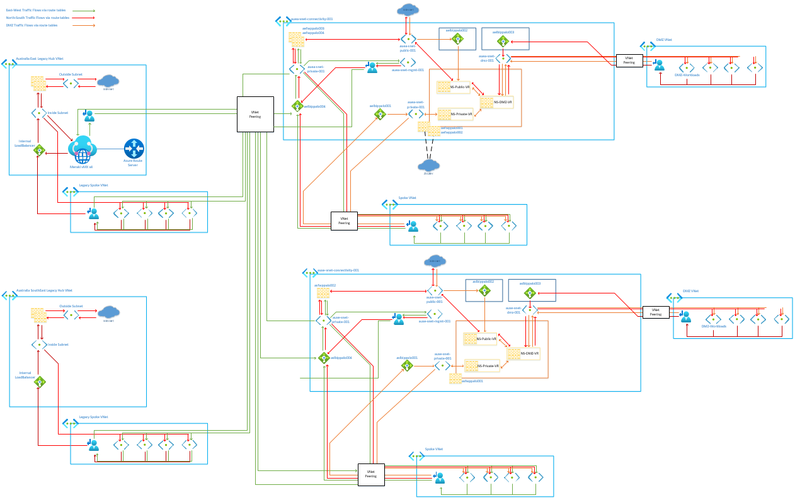
Figure 4-VNET Peering
Azure VM-Series Palo Alto Firewall Instances
Table 1 shows the security appliances with their corresponding locations, the PAN-OS version installed, and the serial number.

Device Name | Platform Model | PANOS Version | Location
aefwppalo001 | 8 vCPU Standard_D8as_v5 | 11.2.7-h7 | Australia East
aefwppalo002 | 8 vCPU Standard_D8as_v5 | 11.2.7-h7 | Australia East
aefwppalo003 | 16 vCPU Standard_D16as_v5 | 11.2.7-h7 | Australia East
aefwppalo004 | 16 vCPU Standard_D16as_v5 | 11.2.7-h7 | Australia East
asfwppalo001 | 8 vCPU Standard_E8-4as_v5 | 11.2.7-h7 | Australia Southeast
asfwppalo002 | 8 vCPU Standard_D8as_v5 | 11.2.7-h7 | Australia Southeast
Panorama
aefwppano01 | 16 vCPU Standard_D16as_v5 | 11.2.7-h7 | Australia East
asfwppano01 | 16 vCPU Standard_D16as_v5 | 11.2.7-h7 | Australia Southeast
Table - Azure VM-Series Palo Alto Firewall Instances

Device Licensing
Table 2 shows the security appliances with their corresponding procured licensing.

Device Name | License
All North/South VM-series firewalls | Advanced Threat Prevention, Advanced Wildfire Filtering, Premium Support.
All East/West VM-series firewalls | Advanced Threat Prevention, Advanced DNS Security, Advanced Wildfire Filtering, Advanced URL Filtering, Premium Support.
Both Panorama instances | Premium, Device Management License.
Table – Applied Firewall Licensing
Firewall High Availability
There is no traditional PAN-OS high availability configured for this deployment. Resilience is instead achieved through use of Azure Load Balancers. In the event of failure or maintenance, the Load-Balancer (LB) health probe detects the failed VM and stops sending traffic to that backend.
Log Forwarding
As per design decision 5.5.1.9 logs from the firewalls are forwarded to Panorama for log collection. This includes security, threat, URL filtering, wildfire, and system logs from all the firewalls. These logs will then be forwarded in syslog format to Azure sentinel via a syslog server VM.
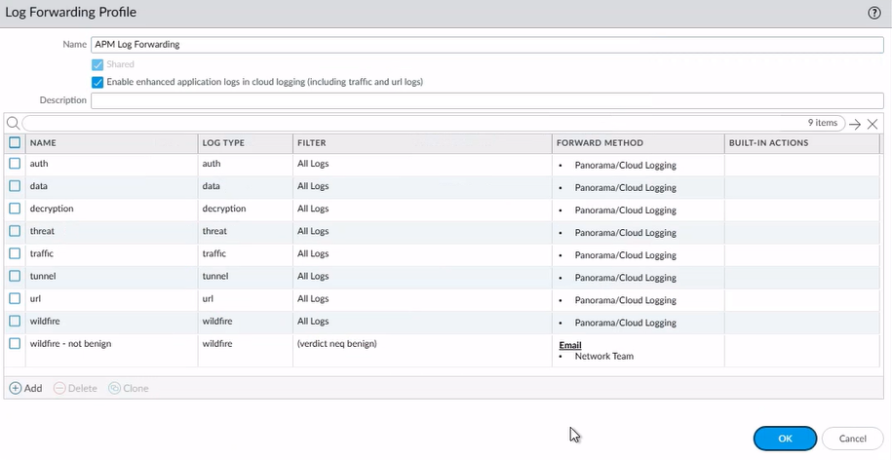
Figure 5 Log Forwarding

Figure Log Forwarding Profile configured and deploy to all firewalls from Panorama
Access and Authentication
Authentication to the management interface of Panorama and the firewalls are via SAML authentication to Entra ID, with a backup local break-glass admin account for access in emergencies. Access to Panorama and the firewall instances will only be allow from a secure high-privileged jump host server.
Panorama Firewall Management
Palo Alto Panorama is a centralised network security management platform that allows organisations to oversee and control multiple Palo Alto next-generation firewalls from a single pane of glass. Two Panorama management instances have been deployed into the Australia East and Australia SouthEast regions to manage all Palo Alto Azure firewalls.
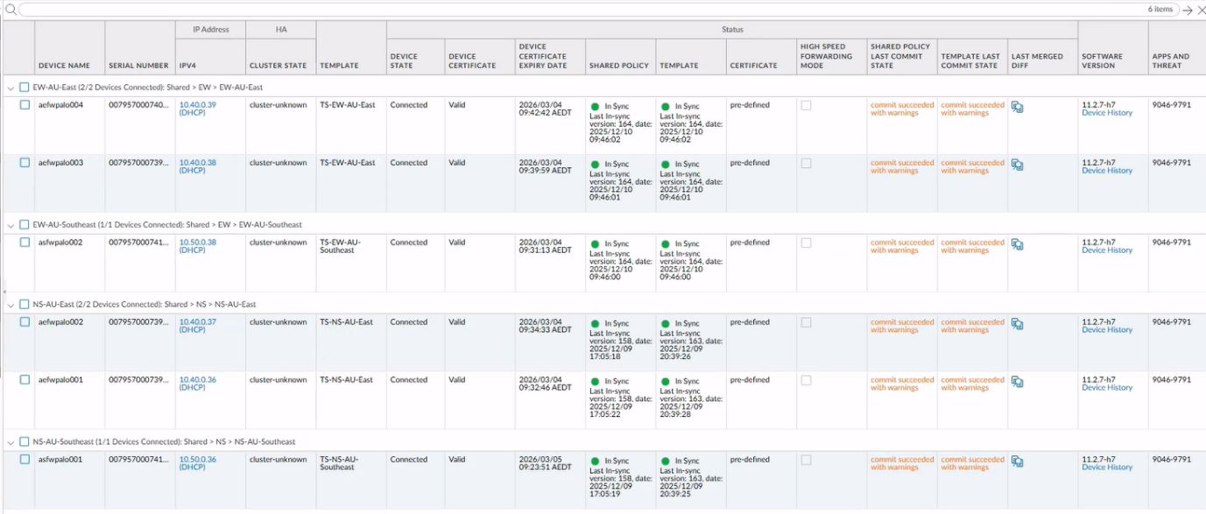
Figure 6 Panorama Firewall Connected Device Summary
A 2TB logging disk has been added to both Panorama instances to provide storage for logs forwarded from all the VM-Series firewalls.
Once the logging disk is filled, Panorama will start deleting the oldest log entries to start a rolling log storage.
Additional 2TB logging disks can be added later to increase the log retention period.
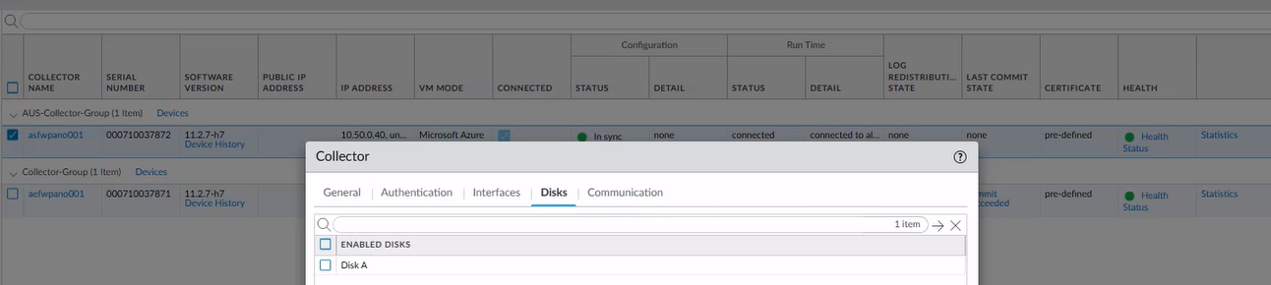
Figure 7 Panorama Log Collector Configuration

Panorama High Availability
Palo Alto Panorama high availability (HA) is a configuration of two Panorama management servers in an active/passive pair to provide redundancy and prevent a single point of failure. The secondary (passive) server has a synchronised copy of the primary (active) server's configuration and automatically becomes active if the primary fails, ensuring continuity of management for connected firewalls.
Two Panorama instances have been deployed, one in each region, with Australia East as the active instance and Australia SouthEast as the passive instance.
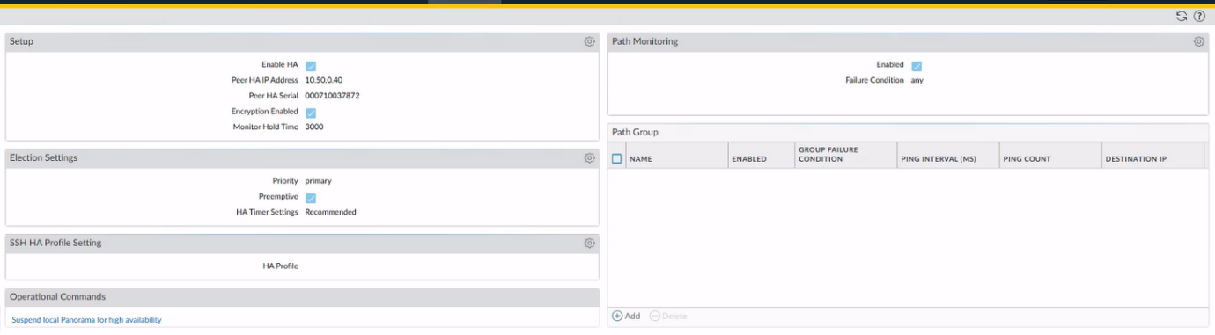
Figure 8 Panorama Primary Instance High Availability Configuration

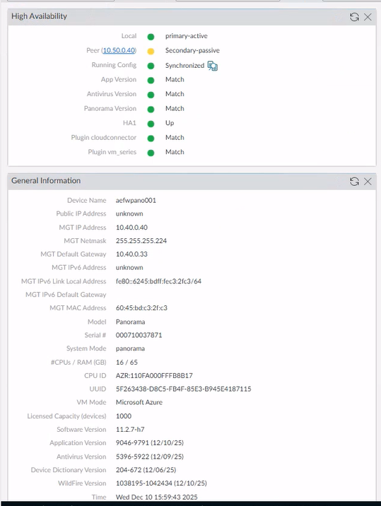
Figure 9 Panorama High Availability Status and General Information

Templates
Due to the varying unique networking configurations required on each firewall, each firewall VM has been assigned to a template stack. Any changes to firewall device configuration will be made via these templates on Panorama instead of locally on the device. This will ensure that all the VMs in a template stack will have identical and consistent configuration that is managed centrally instead of locally on each firewall. It also enables the scaling, where additional firewalls can be added to load balancer backend pools easily if needed in response to increased traffic/resource demand. Certain settings common to all devices (administrators, server profiles, etc) are added to the global template and pushed to all devices.
Template Structure
- TS-NS-AU-East: T-Global->T-NS->T-NS-AU-East
  - aefwppalo001
  - aefwppalo002
- TS-EW-AU-East: T-Global->T-EW->T-EW-AU-East
  - aefwpalo003
  - aefwpalo004
- TS-NS-AU-Southeast: T-Global->T-NS->T-NS-AU-Southeast
  - aefwpalo001
- TS-EW-AU-Southeast: T-Global->T-EW->T-EW-AU-Southeast
  - asfwpalo002
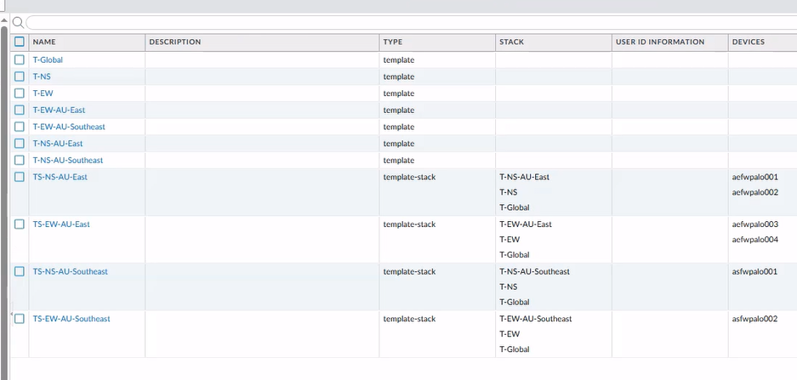
Figure 10 Panorama Template Configuration

Device Groups
Firewall policies have been split between the E/W and N/S firewalls and in each device group all devices will have identical policies. All objects are created in the Shared context and policies in the post-rules of the Azure-specific Device Group.
Device Group Structure
- Shared>EW>EW-AU-East
  - aefwpalo003
  - aefwpalo004
- Shared>EW>EW-AU-Southeast
  - asfwpalo002
- Shared>NS>NS-AU-East
  - aefwpalo001
  - aefwpalo002
- Shared>NS>NS-AU-Southeast
  - asfwpalo001

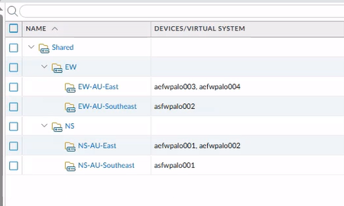eastF
Figure 11 Panorama Device Group Configuration
Operational Interfaces
The operational interfaces are configured to obtain IP addresses from the Azure DHCP. The following IP addresses are configured statically in Azure vNIC configuration.
Table 8 shows the APM Palo Alto interface configuration for all firewalls in both Azure regions.

Device Name | Interface | Type | Mgt Profile | IP | Virtual Router | Zone
aefwpalo001 | mgmt | mgmt | N/A | 10.40.0.36 (DHCP) | N/A | N/A
aefwpalo001 | ethernet1/1 | layer3 | azure-lb-health-probe | 10.40.0.69 (DHCP) | VR-Public | Public
aefwpalo001 | ethernet1/2 | layer3 | azure-lb-health-probe | 10.40.0.101 (DHCP) | VR-Private | Private
aefwpalo001 | ethernet1/3 | layer3 | azure-lb-health-probe | 10.40.0.132 (DHCP) | VR-DMZ | DMZ
aefwpalo001 | tunnel.1 | layer3 | N/A | N/A | VR-Public
aefwpalo002 | mgmt | mgmt | N/A | 10.40.0.37 (DHCP) | N/A | N/A
aefwpalo002 | ethernet1/1 | layer3 | azure-lb-health-probe | 10.40.0.70 (DHCP) | VR-Public | Public
aefwpalo002 | ethernet1/2 | layer3 | azure-lb-health-probe | 10.40.0.102 (DHCP) | VR-Private | Private
aefwpalo002 | ethernet1/3 | layer3 | azure-lb-health-probe | 10.40.0.133 (DHCP) | VR-DMZ | DMZ
aefwpalo002 | tunnel.1 | layer3 | N/A | N/A | VR-Public
aefwpalo003 | mgmt | mgmt | N/A | 10.40.38 (DHCP) | N/A | N/A
aefwpalo003 | ethernet1/1 | layer3 | N/A | 10.40.0.72 (DHCP) | VR | Public
aefwpalo003 | ethernet1/2 | layer3 | azure-lb-health-probe | 10.40.0.103 (DHCP) | VR | Private
aefwpalo004 | mgmt | mgmt | N/A | 10.40.37 (DHCP) | N/A | N/A
aefwpalo004 | ethernet1/1 | layer3 | N/A | 10.40.0.73 (DHCP) | VR | Public
aefwpalo004 | ethernet1/2 | layer3 | azure-lb-health-probe | 10.40.0.104  (DHCP) | VR | Private
asfwpalo001 | mgmt | mgmt | N/A | 10.50.39 (DHCP) | N/A | N/A
asfwpalo001 | ethernet1/1 | layer3 | azure-lb-health-probe | 10.50.0.69 (DHCP) | VR-Public | Public
asfwpalo001 | ethernet1/2 | layer3 | azure-lb-health-probe | 10.50.0.101 (DHCP) | VR-Private | Private
asfwpalo001 | ethernet1/3 | layer3 | azure-lb-health-probe | 10.50.0.132 (DHCP) | VR-DMZ | DMZ
asfwpalo002 | mgmt | mgmt | N/A | 10.50.35 (DHCP) | N/A | N/A
asfwpalo002 | ethernet1/1 | layer3 | azure-lb-health-probe | 10.50.0.70 (DHCP) | VR | Public
asfwpalo002 | ethernet1/2 | layer3 | azure-lb-health-probe | 10.50.0.102 (DHCP) | VR | Private
Table 8 Interface Configurations
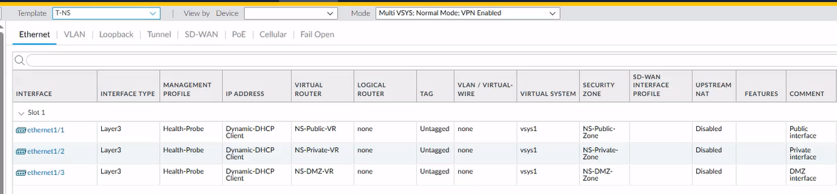
Figure 12 North/South Firewall Interfaces
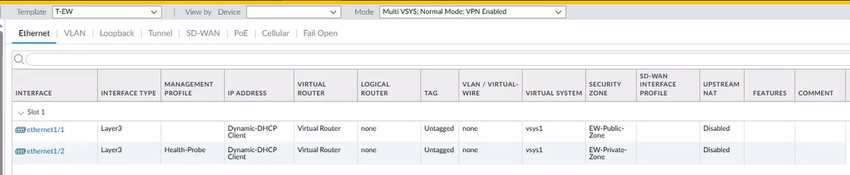
Figure 13 East/West Firewall Interfaces
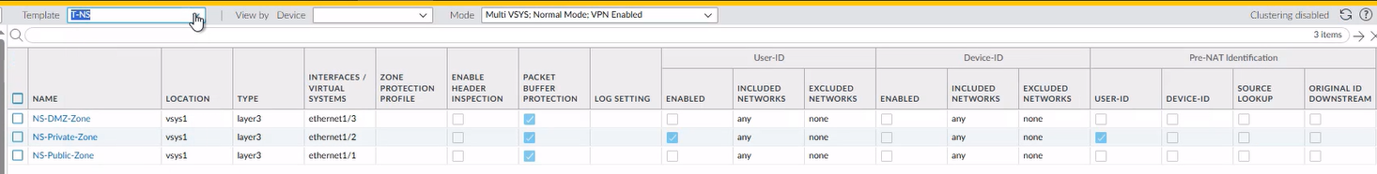
Figure 14 North/South Firewall Zones
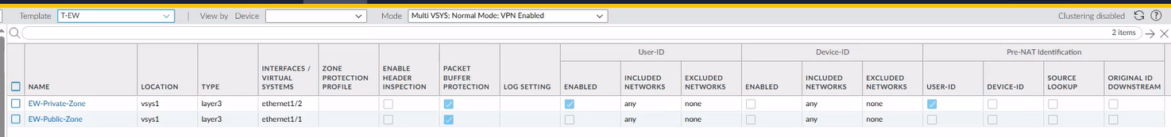
Figure 15 North/South Firewall Zones
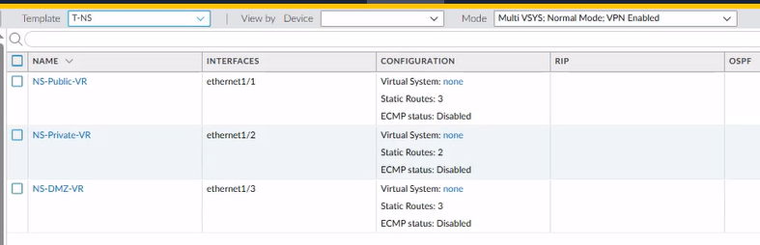
Figure North/South Firewalls Virtual Routers
|
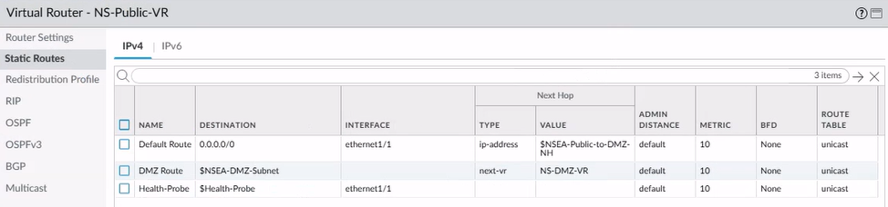
Figure North/South Firewalls NS-Public-VR Virtual Router

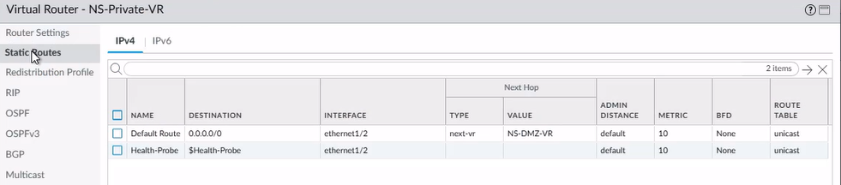
Figure North/South Firewalls NS-Private-VR Virtual Router

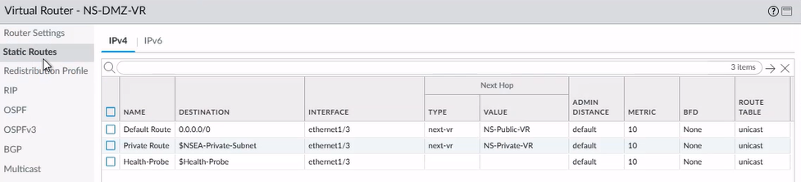
Figure North/South Firewalls NS-DMZ-VR Virtual Router
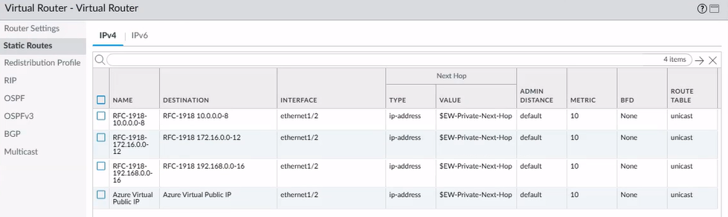
Figure East/West Firewalls Virtual Router
Device Management Settings:

Setting | Value
Domain | apm.com.au
Time Zone | Australia/Melbourne
Panorama Servers | 10.40.0.40  10.50.0.40
Enable pushing device monitoring data to Panorama | Enabled
Enable automated commit recovery | Enabled
Enable Duplicate Logging (Cloud and On-Premise | Enabled
Enabled Enhanced Application Logging | Enabled
Table 9 Management Settings
Services Settings:
Setting | Value
Update Server | updates.paloaltonetworks.com
Primary DNS Server | TBC – Pending decision from Infrastructure Team
Secondary DNS Server | TBC – Pending decision from Infrastructure Team
Primary NTP Server | TBC – Pending decision from Infrastructure Team
Secondary NTP Server | TBC – Pending decision from Infrastructure Team
Service Route for External Dynamic Lists | Use Management Interface for All
Table 10 Services Settings
Management Interface Settings:
Setting | Value
IP Type | Static
IP Address | See Device IP Allocation
Default Gateway | See Device IP Allocation
Administrative Management Services | HTTPS/SSH
Network Services | SNMP/Ping
Table 11 Management Interface Settings

Palo Alto Dynamic update Settings:
Feature | Update Type | Update Frequency
Antivirus | Download and Install | Every Hour
Applications and Threats | Download and Install | Every 30 minutes at 10 minutes past half-hour
GlobalProtect Client | None | None
Wildfire | Download and Install | Every minute
Table 12 Palo Alto firewall Dynamic Update Settings
Security Policy:
A standard set of security policy rules have been created as part of this deployment, this includes the creation of two global blocking rules in the Shared device group which each block traffic to and from known high-risk and malicious IP addresses and fully qualified domain names. These rules use External Dynamic Lists (EDLs) which regularly update the addresses from public lists provided by Palo Alto Networks.
Also included in the initial security policy deployment was the creation of allow rules for the Azure load balancer health probes to ensure that the load balancers backend pools can see the firewalls as online so they will forward traffic to the firewalls when it is received by the load balancers.
There is an allow rule for internal ICMP for network services that rely on ICMP and for network diagnostics and troubleshooting.
Lastly, there are a number of rules to allow other required traffic such as firewalls to Panorama, panorama and the firewalls to the internet, and VPN to Zscaler.
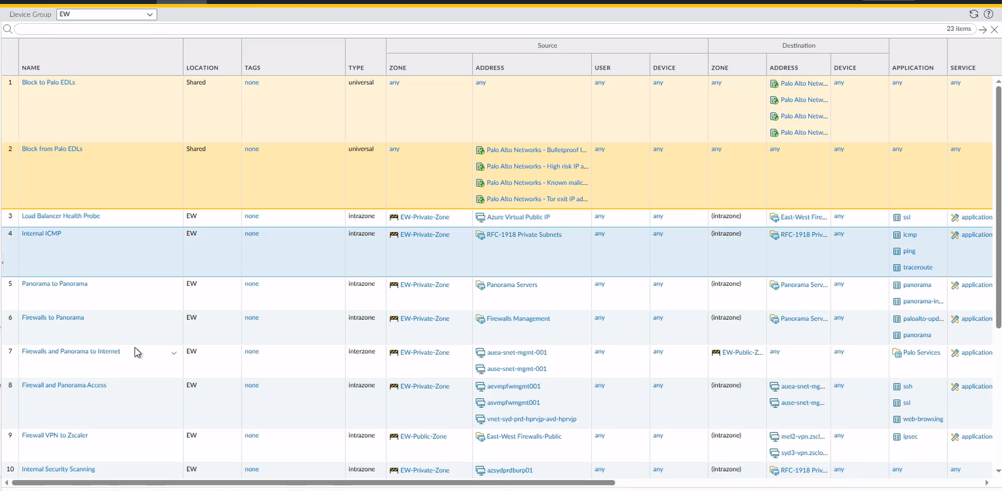
Figure 21 Security Policy

The default interzone and intrazone rules on all the firewalls have been overridden to change the rule behaviour to drop traffic, to log the session drop, and to forward logs to Panorama.
Figure 22 Intrazone & Interzone Rules
NAT Policy:
Network Address Translation (NAT) rules have only been created for the East/West firewall during this deployment to provide outbound access to the internet from the new Landing Zone hub and spoke VNets.
Additional NAT rules will be added later as required to support workloads as they are deployed into the new Azure Environment.
Table 13 North/South Firewall NAT rule

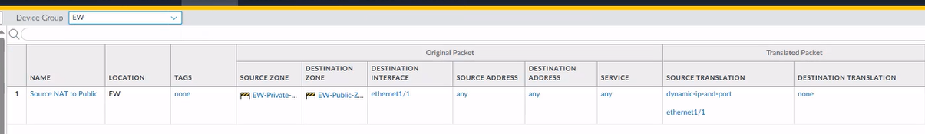
Table 14 East/West Firewall NAT rule
Azure DevOps/Terraform Firewall Deployment

Azure DevOps/Terraform Overview
The implemented solution combines Azure DevOps for orchestration and Terraform for infrastructure provisioning. Azure DevOps serves as the central platform for version control, continuous integration (CI), and continuous deployment (CD). All infrastructure code, configuration files, and automation scripts are maintained within a single repository for each Azure region. Terraform provides the underlying Infrastructure as Code (IaC engine used to build and manage all resources associated with the Palo Alto firewall deployment. Deploying the firewall VMs and their associated resources using Azure DevOps and Terraform meets APM’s requirements to have a consistent deployment method for all Azure resources and enables the re-deployment of resources from code in a disaster recovery scenario.
Architectural Summary
The Terraform solution provisions all Azure components necessary to host the Palo Alto VM-Series firewall instances, including the creation of virtual networks and associated subnets for management, trust, untrust, and DMZ layers. Routing tables and network security rules are constructed in alignment with approved design standards. Firewall virtual machines are deployed in accordance with the required availability, scaling, and performance specifications, ensuring a robust perimeter and internal segmentation capability. The architecture is built so that any environment whether development, testing, or production, can be deployed automatically using the same underlying modules, with differences defined only through environment-specific configuration inputs. This ensures that the overall environment remains aligned to both design and governance standards.
IaC Deployment files:
File Name | File Type | Description
scripts/export-tfvars.ps1 | powershell | Powershell script to generate the terraform.tfvars file with all the variable values from the Azure DevOps variable group
scripts/importVariables.ps1 | powershell | Powershell script to create/update the Azure DevOps variable group and upload variable values from the JSON file
avsetEW.tf | terraform | Deploys the availability set for the East/West firewalls
avsetNS.tf | terraform | Deploys the availability set for the North/South firewalls
azure-pipelines.yml | YAML | Azure pipeline file which manages sets up the deployment, runs the scripts and the runs the terraform deployment inside the Azure DevOps environment
dmz-lb.tf | terraform | Deploys the loadbalancer, LB rules, health probe and frontend and backend pools for the DMZ subnet and links to the North/South firewalls
firewall1.tf | terraform | Deploys North/South firewall 1, vNICs, Public IP (PIP), and OS disk
firewall2.tf | terraform | Deploys North/South firewall 2, vNICs, PIP, and OS disk
firewall3.tf | terraform | Deploys East/West firewall 1, vNICs, PIP, and OS disk
firewall4.tf | terraform | Deploys East/West firewall 2, vNICs, PIP, and OS disk
internal-lb.tf | terraform | Deploys the loadbalancer, LB rules, health probe and frontend and backend pools for the Private subnet and links to the East/West firewalls
main.tf | terraform | Defines all existing resources in Azure that have already been deployed so they can be referenced in other terraform files
panorama.tf | terraform | Deploys Panorama, vNIC, OS disk and logging disk
private-lb.tf | terraform | Deploys the loadbalancer, LB rules, health probe and frontend and backend pools for the Private subnet and links to the North/South firewalls
public-lb.tf | terraform | Deploys the loadbalancer, LB rules, health probe and frontend and backend pools for the Public subnet and links to the North/South firewalls
variables.json | JSON | Contains all the variable values that are uploaded to Azure DevOps variable group during the deployment
variables.tf | terraform | Defines all variables used in the terraform files
Table Deployment Files

Deployment Methodology
The deployment methodology follows a structured CI/CD approach designed to support governance while enabling efficient delivery. As part of the deployment, when the CD pipeline is initiated, a planning sequence where the environment’s configuration is assembled and a Terraform plan is generated. This plan outlines precisely what infrastructure will be created or modified, providing reviewers with full visibility into the scope and impact of the deployment. Once approved, the system executes an automated apply sequence where Terraform provisions or updates the Azure resources. This method ensures full traceability, predictable outcomes, and a clear separation of duties between development, operations, and governance teams. During this deployment, approval was enabled by adding the apply command to the pipeline file once the terraform plan was developed and approved.
Deployment Dependencies:
To facilitate this deployment, there was some manual preparation involved in setting up the deployment, this includes creating the project repository in Azure DevOps, uploading the files to the repository, creating the backend config variable group and adding the values, and creating the pipeline. Once these were created through the Azure DevOps portal, the automation through the pipeline was able to complete the deployment.
Variable Group:
Variable Name | Value | Description
BACKEND_CONTAINER_NAME | firewall-tfstate | Name of the container in the storage account used to store the terraform state file
BACKEND_STATE_KEY | auae-palo-deployment.tfstate  auas-palo-deployment.tfstate | Name of the terraform state file, this will change between deployments in different regions as this will be two different states
BACKEND_STORAGE_ACCOUNT_NAME | auestpdevopstfst001 | Name of the storage account where the container sits
BACKEND_SUBSCRIPTION_ID | 11e390a7-880a-4d2b-8d3e-d80af1138665 | Subscription ID of the storage account for storing terraform state
DEPLOYMENT_SUBSCRIPTION_ID | 8f23887a-5cac-4932-8929-5c6fe0294808 | Subscription ID where the resources will be deployed by terraform
SERVICE_CONNECTION_PLAN | sc-alz-mgmt-apply | Name of the service connection in the Azure DevOps portal
VARIABLE_GROUP | auae-palo-deployment-variables  auas-palo-deployment-variables | Name of the variable group that will be used to store the deployment variable values, this will change between deployments in different regions as this will be two different states
Table Deployment Dependencies

The second dependency for the deployment is the requirement to create a password entry in the Azure Key Vault for the local admin password for the firewall VMs and Panorama once they are deployed.
The secret entry name in the Azure Key Vault should be:
palo-firewall-password
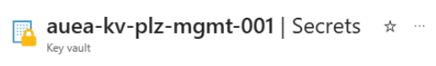
Figure 23 Key vault storage location

Use of Azure DevOps
Azure DevOps plays a central role in orchestrating deployments and maintaining the integrity of the configuration. The repository structure groups Terraform modules, environment configuration, pipeline definitions, and automation scripts into a structured and maintainable layout. All infrastructure state files are securely stored in Azure Storage accounts configured through the pipeline, ensuring consistent state management across deployments. Azure DevOps Service Connections facilitate secure authentication to Azure subscriptions, ensuring that only approved and audited service principals can deploy infrastructure. Variable Groups within DevOps act as the authoritative location for all environment-specific configuration and secret values. This ensures configuration consistency while also enforcing strong security practices around credential storage, as sensitive values are never exposed in code.
Terraform Implementation
Terraform serves as the declarative definition of the firewall environment. Its modular design allows each part of the infrastructure networking, firewall nodes, interfaces, routing, and public IP configuration to be expressed as reusable templates. Environment-specific variables, provided by the JSON file and automatically generated into a tfvars files, make it possible to deploy the same underlying modules into any region simply by substituting input values such as IP ranges, region names, or resource group identifiers.
A critical design feature of this implementation is that the Terraform code is fully reuseable in a disaster recover scenario since no resource is created manually. All components are defined in code; the entire security stack can be redeployed in a new region by executing a standard pipeline and referencing the DR-specific tfvars file. This approach eliminates the need for manual reconstruction of firewall infrastructure during DR events and ensures that redeployed environments maintain architectural integrity, operational consistency, and security posture.
Automation Scripting
Custom automation scripts play an essential role in ensuring that the IaC approach remains reliable, maintainable, and DR-ready. In this deployment one script manages Azure DevOps Variable Groups by reading from the provided JSON variable file stored in the deployment repository. This ensures that environmental parameters such as IP ranges, VM sizing, naming conventions, and region selections are always correct and consistent across deployments. It also means that once the deployment is completed, the variable values used for the deployment are defined inside Azure DevOps library.
A second script generates the Terraform tfvars files used by each deployment. This script retrieves operational values, and from the Azure DevOps library and creates a completed terraform tfvars file for the relevant region. The generation of tfvars files removes human error from the configuration process and ensures that DR deployments use the same tested configuration values that are applied to primary deployments. In a DR scenario, these scripts allow APM to generate environment files dynamically, ensuring the same infrastructure can be reconstructed reliably in any region.
Retrofitted Deployment Code Testing
Developing effective test cases for this deployment is crucial to ensuring that all core requirements such as security, compliance, scalability, and operational readiness are met from the outset. Developing test cases involves mapping these architectural components to business and regulatory needs.
Due to timeline constraints we were unable to deploy the Palo Alto firewall VMs using a fully automated process initially, it was deployed in a semi-manual process where the terraform.tfvars file was manually created and used for the deployment. However, the deployment code has since been updated to include the scripting required to automatically generate the terraform.tfvars file as part of the Azure DevOps pipeline deployment. This code was then tested in a non-production environment with the same variable values as production to ensure that the deployment will succeed without issue if redeployment is required in a DR event.
The below images show the successful pipeline jobs running in Azure DevOps for both regions, and also the deployed resources in the relevant Azure resource groups. It also shows the before and after of the Azure DevOps library demonstrating the successfully importation of variable values into relevant variable groups for each regional deployment.
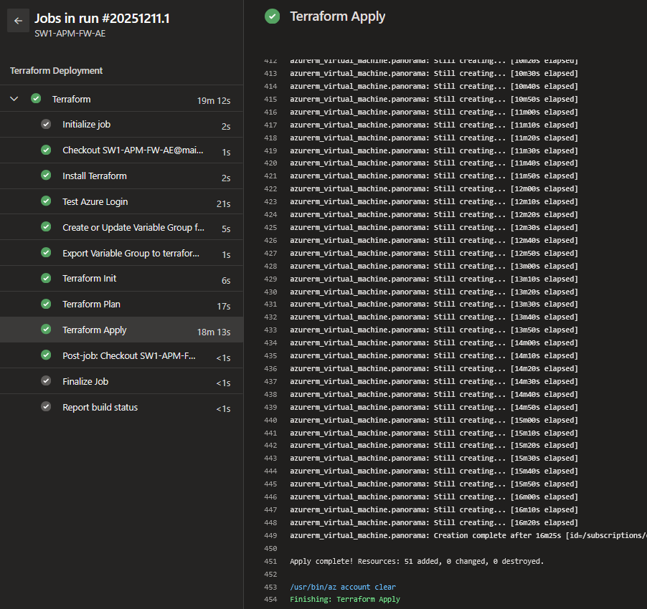
Figure 24 Australia East test firewall test deployment pipeline logs
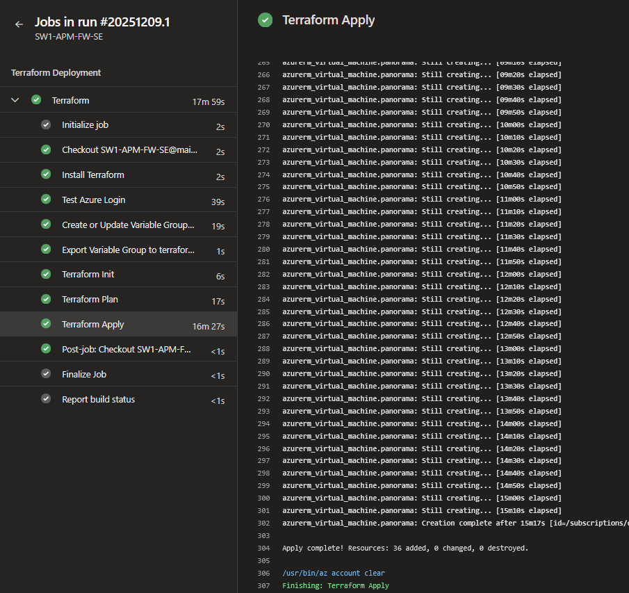
Figure 25 Australia SouthEast test firewall test deployment pipeline logs

Reference Network

Traffic Flow Design
The following diagram shows the network topology and traffic flows for both regions, showing the dual firewalls sets in Australia East region and the single firewall instances in Australia SouthEast.

Figure -Network Traffic Flow

