Detail Design Document
Template V0.1

Project Name:
Document Owner: | Samit Chandra,  Head of Digital Transformation & Architecture
Contact Details: | Samit.Chandra@apm.net.au
Program Name:
Division/Unit:
Document Status:
Document Version:
Product ID:

FOR INTERNAL USE ONLY
Commercial in confidence
© APM

Document control
Version History
Version | Date | Author | Key changes
V0.1

Consultation
Name | Position title | Date

References and Derivation
Version # | Document Title | Reference Location

SDA Approval
Name | Role/Group | Signature | Date

Confidentiality & Disclaimer
This document is provided by Advanced Personnel Management International Pty Ltd and / or its related entities (APM) on a confidential basis. This document is subject to approval of the APM Board and does not constitute an offer capable of acceptance. No agreement binding APM or its related companies in respect of this document is intended or proposed unless and until the terms and conditions between APM or its related entities are agreed in writing in a formal agreement with the named Company or Prospective Client.
APM will not be bound by any pricing or any other material contained in this response until the above has taken place.
Photography
Photographs used in this document are for illustration only
and should not be interpreted to mean that any person or organisation whose assets are shown in them endorses this document.
APM Contact
Communications regarding
this document should be forwarded to:
Head of Digital Transformation & Architecture
P 08 XXXX XXXX
M 08 XXXX XXXX
E samit.chandra@apm.net.au

Contents
1. Introduction 6
1.1 Purpose 6
1.2 Audience 6
2. Overview 7
2.1 Scope 7
2.2 Guiding Principles 7
2.3 Assumptions 7
3. Business Architecture 8
3.1 Business Reference architecture 8
3.2 Business Requirements 9
3.3 Gap treatment 9
4. Application Architecture 9
4.1 System Context Diagram 10
4.2 Solution/Product Component Inventory 10
4.3 Solution Interface Diagram 10
4.4 Solution/Product Interface catalogue 10
5. Technology Architecture 10
5.1 Technology Component Standards 11
5.2 Integration standards and patterns 11
5.3 Network & Infrastructure Standards & Patterns 12
5.4 Technology component Deployment Patterns 12
6. Information & Data Architecture 12
6.1 Information Model 12
6.2 Information Classification 13
6.3 Analytics and reporting Patterns 13
7. Cyber & Security Architecture 13
8. Service Availability and Disaster Recovery 13
8.1 Business Service Tiering 13
8.2 Service Availability 13
8.2 Disaster recovery & Resilience 13
9. Service Management 14
9.1 Service Management principles 14
9.2 Monitoring, Logging, Reporting and Alerting 14

1. Introduction

1.1 Purpose
What goes here: 3–4 sentences: what solution this document designs, what it covers and defers, and its relationship to other design documents. Write in present tense.
Example — This document provides the detailed technical design for the Participant Kiosk solution: a locked-down Windows 11 device build giving participants supervised access to Microsoft 365 web applications at APM sites. It records the agreed architecture, configuration baselines and design decisions, and is the reference for build, test and operational handover.

The purpose of this document is to provide a high-level logical architecture view of the implementation of initiative for << Project>> and related Integration Components and to define any Services required which will be implemented to allow satellite systems to integrate and coexist with inherent eco system. Services are also mapped to requirements (Business Use Cases) as part of this document.
This document will form the basis on which Technical Design document (TDD) for each distinct solution component can be prepared.
The aim of this document is to:
1. Outline the business requirements currently identified
2. Describe the logical architecture to meet those requirements
3. Describe the physical architecture to meet those requirements
4. Describe the solution decisions that have been made with the business requirements in mind and their implications. Though Functional requirements that are partially or fully enabled by solution design (vs tool capabilities) will be considered in this document, Non-functional requirements driven by service tiering and business will be addresses as well.
5. Outline data and cyber security requirements and policies & controls to adhere and meet APM cyber security guidelines and standards

1.2 Audience
Audience | Interest in this document
Architecture & design authority | Review and approval of the design
Cyber security | Control alignment and risk acceptance
Build & operations teams | Implementation and ongoing support
Service management | Support model, monitoring and escalation

The primary audience for the use of this document are APM’s Digital delivery, Digital operations, Cyber security, Information architecture team and project teams responsible for development/build, integration development, support, and maintenance. However, in order to build a framework that will support the business needs of APM, it is critical that the business owners and business operations staff be involved in the development of the framework, especially from the perspective of identifying the business requirements that are driving the development of the framework.
This includes:
- Business Sponsor,
- Business Partners,
- Project Management office,
- Digital Transformation & Architecture,
- Digital Operations
- Digital Delivery
- Cyber Security
And wider Digital teams.

2. Overview
<< Insert a description for the solution/product providing high level context and background for the using business friendly language and terms. >>

2.1 Scope
What goes here: bullet what this design delivers and — just as important — what it explicitly does not. An empty out-of-scope list is a red flag in review.
In scope | Out of scope
Windows 11 device build and kiosk configuration | Site network cabling and switching (network programme)
Conditional Access policy set for kiosk identities | Licensing procurement (reseller)
Intune configuration profiles and compliance policies | End-user support model (service management design)
Device provisioning and enrolment process

<<Insert a statement that explains the business scope including capabilities, process, people, that is impacted directly or indirectly by this initiative.
- What part of the business will this solution/product impact at the high level?
- Overlay of Business Capability Model to demonstrate impacted business areas, capabilities with heatmap
- Clearly outline items that are our-of scope and remediation

2.2 Guiding Principles
What goes here: the principles that shaped this design. Each should be checkable — a reviewer can ask "does the design honour this?"
Example — Modern management only — devices are Entra joined and Intune managed; no Active Directory dependency. Least privilege — no standing administrative access; elevation is time-bound and audited. Compliance by design — controls align to RFFR and the ASD ISM. Reuse before build — enterprise platform patterns are used unless a documented gap exists.

The Guiding Principles are a set of key statements and ideas that drive how elements of the project will be designed, implemented, and operated. These principles are contextualised focusing on the project deliver aligning to the project/program success criteria

2.3 Assumptions
What goes here: what you are relying on being true. If an assumption fails the design changes — each one should be testable and owned.
Ref # | Assumption | Impact if not true
A-01 | Required licensing is available before pilot | Provisioning blocked; pilot slips
A-02 | Site network is delivered before device deployment | Devices cannot reach cloud services
A-03

<<Outline key assumptions across all the architecture domain(business, Technology, Information & Integration and Cyber) made while conceptualisation of the solution>>

2.4 Risks
Ref # | Risk description | Severity | Probability | Mitigation
RK-01 | Upstream network design not approved before build window opens | High | Medium | Escalate via design authority; sequence non-dependent work first
RK-02

2.5 Issues and concerns
What goes here: issues raised in architecture and security reviews, plus unusual requirements. Unresolved issues carry into the project risk register.
Ref # | Issue description | Assigned to | Target resolution
IS-01 | Example — duplicate Conditional Access policies in tenant require consolidation before enablement | Platform team | DD-MM-YYYY
IS-02

2.6 Dependencies
Ref # | Dependency | Owner
D-01 | Code-signing certificate issued for device-side scripts | Cyber security
D-02 | Network design approved and change window scheduled | Network lead
D-03

2.7 Design decisions
What goes here: one card per major decision. The rationale is the most-read cell in the document — write it so a future engineer understands the trade-off without attending the meeting.
DD-01 — Session data persistence approach | Status: APPROVED
Options considered | 1. Persistent local profiles 2. Ephemeral session, wiped at sign-out 3. Roaming profiles
Preferred option | Option 2 — ephemeral session, wiped at sign-out
Rationale | Devices are shared by the public; any persistence risks cross-user data exposure. Wipe-on-exit removes the data-spill risk class entirely. Trade-off accepted: users must save work externally before ending a session.
Approved by | Design authority forum, DD-MM-YYYY
Reference | Decision record link / minutes

DD-02 — Decision to be made | Status: PROPOSED
Options considered | Option A; Option B; Option C
Preferred option | Option A
Rationale | Why the preferred option was selected, including trade-offs accepted
Approved by
Reference

2.8 De-scoped requirements
What goes here: requirements considered and explicitly removed from scope, with who approved the change.
Req # | Change | Details of approval
Example — BR-09 | Offline editing removed from scope | Approved at design forum DD-MM-YYYY

3. Business Architecture

<<The solution/product is a response to target business outcomes. These business outcomes are defined as part of the business architecture (BA).
- Explain how the solution/product supports the business architecture, calling out any objectives and target business outcomes — consistent use of business terms from an accepted glossary is advised. At minimum provide a description of the business capabilities impacted and how these and related BA models need to change to address target business outcomes. Provide a clear link from the BA required transformation to the solution/product.
- However, the scope of your solution/product architecture will determine the scope of the BA to be documented.
- For advice and guidance on BA and deliverables review Tool: Business Architecture Activities and Deliverables Close the Strategy-to-Execution Gap.
- Ensure the BA documentation (diagrams, tables, inventories and, presented conforms to standard notations and formats. Where possible, reuse BA documentation that might reside in a central repository.

3.2 Business Reference architecture
What goes here: where this solution sits in APM’s business capability landscape — which capabilities it enables or changes. One diagram plus a short paragraph.
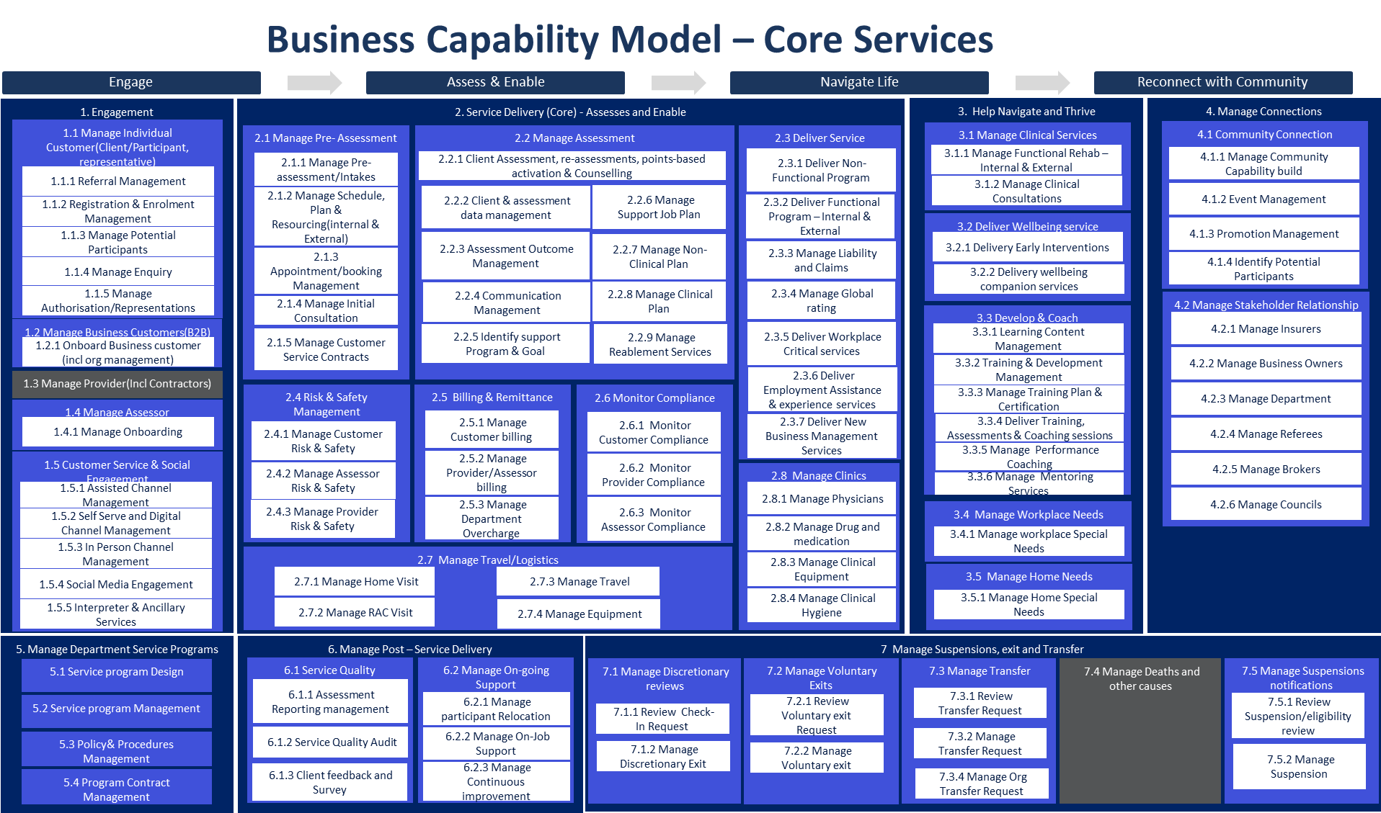
Figure — Example: business capability model with affected capabilities highlighted. Replace with the view for your solution.
<<Insert Business Reference architecture to articulate Business capabilities impacted, uplift expected, Values streams and business process enhanced or impacted as result of this initiative.>>
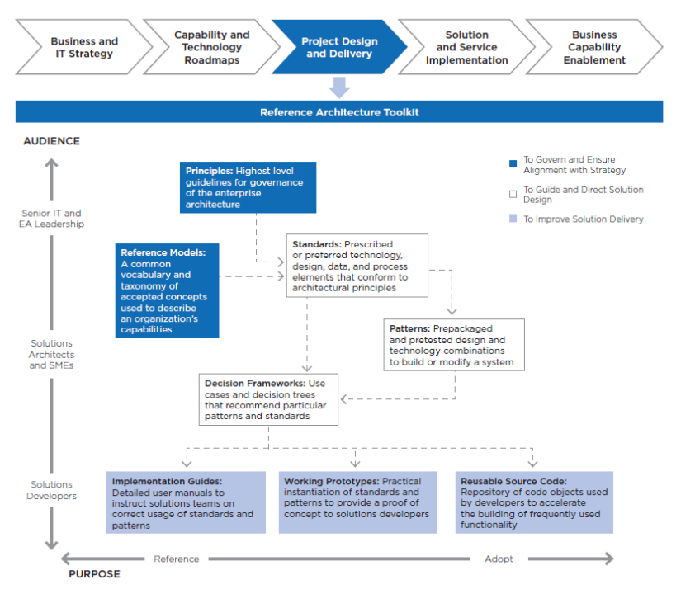
This is a reference from Design definition .This is a reference from Design definition
Figure 1. Reference Architecture Components
- For advice and guidance on BA and deliverables review Tool: Business Architecture Activities and Deliverables Close the Strategy-to-Execution Gap.
- Ensure the BA documentation (diagrams, tables, inventories and, presented conforms to standard notations and formats. Where possible, reuse BA documentation that might reside in a central repository.

3.3 Business Requirements
What goes here: the requirements this design must satisfy, traced from the requirements register. Every requirement should be verifiable in test.
Unique # | Category | Key requirement
BR-01 | Functional | Participants can access approved web applications to create and export documents
BR-02 | Functional | All session data is removed before the next user signs in
NFR-01 | Non-functional | Service available during site operating hours (08:00–18:00 local)
NFR-02 | Non-functional | Solution meets RFFR / ISM control requirements for the data it handles

<<Include architectural significant business requirements and gap analysis with the scope and high-level requirement traceability (met/Not met). Provide the link to business requirements document as a reference
Separate Functional and non-functional requirements to traceability and analysis.

3.4 Gap treatment
What goes here: where the solution cannot fully meet a requirement, record the gap, its impact, and the agreed treatment (accept / mitigate / defer with date).
Gap | Impact | Treatment | Owner
Example — offline editing not available | Connectivity required to work | Accepted — sites provide managed connectivity | Design authority

<<Insert the gap treatment agreed with business to address all the requirement which are not met with solution recommended>>

4. Application Architecture

<<Insert a description of the application architecture required for the solution/product. This description should include an explanation of the system and its components, including all applications and services that need to be integrated with the target solution/product. This section should describe the application architecture required to meet business and data transformation requirements, including data flows and interfaces to other applications and services.
- The description should clearly identify new investments in solution/product components such as the purchase of new software and/or technology components. The rationale for investing in new software or services over the reuse of existing solutions should be included. See The Must-Have Components of Procurement Technology Business Cases.
- Existing components that need to be changed should also be identified and the changes explained.
- If the enterprise application policy is “buy vs build,” and the recommendation is to “build,” then the business case should be included in these sections via a high-level statement and a link to the complete business case document.
- Include references to architecture documentation frameworks that are required by your enterprise. Examples can include:
  - 4+1 View Model — uses five different views (Logical, Development, Process, Physical and Scenarios) to describe software architecture.
  - C4 Model — uses four levels of diagrams (System Context, Container, Component and Code) to describe software architecture.
  - Views and Beyond — is a comprehensive approach to architecture documentation that incorporates multiple types of information.>>
- The scope of your solution/product will determine what application architecture documentation will be required.

- At a minimum, the following sections should be documented:
- For each of the sections, ensure:
- Standard naming conventions, notations, formats and reference data are used.
- Diagrams and inventories are reused from central repositories, and any changes are reflected in central repositories following change management processes.>>

4.1 System Context Diagram
What goes here: one diagram: the solution in the middle, every human and system actor around it, what flows on each line. If a reviewer can’t reconstruct the solution’s boundaries from this diagram alone, it needs more detail.
<<A system context model diagram that shows how the current and target solution/product interacts with other systems and services. This diagram should be in logical format and at high-level and should not detail any solution/product/interface components. Roles and processes, internal and external can be included.>>

4.2 Solution/Product Component Inventory
Component | Function | Version | Environment
Microsoft Edge | Locked-down browser shell for participant sessions | Stable channel | Production
Zscaler Client Connector | Secure web gateway tunnel from device | Latest GA | Production
Microsoft Intune | Device configuration, compliance and app deployment | Service | Production
Microsoft Entra ID | Identity, Conditional Access, device registration | Service | Production

<<An inventory of all solution/product components in scope. Where possible, this inventory should follow existing standards and document mandatory solution/product component reference data and IDs.
Clearly identify the components that are new and/or will require changes.>>
This should include solution version, licensing information.

4.3 Solution Interface Diagram
What goes here: sequence diagrams for the flows that are hard to reason about in prose — sign-in, session start/end, failure paths.
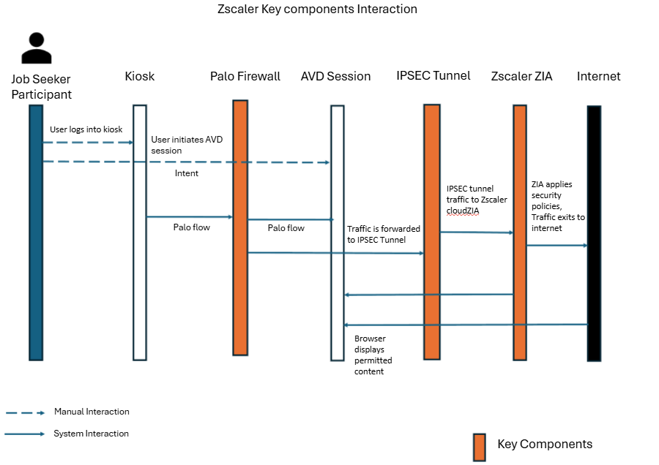
Figure — Example: device / gateway / cloud interaction sequence. Replace with the critical flows for your solution.
<<A diagram showing all solution/product components of type application and service, including all detailed interfaces. The diagram should follow accepted naming conventions for all objects, components and interfaces, referencing the correct master IDs and data in section 5.2 above.>>

4.4 Solution/Product Interface catalogue
Ref # | Source → destination | Method / protocol | Data exchanged
IF-01 | Device → Zscaler ZIA | TLS tunnel (Client Connector) | All web traffic; SSL-inspected per policy
IF-02 | Edge → Microsoft 365 web apps | HTTPS 443 | Authenticated session; documents in transit
IF-03 | Device → Intune / Entra ID | HTTPS 443 | Enrolment, policy, compliance, sign-in

<<Provide an inventory of all solution/product component interfaces in scope. This inventory should follow existing naming standards and document mandatory solution/product component interface reference data and IDs, including data flows, interface patterns (e.g., ETL, File Transfer etc.), interface technologies and services used, such as API Management by Vendor YYYY, ETL product by vendor YYYY.>>

5. Technology Architecture
<<Insert a description of the technology architecture required for the solution/product. This description should include an explanation of the technology reference model (TRM) and the components required to deploy the solution/product into production environment. A description of the DevOps environment can be included to help the reader understand how the solution/product assets will be developed and released into product, including Dev/Test environments. Figure 2 provides an example TRM . >>
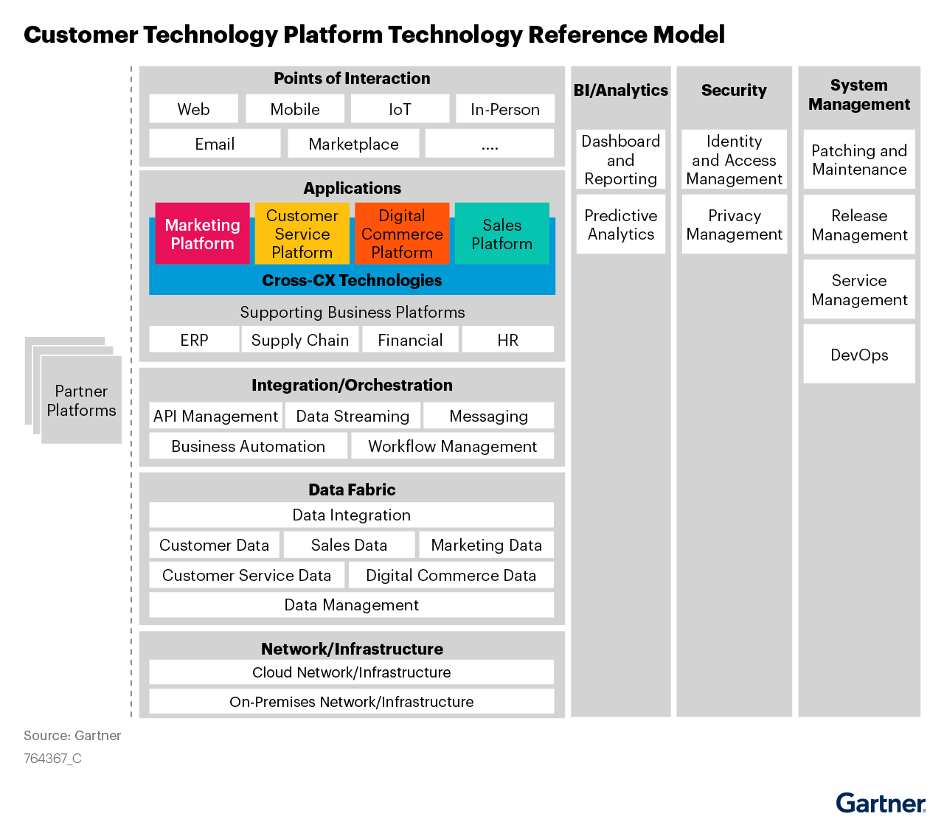

5.1 Technology Component Standards
What goes here: the enterprise platform standards this design builds on, and any deviation with its justification.
Concern | Standard | Deviation in this design
Identity | Microsoft Entra ID | None
Device management | Microsoft Intune | None
Secrets | Azure Key Vault | None
Secure web gateway | Zscaler ZIA | None

<< For the scope for the solution/product architecture, insert an inventory of the technology component standards naming the vendors’ products providing each technology component. The inventory should include all technology components for each of the applicable TRM domains using the enterprise standard naming conventions and notations. See Reference Architecture Implementation Guide.
Ensure the inventory of technology components references any central repositories and uses records within these repositories to document the inventory. The approved status of each technology component should be listed, making it clear what components are approved, under-review or new. Any classification status for approved that allows the limited use of a technology component under specified conditions should also be documented. For example, approved for region, country and use case YYYY.
• Complete the technology component standards list for each for your organizations TRM domains. The below provides an example list.
• List any policies, controls (NIST Control Framework for Security), standards and/or use case limits for each of the domains.>>

5.2 Integration standards and patterns
What goes here: how integrations are built: protocols, auth, event vs batch, error handling. Reference enterprise patterns rather than restating them.
Example — All interfaces are HTTPS with modern authentication; legacy protocols are blocked at the identity layer. No point-to-point integrations are introduced; device state flows through the management plane only.
.
<< Insert details. See the following for guidance and examples:
Choosing Application Integration Platform Technology
Decision Point for Mediating API and Microservices Communication
>>

5.3 Network & Infrastructure Standards & Patterns
What goes here: the network path end to end: VLANs/zones, SSIDs, firewall path, egress, DNS. The zone table must match the diagram exactly — reviewers check.
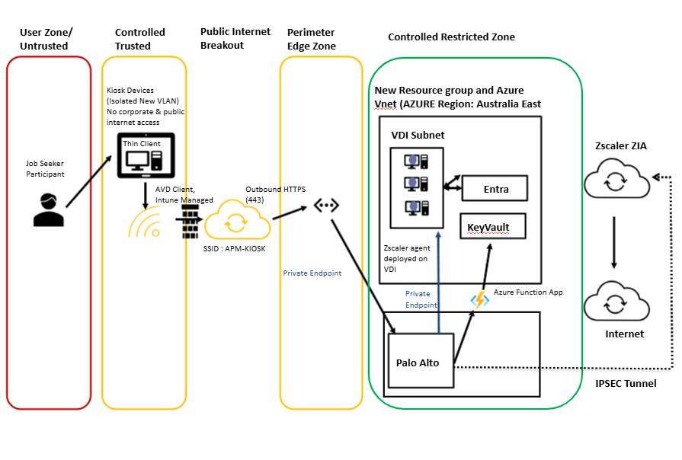
Figure — Example: site network logical diagram. Replace with the network view for your solution.
Example — Devices connect to a dedicated site VLAN via a hidden SSID. All egress traverses the site firewall to the secure web gateway; no lateral access to corporate VLANs is permitted.
Description | VLAN | IP range | Subnet
Example — kiosk device VLAN | 73 | 10.x.x.0/24 | /24

Ref # | Source | Destination | Port / protocol | Purpose
FW-01 | Device VLAN | Zscaler ZIA ranges | 443/TCP, 80/TCP | Web gateway tunnel
FW-02 | Device VLAN | Microsoft 365 / Intune endpoints | 443/TCP | Enrolment, policy, M365 services

<< Insert details. See the following for guidance and examples:
How to Architect Your WAN for Hybrid Cloud and Multicloud
Optimize WAN Architectures for Workloads That Span the Hybrid Cloud and the Multicloud
What Are the Key Factors to Consider When Choosing a Cloud Data Management Architecture?
Infrastructure for Technical Professionals Primer for 2023
Number of environments and technology components available in those environments

5.4 Technology component Deployment Patterns
What goes here: how change reaches production: environments or rings, gates between them, rollback.
Environment / ring | Purpose | Membership
Pilot | Validate changes on real hardware before broad rollout | 2–3 devices per region
Production | All remaining devices | Full fleet

<< Insert a description of the technology component deployment pattern for the solution/product architecture. Indicate whether the pattern is approved and standard or to be updated as a result of this solution/product architecture. See the following for guidance and examples:
A Guidance Framework for Deploying Data and Analytics in the Cloud
Guidance Framework for Deploying Centralized Log Monitoring
Using ‘Policy as Code’ to Secure Application Deployments and Enforce Compliance
Designing and Operating DevOps Workflows to Deploy Containerized Applications With Kubernetes
Quick Answer: How Can I Optimize the Use of Programmable Platforms for Effective Software Delivery?
Solution Path for Cloud-Native Infrastructure With Kubernetes
>>

6. Information & Data Architecture

6.1 Information Model
What goes here: the information entities the solution creates, stores or transits; where each is mastered; what is deliberately NOT stored.
Entity | Mastered in | Flow through this solution
Participant documents | Microsoft 365 (user’s own account) | Created/edited in web apps; never persisted on device
Session telemetry | Entra ID / Intune | Sign-in and compliance logs to tenant

<< Insert details of Conceptual Data model including reference to product specific data model if any available>>

6.2 Information Classification
Data component | Classification | Storage location & protection
Participant documents | OFFICIAL: Sensitive | User’s M365 storage; TLS in transit; wiped from device at session end
Device credentials | OFFICIAL: Sensitive | Azure Key Vault; rotated automatically

<< Insert data classification for all the conceptual data elements identified aligning to APM data classification standards>>

6.3 Analytics and reporting Patterns
What goes here: operational reporting (fleet health, usage) and audit logging (who did what, exported where, kept how long).
Example — Sign-in and audit logs are retained in the tenant for 90 days and exported to the SIEM for 12-month retention. Fleet compliance is reported weekly from Intune; site usage monthly from sign-in telemetry.

<< Insert details of Solution for Building Modern Analytics and BI Architectures to meet APM business requirements. >>

7. Cyber & Security Architecture
What goes here: the control story in one paragraph, then evidence: principles alignment, IAM model, secrets, user roles.
Example — Security is enforced in four independent layers: a locked device shell (only approved apps run), bound identities (Conditional Access ties each sign-in to its device and blocks all non-approved cloud apps), an inspected network path (all egress via the secure web gateway), and a stateless data plane (session wipe at sign-out).
# | Principle | Compliant | Comment
SEC-1 | Minimise the attack surface | Yes | Locked shell; all other executables blocked
SEC-2 | Use defence in depth | Yes | Device, identity, network and data-plane controls are independent
SEC-3 | Limit privileges to those required | Yes | No standing admin; PIM elevation only
SEC-4 | Centralise authentication and audit | Yes | All auth via Entra ID; logs to SIEM
SEC-5 | Protect data commensurate with sensitivity | Yes | Session wipe; no local persistence
SEC-6 | Avoid outdated protocols and versions | Yes | Legacy authentication blocked by CA
 |  | Partial | Gap and treatment

Item | Stored in | Rotation | Owner
Example — code-signing certificate | Azure Key Vault | Annual | Cyber security
Example — device account credentials | Azure Key Vault | Automatic, per schedule | Platform team

Role | Frequency of use | Access privileges required | Administered via
Participant | Per visit | Approved web apps only | Automatic (kiosk identity)
Site staff | Daily | Device restart, session reset | Scoped role
Intune Administrator | As needed | Device configuration | Entra role, PIM-activated

<< Insert details of policies, control and procedures adopted to meet the requirements as described in patterns in section above. Along with this if there is a gap to be addressed as part of current Cyber standard, outline the proposed controls, policies and procedures to be implemented.
- Topics to be covered but not limited to Identity (User, application, integration)
- Data and Network policies
- User accessibility and controls
- Device protection
- Data Sovereignty
- Encryption

>>

8. Service Availability and Disaster Recovery

8.1 Business Service Tiering
Example — Tier 3 — site amenity. Outage degrades participant experience but a manual workaround exists (staff-assisted access). Business-hours support only.
<< This should align and driven by Non-functional requirement captured >>

8.2 Service Availability
Example — Target 99.5% during site operating hours (08:00–18:00 local). Devices are stateless; a failed device is swapped and re-provisioned within one business day.
<< This should align and driven by business Service tiering >>

8.2 Disaster recovery & Resilience
Example — Devices are stateless: recovery is re-provisioning via the enrolment pipeline; RPO n/a — no data persisted. Management plane (Intune/Entra) resilience is inherited from Microsoft; configuration-as-source is exported to the repository on change, giving point-in-time restore of the management plane.
<< Insert details. See the following for guidance and examples:
Quick Answer: Build Network Resilience to Counter the Risks of Sabotage
Designing Availability and Resilience for Applications in Public Cloud IaaS and PaaS
IT Resilience — 7 Tips for Improving Reliability, Tolerability and Disaster Recovery
Fundamental Elements of Business Continuity Management: Third-Party Risk and Contingency Management
>>

9. Service Management

9.1 Service Management principles
Example — Support follows the enterprise model: service desk triage, platform team resolution, vendor escalation. Priority follows the enterprise matrix; a whole-site outage is P2. All changes via release rings with report-only validation before enforcement.

9.2 Monitoring, Logging, Reporting and Alerting
Layer | What is monitored | Tooling | Alert routing
Device | Enrolment state, compliance, storage health | Intune | ServiceNow queue
Identity | Sign-in failures, risk events, CA blocks | Entra ID / SIEM | Security operations
Network | Tunnel state, gateway availability | Zscaler / network NMS | Network provider

9.3 Support model & run procedures
What goes here: who supports what, and the routine tasks that keep the service healthy.
Area of responsibility | Service desk | Application support | Infrastructure support
Example — device offline | Triage, dispatch | — | Swap & re-provision

Task | Purpose | Frequency | Responsible
Example — review compliance report | Catch drift before it strands devices | Weekly | Platform team

9.4 Backup & recovery
Example — Devices hold no data and are not backed up; recovery is re-provisioning. Configuration-as-source (Intune profiles, CA policies, scripts) is exported to the repository on change.

9.5 Updates & patching
Component | Cadence | Ring / window | Owner
Windows quality updates | Monthly | Pilot +0d, broad +7d | Platform team
Edge / apps | Vendor cadence | Managed by Intune | Platform team

9.6 Maintenance windows & remote access
Example — Maintenance occurs outside site hours (18:00–08:00 local). Remote support is attended-only via the approved tool; sessions are logged and require on-site consent.

10. Resource Requirements
What goes here: hardware, software and people needed to deliver and then run the solution.

10.1 Hardware & software requirements
Item | Type | Quantity | Source
Example — kiosk devices | Hardware | N per site | Device partner
Example — per-device licences | Software | 1 per device | Reseller

10.2 Personnel — during delivery
Role | Assigned tasks | Time required
Example — build engineer | Image, profiles, policy build and test | X weeks

10.3 Personnel — support & maintenance
Role | Assigned tasks | Time required
Example — platform team | Patching, compliance review, policy change | X hrs/week

11. Testing and Implementation

11.1 Test plan
What goes here: what will be tested, by whom, against which requirements. Reference the test plan document if separate.
Test area | Verifies | Method
Example — session wipe | BR-02: no data persists between users | Scripted session, forensic check of profile paths

11.2 Implementation strategy
Example — Build order: certificate issuance → management-plane configuration → pilot site (2 devices, 2 weeks) → staged rollout by region. Policies run report-only for two weeks before enforcement.

11.3 Training, release & change management
What goes here: who needs training (site staff, service desk), how releases are packaged and approved, and which changes need CAB.

12. Statement of Delivery Impacts
What goes here: impact to production during delivery, impact on management information/reporting, and operational risk introduced by the change.
Impact area | Description | Mitigation
Example — production | Old equipment removed same day as cutover to avoid parallel unmanaged access | Site-by-site cutover checklist

Appendix A: Terms & Abbreviations
Term / abbreviation | Definition
CA | Conditional Access (Microsoft Entra)
ISM | Information Security Manual (Australian Signals Directorate)
PIM | Privileged Identity Management
RFFR | Right Fit For Risk (DEWR accreditation framework)
SOE | Standard Operating Environment
ZIA | Zscaler Internet Access

How to Document Application Architecture

