
DETAILED DESIGN DOCUMENT
Project Name
One-line description of the solution this design delivers.
Document owner | Head of Digital Transformation & Architecture
Program | Program name
Division / Unit | Division or unit
Status | Draft
Version | V0.1
Product ID
Classification | FOR INTERNAL USE ONLY — Commercial in confidence

© APM

Document control

Version history
Version | Date | Author | Key changes
V0.1 | DD-MM-YYYY | Author name, role | Initial draft for consultation

Consultation
Guidance — list everyone consulted during the design, including architecture and security reviewers.
Name | Position / role | Date
Name | Position title | DD-MM-YYYY

References and derivation
Version | Document title | Reference location
V1.0 | Related document title | SharePoint / repository path

Approval
Name | Role / group | Action | Signature | Date
Name | Solution Design Authority | Approval

Confidentiality & disclaimer
This document is provided by Advanced Personnel Management International Pty Ltd and / or its related entities (APM) on a confidential basis. It does not constitute an offer capable of acceptance, and no agreement binding APM or its related companies is intended or proposed unless and until agreed in writing in a formal agreement. Photographs used in this document are for illustration only. Communications regarding this document should be forwarded to the Head of Digital Transformation & Architecture.

Contents
Right-click here and choose "Update Field" to build the table of contents.

1. Introduction

1.1 Purpose
Guidance — state what this document defines and the decisions it records. Use the SoW or business case for framing.
This document provides the detailed technical design for the solution. It records the agreed architecture, configuration and design decisions, and is the reference for build, test and operational handover. It is a living document and must reflect the production environment in its entirety.

1.2 Audience
Audience | Interest in this document
Architecture & design authority | Review and approval of the design
Cyber security | Control alignment and risk acceptance
Build & operations teams | Implementation and ongoing support

2. Overview

2.1 Scope
In scope | Out of scope
• Item included in this design  • Item included in this design | • Item explicitly excluded  • Item explicitly excluded

2.2 Guiding principles
Guidance — the principles that shaped the design, e.g. modern management only, least privilege, cloud-first.
• Principle one
• Principle two

2.3 Assumptions
Ref # | Assumption
A-01 | Assumption the design relies on

2.4 Dependencies
Ref # | Dependency | Owner
D-01 | What must be in place for this design to land | Owning team

3. Risks, issues & design decisions

3.1 Project risks
Ref # | Risk description | Severity | Probability | Mitigation
RK-01 | Example — upstream network design not approved before build window opens | High | Medium | Escalate via design authority; sequence non-dependent work first
RK-02

3.2 Issues and concerns
Guidance — issues raised in architecture and security reviews, plus unusual requirements. Unresolved issues carry into the project risk register.
Ref # | Issue description | Resolution
IS-01

3.3 Design decisions
DD-01 — Decision to be made | Status: APPROVED
Options considered | Option A; Option B; Option C
Preferred option | Option A
Rationale | Why the preferred option was selected, including trade-offs accepted
Approved by | Design authority / forum, date
Reference | Link to decision record or meeting minutes

Guidance — duplicate the decision table above for each major design decision (DD-02, DD-03…).

4. Business architecture

4.1 Business reference architecture
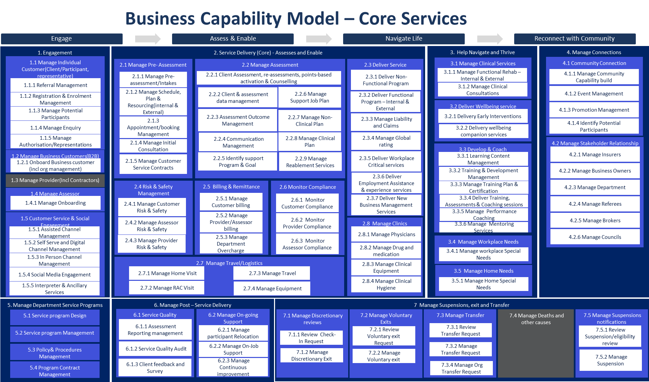
Figure 4.1 — Example: business capability model. Replace with the capability view for your solution.

4.2 Business requirements
Unique # | Category | Key requirement
BR-01 | Functional | What the business needs the solution to do
NFR-01 | Non-functional | Availability, performance, security or compliance requirement

4.3 Gap treatment
Guidance — where the solution does not fully meet a requirement, record the gap, its impact and the agreed treatment.

5. Application architecture

5.1 System context diagram
Guidance — insert the system context diagram — show the solution, its users, and every external system it touches.

5.2 Solution component inventory
Component | Function | Version | Environment
Component name | What it does in the solution | vX.Y | Production

5.3 Interface catalogue
Ref # | Source → destination | Method / protocol | Data exchanged
IF-01 | System A → System B | HTTPS / REST API | What flows, how often, auth method

6. Technology architecture

6.1 Technology component standards
Guidance — the platform standards this design builds on (identity, device management, hosting, tooling) and any deviations.

6.2 Network & infrastructure
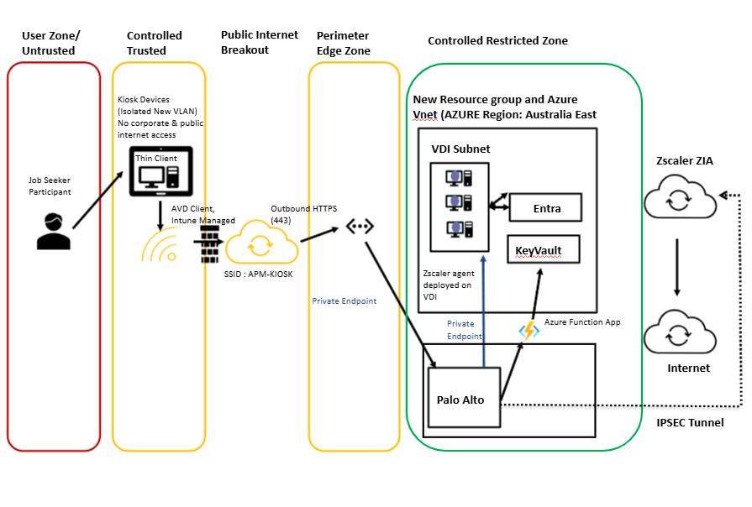
Figure 6.1 — Example: site network logical diagram. Replace with the network view for your solution.
Network zones used by the solution:
Description | VLAN | IP range | Subnet
Example — kiosk device VLAN | 73 | 10.x.x.0–10.x.x.255 | /24

6.3 Infrastructure specification
Attribute | Value
Server / resource name
OS / platform
Location / region
Memory / storage
IP / subnet / gateway / DNS

6.4 Firewall & internet access
Guidance — summarise required firewall policies (full rules belong in the appendix or a linked spreadsheet) and whether the solution needs internet egress, via what path.
Ref # | Source | Destination | Port / protocol | Purpose
FW-01 | Solution VLAN | Service endpoint | 443/TCP | Why the flow is needed

7. Information & data architecture

7.1 Information model
Guidance — the key information entities the solution creates or consumes, where each is mastered, and how it flows.

7.2 Information classification
Data component | Classification | Storage location & protection
Data set or store | OFFICIAL: Sensitive | Where it lives; encryption at rest / in transit; retention

7.3 Analytics & reporting
Guidance — reporting outputs, audit logging, and any SIEM export requirements.

8. Cyber & security architecture

8.1 Security principles alignment
# | Principle | Compliant | Comment
SEC-1 | Minimise the attack surface | Yes | How the design achieves it
SEC-2 | Defence in depth | Yes
SEC-3 | Least privilege | Partial | Gap and treatment

8.2 Identity & access management
Guidance — authentication and authorisation model, RBAC roles and group mapping, Conditional Access, segregation of duties.

8.3 Certificates, keys & secrets
Guidance — cryptographic material the solution depends on, where it is stored (e.g. Key Vault), rotation and expiry ownership.

9. Service availability & disaster recovery
Attribute | Value
Business service tier | Tier and rationale
Availability target | e.g. 99.9% business hours
RTO / RPO | Recovery time / point objectives
DR approach | How service is restored after regional or component failure

10. Service management & supportability

10.1 Monitoring, logging & alerting
Layer | What is monitored | Tooling | Alert routing
Application
Infrastructure
Cyber / SIEM

10.2 Backup, patching & maintenance
Guidance — backup and restore approach, update rings and patch cadence, maintenance windows, and the remote access path for support.

A. Appendix A — Terms & abbreviations
Term / abbreviation | Definition
AVD | Azure Virtual Desktop
DDD | Detailed Design Document

B. Appendix B — Implementation considerations
Guidance — sequencing constraints, cutover notes, and anything the build team must know that doesn’t belong in the body sections.

