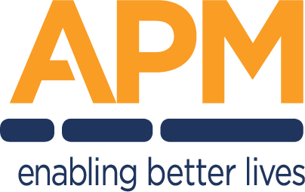
DETAILED DESIGN DOCUMENT
Project Name
One-line description of the solution this design delivers.
Document owner | Head of Digital Transformation & Architecture
Program | Program name
Division / Unit | Division or unit
Status | Draft
Version | V0.1
Product ID
Classification | FOR INTERNAL USE ONLY — Commercial in confidence

© APM

Document control

Version history
Version | Date | Author | Key changes
V0.1 | DD-MM-YYYY | Author name, role | Initial draft for consultation

Consultation
What goes here: everyone consulted during the design — architecture and security reviewers, platform owners, the business stakeholders who validated requirements.
Name | Position / role | Date
Name | Position title | DD-MM-YYYY

References and derivation
What goes here: documents this design draws on or must be read with: the HLD, SoW, security standards, related DDDs.
Version | Document title | Reference location
V1.0 | Related document title | SharePoint / repository path

Approval
Name | Role / group | Action | Signature | Date
Name | Solution Design Authority | Approval
Name | Cyber Security | Review

Confidentiality & disclaimer
This document is provided by Advanced Personnel Management International Pty Ltd and / or its related entities (APM) on a confidential basis. It does not constitute an offer capable of acceptance, and no agreement binding APM or its related companies is intended or proposed unless and until agreed in writing in a formal agreement. Photographs used in this document are for illustration only. Communications regarding this document should be forwarded to the Head of Digital Transformation & Architecture.

Contents
Right-click here and choose "Update Field" to build the table of contents.

1. Introduction

1.1 Purpose
What goes here: 3–4 sentences: what solution this document designs, what the document covers (and what it defers to other documents), and its relationship to the HLD. Write in present tense; the design is a statement of fact, not a proposal.
Example — This document provides the detailed technical design for the Participant Kiosk solution: a locked-down Windows 11 device build giving participants supervised access to Microsoft 365 web applications at APM sites. It records the agreed architecture, configuration baselines and design decisions, and is the reference for build, test and operational handover. High-level context and business justification are covered in the corresponding High Level Design; this document does not repeat them.

1.2 Audience
Audience | Interest in this document
Architecture & design authority | Review and approval of the design
Cyber security | Control alignment and risk acceptance
Build & operations teams | Implementation and ongoing support
Service management | Support model, monitoring and escalation

2. Overview

2.1 Scope
What goes here: bullet what this design delivers and — just as important — what it explicitly does not. An empty out-of-scope list is a red flag in review.
In scope | Out of scope
• Windows 11 device build and kiosk configuration  • Conditional Access policy set for kiosk identities  • Intune configuration profiles and compliance policies  • Device provisioning and enrolment process | • Site network cabling and switching (network programme)  • Licensing procurement (handled by reseller)  • End-user support model (service management design)

2.2 Guiding principles
What goes here: the principles that shaped this design. Each should be checkable — a reviewer can ask "does the design honour this?"
Example — Modern management only — devices are Entra joined and Intune managed; no Active Directory dependency. Least privilege — no standing administrative access; elevation is time-bound and audited. Compliance by design — controls align to RFFR and the ASD ISM. Reuse before build — enterprise platform patterns are used unless a documented gap exists.

2.3 Assumptions
What goes here: what you are relying on being true. If an assumption fails, the design changes — so each one should be testable and owned.
Ref # | Assumption | Impact if false
A-01 | Required licensing (per-device F3 or equivalent) is available before pilot | Provisioning blocked; pilot slips
A-02 | Site network (VLAN, SSID, firewall path) is delivered by the network programme before device deployment | Devices cannot reach cloud services

2.4 Dependencies
Ref # | Dependency | Owner
D-01 | Code-signing certificate issued for device-side scripts | Cyber security
D-02 | Network design approved and change window scheduled | Network lead

3. Risks, issues & design decisions

3.1 Project risks
What goes here: design-level risks only (delivery risks live in the project risk register). Severity and probability are High / Medium / Low; every risk needs a mitigation, even if the mitigation is "accept".
Ref # | Risk description | Severity | Probability | Mitigation
RK-01 | Upstream network design not approved before build window opens | High | Medium | Escalate via design authority; sequence non-dependent work first
RK-02 | Shared kiosk identities exceed licensed concurrent sessions at peak | Medium | Low | Cap powered devices per site; monitor sign-in telemetry
RK-03

3.2 Issues and concerns
What goes here: issues raised in architecture and security reviews, plus unusual requirements. Unresolved issues carry into the project risk register.
Ref # | Issue description | Resolution
IS-01 | Duplicate Conditional Access policies found in tenant with placeholder naming — consolidation required before kiosk policy set is enabled | Consolidate and rename per CA naming standard; re-test in report-only
IS-02

3.3 Design decisions
What goes here: one card per major decision. The rationale is the most-read cell in the document — write it so a future engineer understands the trade-off without attending the meeting.
DD-01 — Session data persistence approach | Status: APPROVED
Options considered | 1. Persistent local profiles 2. Ephemeral session, wiped at sign-out 3. Roaming profiles (FSLogix)
Preferred option | Option 2 — ephemeral session, wiped at sign-out
Rationale | Devices are shared by the public; any persistence risks cross-user data exposure. Wipe-on-exit removes the data-spill class of risk entirely and simplifies privacy compliance. Trade-off accepted: users must save work externally before ending a session.
Approved by | Design authority forum, DD-MM-YYYY
Reference | Decision record link / minutes

DD-02 — Decision to be made | Status: PROPOSED
Options considered | Option A; Option B; Option C
Preferred option | Option A
Rationale | Why the preferred option was selected, including trade-offs accepted
Approved by
Reference

4. Business architecture

4.1 Business reference architecture
What goes here: where this solution sits in APM’s business capability landscape — which capabilities it enables or changes. One diagram plus a short paragraph is enough.
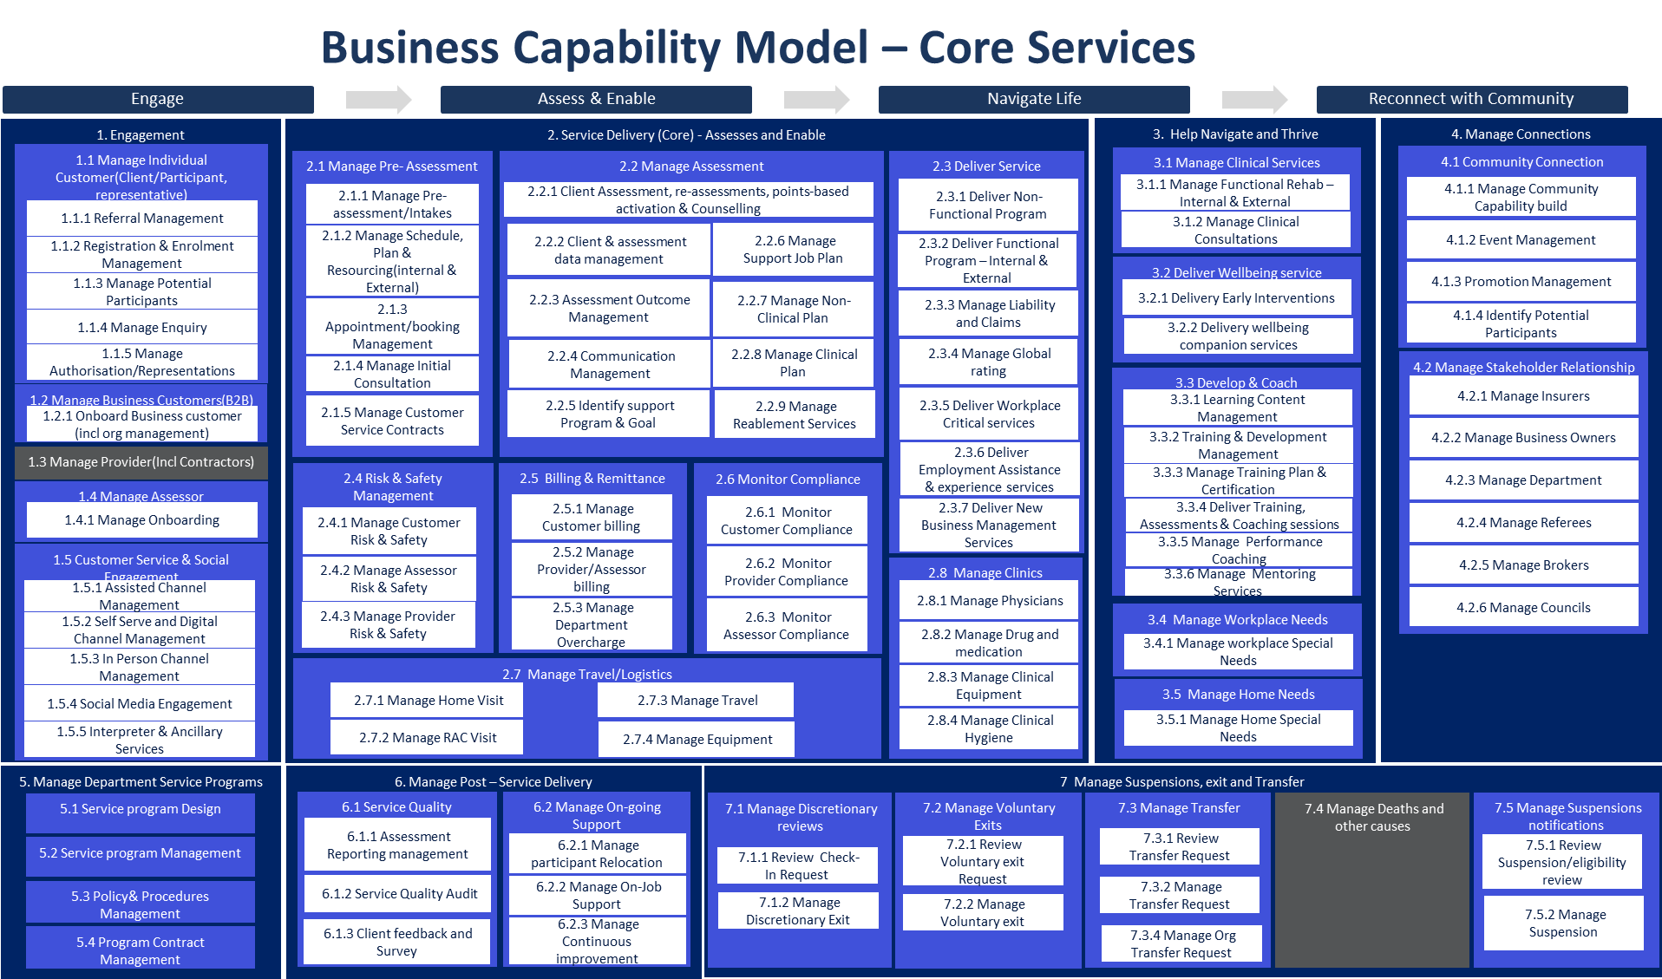
Figure 4.1 — Example: business capability model with the affected capabilities highlighted. Replace with the view for your solution.
Example — The solution supports the Employment Services capability group, specifically participant self-service. It changes how the "participant digital access" capability is delivered (from unmanaged shared PCs to a managed kiosk fleet) and introduces no new business capabilities.

4.2 Business requirements
What goes here: the requirements this design must satisfy, traced from the SoW or requirements register. Every requirement should be verifiable in test.
Unique # | Category | Key requirement
BR-01 | Functional | Participants can access approved web applications to create and export documents
BR-02 | Functional | All session data is removed before the next user signs in
NFR-01 | Non-functional | Kiosks available during site operating hours (08:00–18:00 local)
NFR-02 | Non-functional | Solution meets RFFR / ISM control requirements for the data it handles

4.3 Gap treatment
What goes here: where the solution cannot fully meet a requirement, record the gap, its impact, and the agreed treatment (accept / mitigate / defer with date).
Gap | Impact | Treatment | Owner
Example — offline document editing not available | Participants need connectivity to work | Accepted — sites provide managed connectivity | Design authority

5. Application architecture

5.1 System context diagram
What goes here: one diagram showing the solution in the middle, every human and system actor around it, and what flows on each line. If a reviewer can’t reconstruct the solution’s boundaries from this diagram alone, it needs more detail.
Insert system context diagram here

5.2 Solution component inventory
Component | Function | Version | Environment
Microsoft Edge | Locked-down browser shell for participant sessions | Stable channel | Production
Zscaler Client Connector | Secure web gateway tunnel from device | Latest GA | Production
Microsoft Intune | Device configuration, compliance and app deployment | Service | Production
Microsoft Entra ID | Identity, Conditional Access, device registration | Service | Production

5.3 Interface catalogue
What goes here: every integration the solution has — one row per interface, each traceable to a line on the context diagram.
Ref # | Source → destination | Method / protocol | Data exchanged
IF-01 | Device → Zscaler ZIA | TLS tunnel (Client Connector) | All web traffic; SSL-inspected per policy
IF-02 | Edge → Microsoft 365 web apps | HTTPS 443 | Authenticated session; documents in transit
IF-03 | Device → Intune / Entra ID | HTTPS 443 | Enrolment, policy, compliance, sign-in

5.4 Interaction sequences
What goes here: sequence diagrams for the flows that are hard to reason about in prose — sign-in, session start/end, failure paths. One per critical flow.
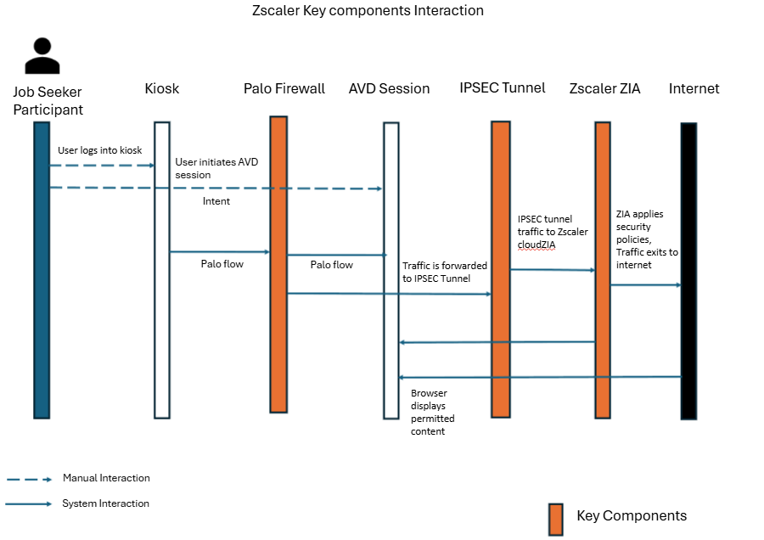
Figure 5.1 — Example: device / Zscaler / cloud interaction sequence. Replace with the critical flows for your solution.

5.5 Environments
What goes here: the environments the solution runs in and how change flows between them. For device solutions this is usually deployment rings, not separate infrastructure.
Environment / ring | Purpose | Membership
Pilot | Validate changes on real hardware before broad rollout | 2–3 devices per region
Production | All remaining devices | Full fleet

5.6 Administration & access
What goes here: who can administer what, via which roles. Show that segregation of duties and least privilege hold.
Role | Access provided | Assigned via
Intune Administrator | Device configuration and app deployment | Entra role, PIM-activated
Helpdesk operator | Remote assistance, device restart | Scoped Intune role

6. Technology architecture

6.1 Technology component standards
What goes here: the enterprise platform standards this design builds on, and any deviation with its justification.
Concern | Standard | Deviation in this design
Identity | Microsoft Entra ID | None
Device management | Microsoft Intune | None
Secrets | Azure Key Vault | None
Secure web gateway | Zscaler ZIA | None

6.2 Network & infrastructure
What goes here: the network path end to end: VLANs/zones, SSIDs, firewall path, egress. The zone table must match the diagram exactly — reviewers check.
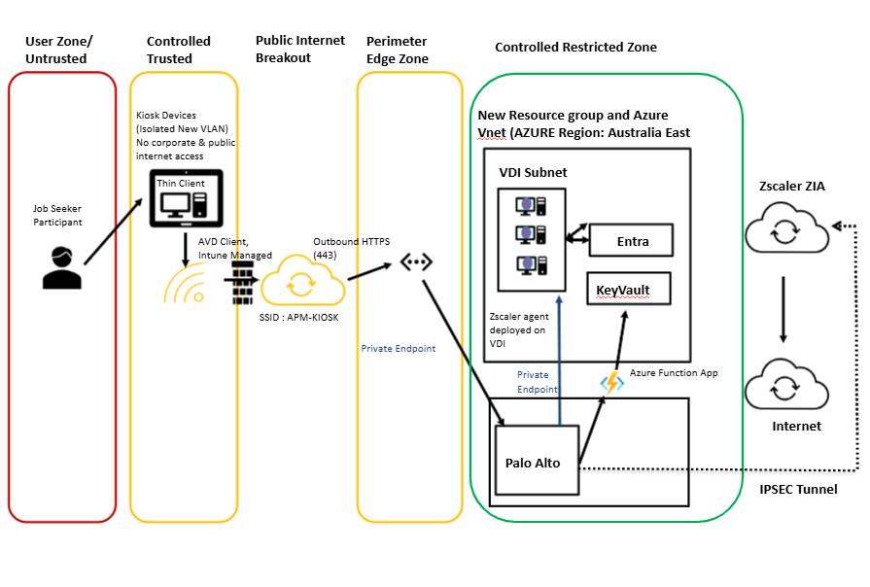
Figure 6.1 — Example: site network logical diagram. Replace with the network view for your solution.
Example — Devices connect to a dedicated site VLAN via a hidden SSID. All egress traverses the site firewall to the secure web gateway; no lateral access to corporate VLANs is permitted.
Description | VLAN | IP range | Subnet
Kiosk device VLAN | 73 | 10.x.x.0/24 | /24

6.3 Infrastructure specification
What goes here: one table per server / host pool / resource. For cloud-only device solutions, record the cloud resources (Key Vault, storage, automation) instead.
Attribute | Value
Resource name | Example — kv-kiosk-prod-ae
Type / platform | Azure Key Vault
Location / region | Australia East
Configuration | RBAC authorisation; private endpoint; purge protection on
Dependencies | Accessed by provisioning pipeline at device build

6.4 Firewall & internet access
What goes here: summarise the flows; the full rule set belongs in an appendix or linked workbook. Include the egress path and any SSL-inspection exemptions.
Ref # | Source | Destination | Port / protocol | Purpose
FW-01 | Kiosk VLAN | Zscaler ZIA ranges | 443/TCP, 80/TCP | Web gateway tunnel
FW-02 | Kiosk VLAN | Microsoft 365 / Intune endpoints | 443/TCP | Enrolment, policy, M365 services

6.5 DNS configuration
What goes here: DNS servers used, any conditional forwarders or split-horizon behaviour, and records the solution needs created.
Record / setting | Value | Purpose
Example — DNS servers (DHCP option) | Site resolver pair | Name resolution for kiosk VLAN

6.6 Software components & licensing
Software | Version | Licence | Source
Windows 11 Enterprise | Current LTSC/GA baseline | Per-device | Volume licensing
Microsoft 365 apps (web) | Service | Per-user F3 (example) | Reseller

7. Information & data architecture

7.1 Information model
What goes here: the information entities the solution creates, stores or transits; where each is mastered; and how it flows. For a kiosk-style solution the interesting answer is usually what is deliberately NOT stored.
Entity | Mastered in | Flow through this solution
Participant documents | Microsoft 365 (user’s own account) | Created/edited in web apps; never persisted on device
Session telemetry | Entra ID / Intune | Sign-in and compliance logs to tenant

7.2 Information classification
Data component | Classification | Storage location & protection
Participant documents | OFFICIAL: Sensitive | User’s M365 storage; TLS in transit; wiped from device at session end
Device credentials | OFFICIAL: Sensitive | Azure Key Vault; rotated automatically

7.3 Analytics & reporting
What goes here: operational reporting (fleet health, usage) and audit logging (who did what, exported where, kept how long).
Example — Sign-in and audit logs are retained in the tenant for 90 days and exported to the SIEM for 12-month retention. Fleet compliance is reported weekly from Intune; site usage is reported monthly from sign-in telemetry.

8. Cyber & security architecture

8.1 Security principles alignment
What goes here: state compliance honestly — a "Partial" with a treatment plan passes review; an unexplained "Yes" does not.
# | Principle | Compliant | Comment
SEC-1 | Minimise the attack surface | Yes | Assigned Access limits shell to approved apps; all other executables blocked
SEC-2 | Use defence in depth | Yes | Device, identity, network and data-plane controls are independent
SEC-3 | Limit privileges to those required | Yes | No standing admin; PIM elevation only
SEC-4 | Centralise authentication and audit | Yes | All auth via Entra ID; logs to SIEM
SEC-5 | Protect data commensurate with sensitivity | Yes | Session wipe; no local persistence
SEC-6 | Avoid outdated protocols and versions | Yes | Legacy authentication blocked by CA
SEC-7 |  | Partial | Gap and treatment

8.2 Identity & access management
What goes here: the authentication and authorisation model end to end: identity types, Conditional Access approach, MFA posture, RBAC, segregation of duties.
Example — Kiosk sessions use dedicated per-device identities bound to their device by Conditional Access; interactive MFA is replaced by device binding plus platform, protocol and risk controls. A default-deny policy blocks all cloud apps except the approved set. Administrative access uses separate identities with PIM-activated roles.

8.3 Certificates, keys & secrets
Item | Stored in | Rotation | Owner
Example — code-signing certificate | Azure Key Vault | Annual | Cyber security
Example — device account credentials | Azure Key Vault | Automatic, per schedule | Platform team

9. Service availability & disaster recovery
What goes here: tier the service, state the availability target in business terms, and describe recovery as a procedure someone could actually follow.
Attribute | Value
Business service tier | Example — Tier 3: site amenity; outage degrades service but has manual workaround
Availability target | Example — 99.5% during site operating hours
RTO / RPO | Example — RTO 1 business day (device replacement); RPO n/a — no data persisted
DR approach | Example — devices are stateless: recovery is re-provisioning via Autopilot/Intune; no backup or restore of devices is required
Capacity & scalability | Example — fleet sized at N devices/site; scale by enrolling additional devices, no infrastructure change

10. Service management & supportability

10.1 Monitoring, logging & alerting
Layer | What is monitored | Tooling | Alert routing
Device | Enrolment state, compliance, storage health | Intune | ServiceNow queue
Identity | Sign-in failures, risk events, CA blocks | Entra ID / SIEM | Security operations
Network | Tunnel state, gateway availability | Zscaler / network NMS | Network provider

10.2 Backup & recovery
What goes here: what is backed up, where, how often — and what is deliberately not backed up. Reference the restore test cadence.
Example — Devices hold no data and are not backed up; recovery is re-provisioning. Configuration-as-source (Intune profiles, CA policies, scripts) is exported to the repository on change, giving point-in-time restore of the management plane.

10.3 Updates & patching
Component | Cadence | Ring / window | Owner
Windows quality updates | Monthly | Pilot +0d, broad +7d | Platform team
Edge / apps | Vendor cadence | Managed by Intune | Platform team

10.4 Maintenance windows & remote access
Example — Maintenance occurs outside site hours (18:00–08:00 local). Remote support is attended-only via the approved remote-access tool; sessions are logged and require on-site consent.

A. Appendix A — Terms & abbreviations
Term / abbreviation | Definition
CA | Conditional Access (Microsoft Entra)
DDD | Detailed Design Document
Intune | Microsoft cloud device management service
ISM | Information Security Manual (Australian Signals Directorate)
PIM | Privileged Identity Management
RFFR | Right Fit For Risk (DEWR accreditation framework)
SOE | Standard Operating Environment
ZIA | Zscaler Internet Access

B. Appendix B — Implementation considerations
What goes here: sequencing constraints, cutover notes, and anything the build team must know that doesn’t belong in the body sections.
Example — Build order: certificate issuance → management-plane configuration → pilot site (2 devices) → staged rollout by region. Conditional Access policies run report-only for two weeks before enforcement. Site cutover requires the old equipment removed the same day to avoid parallel unmanaged access.

