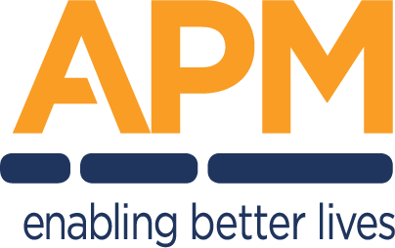
HIGH LEVEL DESIGN
Project Name
One-line description of the solution this design covers.
Document owner | Head of Digital Transformation & Architecture
Program / Project ID | Program name / ID
Division / Unit | Division or unit
Status | Draft
Version | V0.1
Classification | FOR INTERNAL USE ONLY — Commercial in confidence

© APM

Document control

Revision history
Version | Issue date | Description of version / changes | Author
V0.1 | DD-MM-YYYY | Initial draft for consultation | Author name, role

Reference / related documents
What goes here: documents this design draws on or must be read with — the business case, requirements register, related DDDs, security standards.
Title | Version | Relationship to this document
Related document title | V1.0 | e.g. Detailed design that implements this HLD

Review and approval
Name | Title, area | Action | Sections | Date
Name | Solution Design Authority | Approval | All
Name | Cyber Security | Review | Cyber resilience

Confidentiality & disclaimer
This document is provided by Advanced Personnel Management International Pty Ltd and / or its related entities (APM) on a confidential basis. It does not constitute an offer capable of acceptance, and no agreement binding APM or its related companies is intended or proposed unless and until agreed in writing in a formal agreement. Communications regarding this document should be forwarded to the Head of Digital Transformation & Architecture.

Contents
Right-click here and choose "Update Field" to build the table of contents.

1. Project summary

1.1 Background and overview
What goes here: why this project exists and what it delivers, in language a non-technical sponsor can read. 2–3 paragraphs maximum; detail belongs in later sections.
Example — APM provides participants with shared access to digital services at its sites. The current fleet of unmanaged PCs presents security, privacy and supportability risks. This project replaces them with a managed, locked-down kiosk solution giving participants safe access to approved web applications while removing local data persistence.

1.2 Business benefits
Benefit | Measure
Example — reduced data-spill risk on shared devices | Zero local persistence; session wipe verified in test
Example — lower support effort per site | Fewer incident tickets per device per month

1.3 Guiding principles
What goes here: the principles that shaped the design — they explain why options were rejected. Keep to five or fewer.
• Example — modern management only: Entra joined and Intune managed; no dependency on AD DS
• Example — least privilege: no standing administrative access; PIM-activated roles only
• Example — reuse enterprise platforms before building anything new
• Example — stateless endpoints: no participant data at rest on any device

2. Solution scope

2.1 Scope summary
What goes here: the plain-language boundary of the solution before the requirement detail — what this project delivers, and what it explicitly does not.
In scope | Out of scope
Managed kiosk devices at APM sites and the cloud session they connect to | Corporate laptops and the standard user SOE (separate design)
Device build, enrolment and credential automation | Site network hardware delivery (network programme)
Support model, monitoring and patching for the fleet | Content and availability of third-party web applications

2.2 Business functional requirements
What goes here: the requirements this design must satisfy, traced from the requirements register. Each must be verifiable.
Unique # | Category | Key requirement
BR-01 | Access | Participants can access approved web applications to create and export documents
BR-02 | Privacy | All session data is removed before the next user signs in

2.3 Non-functional requirements
Unique # | Category | Requirement
NFR-01 | Availability | Service available during site operating hours (08:00–18:00 local)
NFR-02 | Security | Solution meets RFFR / ISM control requirements for the data it handles

2.4 De-scoped requirements
What goes here: requirements considered and explicitly removed from scope, with who approved the change — this table prevents "I thought that was included" later.
Req # | Change | Details of approval
Example — BR-09 | Offline editing removed from scope | Approved at design forum DD-MM-YYYY

2.5 Application tier
What goes here: the criticality tier of the application/service and what that tier implies for availability, support hours and DR.
Example — Tier 3 — site amenity. Outage degrades participant experience but a manual workaround exists (staff-assisted access). Business-hours support only.

3. Architecture design decisions
What goes here: one card per major decision. The rationale is the most-read cell in the document — write it so a future engineer understands the trade-off without attending the meeting.
DD-01 — Session data persistence approach | Status: APPROVED
Options considered | 1. Persistent local profiles 2. Ephemeral session, wiped at sign-out 3. Roaming profiles
Preferred option | Option 2 — ephemeral session, wiped at sign-out
Rationale | Devices are shared by the public; any persistence risks cross-user data exposure. Wipe-on-exit removes the data-spill risk class entirely. Trade-off accepted: users must save work externally before ending a session.
Approved by | Design authority forum, DD-MM-YYYY
Reference | Decision record link / minutes

DD-02 — Decision to be made | Status: PROPOSED
Options considered | Option A; Option B; Option C
Preferred option | Option A
Rationale | Why the preferred option was selected, including trade-offs accepted
Approved by
Reference

4. Assumptions, risks, issues & dependencies

4.1 Assumptions
Unique # | Assumption | Impact if not true
A-01 | Required licensing is available before pilot | Provisioning blocked; pilot slips
A-02 | Site network is delivered by the network programme before deployment | Devices cannot reach cloud services

4.2 Risks
Ref # | Risk description | Severity | Probability | Mitigation
RK-01 | Upstream network design not approved before build window opens | High | Medium | Escalate via design authority; sequence non-dependent work first
RK-02

4.3 Issues and concerns
Ref # | Issue description | Assigned to | Target resolution
IS-01 | Example — duplicate Conditional Access policies in tenant require consolidation before enablement | Platform team | DD-MM-YYYY

4.4 Dependencies
Ref # | Dependency | Owner
D-01 | Code-signing certificate issued for device-side scripts | Cyber security
D-02 | Network design approved and change window scheduled | Network lead
D-03

5. Compliance

5.1 IT architecture principles alignment
What goes here: state compliance honestly — a "Partial" with a treatment plan passes review; an unexplained "Yes" does not.
# | Principle | Compliant | Comment
EA-1 | Reuse enterprise platforms before building new | Yes | Built entirely on existing identity, device-management and gateway platforms
EA-2 | Cost aware | Yes | Per-device licensing; no new infrastructure
SEC-1 | Minimise the attack surface | Yes | Locked shell; all other executables blocked
SEC-2 | Use defence in depth | Yes | Device, identity, network and data-plane controls are independent
SEC-3 | Limit privileges to those required | Yes | No standing admin; PIM elevation only
SEC-4 | Protect data commensurate with sensitivity | Yes | Session wipe; no local persistence
 |  | Partial | Gap and treatment

6. Application architecture

6.1 High level overview
What goes here: one diagram showing the solution in the middle, every human and system actor around it, and what flows on each line — plus a short narrative.
Figure 6.1 — Example: solution overview / system context — the solution in the middle, every human and system actor around it. Replace with the context for your solution.

6.2 Components & functions
Component | Function | Version | Environment
Microsoft Edge | Locked-down browser shell for participant sessions | Stable channel | Production
Zscaler Client Connector | Secure web gateway tunnel from device | Latest GA | Production
Microsoft Intune | Device configuration, compliance and app deployment | Service | Production

6.3 Integration
What goes here: every integration — one row per interface. For the flows that are hard to reason about in prose, add a sequence diagram.
Ref # | Source → destination | Method / protocol | Data exchanged
IF-01 | Device → Zscaler ZIA | TLS tunnel | All web traffic; SSL-inspected per policy
IF-02 | Edge → Microsoft 365 web apps | HTTPS 443 | Authenticated session; documents in transit

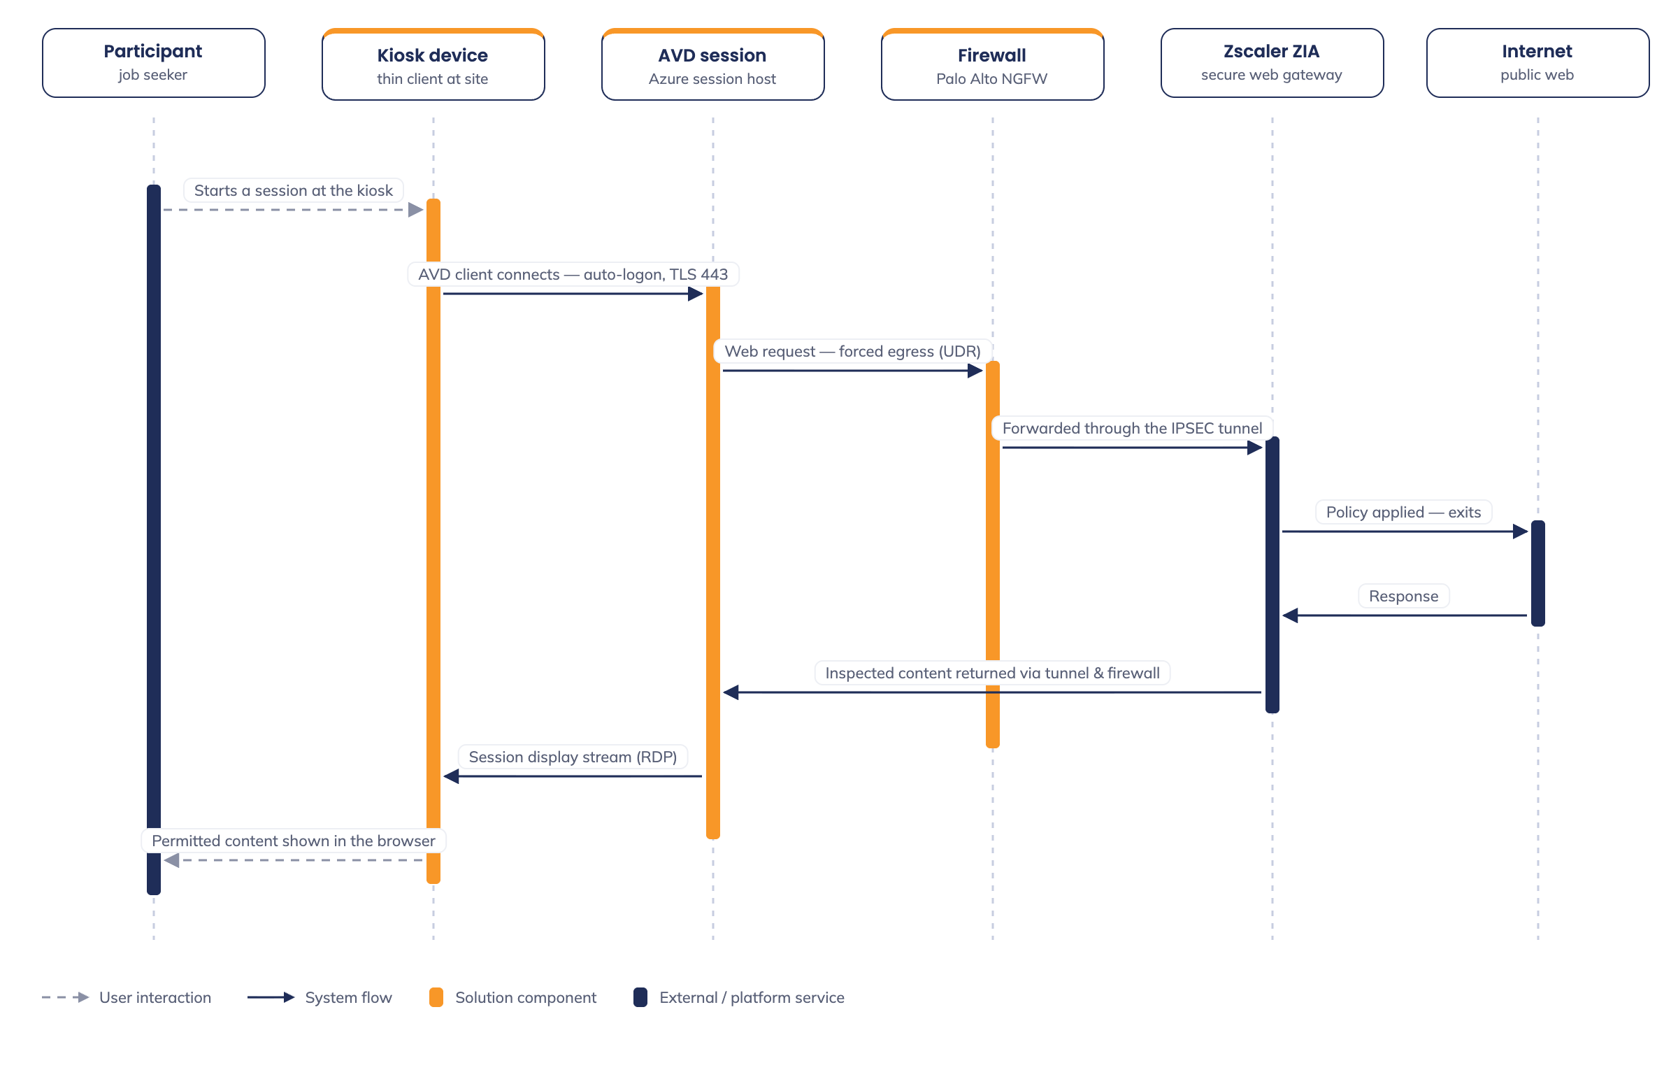
Figure 6.2 — Example: device / gateway / cloud interaction sequence. Replace with the critical flows for your solution.

6.4 Impacted systems
System | Impact | Change required
Example — ServiceNow | New support queue and device CI class | Queue + CMDB update

7. Data architecture

7.1 High level data architecture overview
What goes here: the information entities the solution creates, stores or transits; where each is mastered; what is deliberately NOT stored.
Entity | Mastered in | Flow through this solution
Participant documents | Microsoft 365 (user’s own account) | Created/edited in web apps; never persisted on device
Session telemetry | Entra ID / Intune | Sign-in and compliance logs to tenant

7.2 Data model / data flow diagrams
Figure 7.1 — Example: data flow — session input to inspected egress; nothing persists on the device. Replace with the flows for your solution.

7.3 Reporting
Report | Description | Frequency | Recipients
Example — fleet compliance | Devices compliant vs total, by site | Weekly | Service owner

8. Infrastructure

8.1 High level infrastructure overview
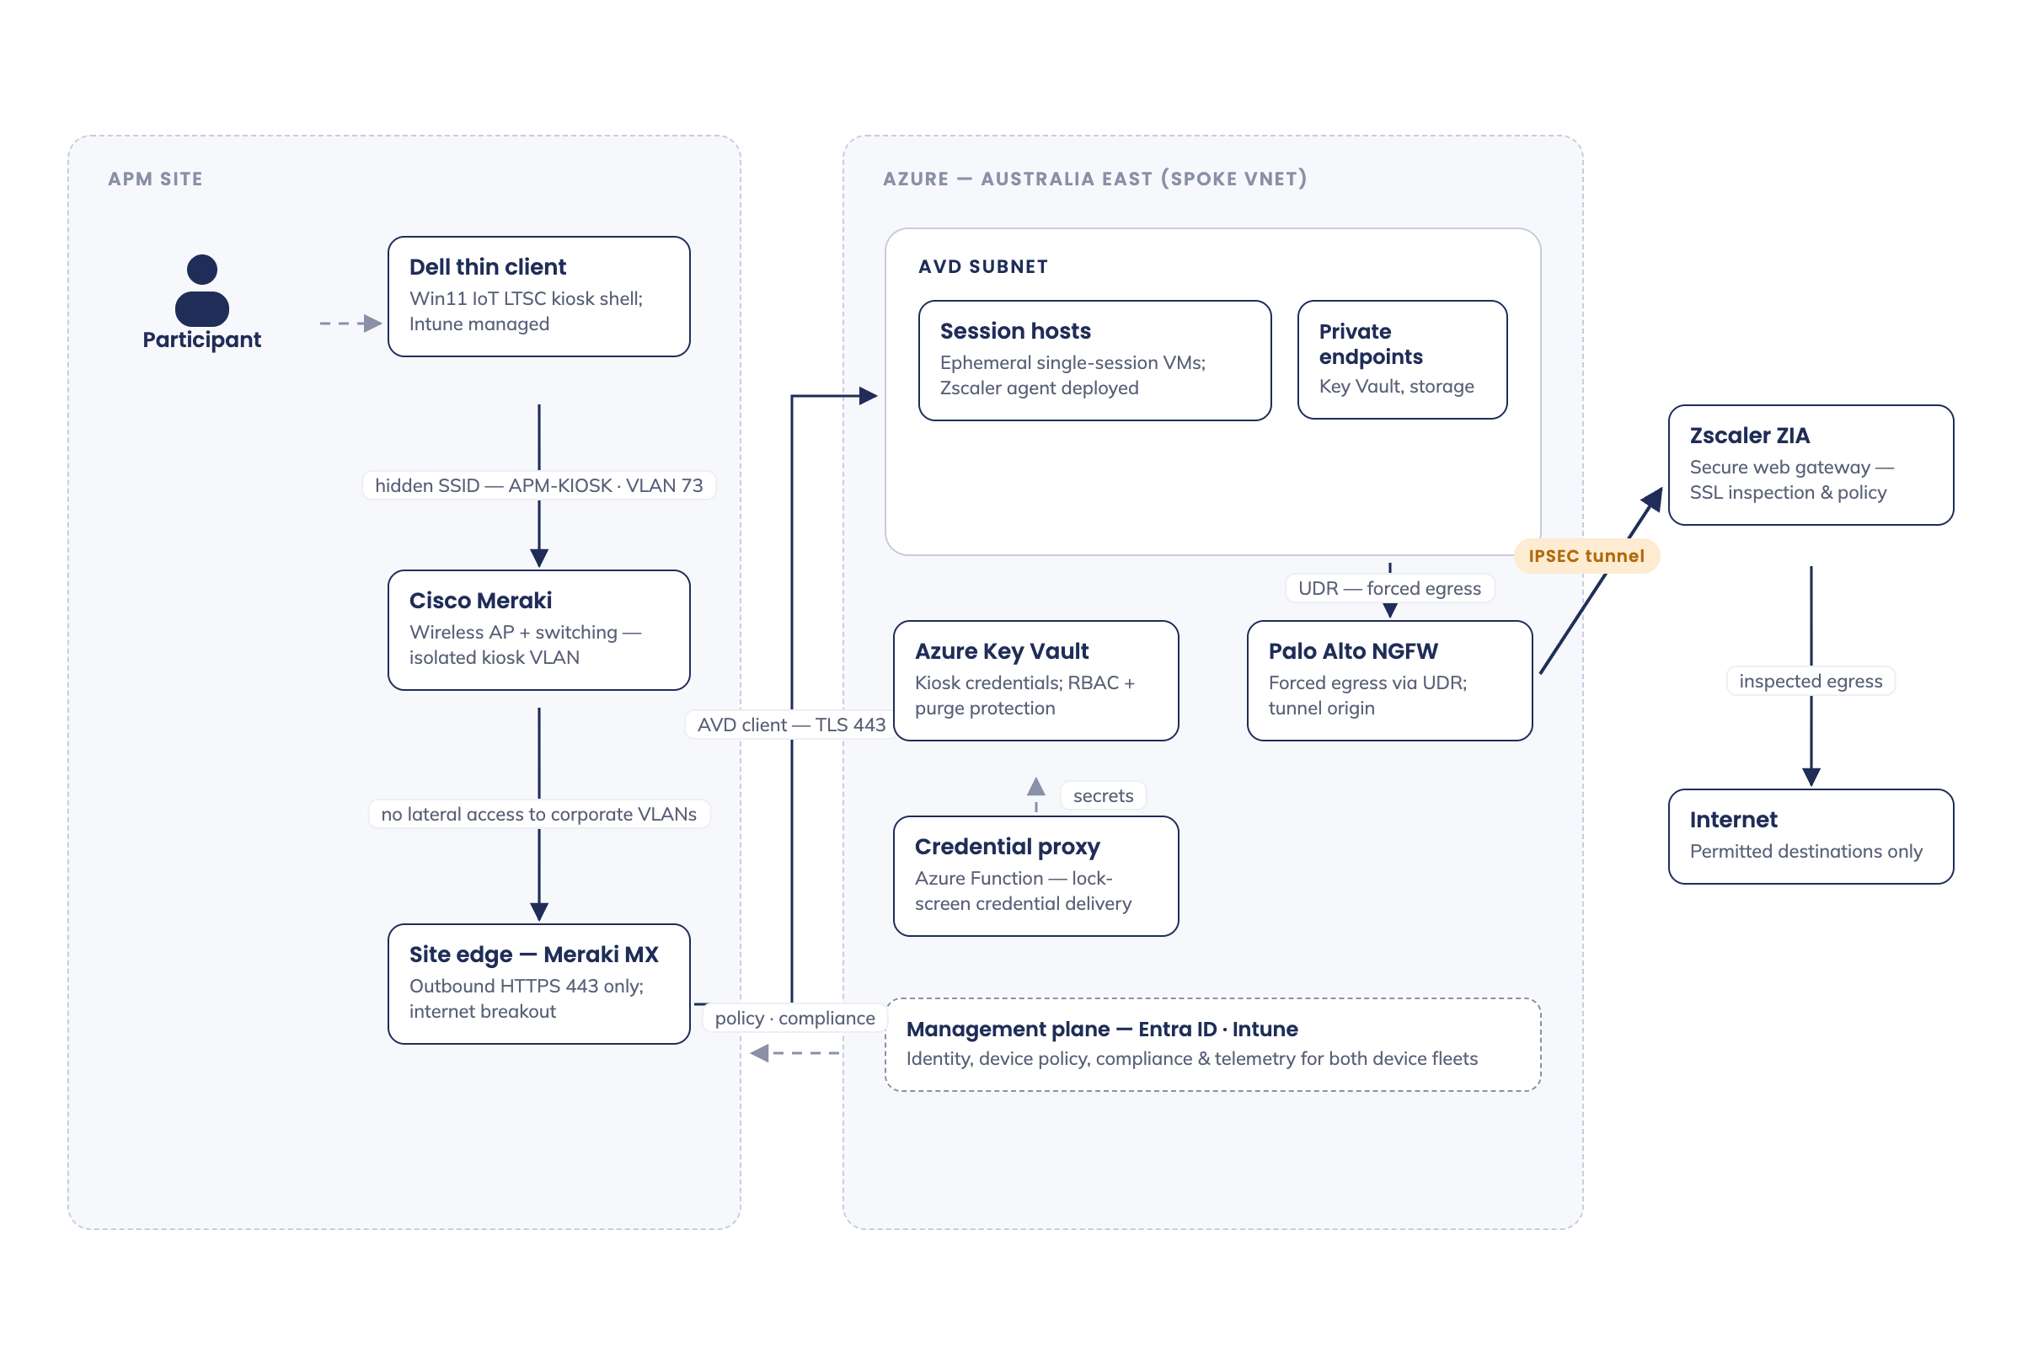
Figure 8.1 — Example: site network logical diagram. Replace with the view for your solution.
Example — Devices connect to a dedicated site VLAN via a hidden SSID. All egress traverses the site firewall to the secure web gateway; no lateral access to corporate VLANs is permitted.

8.2 Infrastructure & database
What goes here: physical/virtual servers, cloud resources, databases. For cloud-only device solutions, record the cloud resources (Key Vault, storage, automation).
Attribute | Value
Resource name | Example — kv-project-prod-ae
Type / platform | Azure Key Vault
Location / region | Australia East
Configuration | RBAC authorisation; purge protection on
Dependencies | Accessed by provisioning pipeline at device build

8.3 Network services

Network cabling
What goes here: is any new cabling needed? Which sites, who delivers it, by when.

Edge / data centre switching
What goes here: which switches devices or servers connect to; port profiles; any new hardware.
Description | VLAN | IP range | Subnet
Example — kiosk device VLAN | 73 | 10.x.x.0/24 | /24

8.4 Firewall policy overview & internet access
Ref # | Source | Destination | Port / protocol | Purpose
FW-01 | Device VLAN | Zscaler ZIA ranges | 443/TCP, 80/TCP | Web gateway tunnel
FW-02 | Device VLAN | Microsoft 365 / Intune endpoints | 443/TCP | Enrolment, policy, M365 services

8.5 DNS configuration
Record / setting | Value | Purpose
Example — DNS servers (DHCP option) | Site resolver pair | Name resolution for device VLAN

8.6 Software components
Software | Version | Licence | Source
Windows 11 Enterprise | Current baseline | Per-device | Volume licensing

8.7 Infrastructure uptime & availability
Example — Target 99.5% during site operating hours. Devices are stateless; a failed device is swapped and re-provisioned within one business day.

8.8 Environments
What goes here: every environment the solution exists in, and how faithfully each mirrors production — name the gaps that matter for testing.
Environment | Purpose | Notes
Production | Live service | Azure Australia East; all controls enforced
Test | Design validation and pre-production change testing | Example — not fully production-like; validate network paths explicitly before relying on results
Image build | Golden image pipeline | Isolated resource group; no user data

9. Cyber resilience

9.1 Security overview
What goes here: the control story in one paragraph: what protects the device, the identity, the network path and the data.
Example — Security is enforced in four independent layers: a locked device shell (only approved apps run), bound identities (Conditional Access ties each sign-in to its device and blocks all non-approved cloud apps), an inspected network path (all egress via the secure web gateway), and a stateless data plane (session wipe at sign-out).

9.2 Data governance and classification
Data component | Classification | Comments
Participant documents | OFFICIAL: Sensitive | User’s M365 storage; wiped from device at session end
Device credentials | OFFICIAL: Sensitive | Key Vault; rotated automatically

9.3 Cryptographic keys & certificate protection
Item | Stored in | Rotation | Owner
Example — code-signing certificate | Azure Key Vault | Annual | Cyber security

9.4 Identity & access management
Example — Sessions use dedicated identities bound to devices by Conditional Access; a default-deny policy blocks all cloud apps except the approved set. Administrative access uses separate identities with PIM-activated roles; no standing privileged access.

9.5 User roles & access administration
What goes here: from the detailed template — user communities, their access privileges, and how access is granted, reviewed and revoked.
Role | Frequency of use | Access privileges required | Administered via
Participant | Per visit | Approved web apps only | Automatic (kiosk identity)
Site staff | Daily | Device restart, session reset | Scoped role

9.6 Control framework alignment
What goes here: the frameworks this solution is assessed against and where compliance is evidenced — one row per framework; the control-by-control detail lives in the control matrix, not here.
Framework | Applies because | Compliance evidenced in
RFFR (DEWR) | Solution handles employment-services participant data | Statement of Applicability; cyber security review of this design
ISM (ASD) | Control baseline underpinning RFFR accreditation | Control matrix / SoA mapping
Essential Eight | Maturity Level 2 target for end-user computing | Application control, patching, MFA and admin-privilege sections of this design

10. Supportability & monitoring

10.1 Monitoring & alerting
Layer | What is monitored | Tooling | Alert routing
Application | Session/app health | Vendor dashboards | ServiceNow queue
Infrastructure | Device compliance, enrolment state | Intune | ServiceNow queue
Cyber | Sign-in risk, CA blocks, vulnerabilities | SIEM / Defender | Security operations

10.2 Support model & run procedures
What goes here: from the detailed template — who supports what, and the routine tasks that keep the service healthy.
Area of responsibility | Service desk | Application support | Infrastructure support
Example — device offline | Triage, dispatch | — | Swap & re-provision

Task | Purpose | Frequency | Responsible
Example — review compliance report | Catch drift before it strands devices | Weekly | Platform team

10.3 Service levels, incident handling & escalation
Example — Priority follows the enterprise matrix; a whole-site outage is P2. Escalation: service desk → platform team → vendor. Response targets per the enterprise SLA for a Tier 3 service.

10.4 Backup & recovery
Example — Devices hold no data and are not backed up; recovery is re-provisioning. Configuration-as-source (policies, profiles, scripts) is exported to the repository on change.

10.5 Updates & patching
Component | Cadence | Ring / window | Owner
Windows quality updates | Monthly | Pilot +0d, broad +7d | Platform team

10.6 Maintenance windows & remote access
Example — Maintenance occurs outside site hours (18:00–08:00 local). Remote support is attended-only via the approved tool; sessions are logged and require on-site consent.

10.7 Disaster recovery
Example — Devices are stateless: recovery is re-provisioning via the enrolment pipeline. Management plane (Intune/Entra) DR is inherited from Microsoft; configuration restore from repository.

10.8 Capacity, performance & scalability
Metric | Design value | Growth headroom
Example — devices per site | N devices | Add devices; no infrastructure change
Example — concurrent sessions | Sized to licence count | Licence uplift

11. Resource requirements
What goes here: from the detailed template — hardware, software and people needed to deliver and then run the solution.

11.1 Hardware & software requirements
Item | Type | Quantity | Source
Example — kiosk devices | Hardware | N per site | Device partner
Example — per-device licences | Software | 1 per device | Reseller

11.2 Personnel — during delivery
Role | Assigned tasks | Time required
Example — build engineer | Image, profiles, policy build and test | X weeks

11.3 Personnel — support & maintenance
Role | Assigned tasks | Time required
Example — platform team | Patching, compliance review, policy change | X hrs/week

12. Testing & implementation

12.1 Test plan
What goes here: what will be tested, by whom, against which requirements. Reference the test plan document if separate.
Test area | Verifies | Method
Example — session wipe | BR-02: no data persists between users | Scripted session, forensic check of profile paths

12.2 Implementation strategy
Example — Build order: certificate issuance → management-plane configuration → pilot site (2 devices, 2 weeks) → staged rollout by region. Policies run report-only for two weeks before enforcement.

12.3 Training, release & change management
What goes here: who needs training (site staff, service desk), how releases are packaged and approved, and which changes need CAB.

13. Statement of delivery impacts
What goes here: from the detailed template — impact to production during delivery, impact on management information/reporting, and operational risk introduced by the change.
Impact area | Description | Mitigation
Example — production | Old equipment removed same day as cutover to avoid parallel unmanaged access | Site-by-site cutover checklist

A. Appendix A — Terms & abbreviations
Term / abbreviation | Definition
CA | Conditional Access (Microsoft Entra)
HLD | High Level Design
ISM | Information Security Manual (Australian Signals Directorate)
PIM | Privileged Identity Management
RFFR | Right Fit For Risk (DEWR accreditation framework)
ZIA | Zscaler Internet Access

B. Appendix B — Implementation considerations
What goes here: sequencing constraints, cutover notes, and anything the delivery team must know that doesn’t belong in the body sections.

