Zscaler Configuration

Overview
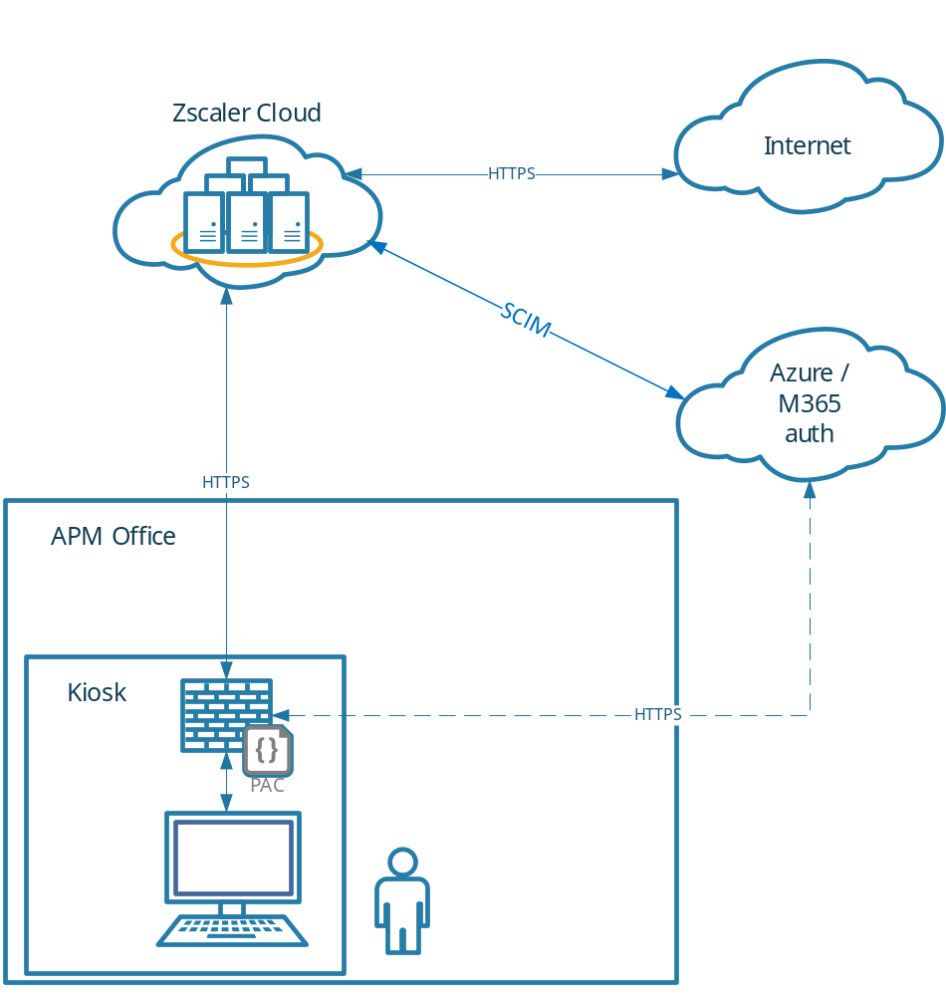

Azure Configuration

Entra Groups:
Group Name | Purpose
apm-js-kiosk-users-internet | Group to apply Zscaler configuration to kiosk users and devices.

Configure:
EntraID -> Groups

Enterprise Application
Setting | Value
Enterprise App Template | Zscaler Internet Access ZSCloud
Assigned Users | apm-js-kiosk-users-internet
Single Sign-On | SAML
Basic SAML Config
Identifier | https://login.zscloud.net/sfc_sso/38777108
Reply URL | https://login.zscloud.net/sfc_sso
Sign on URL | https://login.zscloud.net/sfc_sso
Users and groups | apm-js-kiosk-users-internet
Provisioning
Tenant URL | https://scim.zscloud.net/38777108/4349816/scim
Secret Token | <from Zscaler>
Mappings | Default
Scope | Sync only assigned users and groups
Provisioning Status | On

Zscaler Configuration

Identity Provider
Setting | Value
Name | apmkiosk idp
Status | Enabled
SAML Portal URL | https://login.microsoftonline.com/fa7adf0d-de2d-4570-8f5f-4bca4772988f/saml2
Login Name Attribute | NameID
Org-Specific Entity ID | Enabled
IDP SAML Certificate | <from Entra>
Vendor | Microsoft Entra ID
Authentication Domains | Apmkiosk.net.au
Enable SCIM Provisioning | On

PAC File
PAC File Name | Description | Domain | Obfuscate URL
apm-js-kiosk-users | Jobseeker Kiosk Users | apmkiosk.net.au | Yes

Configure:
Infrastructure -> Internet & SaaS -> Traffic Forwarding -> Traffic Steering -> Hosted PAC Files

Content:
Appendix A

Forwarding Profile
Setting | Value
Profile Name | apm-js-kiosk-users-fp
Trusted Network Criteria | None
Trusted Network Evaluation | All disabled
Windows Driver Selection | Packet Filter-Based
On-Trusted Network | Tunnel
Tunnel version selection | Z-Tunnel 2.0
Advanced Z-Tunnel 2.0 Config
Primary Transport Selection | DTLS
DTLS Connection Timeout | 9
TLS Connection Timeout | 5
MTU for Zscaler Adapter | 0
Path MTU Discovery | On
Allow TLS Fallback | On
Z-Tunnel 2 setup failure | Fallback to Z-Tunnel 1.0 and Bypass non-web traffic
Redirect Web Traffic to ZCC | No
Use Z-Tunnel 2.0 for Proxied Web Traffic | Not selected
Block Unreachable domains Traffic | On
Drop IPv6 in Dual Stack | On
Drop IPv6 in IPv6 Only | Off
Dynamic ZIA Service Edge | Off
VPN Trusted Network | Select same as “On-Trusted Network”
Off-Trusted Network | Select same as “On-Trusted Network”

Configure:
Infrastructure -> Connectors -> Client -> Forwarding Profiles -> Forwarding Profile for Platforms

App Profile
Setting | Value
Name | apm-js-kiosk-users-ap
Rule Order | 2
Forwarding Profile | apm-js-kiosk-users-fp
Status | Enabled
ZIA Posture Profile | Leave blank
Install Zscaler SSL Certificate | On
Install WFP Driver | On
Location Policy Override | Off
Notification Template | Legacy Notification Template
User groups | apm-js-kiosk-users-internet
Users | None
Follow Global Settings for Partner Login | Off
Allow Users of this Tenant to Login to Other Tenants | Off
Custom PAC URL | {TBC – from apm-js-kiosk-users PAC file – generated at creation}
Fallback to gateway domain | Selected
Use Preferred port from PAC for Tunnel 1.0 | Not selected
Use Preferred port from PAC for Tunnel 2.0 | Not Selected
Strict Enforcement Mode | Not Selected
Override WPAD | On
Disable Loopback Restriction | Off
Restart WinHTTP Service | On
V8 Javascript-based PAC Parser | On
Cache System proxy on startup | Off
App Failover Settings
ZIA Cloud Not reachable | Follow Global Config
Z-Tunnel Failover | Follow Global Config
Firewall | All Off
Passwords (all) | {set – record in passwordstate}
Authentication
Prevent Auto Reauth During Device Lock | Off
Follow Global Settings for ZPA Reauth | On
Notification and Logging
Log mode | Default
Log File Size | 100 (MB)
Use Zscaler Notification Framework | Off
Captive Portal Detection | On
Captive portal disable web security | 10 (minutes)
Embedded Captive Portal | Off
Packet Capture Captive Portal | On
Client Connect UI
Default Language | Use System Language
SCCM Client Configuration | Off
Command Line Interface | Off
Advanced
Enable Anti Tampering | On
Override Anti-tampering install parameter | Off
Send Disable Service Reason | On
Enable Client Connector Revert | Off
Highlight Active Control | On
Clear Kerberos DC | Off
Description | Jobseeker Kiosk Users Zscaler App Profile.

Configuration:
Infrastructure -> Connectors -> Client -> Platform Settings -> Windows -> App Profiles

URL Filtering
Order | Name | Enabled | Categories | Groups | Action | Description
1 | js-kiosk-allow | Yes | -Business and Economy  -Education  -Entertainment/Recreation  -Government and Politics  -Health  -Advertising [TBC]  -CDN  -FileHost  -General AI & ML Applications  -Generative AI and ML Applications  -Other Information Technology  -Portals  -Safe Search Engine  -Translators  -Web Search  -Blogs  -Discussion Forums  -Internet Services  -Online Chat  -Other Internet Communication  -Web Conferencing  -Webmail  -Zscaler Proxy Ips  -Job Search  -News and Media  -Social and Family Issues  -Society and Lifestyle  -Special Interests/Social Organisations  -Travel  -Vehicles | apm-js-kiosk-users-internet | Allow | Allowed JS Kiosk users internet access.
2 | js-kiosk-deny-all | Enabled | All | apm-js-kiosk-users-internet | Block | Block all unapproved JS Kiosk user internet access

Configuration:
Policies -> Internet & SaaS -> URL Control -> URL Filtering

Note: Policies are applied top down, allowed categories will be permitted, all others will be blocked.

Appendix A – PAC File
function wssBypass(url, host) {
return (
shExpMatch(host, '*.ad.apm.net.au') || shExpMatch(host, 'ad.apm.net.au') ||
shExpMatch(host, '*.apm.net.au') || shExpMatch(host, 'apm.net.au')
);
}

function FindProxyForURL(url, host) {

// APM Bypass
if (wssBypass(url, host)) return "DIRECT";

// Microsoft Update Exceptions
if (((localHostOrDomainIs(host, "download.visualstudio.microsoft.com"))||
(localHostOrDomainIs(host, "au.download.windowsupdate.com"))||
(localHostOrDomainIs(host, "download.windowsupdate.com")) ) &&
(url.substring(0,5) == "http:" || url.substring(0,6) == "https:"))
return "DIRECT";

// Azure Bypass
if(dnsDomainIs(host,"login.microsoft.com")||
dnsDomainIs(host,"login.microsoftonline.com")||
dnsDomainIs(host,"manage.microsoft.com")||
dnsDomainIs(host,"r.manage.microsoft.com")||
dnsDomainIs(host,"login.windows.net")||
dnsDomainIs(host,"microsoftonline-p.com")||
dnsDomainIs(host,"devices.myki.io")||
dnsDomainIs(host,"login.live.com")||
dnsDomainIs(host,"intunendes3-advancedpersonnelmanagement.msappproxy.net")||
dnsDomainIs(host,"msftauth.net"))
return "DIRECT";

var privateIP = /^(0|10|127|192\.168|172\.1[6789]|172\.2[0-9]|172\.3[01]|169\.254|192\.88\.99)\.[0-9.]+$/;
var resolved_ip = dnsResolve(host);
// var country = "${COUNTRY}";

/* Don't send non-FQDN or private IP auths to us */
if (isPlainHostName(host) || isInNet(resolved_ip, "192.0.2.0","255.255.255.0") || privateIP.test(resolved_ip))
return "DIRECT";

/* FTP goes directly
if (url.substring(0,4) == "ftp:")
return "DIRECT"; */

/* test with ZPA */
if (isInNet(resolved_ip, "100.64.0.0","255.255.0.0"))
return "DIRECT";

/* Updates are directly accessible */
if (((localHostOrDomainIs(host, "trust.zscaler.com")) ||
(localHostOrDomainIs(host, "trust.zscaler.net")) ||
(localHostOrDomainIs(host, "trust.zscalerone.net")) ||
(localHostOrDomainIs(host, "trust.zscalertwo.net")) ||
(localHostOrDomainIs(host, "trust.zscalerthree.net")) ||
(localHostOrDomainIs(host, "trust.zscalergov.net")) ||
(localHostOrDomainIs(host, "trust.zsdemo.net")) ||
(localHostOrDomainIs(host, "trust.zscloud.net")) ||
(localHostOrDomainIs(host, "trust.zsfalcon.net")) ||
(localHostOrDomainIs(host, "trust.zdxcloud.net")) ||
(localHostOrDomainIs(host, "trust.zdxpreview.net")) ||
(localHostOrDomainIs(host, "trust.zdxbeta.net")) ||
(localHostOrDomainIs(host, "trust.zsdevel.net")) ||
(localHostOrDomainIs(host, "trust.zsbetagov.net")) ||
(localHostOrDomainIs(host, "trust.zspreview.net")) ||
(localHostOrDomainIs(host, "trust.zscalerten.net")) ||
(localHostOrDomainIs(host, "trust.zdxten.net")) ||
(localHostOrDomainIs(host, "trust.zdxdevel.net")) ||
(localHostOrDomainIs(host, "trust.zdxgov.net")) ||
(localHostOrDomainIs(host, "trust.zscaler.us")) ||
(localHostOrDomainIs(host, "trust.zsqa.net")) ) &&
(url.substring(0,5) == "http:" || url.substring(0,6) == "https:"))
return "DIRECT";

/* for users of Canada if you want to direct traffic to only canada gateways*/
// if (shExpMatch(country, "Canada")) {
// return "PROXY ${COUNTRY_GATEWAY_FX}:80; PROXY ${COUNTRY_SECONDARY_GATEWAY_FX};DIRECT";
// }

/* for all users if you want to direct traffic to country gateways by default */
// return "PROXY ${COUNTRY_GATEWAY_FX}:80; PROXY ${COUNTRY_SECONDARY_GATEWAY_FX};DIRECT";

/* Default Traffic Forwarding. Forwarding to Zen on port 80, but you can use port 9400 also */
return "PROXY ${GATEWAY_FX}:80; PROXY ${SECONDARY_GATEWAY_FX}:80; DIRECT";
}

