Harmony Cornett

10/03/2013

Problem Solving

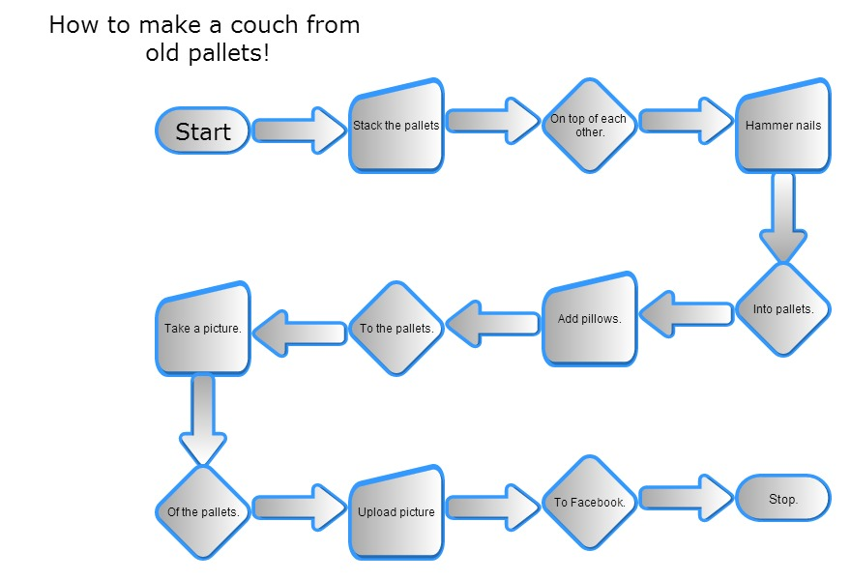

Here is a link to my git hub: <https://github.com/harmonycornett/Problem-Solving>