数组

NO.1
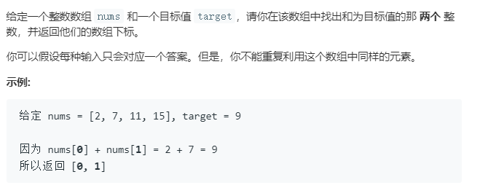
我的答案:
public static int[] twoSum(int[] nums, int target) {
int[] result = new int[2];
for (int i = 0; i < nums.length; i++) {
for (int j = i+1; j < nums.length; j++) {
if(nums[i] == target - nums[j]){
result[0] = i;
result[1] = j;
}
}
}
return result;
}

NO.4 数组（有点难，过段时间再来）
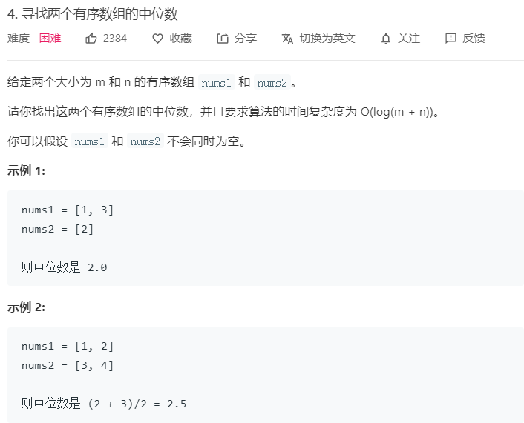

NO.26
