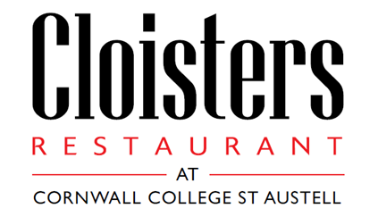

***Lunch Menu***

*10th January – 10th February, 2017*

***Starters - £3.00***

Cream of mushroom soup, with truffle

~

Smoked haddock and spring onion fish cake, red pepper aioli

~

Pan fried halloumi, parsley, tomato and caper dressing   
~

Duck, cous cous and hoisin spring roll, cucumber and spring onion, homemade sweet chilli

***Mains - £7.50***

Belly of pork, pomme fondant, spiced red cabbage, caramelised pear, Madeira jus

~

Fillet of salmon, sauce Veronique, sauté potatoes

~

Slow braised feather blade of beef, horseradish pomme puree, red wine sauce, parsnip crisps

~

Smoked cheddar, grain mustard and leek croquette, pea and broad bean ragout

**All Served With Seasonal Vegetables**

***Sweets - £3.00***

Rhubarb vacherin, vanilla ice cream

~

Honey panna cotta, blood orange, hazelnut shortbread

~

Raspberry and pistachio frangipane tart, cherry ripple ice cream

**3 Courses £12.00**

Tea or Filter Coffee £1.00 per Cup

**For A Selection of Specialist Coffees Please See Separate Menu**