

Instituto Politécnico Nacional

Escuela Superior de Cómputo

INGENIERÍA EN SISTEMAS COMPUTACIONALES

Lab 13.

Schoolbook RSA

Corona Hernández Martín Rafael

6CV3

Introduction to Cryptography

June 17, 2026

FUNCTIONS

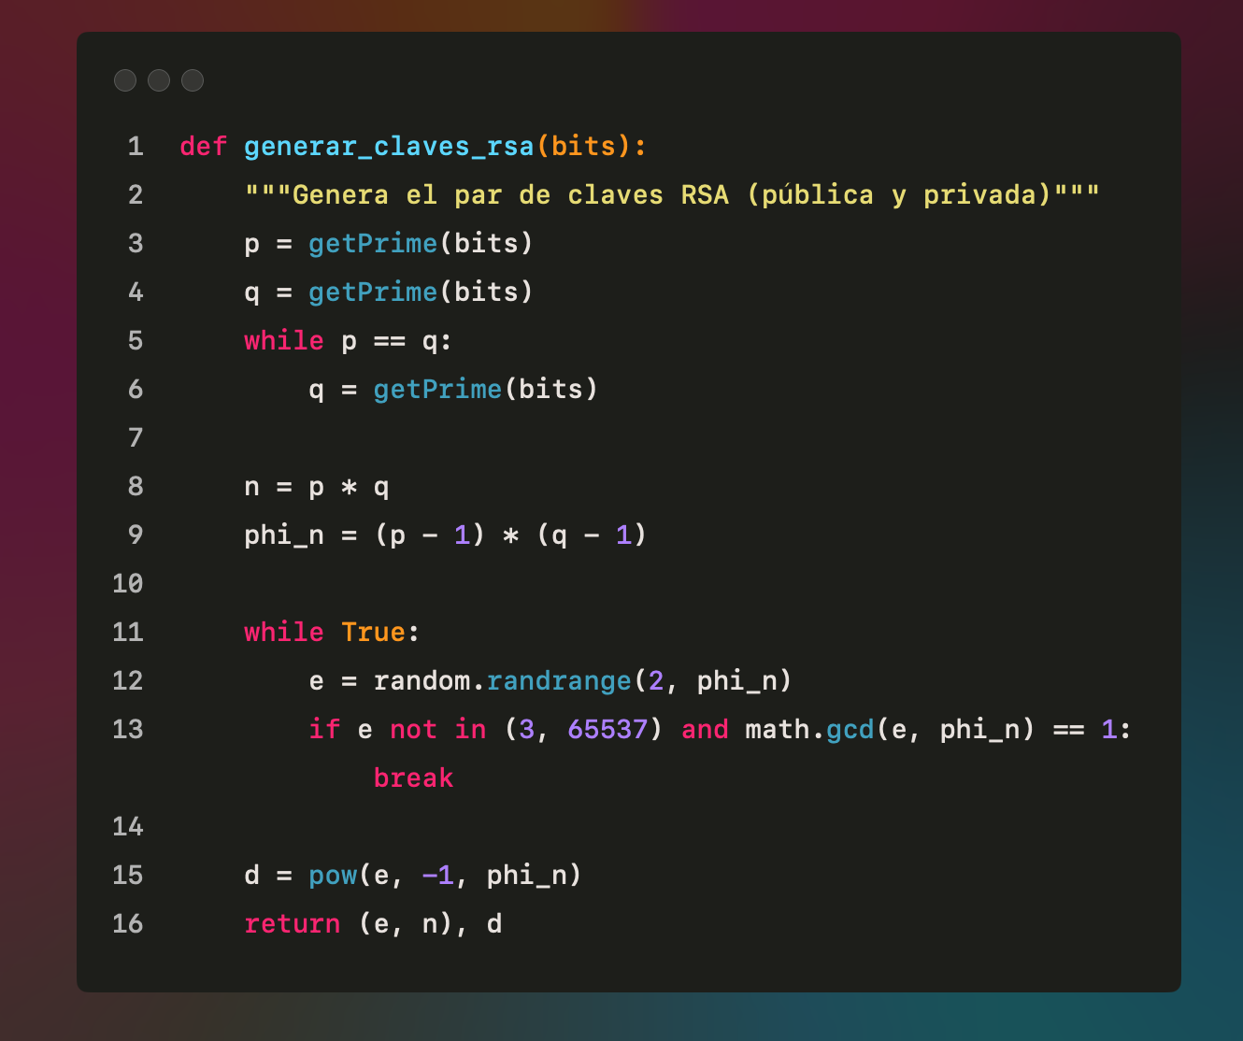

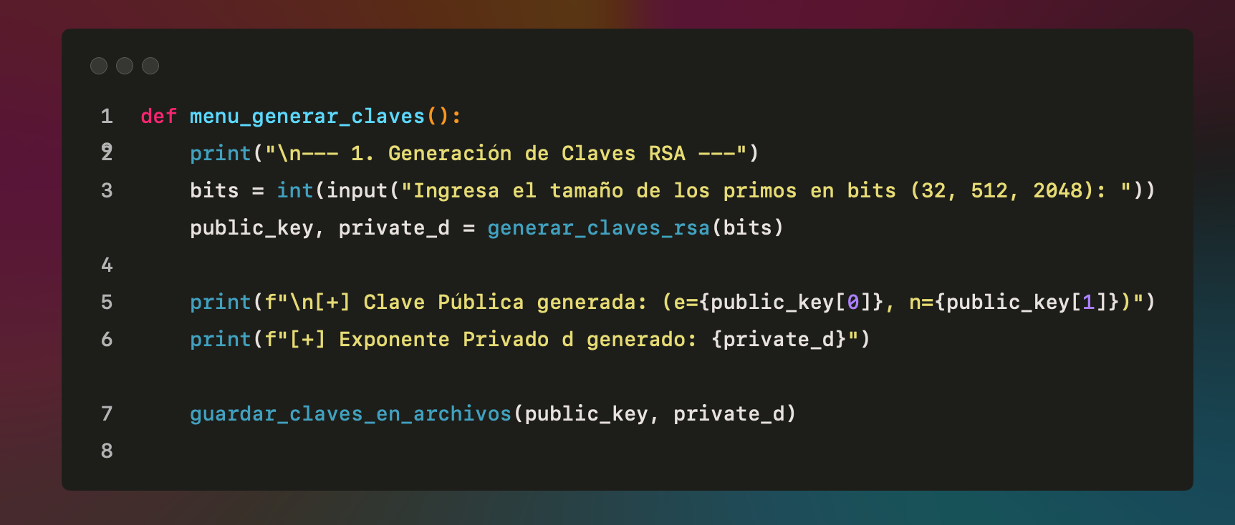

The program generates a valid RSA key pair by selecting two prime numbers of a specified bit length. It explicitly ensures that the public exponent $e$ is valid ($e∉\left\{3,65537\right\}$ and $\gcd\left(e,ϕ\left(n\right))=1\right)$) and calculates the private exponent $d$. The keys are exported to text files for easy sharing.
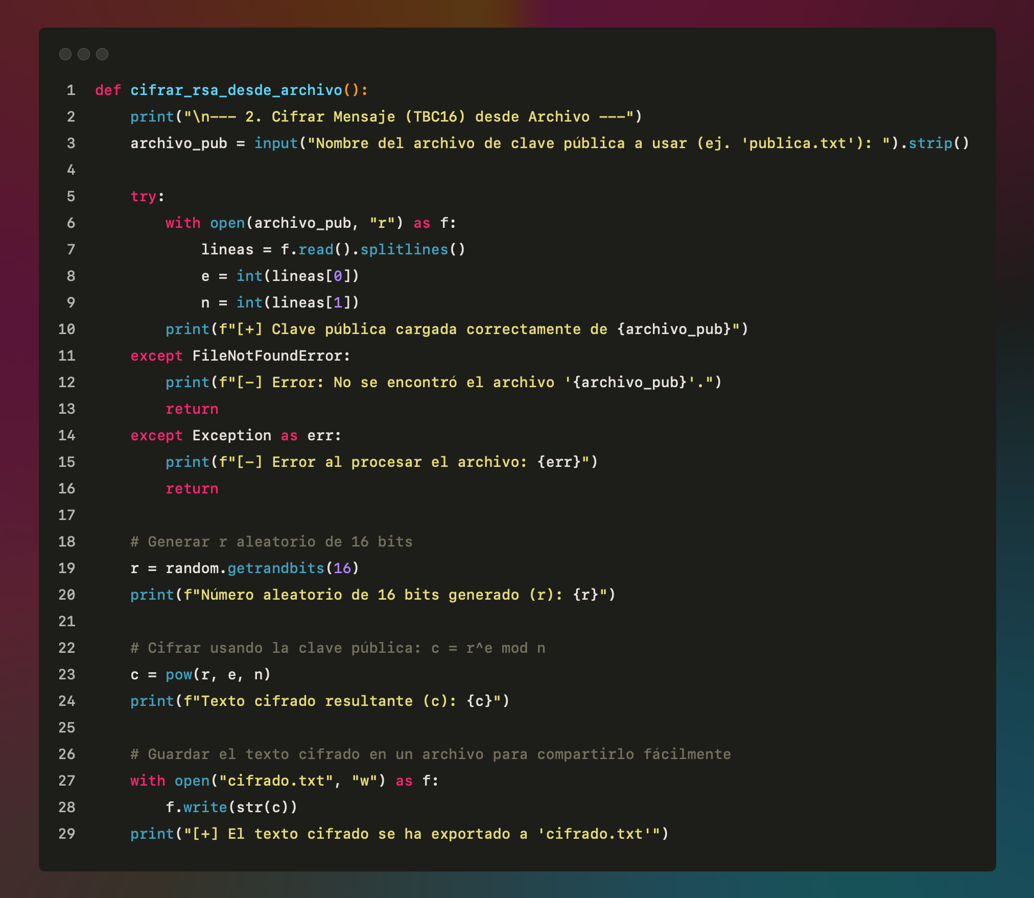

Encryption: It reads a partner's public key from a text file, generates a random 16-bit integer $r$ to simulate a symmetric key, and encrypts it using the formula $c=r^{e} \operatorname{mod}{n}$. The resulting ciphertext is saved to a file.
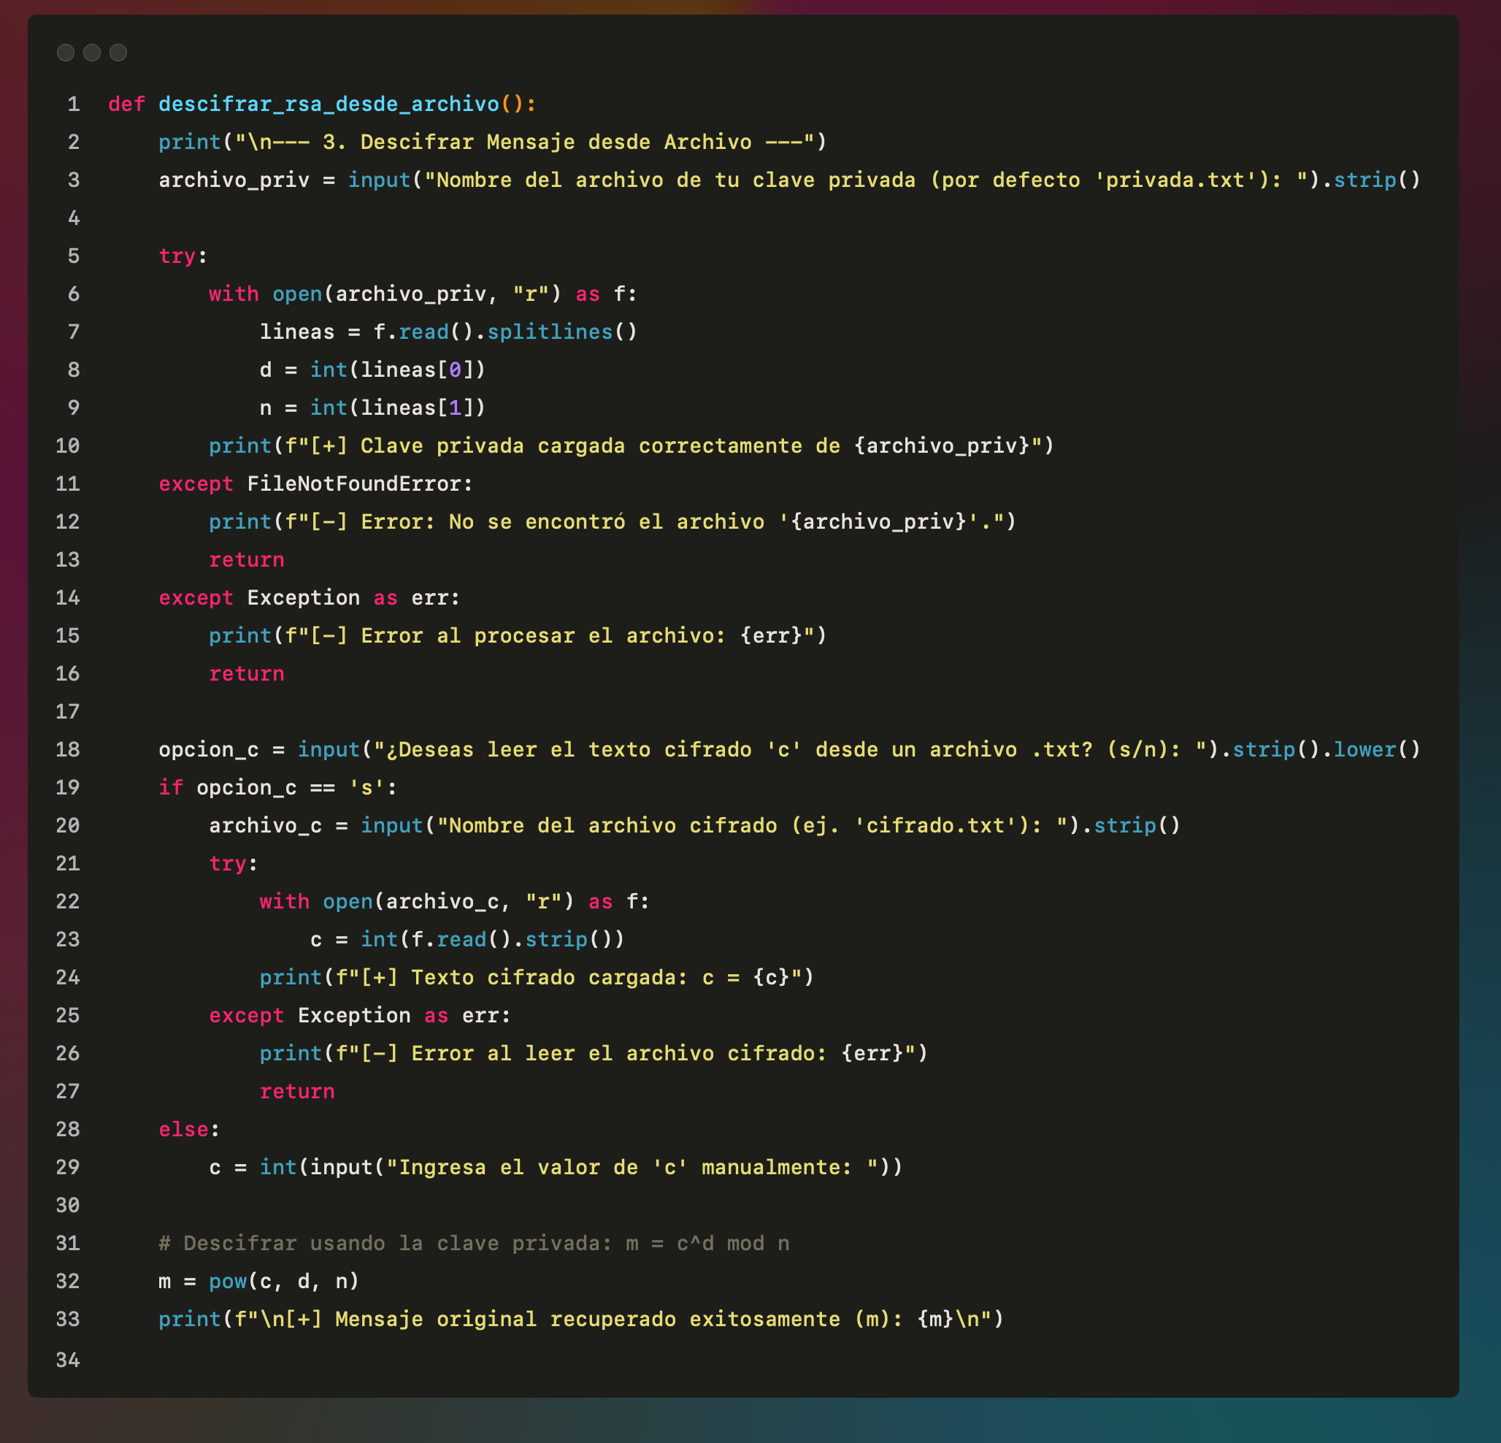

Decryption: It reads the user's private key and the ciphertext from their respective files, applying the formula $m=c^{d} \operatorname{mod}{n}$ to successfully recover the original 16-bit message.

SCREENSHOTS CODE RUNNING

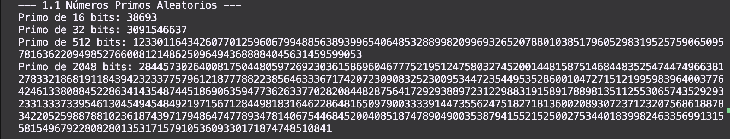

KEYS GENERATION
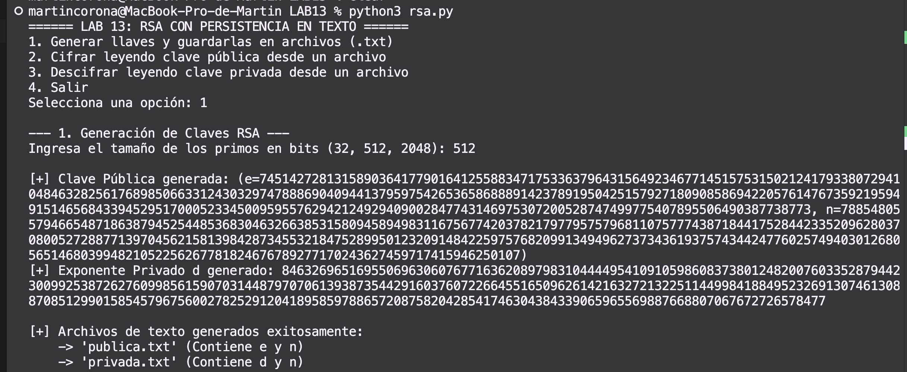

CIPHER
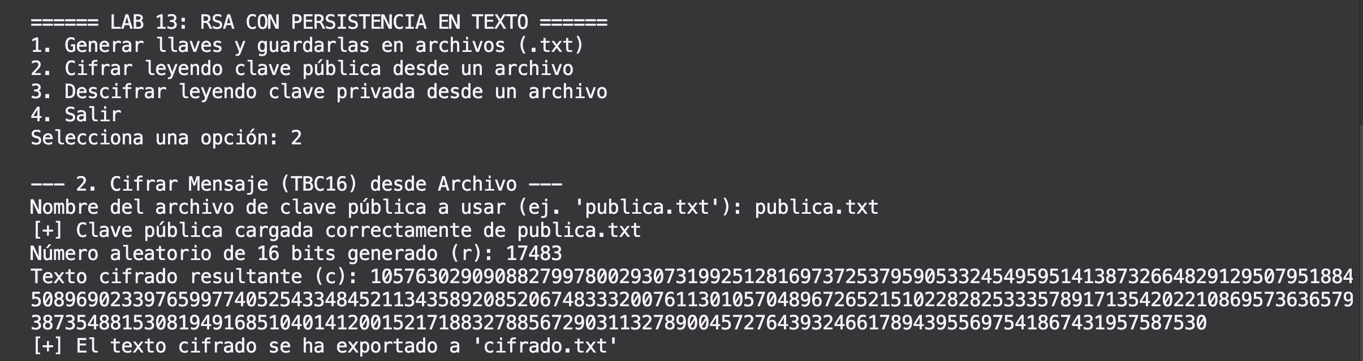

DECIPHER
