Thomas Grönroos

Firebase instructions

# Introduction

This document instructs on how to create a Firebase real-time data base and connect it with this project <https://github.com/Corosect-project/Project_2>.

# Creating Firebase project

To start click on "Create a project".

And fill out all the required information. For this project we will name it corosect-2.

# Adding database to the project

Once the project is ready click "Continue" and go to the left-hand side sidemenu and select "All products".

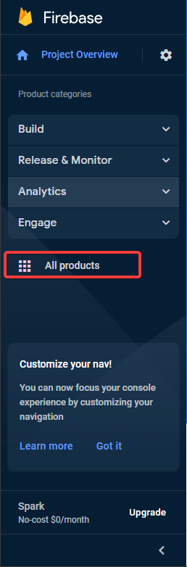

In the list find and select "Realtime Database". Next click "Create Database".

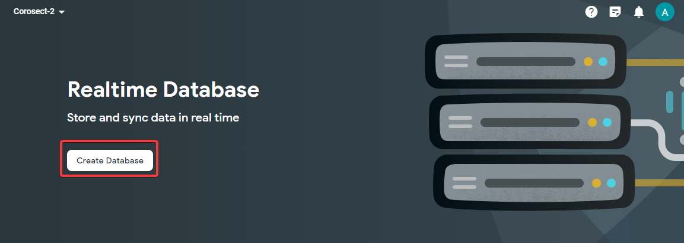

Select database location and select "Start in locked mode" for security rules. For this project we will leave it in locked mode and use an admin account to access it.

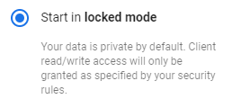

# Get access key and configure database access

Next got to project settings by clicking the cogwheel in the sidemenu and select "Project settings".

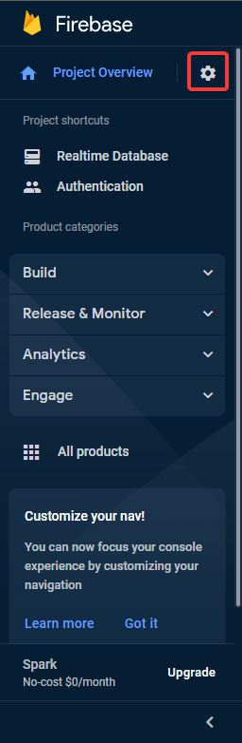

Now go to the “Service accounts" tab and select "Firebase Admin SDK".

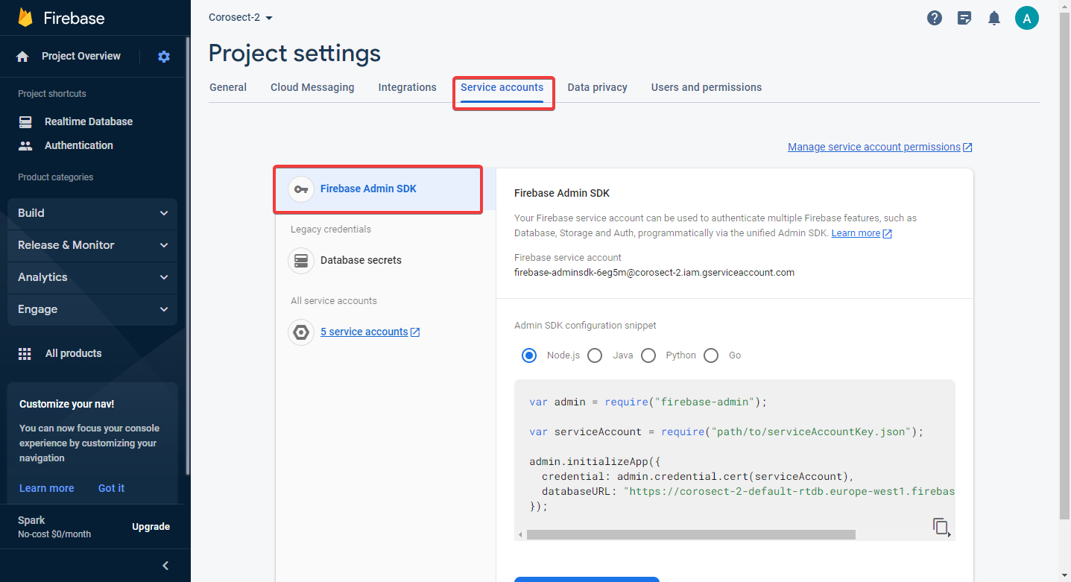

Scroll down and click "Generate new private key”.



We now have a real-time database and admin access key for it. For this project rename the key file to **firebase-admin-cert.json** and move it to the projects python client’s config folder *firebase/python/src/config*. You can also use the same steps for any other firebase project that wants to use the admin key to access the database.