TECHNICAL ARCHITECTURE

LibraryForge
  - Intelligent Library Management System
WPF • .NET 8 • MVVM • EF Core 8 • SQLite
Living architecture document
Baseline 1.1 | 18 July 2026

1. Purpose and architecture principles
This document describes the implemented LibraryForge architecture and is intended to evolve alongside the application. It captures the current component boundaries, dependency direction, data relationships, critical workflows, and deliberate extension points.
- Offline-first: core circulation and local sign-in work without network services.
- Service boundaries: business rules stay outside WPF code-behind.
- Transactional consistency: copy counts and loan state change together.
- Secure access: BCrypt local credentials and optional Google identity converge on RBAC-protected services.
- Replaceable edges: identity providers, reporting, metadata lookup, recommendations, and sync can evolve independently.
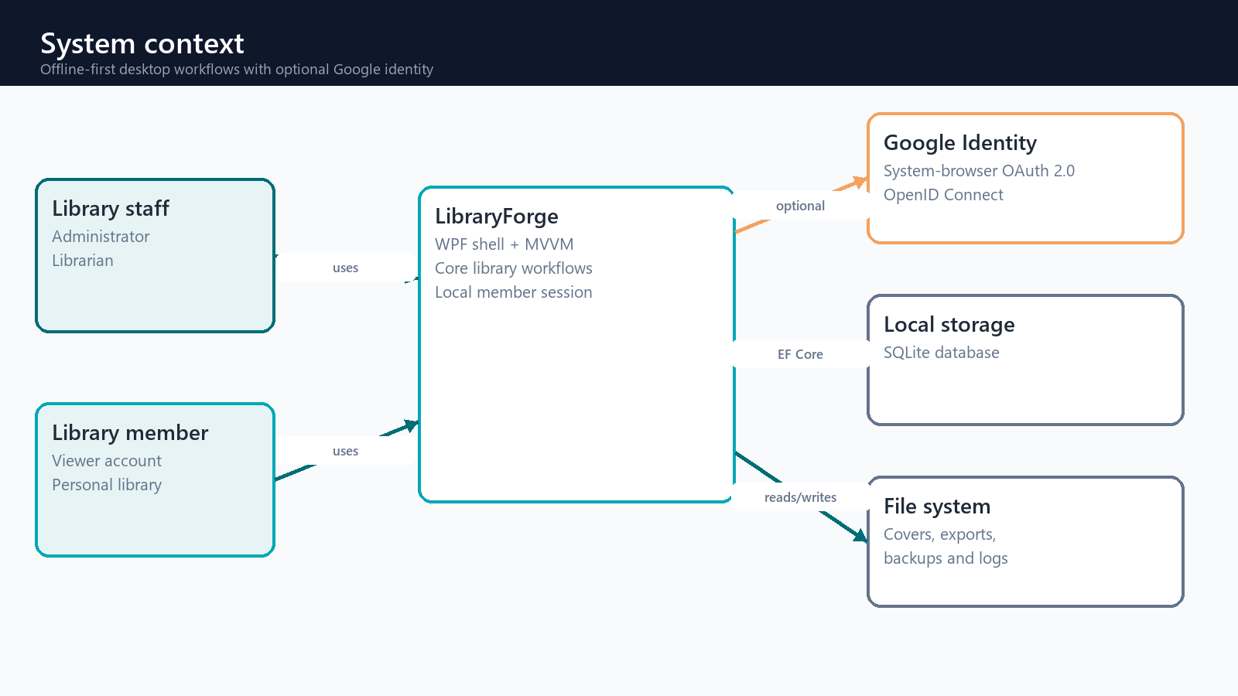
Figure 1. LibraryForge system context

2. Solution structure and dependency direction
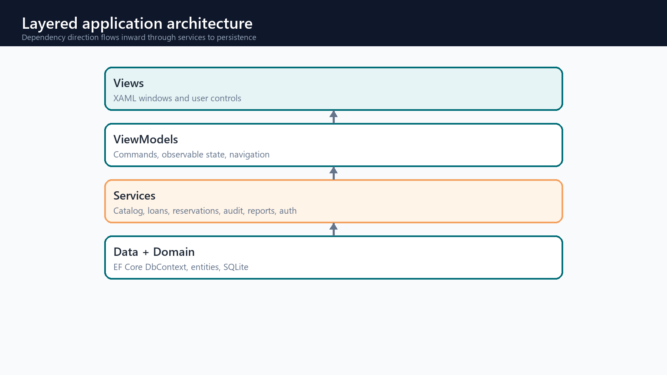
Figure 2. Layered application architecture
Layer | Current responsibility | Representative types
Views | Rendering, input, dialogs, accessibility | MainWindow, LoginWindow, RegistrationWindow
ViewModels | Observable state and commands | MainViewModel, MemberPortalViewModel
Services | Business workflows, identity, authorization | LoanService, AccountRegistrationService
Data / Domain | Persistence and entity rules | LibraryDbContext, Member, User, ExternalLogin

3. Composition, startup, and navigation
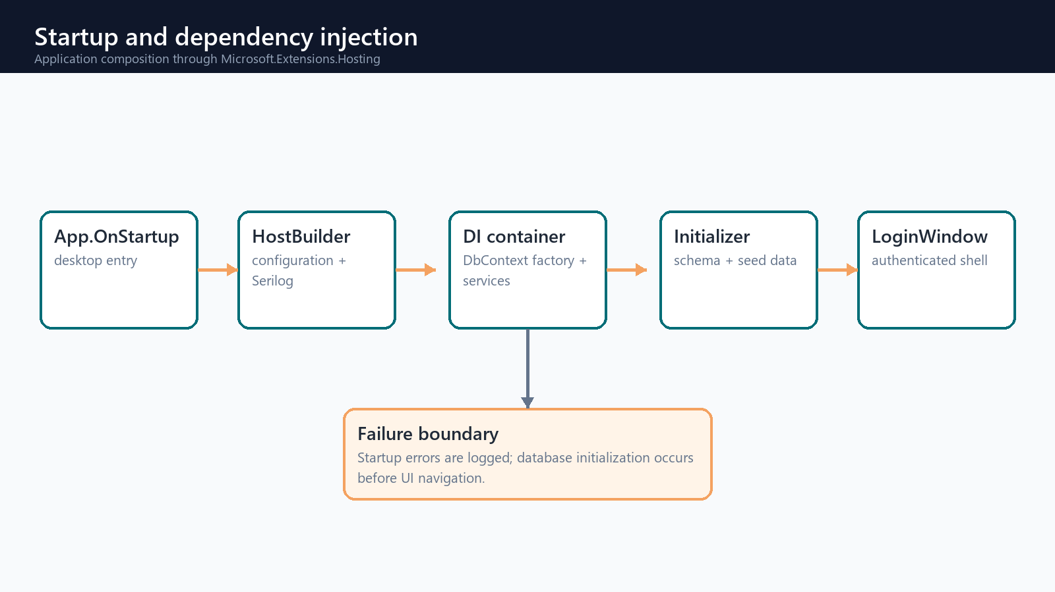
Figure 3. Startup and dependency injection flow
App.xaml.cs owns the desktop lifecycle. Program.CreateHostBuilder composes configuration, Serilog, the pooled EF Core context factory, singleton services, transient view models, and transient views. The database initializer completes before the login window is shown. Successful authentication resolves and opens the main shell.

Navigation model
- MainViewModel selects views through the service provider.
- Viewer accounts open a personal My Library dashboard and read-only catalog; staff retain operational modules.
- Admin navigation is only visible for administrators, and UserAdministrationService repeats the authorization check at the business boundary.

4. Authentication and authorization
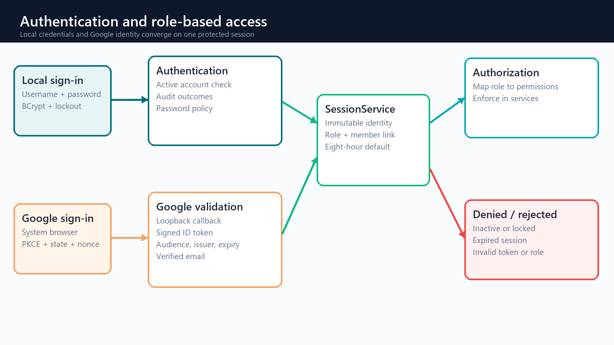
Figure 4. Authentication and RBAC decision flow
Passwords are never stored in plaintext. Local authentication verifies BCrypt hashes and applies lockout policy. Registration creates a linked Viewer user and Member record in an unverified state. Optional Google sign-in uses the system browser, Authorization Code with PKCE, a loopback callback, state and nonce checks, and validation of the signed OpenID Connect ID token before linking a provider subject to a local account. Provider tokens are not persisted.
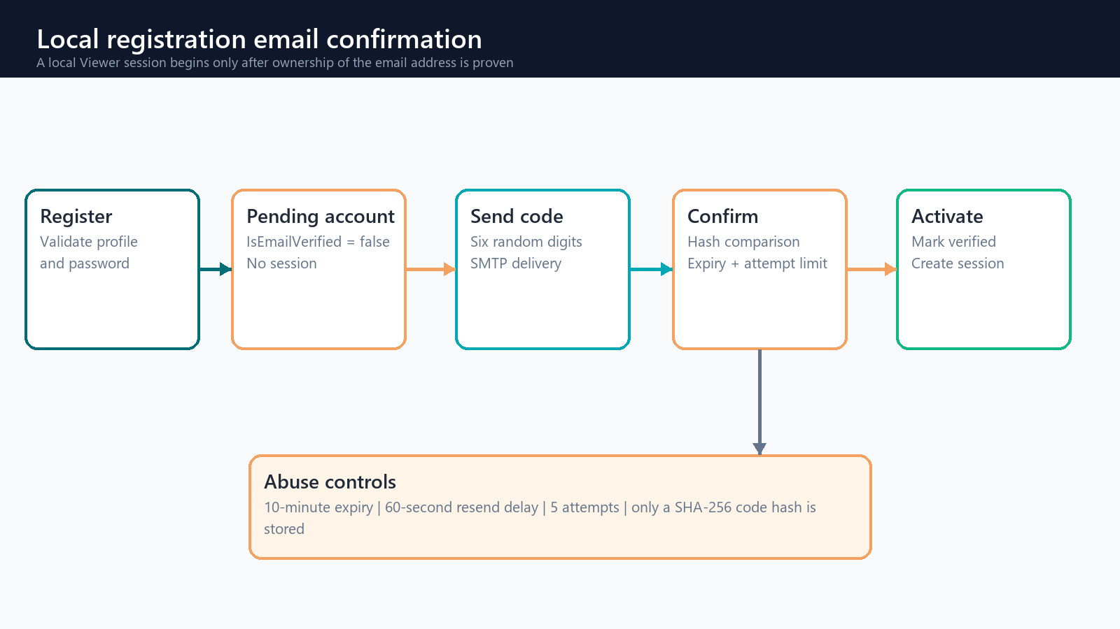
Figure 4B. Local email verification and session activation
- A six-digit code is generated with a cryptographic random-number generator; only its SHA-256 hash is stored.
- Codes expire after ten minutes, resend is delayed for sixty seconds, and five incorrect attempts require a new code.
- Local login is rejected until IsEmailVerified is true; successful verification creates the member session.
- Default session duration is eight hours; the shell returns to login when it expires.
- New and reset local passwords require at least 12 characters with upper/lowercase, a number, and a symbol.
- Google-only accounts use Google's verified email claim and do not expose the local password-change action.
- Navigation visibility improves usability, while AuthorizationService.Demand enforces the same permission at each business-service boundary.
Role | Permission profile | Protected operations
Viewer | My Library and catalog | Personal loans, reservations, history, read-only discovery
Librarian | Viewer access plus catalog, members, circulation, reservations | Book/member changes, issue/return, waitlists
Administrator | All permissions | Users, audit log, backup/restore, all staff workflows

5. Domain model and database
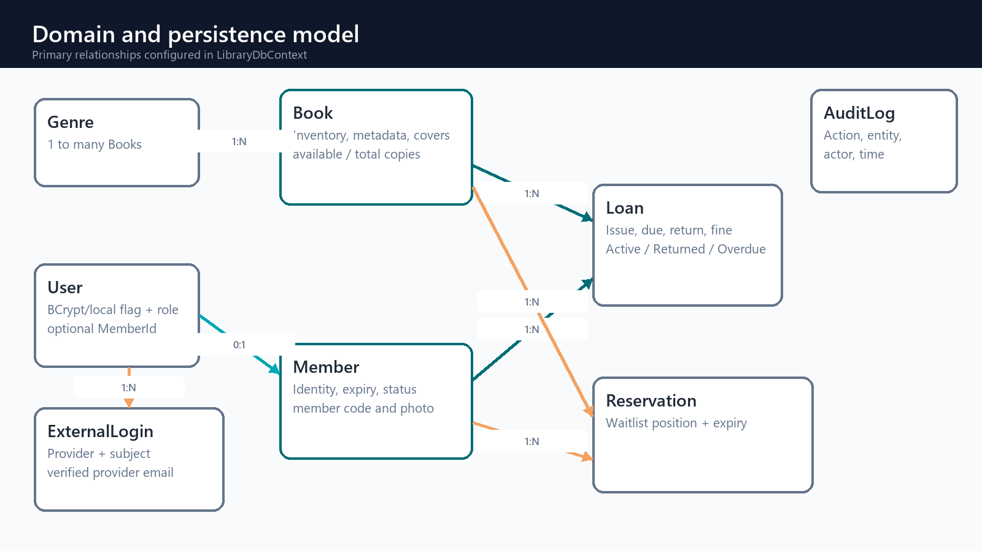
Figure 5. Simplified entity relationship model
LibraryDbContext exposes Books, BookCopies, InventoryEvents, Genres, Members, Loans, Reservations, Users, ExternalLogins, EmailVerifications, and AuditLogs. Each Book has many accessioned BookCopies; a Loan optionally references one exact copy so upgraded legacy loans remain readable. Users can optionally link one-to-one to a Member profile, one-to-many to external identity records, and one-to-zero-or-one pending verification record. Fluent configuration defines unique keys, lookup indexes, restricted deletes for circulation history, and inventory invariants.

Performance-oriented indexes
- Book ISBN and composite title/author lookup.
- Unique BookCopy accession code and optional barcode; book/status lookup for availability.
- InventoryEvent copy/time lookup for condition and state history.
- Member email and member code uniqueness.
- Loan status/due-date and optional BookCopyId lookup.
- Reservation book/status/queue-position lookup.
- Unique user name, optional User.MemberId, and external provider subject.

Physical-copy inventory and internal QR security
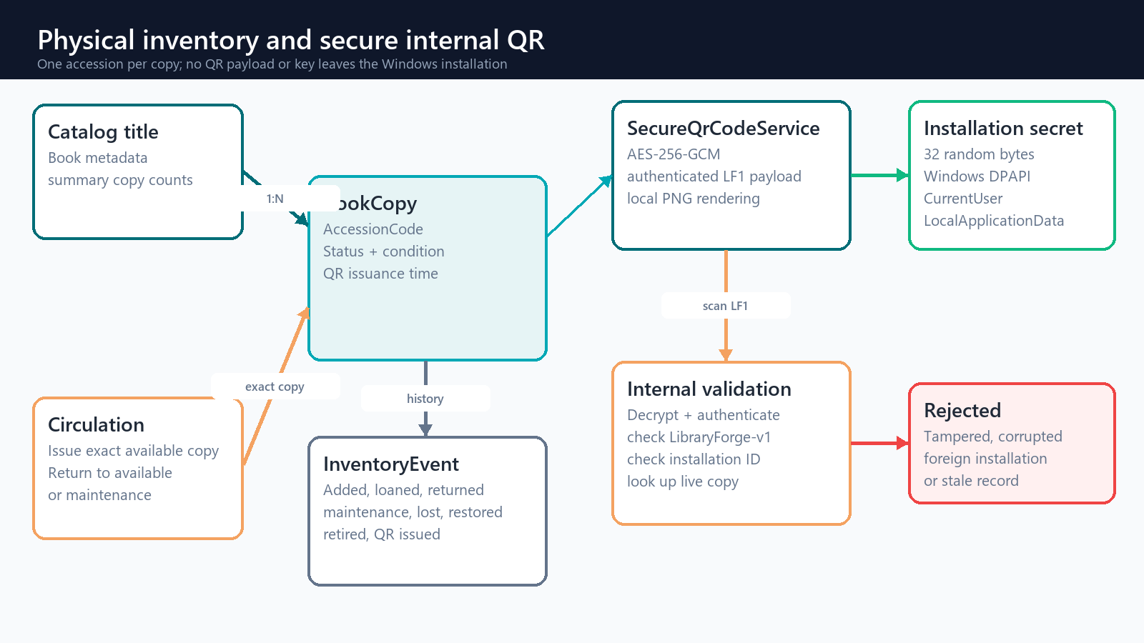
Figure 5B. Accession inventory and installation-bound QR security boundary
LibraryForge creates and validates QR content locally. QRCoder renders a standard QR image without contacting a hosted QR service. The encoded LF1 text is opaque AES-256-GCM ciphertext containing only the signed LibraryForge version, installation identifier, entity type, copy identifier, accession code, and issuance time. The encryption key is random per installation and protected with Windows Data Protection API for the current Windows user. A different installation, a modified token, or a mismatched database record is rejected before any action occurs.
- Standard scanners can extract the LF1 ciphertext text, but cannot recover or alter authenticated content without the installation key.
- Permanent book labels record IssuedAtUtc for audit and key-rotation analysis; they do not expire during ordinary shelf life.
- Future short-lived action QR tokens may add expiry and replay protection, but must use a separate payload purpose from permanent identity labels.
- Database backup and QR-key backup are separate concerns: restoring the database under a different Windows identity requires an authorized key-transfer procedure that is not yet implemented.

6. Circulation workflow
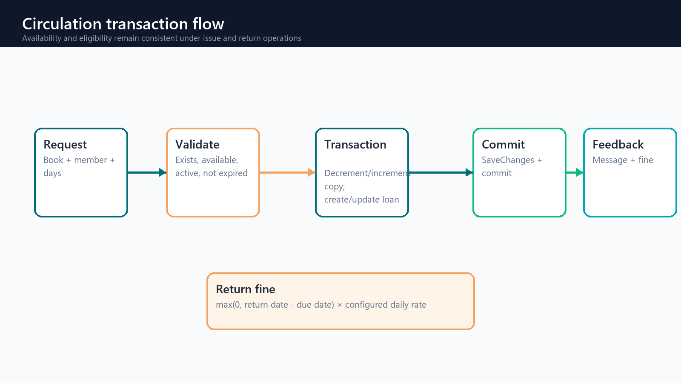
Figure 6. Issue and return transaction flow

Issue book
- Load the requested title, one Available BookCopy, and the member inside a database transaction.
- Reject missing entities, unavailable physical copies, protected reservations, inactive members, and expired memberships.
- Mark the exact copy Loaned, create the active loan with BookCopyId and due date, write its InventoryEvent, and recalculate title summaries.
- Save the audit and inventory changes and commit as one unit.

Return book
- Reject a missing or already returned loan.
- Calculate overdue days against the configured daily fine rate.
- Mark the loan returned and store the fine; return a healthy copy to Available or a damaged copy to Maintenance.
- Write the InventoryEvent, recalculate title summaries, promote the reservation queue, and commit.

7. Reservation lifecycle
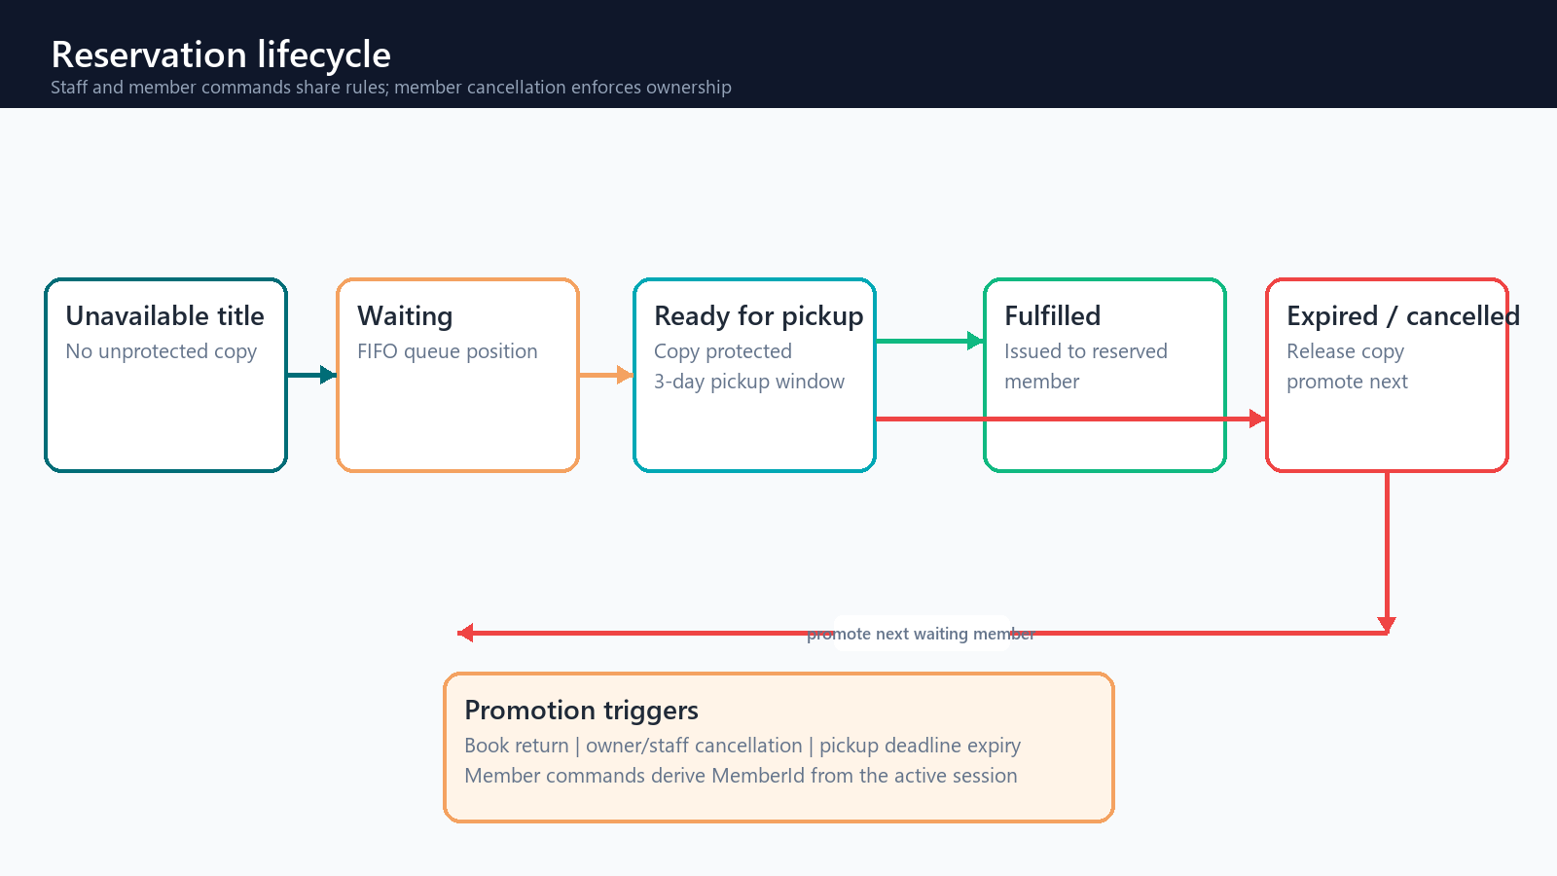
Figure 7. Reservation queue and promotion lifecycle
ReservationService owns waitlist eligibility, FIFO queue positions, pickup expiry, cancellation, and promotion. Staff commands require ManageReservations. Member self-service commands derive MemberId from the active session and never accept an arbitrary member identifier. A title can be reserved only when all available copies are already protected or on loan.
- A member cannot hold a duplicate active reservation or reserve a title they already have on loan.
- A member can cancel only a reservation whose MemberId matches the signed-in session; staff retain administrative cancellation.
- Ready copies cannot be issued to another member when no unprotected copy remains.
- Issuing to the reserved member marks the reservation fulfilled in the loan transaction.
- Cancellation or pickup expiry reorders the queue and promotes the next eligible member.
- Every state transition creates an AuditLog record in the same unit of work.

8. Feature modules
Module | View / VM | Service | Current capability
Registration | RegistrationWindow / ViewModel | AccountRegistrationService, IEmailSender | Local registration, email confirmation, resend and Google linking
Settings | SettingsView / ViewModel | MemberPortalService, ThemeService, ProfileImageStorageService | Profile/photo editing, persistent appearance and password entry
My Library | MemberPortalView / ViewModel | MemberPortalService, ReservationService | Loans, reservations and owner-only cancellation
Browse | BrowseCatalogView / ViewModel | CatalogService, ReservationService | Viewer-safe search and self-service waitlist entry
Dashboard | DashboardView / ViewModel | DashboardService | Staff inventory, member and overdue statistics
Books | BooksView + editor/copies dialogs | CatalogService, InventoryService, SecureQrCodeService | CRUD, accession inventory, condition/status history, internal QR labels, import/export
Members | MembersView + MemberEditorWindow | MemberService | Validated membership editor and borrowing history
Circulation | Loans + Reservations views | LoanService, ReservationService | Exact-copy issue/return, fines, waitlist and promotion
Admin | AdminView / ViewModel | UserAdministrationService, AuditService, BackupService | Users, roles, audit and database maintenance

Settings, profile images, and preferences
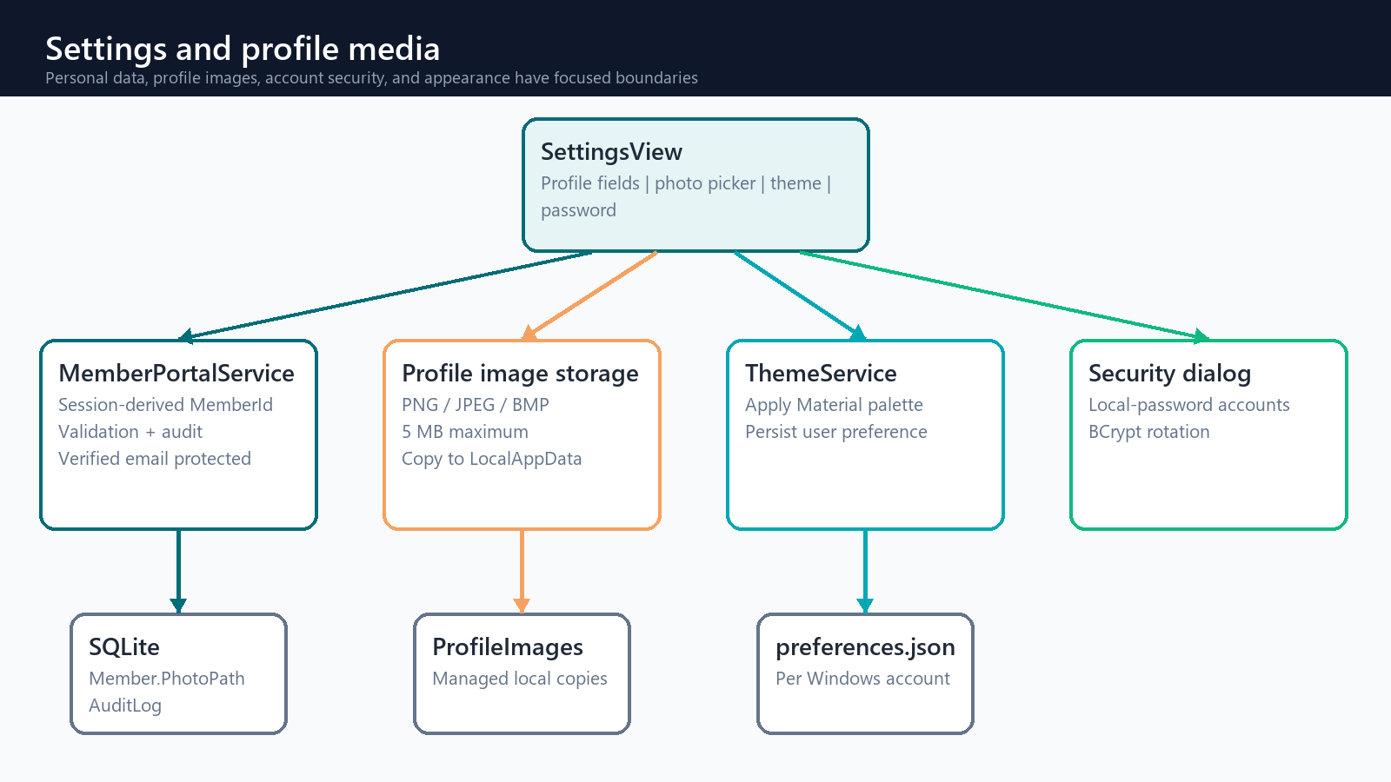
Figure 8B. Settings and profile-media boundaries
- Profile edits derive MemberId from the authenticated session; verified email is read-only.
- Profile images are restricted to PNG, JPEG, or BMP and five megabytes, then copied into the user LocalApplicationData LibraryForge directory.
- Theme choice is applied through ThemeService and persisted per Windows account in preferences.json.
- Book and member grids are read-only; dedicated editor dialogs validate detached copies before a service updates tracked entities.
- CSV import requires Title and Author headers, handles quoted commas, skips invalid or duplicate-ISBN rows, and audits the batch.

9. Cross-cutting operations
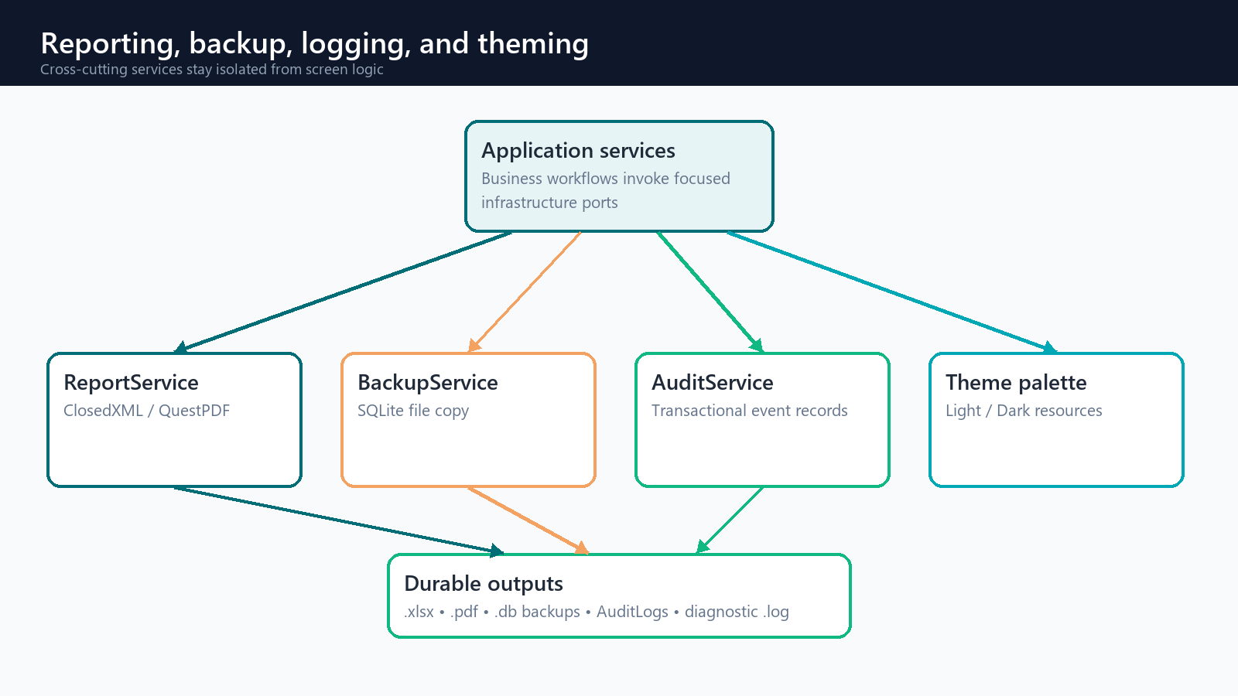
Figure 8. Reporting and operational services
- ReportService generates inventory workbooks with ClosedXML and overdue PDFs with QuestPDF.
- BackupService closes the EF database connection before copying or restoring the SQLite file.
- AuditService records actor, action, entity, details, and UTC time; administrators can inspect recent events.
- Serilog provides rolling diagnostic logs; MaterialDesign resources and PaletteHelper provide runtime light/dark switching.

10. Implemented baseline and extension roadmap
The following boundary is intentional: this document treats compiled code as the implemented baseline and records Phase 2 capabilities as extension points, not as completed features.
Status | Capability | Architectural landing zone
Implemented | Verified identity, Settings/profile images, self-service reservations, accession inventory, condition/loss history, installation-bound encrypted QR, exact-copy circulation, import/export, reports, RBAC, audit and themes | Existing services, views and database upgrade path
Next | Printable multi-label sheets, member-card QR and authorized QR-key recovery | Report templates and protected key-transfer workflow
Next | Configurable lending policies and reservation-ready notifications | Policy service and notification adapters
Future | Recommendations, fuzzy search, metadata lookup | Intelligence service interfaces; optional network adapters
Future | Kiosk camera decoding, barcode hardware, notifications and sync | Peripheral adapters and background hosted services

11. Architecture update checklist
- Update the domain diagram when an entity, relationship, or index changes.
- Update the relevant flow when a business rule or transaction boundary changes.
- Add every new screen to the feature-module matrix and dependency diagram.
- Document external APIs, hardware, or hosted services at the system-context boundary.
- Rebuild and visually verify this DOCX after each meaningful architecture change.

