Define “CAD”. What are the major benefits of CAD Systems in modern world industry?

CAD (computer-aided design) software is used by architects, engineers, drafters, artists, and others to create precision drawings or technical illustrations. CAD software can be used to create two-dimensional (2-D) drawings or three-dimensional (3-D) models.

**Benefits of the CAD Software**

 CAD software is being used on large scale basis by a number of engineering professionals and firms for various applications. The most common application of CAD software is designing and drafting. Here are some of the benefits of implementing CAD systems in the companies:

**1) Increase in the productivity of the designer**: The CAD software helps designer in visualizing the final product that is to be made, it subassemblies and the constituent parts. The product can also be given animation and see how the actual product will work, thus helping the designer to immediately make the modifications if required. CAD software helps designer in synthesizing, analyzing, and documenting the design. All these factors help in drastically improving the productivity of the designer that translates into fast designing, lower designing cost and shorter project completion times.

**2) Improve the quality of the design**: With the CAD software the designing professionals are offered large number of tools that help in carrying out thorough engineering analysis of the proposed design. The tools also help designers to consider large number of investigations. Since the CAD systems offer greater accuracy, the errors are reduced drastically in the designed product leading to better design. Eventually, better design helps carrying out manufacturing faster and reducing the wastages that could have occurred because of the faulty design.

**3) Better communications**: The next important part after designing is making the drawings. With CAD software better and standardized drawings can be made easily. The CAD software helps in better documentation of the design, fewer drawing errors, and greater legibility.

**4) Creating documentation of the designing**: Creating the documentation of designing is one of the most important parts of designing and this can be made very conveniently by the CAD software. The documentation of designing includes geometries and dimensions of the product, its subassemblies and its components, material specifications for the components, bill of materials for the components etc.

**5) Creating the database for manufacturing**: When the creating the data for the documentation of the designing most of the data for manufacturing is also created like products and component drawings, material required for the components, their dimensions, shape etc.

**6) Saving of design data and drawings**: All the data used for designing can easily be saved and used for the future reference, thus certain components don’t have to be designed again and again. Similarly, the drawings can also be saved and any number of copies can be printed whenever required. Some of the component drawings can be standardized and be used whenever required in any future drawings.

2 Discuss in detail different memory types in computer system?

**Major computer memory types**

There are three major types of memory in a typical computer. All the other types of memories are grouped into one of the three.

These are:-

**1. Read-Only Memory (ROM)**

This type of memory holds information permanently written on it. Usually it is called non-volatile memory because it retains the information when the power is turned off. This is an important feature of **Read Only Memory**.

ROM is used to store computer **startup instructions**. The instruction is pre-programmed by the manufacturer; means you can’t modify or write back on ROM.

However, in recent systems it is possible to **update BIOS** using a new version supplied by the manufacturer.

The other **types of non-volatile memory** are **EPROM** and **PROM.**

**PROM (Programmable read-only memory)** is a type of ROM on which instruction is programmed. It used in video games to store instructions and settings.

**EPROM (Erasable programmable read-only memory)** is a type of ROM which can be erased and reprogrammable.

**2. Random Access Memory (RAM)**

This is a type of memory serves as ***main memory of a computer***. It temporarily stores copy of information and files loaded from a [computer hard drive](https://www.all-about-computer-parts.com/computer_hard_drives.html) that are required by a processor. After finishing the modification or change you made on the loaded file, it must be saved back to the hard drive before the power is turned off. If power is switched off without saving, you won’t retrieve the change made on the original file.

***These computer memory types referred as volatile*** since they lose the information when the power is switched off.

**Random Access Memory Types**

There are many varieties of RAM, these are:-

- **Fast Page DRAM**

- **Extended Data Out or EDO RAM** is the other type of RAM which is faster than earlier memory types.

- **Synchronous DRAM (SDRAM)** provides faster transfer speed between CPU and memory.

- **Double Data Rate SDRAM (DDR SDRAM)** – its transfer speed is double that of SDRAM

- **DDR2 and DDR3 SDRAM** – these are computer memory types found in recent systems. DDR3 is the latest and the fastest by breaking the maximum speed of 1066MHz achieved by DDR2 RAM. Its electric consumption is also lower than DDR2.

RAM is inexpensive and available at different capacity and size. However, comparing to the speed of a processor, computer memory is still slow, which hangs the performance a processor. To tackle this problem new type of memory is developed – SRAM.

**3. Static RAM (SRAM)**

**Static RAM** is different in its technology from other computer memory types. SRAM is special type of **high-speed memory** which serves to supply the most frequently used data instantly to a processor. **Unlike main memory it can nearly run as fast as to the speed of a processor.** This way a processor executes instructions more rapidly.

***Static RAM referred as cache memory in modern systems***. There are more than two levels (L1, L2, L3, etc) of cache exist in modern computer systems.

**Level 1** is the fastest cache which is built directly on the CPU chip. In earlier systems, **Level 2 cache** is built on [computer motherboard](https://www.all-about-computer-parts.com/computer_motherboard.html) but connects with CPU using high-speed interface.

In recent systems L2 cache is also incorporated with a processor which **boosts CPU performance significantly**. The third type of cache is built outside the CPU.

3 What is PLC? List and explain different components of PLC.

**Programmable Logic Controller** (**PLC**) is a digital computer used for the automation of various electro-mechanical processes in industries. These controllers are specially designed to survive in harsh situations and shielded from heat, cold, dust, and moisture etc. **PLC** consists of a microprocessor which is programmed using the computer language.

**Hardware Components of a PLC System**Processor unit (CPU), Memory, Input/Output, Power supply unit, Programming device, and other devices.

**Central Processing Unit (CPU)**CPU – Microprocessor based, may allow arithmetic operations, logic operators, block memory moves, computer interface, local area network, functions, etc.  
CPU makes a great number of check-ups of the PLC controller itself so eventual errors would be discovered early.

**System Busses**The internal paths along which the digital signals flow within the PLC are called  
busses.  
The system has four busses:  
– The CPU uses the data bus for sending data between the different elements,  
– The address bus to send the addresses of locations for accessing stored data,  
– The control bus for signals relating to internal control actions,  
– The system bus is used for communications between the I/O ports and the I/O unit.

**Memory**  
System (ROM) to give permanent storage for the operating system and the fixed data used by the CPU.  
RAM for data. This is where information is stored on the status of input and output devices and the values of timers and counters and other internal devices. EPROM for ROM’s that can be programmed and then the program made permanent.

**I/O Sections**  
Inputs monitor field devices, such as switches and sensors.  
Outputs control other devices, such as motors, pumps, solenoid valves, and lights.

**Power Supply**  
Most PLC controllers work either at 24 VDC or 220 VAC. Some PLC controllers have electrical supply as a separate module, while small and medium series already contain the supply module.

**Programming Device**  
The programming device is used to enter the required program into the memory of the processor.  
The program is developed in the programming device and then transferred to the  memory unit of the PLC.

4 what are different modes of graphics output operation in a cad system

Plotter

Early pen plotters, e.g., the [Calcomp 565](http://en.wikipedia.org/wiki/Calcomp_plotter) of 1959, worked by placing the paper over a roller that moved the paper back and forth for X motion, while the pen moved back and forth on a track for Y motion. Another approach, e.g. [Computervision](http://en.wikipedia.org/wiki/Computervision)'s Interact I, involved attaching ball‐point pens to drafting [pantographs](http://en.wikipedia.org/wiki/Pantograph) and driving the machines with motors controlled by the computer. This had the disadvantage of being somewhat slow to move, as well as requiring floor space equal to the size of the paper, but could double as a [digitizer.](http://en.wikipedia.org/wiki/Digitizer) A later change was the addition of an electrically controlled clamp to hold the pens, which allowed them to be changed, and thus create multicolored output

Hewlett Packard and [Tektronix](http://en.wikipedia.org/wiki/Tektronix) produced small, desktop‐sized flatbed plotters in the late 1960s and 1970s. The pens were mounted on a traveling bar, whereby the y‐axis was represented by motion up and down the length of the bar and the x‐axis was represented by motion of the bar back and forth across the plotting table. Due to the mass of the bar, these plotters operated relatively slowly

Plotters are mainly used in CAD applications and drafting .

Printer

First printer type that is similar to typewriter. Characters are pressed similar to typewriter. First samples are in typewriter structure. Later there exists models that type a line at once. This type of printers are not used widely today due tı complex electromechanical structures, low speeds and limited printing capabilities.

CRT

* A cathode ray tube (CRT) is a specialized vacuum tube in which images are produced when an electron beam strikes a phosphorescent surface. Most desktop computer displays make use of CRTs. The CRT in a computer display is similar to the "picture tube" in a television receiver.
* A cathode ray tube consists of several basic components. The electron gun generates a narrow beam of electrons. The anodes accelerate the electrons. Deflecting coils produce an [extremely low frequency](http://searchnetworking.techtarget.com/sDefinition/0,,sid7_gci213933,00.html) electromagnetic field that allows for constant adjustment of the direction of the electron beam. There are two sets of deflecting coils: horizontal and vertical. The intensity of the beam can be varied. The electron beam produces a tiny, bright visible spot when it strikes the phosphor‐coated screen.
* To produce an image on the screen, complex signals are applied to the deflecting coils, and also to the apparatus that controls the intensity of the electron beam. This causes the spot to race across the screen from right to left, and from top to bottom, in a sequence of horizontal lines called the raster. As viewed from the front of the CRT, the spot moves in a pattern similar to the way your eyes move when you read a single‐column page of text. But the scanning takes place at such a rapid rate that your eye sees a constant image over the entire screen.
* Virtually all CRTs today render color images. These devices have three electron guns, one for the primary color red, one for the primary color green, and one for the primary color blue. The CRT thus produces three overlapping images: one in red (R), one in green (G), and one in blue (B). This is the so‐called [RGB](http://searchcio-midmarket.techtarget.com/sDefinition/0,,sid183_gci212900,00.html) color model.
* In computer systems, there are several [display modes,](http://searchcio-midmarket.techtarget.com/sDefinition/0,,sid183_gci211966,00.html) or sets of specifications according to which the CRT operates. The most common specification for CRT displays is known as SVGA (Super Video Graphics Array). Notebook computers typically use [liquid crystal display.](http://searchcio-midmarket.techtarget.com/sDefinition/0,,sid183_gci214075,00.html) The technology for these displays is much different than that for CRTs.

5 List different standards for graphics programming. Describe IGES in detail,

GKS (Graphical Kernal System)

PHIGS(Programmer’s hierarchal interface for Graphics)

CORE( ACM-SIGGRAPH)

GKS-3D

IGES(Initial graphic exchange specification)

IGES

Soon after, an open meeting was held at the National Academy of Sciences on October 10, 1979. Approximately 200 people attended to herald the birth of IGES.”  Quoted from B. Goldstein, S. Kemmerer, C. Parks, “, [A Brief History of Early Product Data Exchange Standa](https://osu.pb.unizin.org/graphicshistory/wp-content/uploads/sites/45/2017/09/iges.pdf)

[rds](https://osu.pb.unizin.org/graphicshistory/wp-content/uploads/sites/45/2017/09/iges.pdf)” NISTIR 6221, September 1998.

See <http://www.nist.gov/iges/>

The mid-1980s saw the use of CAD playing a more significant role in aircraft design. Boeing decided to design its 777 aircraft totally on the computer, using CATIA. In Europe, a consortium of manufacturers (Aerospatiale(France), British Aerospace, CASA (Spain) and MBB (West Germany)) began the design of the Airbus 320 totally using CAD. The differing systems used by these companies demanded a standard for data interchange, and the SET (Standard D’Exchange et De Transfert) standard was developed. It was seen by many to be the main challenge to the IGES standard evolving in the U.S.  SET began development in 1983 at Aerospatiale as a response to the halting implementation of the IGES standard, and because it was developed in one company, its proponents argued that it was faster and more dependable. Others, including U.S. standards officials, saw the emergence of two competitive standards as an impediment to the acceptance  of a standard, because of problems of interpretation and agreement among standards makers.

Other standards which have been adopted (some are not official standards, but rather can be considered industry standards) include OpenGL (1992) from SGI, Java-2D and Java-3D from Sun, DirectX (1995) from Microsoft, X-windows (developed at MIT in the late 1980s ), PEX (PHIGS extension to X), PostScript, VRML, NTSC (PAL and SECAM), D1 (D2, D3, D5) and many more.

Although it is beyond the scope of this Section to accurately define file formats for graphics, it is worth noting that several have become de facto standards, and several more have come out of actual standards working groups and have either been designated as standards, or are being considered. For example, JPEG is an adopted standard (ISO WG 10, 1991) for encoding and compressing continuous tone raster still images. It was proposed by the Joint Photographics Expert Group, hence its name. Likewise, MPEG (ISO WG11, 1991) is a standard for encoding video and audio sequences, from the Moving Picture Experts Group.

6 Explain in detail “ Randering”.

Rendering is the most technically complex aspect of 3D production, but it can actually be understood quite easily in the context of an analogy: Much like a film photographer must develop and print his photos before they can be displayed, computer graphics professionals are burdened a similar necessity.

When an artist is working [on a 3D scene](https://www.lifewire.com/what-is-3d-modeling-2164), the models he manipulates are actually a mathematical representation of points and surfaces (more specifically, vertices and polygons) in three-dimensional space.

The term [rendering](https://www.lifewire.com/passes-compositing-and-touch-ups-2127) refers to the calculations performed by a [3D software package’s](https://www.lifewire.com/full-3d-suites-2006)render engine to translate the scene from a mathematical approximation to a finalized 2D image. During the process, the entire scene’s spatial, textural, and lighting information are combined to determine the color value of each pixel in the flattened image.

### Two Types of Rendering:

There are two major types of rendering, their chief difference being the speed at which images are computed and finalized.

1. **Real-Time Rendering:** Real-Time Rendering is used most prominently in gaming and interactive graphics, where images must be computed from 3D information at an incredibly rapid pace.  
   * **Interactivity:** Because it is impossible to predict exactly how a player will interact with the game environment, images must be rendered in “real-time” as the action unfolds.
   * **Speed Matters:** In order for motion to appear fluid, a minimum of 18 - 20 frames per second must be rendered to the screen. Anything less than this and action will appear choppy.
   * **The methods:** Real-time rendering is drastically improved by [dedicated graphics hardware](https://www.lifewire.com/top-video-cards-for-computer-gaming-1983599) (GPUs), and by pre-compiling as much information as possible. A great deal of a game environment’s lighting information is pre-computed and “baked” directly into the environment’s texture files to improve render speed.
2. **Offline or Pre-Rendering:** Offline rendering is used in situations where speed is less of an issue, with calculations typically performed using multi-core CPUs rather than dedicated graphics hardware.  
   * **Predictability:** Offline rendering is seen most frequently in animation and effects work where visual complexity and photorealism are held to a much higher standard. Since there is no unpredictability as to what will appear in each frame, large studios have been known to dedicate up to [90 hours render time](http://news.cnet.com/8301-13772_3-20068109-52/new-technology-revs-up-pixars-cars-2/) to individual frames.
   * **Photorealism:** Because offline rendering occurs within an open-ended time-frame, higher levels of photorealism can be achieved than with real-time rendering. Characters, environments, and their associated textures and lights are typically allowed higher polygon counts, and 4k (or higher) resolution texture files.

### Rendering Techniques:

There are three major computational techniques used for most rendering. Each has its own set of advantages and disadvantages, making all three viable options in certain situations.

* **Scanline (or rasterization):** Scanline rendering is used when speed is a necessity, which makes it the technique of choice for real-time rendering and interactive graphics. Instead of rendering an image pixel-by-pixel, scanline renderers compute on a polygon by polygon basis. Scanline techniques used in conjunction with precomputed (baked) lighting can achieve speeds of 60 frames per second or better on a high-end graphics card.
* **Raytracing:** In raytracing, for every pixel in the scene, one (or more) ray(s) of light are traced from the camera to the nearest 3D object. The light ray is then passed through a set number of "bounces", which can include reflection or refraction depending on the materials in the 3D scene. The color of each pixel is computed algorithmically based on the light ray's interaction with objects in its traced path. Raytracing is capable of greater photorealism than scanline but is exponentially slower.
* **Radiosity:** Unlike raytracing, radiosity is calculated independent of the camera, and is surface oriented rather than pixel-by-pixel. The primary function of radiosity is to more accurately simulate surface color by accounting for indirect illumination (bounced diffuse light). Radiosity is typically characterized by soft graduated shadows and color bleeding, where light from brightly colored objects "bleeds" onto nearby surfaces.
* In practice, radiosity and raytracing are often used in conjunction with one another, using the advantages of each system to achieve impressive levels of photorealism.

### Rendering Software

Although rendering relies on incredibly sophisticated calculations, today’s software provides easy to understand parameters that make it so an artist never needs to deal with the underlying mathematics. A render engine is included with every major 3D software suite, and most of them include material and lighting packages that make it possible to achieve stunning levels of photorealism.

### The two most common render engines:

* **Mental Ray**– Packaged with Autodesk Maya. [Mental Ray](https://www.lifewire.com/maya-tutorial-basic-render-settings-2105) is incredibly versatile, relatively fast, and probably the most competent renderer for character images that need subsurface scattering. Mental ray uses a combination of raytracing and "global illumination" (radiosity).
* **V-Ray** – You typically see [V-Ray](http://www.chaosgroup.com/en/2/vray.html) used in conjunction with 3DS Max—together the pair is absolutely unrivaled for architectural visualization and environment rendering. Chief advantages of V Ray over its competitor are its lighting tools and extensive materials library for arch-viz.

7 write a brief note on “Three dimensional Geometric Transformation”.

**Three-Dimensional Geometric and Modeling Transformations**

Methods for geometric transformations and object modeling in three dimensions are extended from two-dimensional methods by including considerations for the ***z*** coordinate.

We now translate an object by specifying a three-dimensional translation vector, which determines how much the object is tobe moved in each of the three coordinate directions. Similarly, we scale an object with three coordinate scaling factors.

**TRANSLATION**

In a three-dimensional homogeneous coordinate representation, a point is translated (Fig. **17-1)** from position P = ***(x,*** **y,** ***z)*** to position P' = ***(x',*** **y',** z') with the matrix Operation

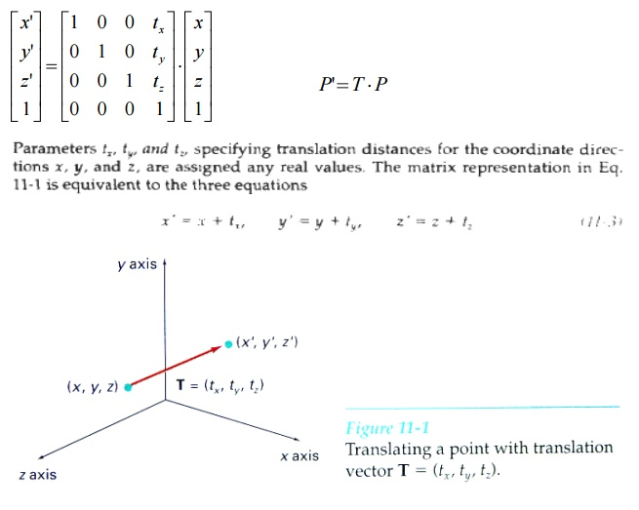

An object is translated in three dimensions by transforming each of the defining points of the object.

ROTATION

To generate a rotation transformation for an object, we must designate an axis of rotation (about which the object is to be rotated) and the amount of angular rotation.

Unlike two-dimensional applications, where all transformations are carried out in the **xy** plane, a three-dimensional rotation can be specified around any line in space.

The easiest rotation axes to handle are those that are parallel to the coordinate axes. Also, we can use combinations of coordinate axis rotations (along with appropriate translations) to specify any general rotation.

By convention, positive rotation angles produce counterclockwise rotations about a coordinate axis, if we are looking along the positive half of the axis toward the coordinate origin.

**Coordinate-Axes Rotations**

The two-dimensional z-axis rotation equations are easily extended to three dimensions:

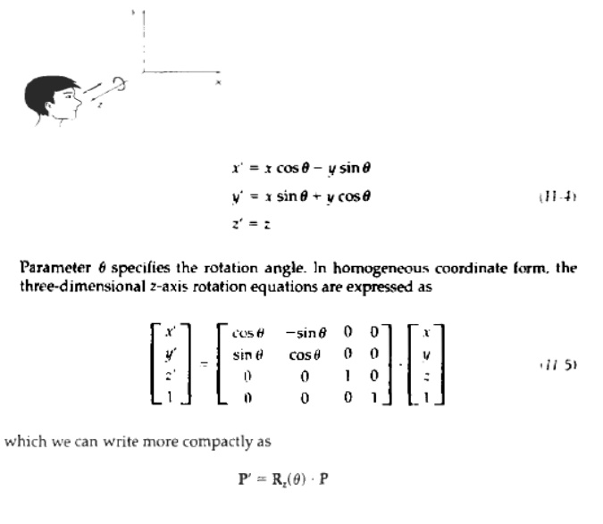

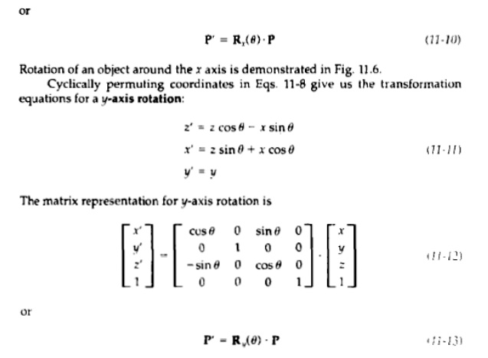

General Three-Dimensional Rotations

**A**rotation matrix for any axis that does not coincide with a coordinate axis can be set up as a compositetransformation involving combinations of translations and the coordinate-axes rotations. .

Any coordinate position **P** on the object in this figure is transformed with the sequence shown as

http://www.brainkart.com/media/extra/pwB11Wm.jpg

where the composite matrix for the transformation is

http://www.brainkart.com/media/extra/gzqecJW.jpg

Given the specifications f or the rotation axis and the rotation angle, we can accomplish the required rotation in five s t e p

1 Translate the object so that the rotation axis pass= through the coordinate origin.

**2.** Rotate the object so that the axis of rotation coincides with one of the coordinate axes.

3. Perform the specified rotation about that coordinate axis.

4. Apply inverse rotations to bring the rotation axis back to original orientation.

5. Apply the inverse translation to bring the rotation axis back to its original position

A rotation axis can be defined with coordinate positions, as in fig or with one coordinate point and direction angles between the rotation axis and two of the coordinate axes. We will assume that the rotation axis is defined by two points and that the direction of rotation axes is to be counter clockwise when looking along the axis from P1 to P2

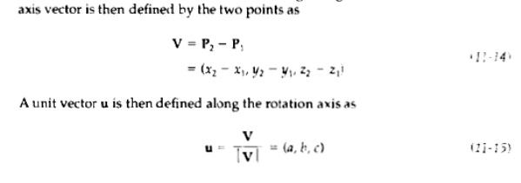

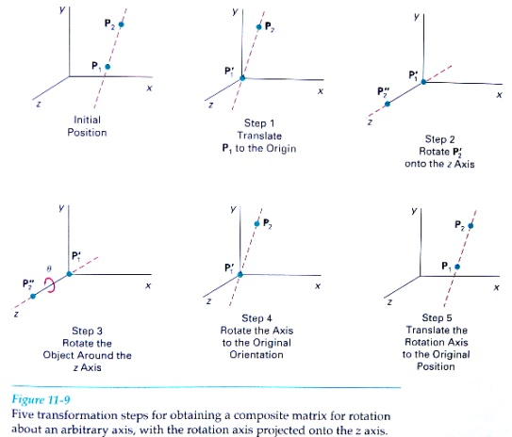

**SCALING**

The matrix expression tor the scaling transformation of a position P = **(x,** y, *z)* relative to the coordinate origin can be written as

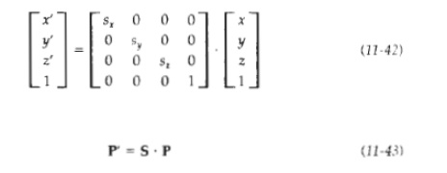

where scaling parameters sx, **sy,** and **sz,** are assigned any positive values. Explicit expressions for the coordinate transformations for scaling relative to the origin are

http://www.brainkart.com/media/extra/ZhxhqfP.jpg

Scaling an object with transformation changes the size of the object and repositions the object relative to the coordinate origin. Also, if the transformation parameters are not all equal, relative dimensions in the object are changed:

Scaling with respect to a selected fixed position **(x,** y, z***,)*** can be represented with the following transformation sequence:

1. Translate the fixed point to the origin.2. Scale the object relative to the coordinate origin using Eq. **11-42.**3. Translate the fixed point back to its original position.

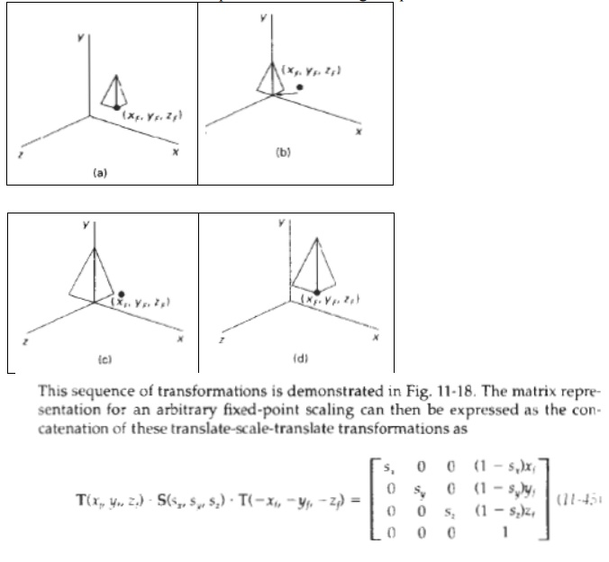

**Reflections**

**A**three-dimensional reflection can be performed relative to a selected***reflection axis***or withrespect to a selected ***reception plane.*** In general, three-dimensional reflection matrices are set up similarly to those for two dimensions.

Reflections relative to a given axis are equivalent to 180 rotations about that axis. Reflections with respect to a plane are equivalent to 160' rotations in four-dimensional space.

When the reflection plane is a coordinate plane (either **xy,** ***xz, or*** yz), we can think of the transformation as a conversion between Left-handed and right-handed systems.

An example of a reflection that converts coordinate specifications from aright-handed system to a left-handed system (or vice versa)

This transformation changes the sign of the z coordinates, leaving the ***x*** and y-coordinate values unchanged. The matrix representation for this reflection of points relative to the **xy** plane is

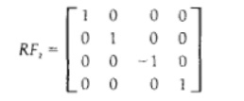

8 define parametric representation. discuss how the limitations of the non-parametric representation are overcome here.

Parametric equations are a set of equations that express a set of quantities as explicit functions of a number of independent variables, known as "parameters."

9 briefly explain composite surface and Bezier surface.

A composite surface is a collection of connected surfaces. The components can be any surface type, including nesting composite surfaces. While it is often expected that composite surfaces are contiguous, no such topological restrictions are enforced by FME in storing composite surfaces.

The orientation of the composite surface is determined by checking the orientation of the first surface. It is intended that all members of the composite are oriented in a way consistent with their neighbors. That is, it is not expected that connected adjacent surfaces have opposing orientations, like in a checkerboard. However, no such adjacent orientation restrictions are enforced by FME in storing composite surfaces.

If required, transformers may be used to alter or repair composite surfaces.

Composite surfaces may possess optional front or back [appearances](https://docs.safe.com/fme/html/FME_Desktop_Documentation/FME_Workbench/!FME_Geometry/appearance.htm), and may be single or double [sided](https://docs.safe.com/fme/html/FME_Desktop_Documentation/FME_Workbench/!FME_Geometry/Sidedness.htm).

**Bézier surfaces** are a species of [mathematical spline](https://en.wikipedia.org/wiki/Spline_(mathematics)) used in [computer graphics](https://en.wikipedia.org/wiki/Computer_graphics), [computer-aided design](https://en.wikipedia.org/wiki/Computer-aided_design), and [finite element](https://en.wikipedia.org/wiki/Finite_element) modeling. As with the [Bézier curve](https://en.wikipedia.org/wiki/B%C3%A9zier_curve" \o "Bézier curve), a Bézier surface is defined by a set of control points. Similar to interpolation in many respects, a key difference is that the surface does not, in general, pass through the central control points; rather, it is "stretched" toward them as though each were an attractive force. They are visually intuitive, and for many applications, mathematically convenient.

10) how do you define solid model? Compare various modeling schemes with their application and limitations.

Solid [Modeling](http://browseme.info/database_modeling.asp) is a modeling that provides a complete representation of an object than a wire frame modeling and surface modeling. In this [model](http://browseme.info/database_modeling.asp), the appearance of an object is displayed in solid design. The solid model can be made very realistic by adding colors to the images. Solid modeling can be created and modified very quickly when compared to other types of modeling. The below figure shows a 3 dimensional solid model. **Approaches for Solid Modeling:** Solid Modeling has several approaches for representing or creating a solid model

## Wireframe model

It is the simplest geometrical model an object and used to represent mathematically in the computer. It is also called edge representation. Wireframe model consists of points, lines, arcs and circles, conics and curves. It doesn’t require much computer time and memory and hence is considered to be the simplest. The major disadvantage is the ambiguous representation of real object and purely depends on human interpretation. In fact, the interpretation of the correct object becomes difficult in the case of complex model.This limits the application of wireframe models from engineering viewpoint.

 Advantages :(i) Easy to create.(ii) Provides a convenient geometric definition for many engineering applications.ν Disadvantages :(i) Inability to produce blended and rounded surfaces.(ii) Inability to differentiate b/w the inside & outside of objects.(iii) In 3-D, backside of the model is visible.

## 2. Surface model

Shape design and representation of complex object such as bodies of car, ship, airplane etc can’t be represented by wireframe model. In such cases surface models are to be used for precise and accurately representation. In comparison to wireframe model, surface models of an object provide more complete and less ambiguous representation. In the surface model, the geometry of the object is defined without storing any information about topology.

### [Advantages](http://browseme.info/document_managementadvantages.asp) ****of Surface Modeling:****

* It is less ambiguous.
* Complex surfaces can be easily identified.
* It removes hidden line and adds realism.

**Disadvantages of Surface Modeling:**

* Difficult to construct.
* Difficult to calculate mass property.
* More time is required for creation.
* Requires high storage space.
* Also requires more time for manipulation.

## 3. Solid model

A solid model of an object provides more complete representation than its surface model. The database of the solid model stores geometric data and topological information of the corresponding object. Geometry is the actual dimension that defines entities of the object whereas topology on the other hand is the connectivity and associativity of the object.

[**Advantages**](http://browseme.info/document_managementadvantages.asp)**of Solid Modeling:**

* Complete modeling.
* Unambiguous.
* Best suitable for calculating mass properties.
* Very much suitable for automated applications.
* Fast creation.
* Gives huge information.

**Disadvantages of Solid Modelling:**

* Requires large memory.
* Slow manipulation.

### Feature based model

Feature and feature-based terms are used in feature-based model. However, the above two terminologies have been used in different meaning by different researchers. Definitions available for these terminologies in the literature are provided here. Those are Features represent shapes and technological attributes associated with manufacturing operations and tools [Shah 1990]. Features are groupings of geometric or topological entities that need to be referenced together [Shah 1990]. Features are elements used in generating, analyzing, and evaluating design [Shah 1990]. Features are set of information related to an object’s description. This description could be for design, for manufacturing or even for administrative purposes.