1. What is java, and why is it not considered a pure object-oriented programming language?
Java is class base object-oriented programming language designed for simplicity and portability. Key feature is write once run anywhere (WORA)
Compile java code, it can run on any platform that supports Java without recompiling. This makes java popular choice for enterprise application due to its robustness, security and easy to use.
However, Java isn’t a pure object-oriented world, why?
Because in java, everything is not an object



Static method and Static variable can be accessed without creating an object of the class which breaks the object-oriented principle that everything should be done through the objects
While java offers Wrapper classes like integer and float to converting primitive into objects. it still allows direct operation on Primitive. Which is why it not fully object oriented programming language.

2. Explain the key components involved in running a java program?
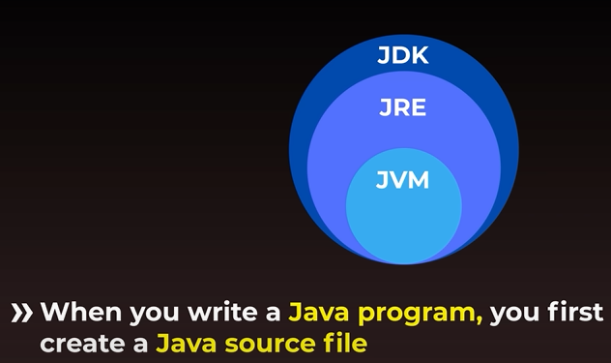
Every source file compiled before it can run 
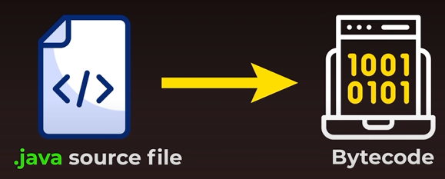

Bytecode is platform-independent, Bytecode can run on any system
