Classifying Handwritten Digits as Sequences with an LSTM
Week 5 Assignment: Recurrent Neural Networks
[Your full name]
TECH 405
October 5, 2026
Code: [paste your GitHub repository link here]

Classifying Handwritten Digits as Sequences with an LSTM
Many real problems involve data where order matters, such as text, speech, and sensor readings. Recurrent neural networks (RNNs) handle this by passing a hidden state from one time step to the next, so the output at any step can depend on everything the network has already read. Training such a network relies on backpropagation (Rumelhart et al., 1986), applied across the unrolled time steps. In practice this becomes difficult as sequences grow longer, because the learning signal that reaches early steps tends to fade, and Bengio et al. (1994) showed that gradient descent finds it increasingly hard to capture dependencies as their span increases. The long short term memory network (LSTM) was designed to address this problem. It uses gated units that control what is stored and passed on, which lets error signals flow across many steps (Hochreiter & Schmidhuber, 1997).
The aim of this assignment was to implement an LSTM on a small public dataset, report its test accuracy, and compare it with the stated baseline and target. I chose the handwritten digits dataset because it is small, needs no text preprocessing, and trains in seconds on a CPU.

Dataset and Problem
The experiment uses the optical recognition of handwritten digits dataset (Alpaydin & Kaynak, 1998), loaded through scikit-learn (Pedregosa et al., 2011). The original authors extracted bitmaps from forms completed by 43 people and reduced each 32 by 32 bitmap to an 8 by 8 grid by counting the filled pixels in every 4 by 4 block, so each pixel is an integer from 0 to 16. The copy bundled with scikit-learn contains 1,797 images of the digits 0 to 9, with between 174 and 183 images per class. Because the classes are almost perfectly balanced, a random guess scores about 10%, and the assignment target for this dataset is a test accuracy of 93%.
Although the images are static, they can be treated as a sequence problem. Each image is read from the top row to the bottom row, which gives a sequence of 8 time steps with 8 pixel values at each step. Strokes continue from one row to the next, so the rows depend on each other, and a recurrent model can carry what it has seen in earlier rows forward to the later ones.

Method
Pixel values were divided by 16 so that inputs lie between 0 and 1. The data were split once with a fixed random seed of 42, using a stratified 80/20 split into 1,437 training images and 360 test images. A validation set of 144 images was taken from inside the training portion to monitor the loss, which leaves 1,293 images for fitting the model. The test set was used only once, after training had finished.
The model is a single layer LSTM with 8 input features and 128 hidden units. A linear layer maps the final hidden state, which is the state after the eighth row, to 10 class scores. The model has 71,946 trainable parameters. I implemented it in PyTorch (Paszke et al., 2019) and trained it with cross entropy loss and the Adam optimizer (Kingma & Ba, 2015) at a learning rate of 0.003. The batch size was 64, training ran for 40 epochs on a CPU, and no pretrained weights were used. The model from the final epoch was evaluated, without choosing the best epoch afterwards.

Results
Figure 1 shows the data after loading. The array has the shape 1,797 by 8 by 8, which is samples, time steps, and features, and the printed class counts confirm the balance between digits.
Figure 1
Data Shapes and Sample Digits
Images: (1797, 8, 8) -> (samples, 8 steps, 8 features)
Labels: (1797,)
Class counts: [178 182 177 183 181 182 181 179 174 180]
Train: (1293, 8, 8) Val: (144, 8, 8) Test: (360, 8, 8)

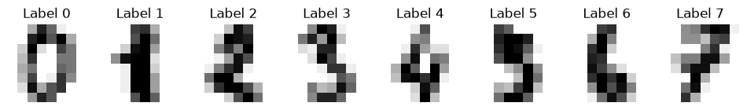
Note. The first eight images in the dataset with their labels. Each 8 by 8 image is fed to the LSTM as 8 rows.
Figure 2 shows the model definition and its parameter count.
Figure 2
LSTM Model Definition
class LSTMClassifier(nn.Module):
def __init__(self, input_size=8, hidden_size=128, num_classes=10):
super().__init__()
self.lstm = nn.LSTM(input_size, hidden_size, batch_first=True)
self.fc = nn.Linear(hidden_size, num_classes)

def forward(self, x):
_, (h_n, _) = self.lstm(x)
return self.fc(h_n[-1])

LSTMClassifier(
(lstm): LSTM(8, 128, batch_first=True)
(fc): Linear(in_features=128, out_features=10, bias=True)
)
Trainable parameters: 71946
Note. The final hidden state of the LSTM, after the eighth row, is the only input to the classifier.
Training loss fell quickly, from 2.1835 in the first epoch to below 0.05 by epoch 20, as shown in Table 1 and Figure 3. Validation accuracy first passed 95% at epoch 15.
Table 1
Training Log at Selected Epochs
Epoch | Train loss | Validation loss | Validation accuracy
1 | 2.1835 | 1.9138 | .2708
5 | 0.5263 | 0.5089 | .8472
10 | 0.2465 | 0.2614 | .9236
15 | 0.1413 | 0.1814 | .9583
20 | 0.0441 | 0.1884 | .9444
25 | 0.0464 | 0.1607 | .9583
30 | 0.0368 | 0.1605 | .9514
35 | 0.0054 | 0.1430 | .9583
40 | 0.0137 | 0.2804 | .9167
Note. Loss values are cross entropy. Accuracy is the proportion of correct predictions on the 144 validation images.
Figure 3
Loss per Epoch and Validation Accuracy
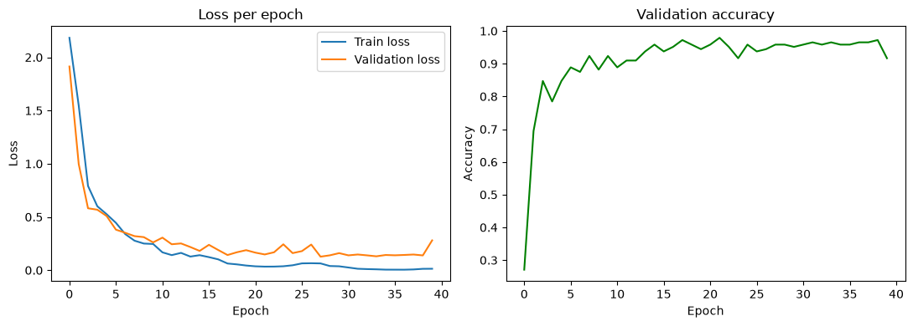
Note. Left: training and validation loss over 40 epochs. Right: validation accuracy over the same epochs.
On the test set, the model reached an accuracy of 95.56%, which is 344 correct predictions out of 360. Figure 4 shows the confusion matrix. The digits 2, 3, 4, and 7 were classified perfectly. Seven of the 16 errors were images of the digit 5 predicted as 8, and two images of the digit 6 were also predicted as 8, so the digit 8 was the most common wrong answer.
Figure 4
Test Accuracy and Confusion Matrix
Test accuracy: 95.56%
Test accuracy 95.56% vs baseline 10% and target 93%: target met

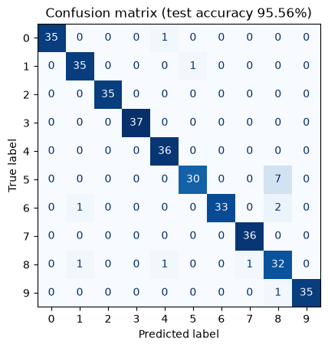
Note. Rows are true labels and columns are predicted labels for the 360 test images.

Comparison With Baseline and Target
The model scored 95.56% on the test set, which is far above the 10% baseline and 2.56 percentage points above the 93% target.

Discussion
The LSTM learned the task quickly and met the target, but training was not fully stable. Training loss approached zero while validation loss stopped improving, and among the logged epochs it was lowest at epoch 35 (0.1430) before jumping to 0.2804 at epoch 40. A final training loss of 0.0137 against a validation loss of 0.2804 suggests some overfitting on a training set of only 1,293 images. Validation accuracy also moved between 91.7% and 95.8% across the logged epochs, which is a difference of about six images in a set of 144. Stopping early, around epoch 15 to 35, or adding dropout would likely give a steadier result.
The digits 5, 6, and 8 share closed or curved strokes, and at only 8 by 8 pixels the differences between them are small, so confusion among them is understandable.

Limitations
These results come from a single run with one random seed, so a repeat run could land slightly higher or lower. The test set has only 360 images, so each wrong prediction moves accuracy by about 0.28 points, and an approximate 95% confidence interval around 95.56% runs from about 93.4% to 97.7%. The lower end sits only just above the target. The split was also random, and because the images come from a small group of writers, images by the same writer may appear in both the training and test sets, which could make the task easier than a split by writer. Finally, I trained only an LSTM, so this report cannot say how much it improves on a simple RNN for this task.

Conclusion
An LSTM that reads each 8 by 8 digit image as eight rows of eight values reached 95.56% test accuracy, which exceeds both the 10% baseline and the 93% target. The main weakness was mild overfitting late in training, and the main remaining errors were between the digits 5, 6, and 8. Future work could add dropout, repeat the run across several seeds, and compare against a simple RNN.

Code Availability
The full notebook and instructions for running it are available at [paste your GitHub repository link here].

References
Alpaydin, E., & Kaynak, C. (1998). Optical recognition of handwritten digits [Data set]. UCI Machine Learning Repository. https://doi.org/10.24432/C50P49
Bengio, Y., Simard, P., & Frasconi, P. (1994). Learning long-term dependencies with gradient descent is difficult. IEEE Transactions on Neural Networks, 5(2), 157–166. https://doi.org/10.1109/72.279181
Hochreiter, S., & Schmidhuber, J. (1997). Long short-term memory. Neural Computation, 9(8), 1735–1780. https://doi.org/10.1162/neco.1997.9.8.1735
Kingma, D. P., & Ba, J. (2015). Adam: A method for stochastic optimization. In Proceedings of the 3rd International Conference on Learning Representations. https://doi.org/10.48550/arXiv.1412.6980
Paszke, A., Gross, S., Massa, F., Lerer, A., Bradbury, J., Chanan, G., Killeen, T., Lin, Z., Gimelshein, N., Antiga, L., Desmaison, A., Köpf, A., Yang, E., DeVito, Z., Raison, M., Tejani, A., Chilamkurthy, S., Steiner, B., Fang, L., . . . Chintala, S. (2019). PyTorch: An imperative style, high-performance deep learning library. Advances in Neural Information Processing Systems, 32. https://doi.org/10.48550/arXiv.1912.01703
Pedregosa, F., Varoquaux, G., Gramfort, A., Michel, V., Thirion, B., Grisel, O., Blondel, M., Prettenhofer, P., Weiss, R., Dubourg, V., Vanderplas, J., Passos, A., Cournapeau, D., Brucher, M., Perrot, M., & Duchesnay, É. (2011). Scikit-learn: Machine learning in Python. Journal of Machine Learning Research, 12(85), 2825–2830. https://doi.org/10.48550/arXiv.1201.0490
Rumelhart, D. E., Hinton, G. E., & Williams, R. J. (1986). Learning representations by back-propagating errors. Nature, 323(6088), 533–536. https://doi.org/10.1038/323533a0

