Checking Lab Range

MS Registry DQ Work

Ziyu Huang

2024-05-30

Table of Contents

# Summary

This is to examine the MS lab and imaging data and help make a decision where some variables might have ambiguous “standard units”.

# Variables

## Lymphocytes

Here’s a summary of the results recorded for Lymphocytes.

|  | min | Q1 | median | Q3 | max | mean | sd | n | missing |
| --- | --- | --- | --- | --- | --- | --- | --- | --- | --- |
|  | 0.1 | 16.4 | 23.8 | 31.325 | 4924 | 29.11593 | 97.28971 | 6836 | 28 |

Here, only 34 observations out of 6864 is over 100, which accounts for 0.5%.

| category | n | percentage |
| --- | --- | --- |
| Over 100 | 34 | 0.50 |
| Under or Equal to 100 | 6802 | 99.10 |
| NA | 28 | 0.41 |

| category | n | percentage |
| --- | --- | --- |
| 0 to 10 | 695 | 10.13 |
| 10 to 65 | 6088 | 88.69 |
| 65 to 100 | 19 | 0.28 |
| Over 100 | 34 | 0.50 |
| NA | 28 | 0.41 |

Setting a lower bound of range check to be 10% means we will see 695 observations in the report, which accounts for 10.13% of the observations.

## Summary of other variables

| eventtypedesc | event_type_dec | failures | total_observations | percent_failure |
| --- | --- | --- | --- | --- |
| 25-OH Vitamin D | NA | 565 | 4443 | 12.7% |
| Anti-JCV Antibody Index | NA | 800 | 2806 | 28.5% |
| Hematology | HCT | 59 | 7064 | 0.8% |
| Hematology | HGB | 68 | 7077 | 1% |
| Hematology | Lymphocytes | 737 | 6864 | 10.7% |
| Hematology | MCV | 38 | 7009 | 0.5% |
| Hematology | Neutrophils | 907 | 6702 | 13.5% |
| Hematology | Platelets | 267 | 7022 | 3.8% |
| Hematology | WBC | 40 | 7090 | 0.6% |
| LFT Results | ALP | 31 | 5394 | 0.6% |
| LFT Results | ALT | 487 | 6689 | 7.3% |
| LFT Results | AST | 72 | 6638 | 1.1% |
| LFT Results | Direct Bilirubin | 266 | 2765 | 9.6% |
| LFT Results | Total Bilirubin | 59 | 5761 | 1% |
| Renal Function Results | BUN | 19 | 3270 | 0.6% |
| Renal Function Results | Creatinine | 36 | 3949 | 0.9% |

## Tests with more than 10% failure

| eventtypedesc | event_type_dec | failures | total_observations | percent_failure |
| --- | --- | --- | --- | --- |
| 25-OH Vitamin D | NA | 565 | 4443 | 12.7% |
| Anti-JCV Antibody Index | NA | 800 | 2806 | 28.5% |
| Hematology | Lymphocytes | 737 | 6864 | 10.7% |
| Hematology | Neutrophils | 907 | 6702 | 13.5% |

## Jitter plots

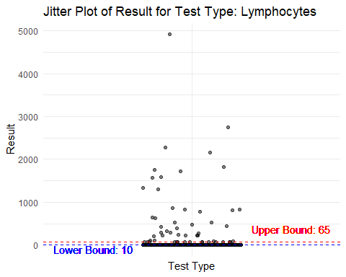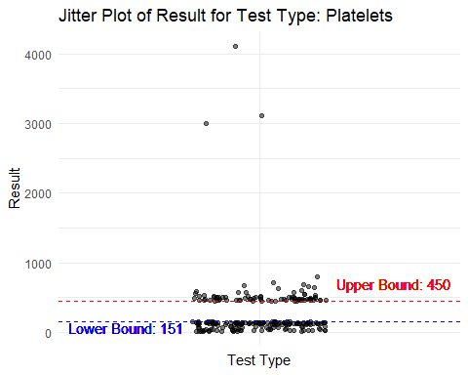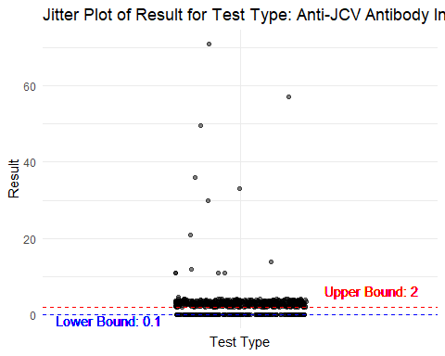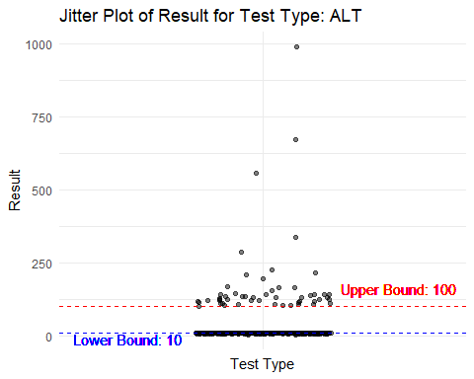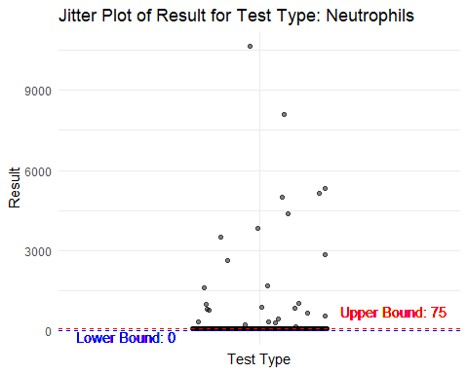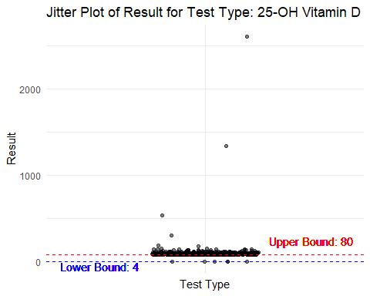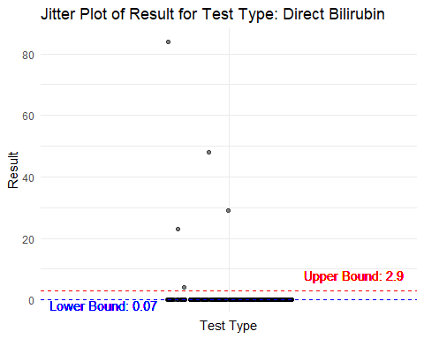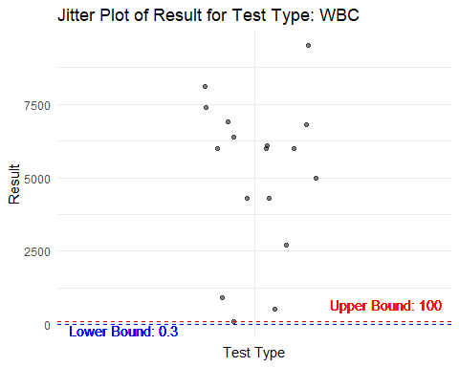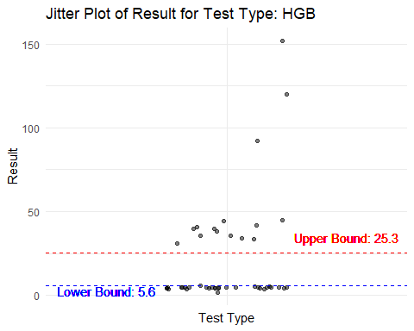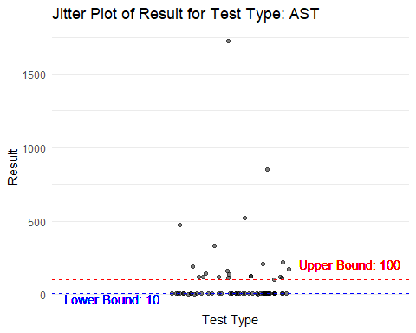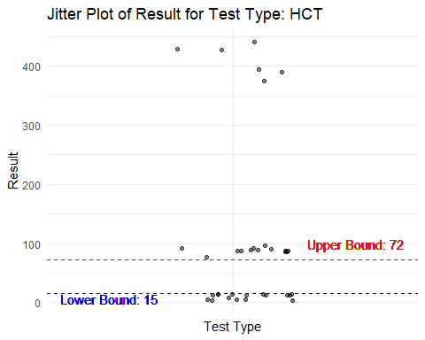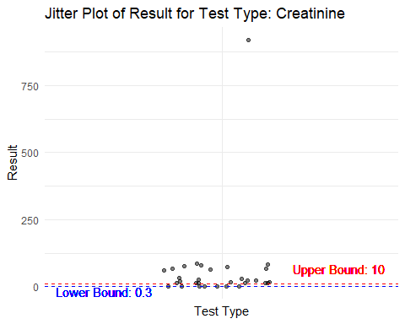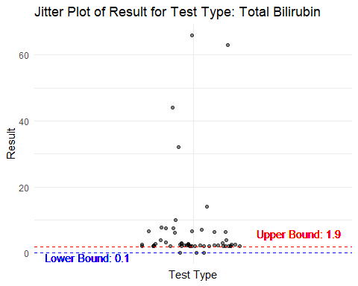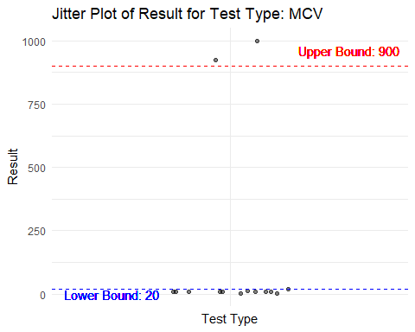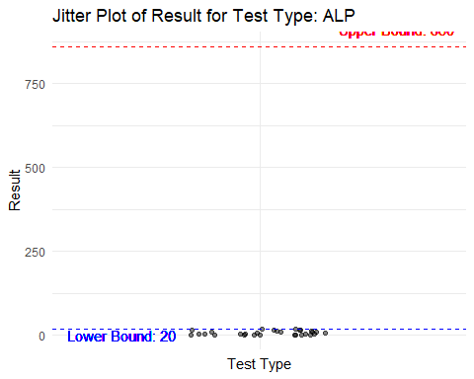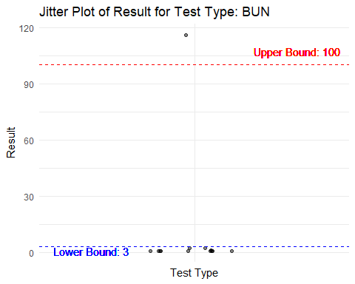

# Session Information

R version 4.3.3 (2024-02-29 ucrt)  
Platform: x86_64-w64-mingw32/x64 (64-bit)  
Running under: Windows 11 x64 (build 22631)  
  
Matrix products: default  
  
  
locale:  
[1] LC_COLLATE=English_United States.utf8 LC_CTYPE=English_United States.utf8   
[3] LC_MONETARY=English_United States.utf8 LC_NUMERIC=C   
[5] LC_TIME=English_United States.utf8   
  
time zone: America/New_York  
tzcode source: internal  
  
attached base packages:  
[1] stats graphics grDevices utils datasets methods base   
  
other attached packages:  
 [1] rmarkdown_2.26 ggrepel_0.9.5 lubridate_1.9.3 forcats_1.0.0   
 [5] stringr_1.5.1 purrr_1.0.2 readr_2.1.5 tidyr_1.3.1   
 [9] tibble_3.2.1 tidyverse_2.0.0 haven_2.5.4 readxl_1.4.3   
[13] magrittr_2.0.3 mosaicData_0.20.4 ggformula_0.12.0 dplyr_1.1.4   
[17] Matrix_1.6-5 ggplot2_3.5.1 lattice_0.22-6   
  
loaded via a namespace (and not attached):  
 [1] sass_0.4.9 utf8_1.2.4 generics_0.1.3 stringi_1.8.3   
 [5] hms_1.1.3 digest_0.6.35 timechange_0.3.0 evaluate_0.23   
 [9] grid_4.3.3 pkgload_1.3.4 fastmap_1.1.1 jsonlite_1.8.8   
[13] cellranger_1.1.0 fansi_1.0.6 scales_1.3.0 mosaic_1.9.1   
[17] jquerylib_0.1.4 cli_3.6.2 labelled_2.13.0 rlang_1.1.3   
[21] munsell_0.5.1 cachem_1.0.8 withr_3.0.0 yaml_2.3.8   
[25] tools_4.3.3 tzdb_0.4.0 colorspace_2.1-0 mosaicCore_0.9.4.0  
[29] vctrs_0.6.5 R6_2.5.1 ggridges_0.5.6 lifecycle_1.0.4   
[33] MASS_7.3-60.0.1 pkgconfig_2.0.3 bslib_0.7.0 pillar_1.9.0   
[37] gtable_0.3.5 Rcpp_1.0.12 glue_1.7.0 highr_0.10   
[41] xfun_0.43 tidyselect_1.2.1 rstudioapi_0.16.0 knitr_1.46   
[45] farver_2.1.1 htmltools_0.5.8.1 labeling_0.4.3 compiler_4.3.3