Cleaning Pitch and Resin Off Blades and Bits Safely
Built-up pitch quietly wrecks your cut quality and your safety margin — here's how to strip it off without damaging the carbide or the coating.
Category: Tool Maintenance | Tags: blade cleaning, pitch removal, carbide blades, router bits, table saw safety | Author: Kerph Team
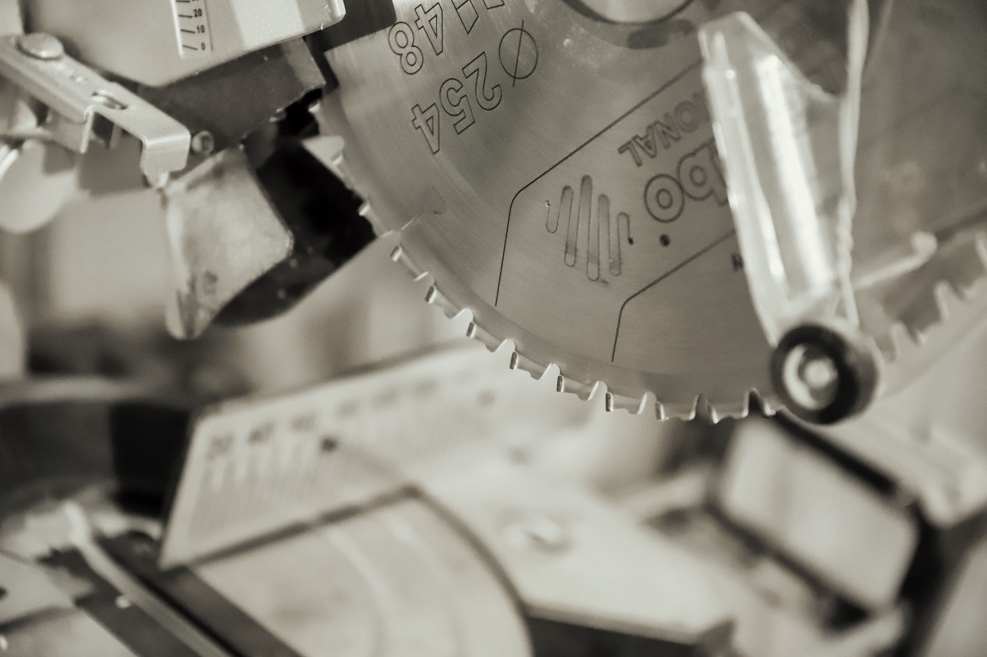
Run a fingernail across the face of a blade that's cut a few hundred feet of pine, and you'll feel it before you ever see it — a dark, tacky ridge sitting right where the carbide meets the plate. That's pitch and resin. And here's the part that surprises people: it's not a cosmetic problem. It's not even really about how the blade looks. It's about how the blade cuts, how hot it runs, and how it behaves the second something binds.

Why Pitch Buildup Is a Bigger Deal Than It Looks
So what's actually going on under that gunk? Pitch acts like insulation between the carbide and the wood, which sounds harmless right up until you think through what insulation actually does here. First: more friction. The blade pushes through the cut instead of slicing it, so cutting force and heat both climb. Second: that heat has nowhere to go, because the same layer that's ruining your cut is also blocking the carbide from shedding heat into the airstream and sawdust the way a clean edge would. Third, and this is the one that actually matters for your safety, not just your cut quality: a gummed-up blade binds in the kerf more easily. Bind even a little, and the workpiece can lift or grab — that's exactly the mechanism behind kickback. And underneath all of it, a resin-coated edge dulls faster than a clean one. You paid for a sharp blade. Congratulations, you're now running a dull one, and the carbide itself hasn't actually worn down at all.
📷 Photo placeholder — macro shot of a carbide table saw tooth with visible dark brown pitch buildup coating the gullet and tooth face, lit at an angle to show the texture of the residue.

Dedicated Cleaners vs. Household Options
You've got two real paths here, and both actually work — when you use them correctly.
Dedicated blade and bit cleaners like CMT Blade and Bit Cleaner and oxalic-acid-based options such as Boeshield Blade and Bit Cleaner are built specifically to dissolve pitch and resin without attacking carbide braze joints, anti-stick coatings (the black non-stick finish on a lot of Freud and CMT blades), or aluminum router bit bodies. They're the safe default, especially for anything with a coating worth keeping, and most work in 5-10 minutes without any scrubbing.
Household options can work, but they come with real tradeoffs. Diluted Simple Green (roughly 1:1 with water, straight for heavy buildup) is a solid budget pick — gentle enough for regular use, won't touch most coatings or braze joints, genuinely fine as an everyday cleaner. Just slower than a dedicated pitch remover on the heavy stuff. Oven cleaner is the one you'll see recommended online, and it deserves a hard caution, not a shrug. Yes, it cuts through pitch fast. It's also a strong lye solution that's more than happy to eat the aluminum shank right off a router bit while it's at it, discolor or strip an anti-stick coating, and irritate your skin and lungs if you're not gloved up and ventilated. If you're still going to use it, keep it to steel-body, uncoated blades only, keep contact time short, and rinse thoroughly. Anything with aluminum or a coated finish, leave the oven cleaner in the kitchen where it belongs.

The Soak-and-Brush Process
Once you've picked a cleaner, the process is the same no matter which one you went with:
1. Lay the blade or bit flat in a shallow plastic tray or an old cake pan. Never a container you're going to reuse for food. I know it's the perfect size. No.
2. Cover it with cleaner so both faces are wetted, or spray liberally if you're running an aerosol formula.
3. Soak 5-15 minutes. Older, heavier buildup gets the longer end of that range. Don't walk away for hours thinking more is better — it isn't. Extended soaking doesn't clean it any faster, it just prolongs chemical exposure to metal that didn't need it.
4. Brush the gullets and tooth faces with a nylon-bristle brush (an old toothbrush works fine) or brass bristles for the stubborn spots. Brass is soft enough not to scratch carbide or steel, but it's still got enough bite to knock resin loose.
5. Rinse with water and dry immediately — compressed air or a clean towel, then let it finish air-drying before it goes back into storage. Leftover moisture on bare steel will flash-rust within the hour. That's not a maybe.
6. Wipe on a light coat of oil before the blade goes back in the drawer or the tool goes back on the shelf. A drop of machine oil, or a wipe of whatever rust inhibitor you're already using on your cast iron top, keeps surface rust from showing up between uses.
📷 Photo placeholder — a blade soaking flat in a shallow tray of cleaner, with a nylon brush resting nearby, shot from directly above to show the resin lifting off into the liquid.

Slowing Buildup Before It Starts
Cleaning is damage control. There's also a real prevention step most people skip entirely: a dry-film blade lubricant, sprayed on before you cut anything resinous, coats the carbide in a slick barrier that pitch has a much harder time sticking to in the first place. Bostik TopCote — the same stuff a lot of shops use on cast iron tops — works here too, and a light coat before a long session ripping pine or fir measurably cuts down how much actually bonds to the tooth face. It's not a replacement for the cleaning routine above. Pitch that's going to build up eventually builds up regardless. But "eventually" stretches out a lot further, and the cleaning sessions you do end up needing come off a lot easier when they're not fighting months of baked-on residue.
Worth knowing while you're at it: not all blades resist pitch equally. A blade with a factory non-stick coating (Freud's Perma-Shield, CMT's Xtreme coating, and similar) genuinely does build up slower than bare steel or uncoated carbide — that coating is doing real, measurable work, not just marketing copy. It's one more reason to treat a coated blade gently when you do clean it; strip the coating off with the wrong cleaner or an abrasive pad, and you've just erased the exact advantage you paid extra for.

What Not to Use
Skip wire brushes and wire wheels entirely. Steel bristles are hard enough to scratch both the carbide and the anti-stick coating that was slowing down buildup in the first place — so you'd be trading a five-minute clean today for a worse one next month. Skip strong chlorinated solvents and straight acetone on coated blades and bits too; they'll soften or lift the coating right along with the resin. And never fully submerge a bit or blade that has bearings — guided bits, ball-bearing pilot bits. Solvent that gets into the bearing race washes the grease straight out, and now you've got a gritty bearing on a slow march toward failure. Wipe those by hand and keep the liquid off the bearing itself.

How Often to Check
Rule of thumb: check after every 4-8 hours of cutting resinous softwoods — pine, fir, spruce — or any time the saw starts working harder than it used to, the motor bogs on a cut that used to be easy, or you catch a faint burning smell at a feed rate that never smelled like anything before. A quick visual check — tilt the blade toward the light, look at the gullets — takes ten seconds and tells you everything you need to know. Hardwoods and sheet goods build up pitch a lot slower, so once a month covers it there.
Keeping track of when each blade and bit was actually last cleaned beats guessing — Kerph's tool maintenance tracker gives you a place to log that history alongside the rest of your gear.

