How to Tune Up a Table Saw in 30 Minutes
A real, timed checklist for aligning your blade, fence, and tilt stops, plus the exact tools you need to get shop-grade accuracy in half an hour.
Category: Tool Maintenance | Tags: table saw tune-up, blade alignment, fence alignment, riving knife, saw maintenance | Author: Kerph Team
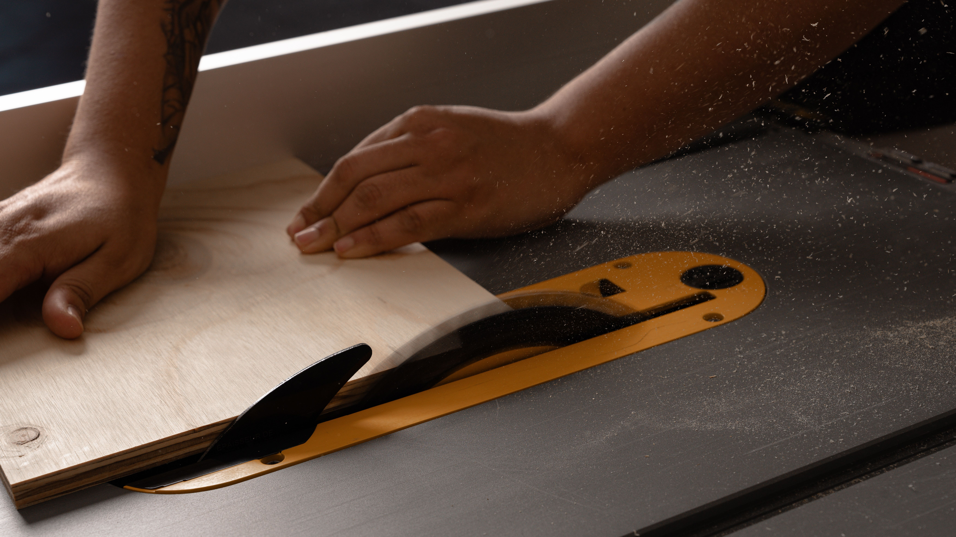
Most of what people blame on their own technique — burning, cuts that drift, a fence that seems to wander no matter how careful they are — isn't a technique problem. It's an alignment problem. A saw that's a few thousandths out of parallel will fight you all day and never once tell you why. Most home shops check alignment exactly once: out of the box. This is the checklist to run every few months, or the moment the saw gets moved, drops a belt, or just starts cutting worse than it used to. Budget 30 minutes. None of it requires a machinist background — just a wrench, some patience, and a willingness to actually check instead of guess.

Signs You Need This Now, Not "Eventually"
Some symptoms point straight at misalignment, not technique or a dull blade. Burning on rip cuts, especially only on one face of the cut, usually means the fence has crept out of parallel — the workpiece is getting squeezed against a blade it's not quite aligned with, and friction does the rest. A cut that drifts away from the fence partway through, even with steady feed pressure, points at the same thing from the other direction. A crosscut that comes out a hair off square despite the miter gauge reading dead-on at 90° means the blade itself isn't actually square to the table, not that your gauge is lying to you. And any cut that feels like it's fighting you — more resistance than the wood or blade sharpness explains — is worth checking before you reach for a new blade and spend money solving the wrong problem. None of these prove misalignment on their own. All of them are reason enough to run the checklist below before you do anything else.

What You'll Need (5 minutes to gather)
You don't need a full metrology kit — this isn't a machine shop. The minimum useful setup is a reliable combination square and a feeler gauge set. If you want something tighter than eyeballing a gap, a dial indicator with a magnetic base turns "looks about right" into an actual number — worth owning if you're doing this more than once a year. Round out the kit with the wrench or hex key that actually fits your trunnion bolts, a scrap of hardwood, and your usual cleaning and waxing supplies.

Step 1: Blade-to-Miter-Slot Alignment (5 minutes)
This is the one that matters most. Everything else on this list is referenced off it, so if you only have time for one step, make it this one. Clamp a scrap block in the miter slot with a point — a screw tip works fine — just touching a tooth at the front of the blade. Rotate the blade by hand so that same tooth is now at the back, and check the gap again. Dial indicator: you want the reading to hold within 0.005" front to back. Feeler gauge: you're checking whether a given thickness just barely fits at one end and not the other. Off? Loosen the trunnion bolts under the table (check your manual for exact locations — most contractor and cabinet saws adjust the trunnion, not the blade) and nudge until front and back match. Then retorque.

Step 2: Fence Parallelism (5 minutes)
Now that the blade's actually trustworthy, lock the fence a set distance from it and measure from the fence face to the miter slot at the front of the table, then again at the back, same square or indicator. Fences should be dead parallel, or toe out very slightly at the back — no more than about 0.010". Never toeing in. Toe-in is what causes burning and kickback on rip cuts, because the workpiece gets pinched between the blade and the fence right as it exits — that's not a maybe, that's just physics doing what physics does. Most fences have two adjustment screws where the head locks to the rail. Loosen those, tap the fence until the reading's right, retighten while holding position.
📷 Photo placeholder — dial indicator mounted on a magnetic base, needle touching a saw blade tooth, positioned to show the measurement setup for checking blade-to-miter-slot alignment.

Step 3: Blade Tilt Stops at 90° and 45° (5 minutes)
Raise the blade fully, set the tilt to 90°, and check square against the flat body of the blade plate — not a tooth. Carbide teeth have inconsistent set, and checking against one will lie to you. Gap? Adjust the 90° set screw (usually near the handwheel or under the table by the trunnion) until the square sits flush, lock it down, then do the same for the 45° stop. Don't just trust the number — make an actual test cut in scrap and measure the resulting angle before you trust either stop on a real project.

Step 4: Riving Knife Alignment (5 minutes)
The riving knife has one job, and it needs to be sized right to do it: thin enough not to bind, thick enough to actually work — roughly the same thickness as the blade's kerf, thinner than the plate but wider than the blade body. What matters more day to day is whether it's coplanar with the blade. Lay a straightedge across both at the same height and check for any visible offset side to side. A knife angled off to one side pushes cut stock sideways and can bind instead of doing the one thing it's there for — preventing kickback. Most riving knives have a quick-release lever. Loosen it, square the knife against the blade by eye or straightedge, reseat.

Step 5: Inspect the Blade, Check the Belt, Clean and Wax the Top (5-10 minutes)
Everything's already open, so use it. Give the blade a visual check for missing carbide, a cracked plate, or the dark resin buildup that slows cuts and raises your kickback risk right along with it. Coated and gummed up? This is the moment to plan a real cleaning instead of pushing through one more project on a dull edge and pretending it's fine. Belt-driven saw: check tension by pressing on the belt midway between the pulleys. You want roughly half an inch of deflection under moderate thumb pressure, no more. Too loose and it slips and bogs under load; too tight and you're straining the arbor bearings for no reason. Last thing — wipe the cast iron top clean of dust and old wax, and lay down a fresh coat of paste wax or rust inhibitor. Same routine as Kerph's guide to keeping cast iron tables rust-free. The table should be slick and protected before it goes back to work, not just clean.
📷 Photo placeholder — hand pressing down on a table saw drive belt to check deflection, with a ruler or straightedge in frame showing roughly half an inch of give.

Putting It Together
Run it in order — blade to slot, fence to blade, tilt stops, riving knife, then the inspection and cleanup pass — and 30 minutes is realistic even the first time through. Faster once it's a habit. Do this every few months in a shop that sees regular use, and immediately any time the saw gets moved, tipped, or drops a belt. A saw that's actually in alignment cuts safer and faster than any blade upgrade you could buy instead, and it costs nothing but the half hour you were going to spend complaining about the cut quality anyway.
Write down what you find, too — even just scribbled on a sticky note stuck to the inside of the cabinet door. A saw that measured dead-on three months ago and is now off by a few thousandths didn't get that way overnight, and knowing the trend tells you whether something's loosening gradually (a real problem worth tracking down) or whether one specific event knocked it out (obvious once you think back to what happened right before the numbers changed).
Missing any of the measuring tools above? They're linked up top — no need to guess at what fits. Once your kit's complete, Kerph's tool maintenance tracker is worth using to log when you last actually checked alignment, so "every few months" doesn't quietly turn into eight months.

