Dust Collection Setup: Tips & Tricks for a Shop That Actually Breathes
Dust collection fails quietly. Sizing, layout, and the small mistakes that quietly rob a dust collector of half its suction -- a practical list for planning or fixing your shop's dust collection.
Category: Dust Collection | Tags: dust-collection, shop-setup, airflow, safety | Author: Kerph Team | Video: https://www.youtube.com/watch?v=NzBZk1NxQfg
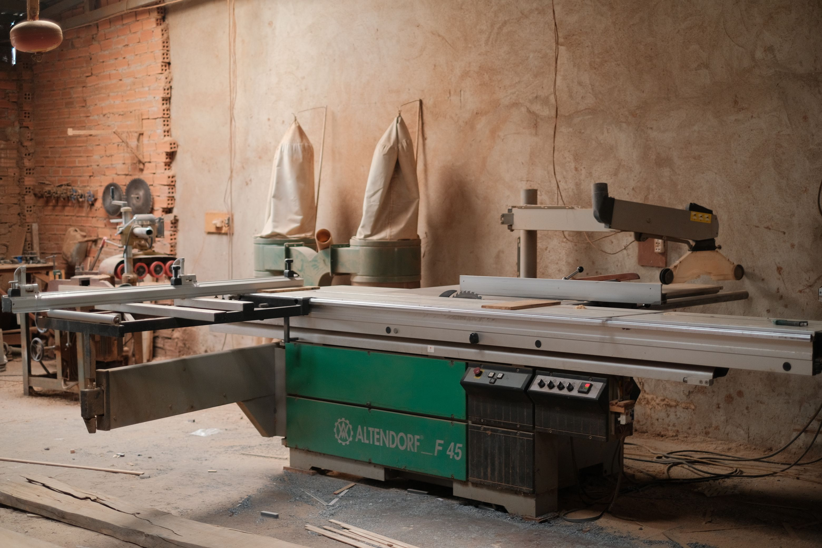
Dust collection has a way of failing quietly, which is exactly what makes it dangerous. A collector rated for 1,200 CFM can end up moving a few hundred by the time the air actually reaches the far end of an undersized branch line, and a shop just slowly fills up with fine dust nobody notices accumulating until it's everywhere -- on every horizontal surface, in every lungful of shop air. Here's the part that surprises people: the collector matters less than they think. The system around it is what actually decides whether any of it works.
📷 Photo placeholder — a single-stage dust collector (e.g. a JET DC-1100VX) in a shop corner with its main trunk line running off toward the ceiling, showing real duct sizing for scale.

Size the main trunk to the collector, not the biggest machine
The main trunk needs to move as much air as the collector can actually produce. Undersize it and the whole system chokes, no matter how good the collector looks on the box. A common single-stage 1–2 HP setup, like a JET DC-1100VX, runs a 4"–6" main trunk. Check the collector's rated CFM against a duct sizing chart before committing to a diameter -- guessing here is the single most common way a new dust collection system underperforms from day one, and it's completely avoidable with ten minutes of math.

Branch lines can step down, but do the CFM math first
Branch runs to an individual machine can usually step down from there, often to 4" for a single-machine drop. What actually matters is whether that branch can still deliver the CFM the tool needs -- a table saw wants somewhere around 350–400 CFM at the cutting zone, a jointer or planer with a wide cutterhead closer to 400–450+. A branch that looks fine on paper can still starve the tool at the far end if it runs too long or picks up one too many fittings along the way.
This walkthrough covers the CFM math in more detail if you want to run the numbers yourself before buying pipe.

Blast gates: one open at a time
Every blast gate left open splits the collector's suction across all of them. That's a very easy way to end up with a system that "should" be moving plenty of air on paper but doesn't feel like it at any single machine. Close everything except whatever's actually running -- it's the single cheapest fix available, and it costs nothing but a habit. No new equipment, no rebuild, just remembering to shut the gate behind you. Kerph's Workshop Planner has a dedicated Dust Collection layer for placing and labeling blast gates right on the actual shop layout, so it's obvious at a glance which gate belongs to which run instead of a guessing game every time.
📷 Photo placeholder — a cyclone separator (e.g. an Oneida Super Dust Deputy) mounted between a shop vac and the ductwork, showing the debris bin underneath.

Minimize elbows, maximize sweep
Every 90° elbow costs roughly as much static pressure as several feet of straight pipe -- which sounds abstract right up until you realize that's airflow you paid for and aren't getting. Two 45s, or a long-sweep 90 instead of a tight one, move the same air with noticeably less resistance. Worth the few extra dollars in fittings on any run longer than a few feet.

Ground it if you're running plastic pipe
PVC and other plastic ducting build up static charge as dust moves through it. That's worth taking seriously, not dismissing as shop folklore the way a lot of people do right up until they get a very specific reminder not to. Running a grounding wire through or along the inside of the pipe, bonded to a real ground, is standard practice for plastic dust collection systems. Do it from the start. Not after something gets somebody's attention.

Filter micron rating matters more than bag size
A big felt collection bag looks like it's doing the job. It's catching the visible stuff -- the chips, the coarse dust -- and that's exactly the problem: it's only catching the stuff you can see. Standard bags are usually only rated down to somewhere around 30–75 microns, and the dust that actually matters for your lungs sails right through that and settles right back over the shop like nothing happened. Swapping to a 1-micron canister or cartridge filter is, dollar for dollar, probably the single highest-impact upgrade a dust collection system can get.

Plan the system before the pipe goes up
Duct runs are a lot easier to size right on a layout than to rebuild after the fact, and rebuilding after the fact is exactly what happens to anyone who skips this step. Kerph's Dust Collection layer includes a sizing calculator that checks branch-vs-main duct sizing against a real collector fan curve and estimates system cost before a single foot of pipe gets bought -- worth ten minutes before committing to a path you'll be living with for years.

