Kickback: Why It Happens and How to Prevent It
Kickback isn't bad luck -- it's physics, and almost every real incident traces back to one of a handful of preventable causes worth knowing before your hand is anywhere near the blade.
Category: Safety | Tags: kickback, table saw safety, riving knife, blade safety, shop safety | Author: Kerph Team
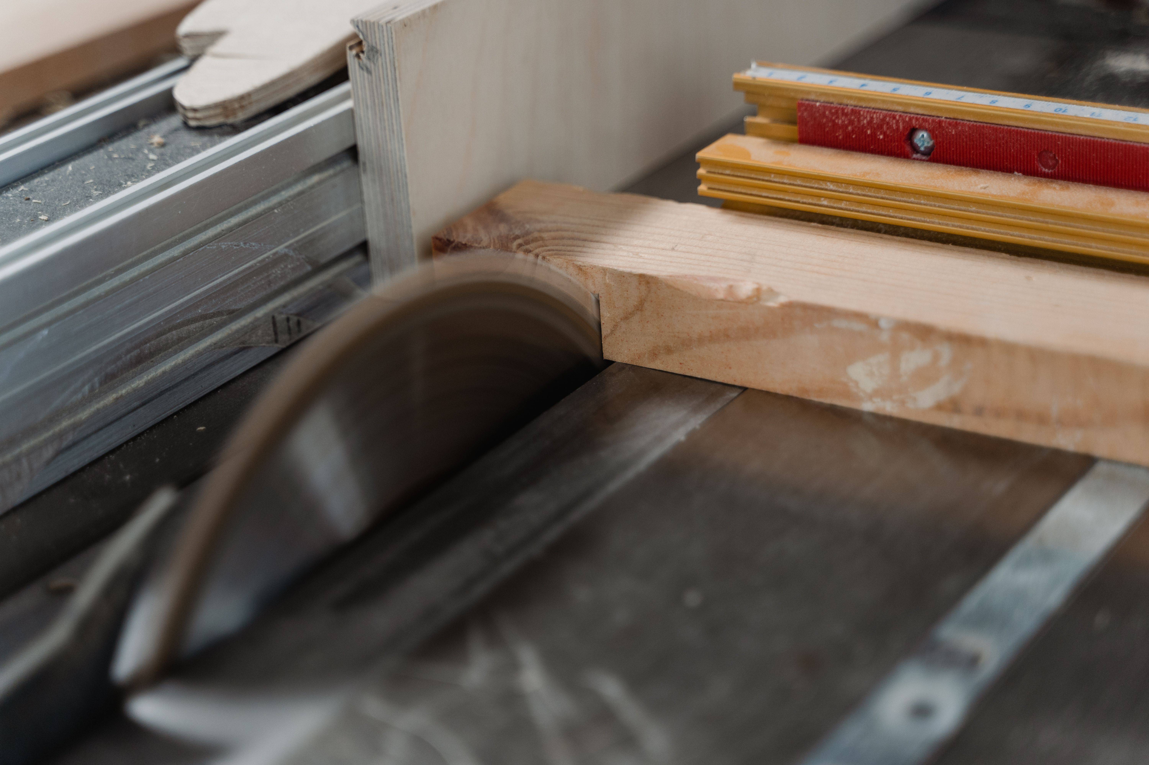
Ask anyone who's actually had it happen and they'll tell you the same thing: it's fast. Not "fast for a woodworking accident" fast. Actually fast -- gone before you've registered anything went wrong. The simple answer to "what is kickback" is that the workpiece gets thrown back at you. The real answer is a lot more specific than that, and it's worth understanding in detail, because the mechanism itself is exactly what tells you how to stop it from happening in the first place.

What Kickback Actually Is
A table saw blade only cuts on the way up at the back of the arbor -- the teeth exit the table moving up and toward the operator, not down and away from them. That's not a design flaw. It's how every table saw on the market works, and it's fine, right up until something goes wrong. If a workpiece or an offcut gets pinched, twisted, or lifted even slightly, those same back-rotating teeth can grab it and fling it backward off the table at whatever speed the blade happens to be spinning. And that speed is a lot higher than it feels like, standing next to the saw.
Here's the number that actually matters: a standard 10" blade spinning at 3450 RPM -- a completely typical no-load speed for a cabinet or contractor saw -- has a rim speed of roughly 100 mph. That's not an exaggeration for effect. It's just the math. Rim speed works out to pi times the diameter times the RPM: pi &times; 10" &times; 3450 RPM comes to a little over 108,000 inches a minute, which converts to right around 103 mph at the tip of the blade. That's the speed a tooth is moving when it catches something. A piece of wood. Or a piece of you.
Say that number out loud and it stops sounding like "be careful out there" advice and starts sounding like what it actually is: a genuine, sudden, high-velocity event. A kickback doesn't graze you. It's not a nudge. It's a piece of hardwood launched at highway speed from three feet away, and by the time your brain has processed that something's wrong, it's already over.

The Real Causes
Kickback isn't random, and it isn't bad luck. Every real incident traces back to one of a small number of causes, and most of them are boring, mechanical, and completely preventable once you know to look for them.
First: the fence isn't parallel to the blade -- or worse, it's toed in. Kerph's table saw tune-up guide covers this in detail, but the short version is that a fence toeing in, even slightly, pinches the workpiece between the blade and the fence right as it exits the cut. That pinch has to go somewhere. "Somewhere" is usually back at you.
Second: no riving knife, or one that's poorly aligned. The riving knife's whole job is to hold the kerf open behind the blade so the wood can't close back up and grab the teeth. Remove it, or let it drift out of alignment, and you've taken away the one part of the saw built specifically to prevent this.
Third: feeding stock freehand at an angle instead of straight into the blade. Any lateral drift lets the back teeth catch an edge that isn't supposed to be there, and once they catch, the workpiece twists before you can react.
Fourth: internal stress in the wood itself. Reaction wood and case-hardened lumber can hold real tension inside the board, and ripping it releases that tension mid-cut -- the kerf closes around the blade on its own, with no input from you at all. This one isn't about technique. It's about the board. It's also exactly why the rest of this list matters: you can't control every piece of lumber that comes through the door, but you can control everything else on this page.
Fifth: a dull or pitch-loaded blade. Kerph's guide to cleaning pitch and resin off blades gets into why in more detail, but the short version is that a gummed-up blade needs more force to push through the cut. More force means more binding, and more binding means more chances for the workpiece to catch and lift.
Sixth: cutting into a knot or a grain reversal. A tooth catches unevenly on hard, irregular grain, and the sudden change in resistance twists the workpiece before you can compensate. This one's mostly bad luck in the wood itself -- which is exactly why the rest of this list matters so much. You can't out-technique a hidden knot. You can out-technique everything else.
Seventh: using the rip fence and miter gauge together on a crosscut. This is a well-known no-no for a specific mechanical reason, not just tradition: the offcut gets trapped between the fence and the blade with nowhere to go, and the spinning blade throws it back the instant it's fully cut free. Use one or the other. Never both at once.
Eighth: letting go of the workpiece before it's fully past the blade. The instant your hand comes off, you lose the ability to counter any sideways force the blade is putting into the stock -- and that's exactly the moment a kickback is most likely to start.
Ninth: standing directly in line with the blade instead of off to one side. This one doesn't cause kickback. It decides what kickback hits. Stand in the firing line and a kicked workpiece has a straight, unobstructed path to your torso. Stand off to the side and the same kickback sails past you into empty air.
None of this is guesswork. A CPSC staff survey of table and bench saw injuries treated in U.S. emergency departments during 2007–2008 found that the workpiece kicked back or jumped in 40.5 percent of the reported injury cases — Survey of Injuries Involving Stationary Saws: Table and Bench Saws, 2007–2008, U.S. Consumer Product Safety Commission. That's not a rare edge case. That's close to two out of every five table saw injuries serious enough to land someone in an emergency room.
📷 Photo placeholder — a riving knife correctly positioned directly behind the blade, coplanar and close, showing the small gap that keeps the kerf from closing on the blade.

Prevention
The good news is that every cause on that list above has a direct, specific fix, and none of them cost much more than attention.
Start with the riving knife. Keep it installed, keep it aligned, every time the saw is set up to rip. Kerph's table saw tune-up guide walks through checking it in about five minutes -- there's no real excuse for skipping it once you know how fast the alternative is.
Keep the blade clean and sharp. A blade cutting cleanly needs less force to get through the wood, which means less binding, which means fewer chances for a kickback to get started in the first place. Kerph's guide to cleaning pitch and resin off blades covers the process start to finish.
Use push sticks, push blocks, and featherboards -- and use the right one for the cut you're actually making, not just whichever one happens to be closest. Kerph's full breakdown of push sticks, push blocks, and featherboards covers exactly which tool solves which hazard. A set of anti-kickback pawls mounted just behind the blade adds another layer built specifically to catch a workpiece the instant it starts moving backward, before it can build up any real speed.
📷 Photo placeholder — a push stick in use finishing a rip cut, hand well clear of the blade, notch hooked over the trailing edge of the workpiece.
Never stand directly in line with the blade. Every single cut, take the half-step to the side before you start feeding stock. It costs nothing, and it's the one habit on this entire list that protects you even when everything else goes wrong.
For crosscuts, use a crosscut sled or a miter gauge -- instead of the fence, not alongside it. Pick one method per cut and commit to it. This is the fix for cause seven above, and it's a completely free one.
Don't remove the factory safety guards. They come off for "convenience" a lot more often than for any real functional reason, and every one of them -- the riving knife, the anti-kickback pawls, the blade guard itself -- is there because someone at the saw manufacturer already thought through exactly the failure this article is describing.
Flesh-detection saw technology, as a category, not any one brand, is worth taking seriously if you're shopping for a saw right now. It doesn't prevent kickback directly, but it's a real, proven layer of protection for the moment things go wrong that no amount of technique can fully guarantee against on its own.
📷 Photo placeholder — a combination square measuring the gap between the rip fence and the miter slot at the front and back of the table, checking for toe-in.
And last, the one that's hardest to put a checklist next to: stay present. A real, honest look at how most kickback incidents actually happen turns up the same story again and again -- someone rushing to finish a cut before a phone call, someone distracted mid-project, someone who's made this exact cut five hundred times and stopped really looking at it on the five-hundred-and-first. The saw doesn't know the difference between an expert having an off moment and a beginner who's never made the cut before. It only knows whether the setup was right and whether your attention was actually on the wood.
Setting the saw up right is half of this. The other half is where it lives in your shop -- how much room you've actually got to stand off to the side of that blade, whether there's a clear path behind you if something does go wrong, and whether the cut you're about to make even fits the space around the saw the way you think it does. Kerph's Workshop Planner lets you lay out real clearances around a table saw before you're standing in a tight spot wishing you had.

