Cleaning Pitch and Resin Off Blades and Bits Safely
Built-up pitch quietly wrecks your cut quality and your safety margin — here's how to strip it off without damaging the carbide or the coating.
Category: Tool Maintenance | Tags: blade cleaning, pitch removal, carbide blades, router bits, table saw safety | Author: Kerph Team
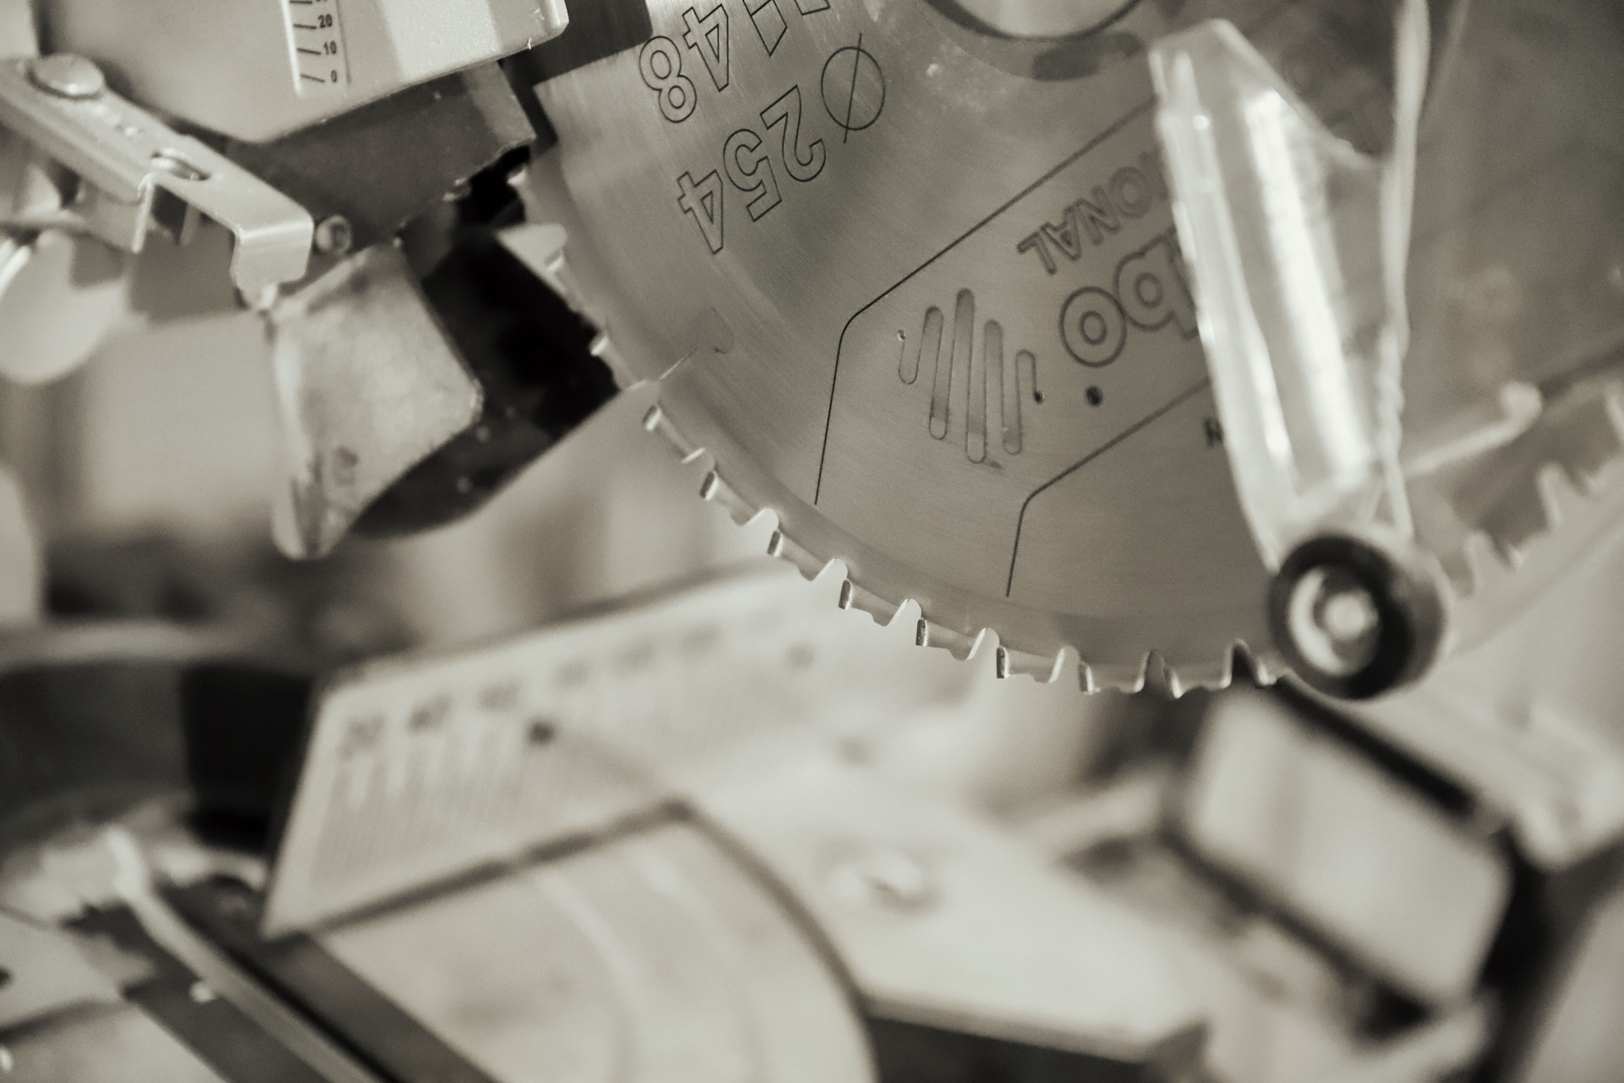
Run a fingernail across the face of a blade that's cut a few hundred feet of pine and you'll feel it — a dark, slightly tacky ridge built up right where the carbide meets the plate. That's pitch and resin, and it's doing more damage than most people realize. It's not just a cosmetic problem; it changes how the blade cuts, how hot it runs, and how it behaves the moment something binds.

Why Pitch Buildup Is a Bigger Deal Than It Looks
Pitch acts as an insulating layer between the carbide tip and the wood, which sounds harmless until you think through what it actually does. First, it increases friction — the blade has to push through the cut instead of slicing, which raises cutting force and heat. Second, that extra heat has nowhere to go, because the pitch layer is also blocking the carbide from shedding heat into the airstream and sawdust the way a clean edge does. Third, and most important for safety, a gummed-up blade is more prone to binding in the kerf. A blade that binds even slightly can cause the workpiece to lift or grab, which is exactly the mechanism behind a kickback. On top of all that, a resin-coated edge dulls faster than a clean one — you're effectively cutting with a duller tool long before the carbide itself has actually worn down.
📷 Photo placeholder — macro shot of a carbide table saw tooth with visible dark brown pitch buildup coating the gullet and tooth face, lit at an angle to show the texture of the residue.

Dedicated Cleaners vs. Household Options
You've got two real paths here, and both work when used correctly.
Dedicated blade and bit cleaners like CMT Blade and Bit Cleaner and oxalic-acid-based options such as Boeshield Blade and Bit Cleaner are formulated specifically to dissolve pitch and resin without attacking carbide braze joints, anti-stick coatings (like the black non-stick coating on many Freud and CMT blades), or aluminum router bit bodies. They're the safest default choice, especially for anything with a coating you want to preserve, and most work in 5-10 minutes without scrubbing.
Household options can work but come with real tradeoffs. Diluted Simple Green (roughly 1:1 with water, or straight for heavy buildup) is a solid budget option that's gentle enough for daily use and won't touch most coatings or braze joints — it's genuinely a reasonable everyday cleaner, just slower than a dedicated pitch remover on heavy buildup. Oven cleaner is the one you'll see recommended online that deserves a hard caution: it's a strong lye (sodium hydroxide) solution, and while it does cut through pitch fast, it's harsh enough to attack aluminum router bit shanks and bases, can discolor or strip anti-stick coatings, and will irritate skin and lungs without gloves and ventilation. If you use it, limit it to steel-body, uncoated blades, keep contact time short, and rinse thoroughly — but for anything with aluminum or a coated finish, skip it entirely.

The Soak-and-Brush Process
Once you've picked a cleaner, the actual process is the same regardless of which one:
1. Lay the blade or bit flat in a shallow plastic tray or an old cake pan — never a container you'll reuse for food.
2. Cover it with cleaner so both faces are wetted, or spray liberally if you're using an aerosol formula.
3. Soak 5-15 minutes. Heavier, older buildup needs the longer end of that range. Don't walk away for hours — extended soaking doesn't help much and just prolongs unnecessary chemical exposure to the metal.
4. Brush the gullets and tooth faces with a nylon-bristle brush (an old toothbrush works) or a brass-bristle brush for stubborn spots. Brass is soft enough not to scratch carbide or steel but still has enough bite to knock resin loose.
5. Rinse with water and dry immediately — compressed air or a clean towel, then let it air-dry fully before storage. Any leftover moisture on bare steel will flash-rust within the hour.
6. Wipe on a light coat of oil before the blade goes back in the drawer or the tool goes back on the shelf. A drop of machine oil or a wipe of the same rust inhibitor you use on your cast iron top will keep it from developing surface rust between uses.
📷 Photo placeholder — a blade soaking flat in a shallow tray of cleaner, with a nylon brush resting nearby, shot from directly above to show the resin lifting off into the liquid.

What Not to Use
Skip wire brushes and wire wheels entirely — steel bristles are hard enough to scratch both carbide and the anti-stick coatings that keep pitch from building up as fast in the first place, which ironically makes the next cleaning harder. Skip strong chlorinated solvents and straight acetone on coated blades and bits, since they can soften or lift the coating along with the resin. And never soak router bits or blades with bearings (guided bits, ball-bearing pilot bits) fully submerged — water and solvent that gets into the bearing race will wash out the grease and lead to a gritty, failing bearing down the line. Wipe those by hand instead, keeping liquid off the bearing itself.

How Often to Check
As a rule of thumb, inspect after every 4-8 hours of cutting resinous softwoods like pine, fir, or spruce, or any time you notice the saw working harder, the motor bogging on cuts that used to be easy, or a faint burning smell during otherwise normal feed rates. A quick visual check — tilt the blade toward a light and look at the gullets — takes ten seconds and tells you everything you need to know. Hardwoods and sheet goods build up pitch much more slowly, so a monthly check is usually enough there.
Keeping tabs on when each blade and bit was last cleaned is a lot easier when it's logged somewhere instead of guessed at — Kerph's tool tracking gives you a place to keep that history alongside the rest of your gear.

