How to Tune Up a Table Saw in 30 Minutes
A real, timed checklist for aligning your blade, fence, and tilt stops, plus the exact tools you need to get shop-grade accuracy in half an hour.
Category: Tool Maintenance | Tags: table saw tune-up, blade alignment, fence alignment, riving knife, saw maintenance | Author: Kerph Team
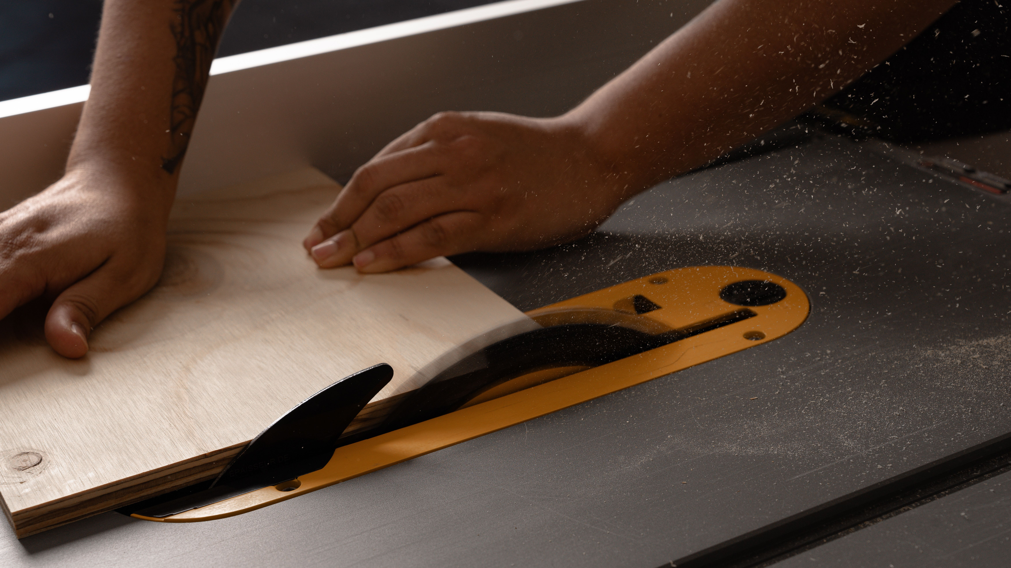
Most table saw problems people blame on technique — burning, drifting cuts, a fence that seems to wander — are actually alignment problems. A saw that's a few thousandths out of parallel will fight you all day, and most home shops never check it after the initial setup out of the box. This is the checklist to run through every few months, or any time the saw's been moved, dropped a belt, or just started cutting worse than it used to. Budget 30 minutes; none of it requires a machinist background.

What You'll Need (5 minutes to gather)
You don't need a full metrology kit. The minimum useful setup is a reliable combination square and a feeler gauge set. If you want tighter tolerances than eyeballing a gap, a dial indicator with a magnetic base turns "close enough" into an actual measured number, and it's worth owning if you tune up more than once a year. You'll also want the wrench or hex key that fits your trunnion bolts, a scrap of hardwood, and your usual cleaning and waxing supplies.

Step 1: Blade-to-Miter-Slot Alignment (5 minutes)
This is the alignment that matters most — everything else is referenced off it. Chalk mark or clamp a scrap block in the miter slot with a point (a screw tip works) just touching a tooth at the front of the blade. Rotate the blade by hand so that same tooth is now at the back, and check the gap again. With a dial indicator you're looking for the reading to hold within 0.005" front to back; with a feeler gauge, you're checking whether a given thickness gauge just barely fits at one end and not the other. If it's off, loosen the trunnion bolts under the table (check your manual for exact locations — most contractor and cabinet saws adjust the trunnion, not the blade itself) and nudge until front and back readings match, then retorque.

Step 2: Fence Parallelism (5 minutes)
With the blade alignment now trustworthy, lock the fence a set distance from the blade and measure from the fence face to the miter slot at the front of the table and again at the back, using the same square or indicator. Fences should either be dead parallel or toe out very slightly at the back — no more than about 0.010", never toeing in. Toe-in is what causes burning and kickback on rip cuts because the workpiece gets pinched between the blade and the fence as it exits. Most fences have two adjustment screws on the head where it locks to the rail; loosen those, tap the fence to correct the reading, and retighten while holding position.
📷 Photo placeholder — dial indicator mounted on a magnetic base, needle touching a saw blade tooth, positioned to show the measurement setup for checking blade-to-miter-slot alignment.

Step 3: Blade Tilt Stops at 90° and 45° (5 minutes)
Raise the blade fully, set the tilt to 90°, and check square using the flat body of the blade plate — not a tooth, since carbide teeth can have inconsistent set that throws off the reading. If there's a gap, adjust the 90° set screw (usually accessed near the handwheel or under the table near the trunnion) until the square sits flush, then lock it down and repeat for the 45° stop. Confirm both with an actual test cut in a piece of scrap — measure the resulting angle with the square before trusting the stops for a real project.

Step 4: Riving Knife Alignment (5 minutes)
The riving knife needs to be thin enough not to bind but thick enough to actually do its job — check that it's roughly the same thickness as the blade's kerf, slightly thinner than the plate but wider than the blade body. More important day to day is that it's coplanar with the blade: lay a straightedge across both the blade and the knife at the same height and confirm there's no visible offset side to side. A riving knife that's angled off to one side will push cut stock sideways and can bind instead of preventing kickback the way it's designed to. Most riving knives have a quick-release lever; loosen it, square the knife against the blade by eye or with the straightedge, and reseat.

Step 5: Inspect the Blade, Check the Belt, Clean and Wax the Top (5-10 minutes)
While everything's open, give the blade a visual check for missing carbide, cracked plate, or the dark resin buildup that slows cuts and increases kickback risk — if it's coated, this is a good moment to plan a cleaning rather than pushing through another project with a gummed-up edge. If your saw is belt-driven, check belt tension by pressing on the belt midway between the pulleys; you want roughly half an inch of deflection under moderate thumb pressure, no more. A belt that's too loose will slip and bog under load; too tight strains the arbor bearings. Finally, wipe the cast iron top clean of dust and old wax residue and lay down a fresh coat of paste wax or rust inhibitor — the same routine covered in Kerph's guide to keeping cast iron tables rust-free — so the table's slick and protected before you put it back to work.
📷 Photo placeholder — hand pressing down on a table saw drive belt to check deflection, with a ruler or straightedge in frame showing roughly half an inch of give.

Putting It Together
Run in order — blade to slot, fence to blade, tilt stops, riving knife, then the inspection and cleanup pass — and 30 minutes is realistic even the first time through, faster once it's a habit. Do this every few months in a shop that sees regular use, and immediately after any time the saw gets moved, tipped, or drops a belt. A saw that's actually in alignment cuts safer and faster than any blade upgrade will, and it costs nothing but the half hour.
If you're missing any of the measuring tools above, it's worth comparing options before you buy — check out Kerph's tool catalog to see what fits your saw and your budget.

