Push Sticks, Push Blocks, and Featherboards: What to Actually Use
Three different tools protect against three different hazards — here's what each one actually does, when you need it, and a 5-minute DIY push stick to start with.
Category: Safety | Tags: push stick, push block, featherboard, table saw safety, kickback prevention | Author: Kerph Team
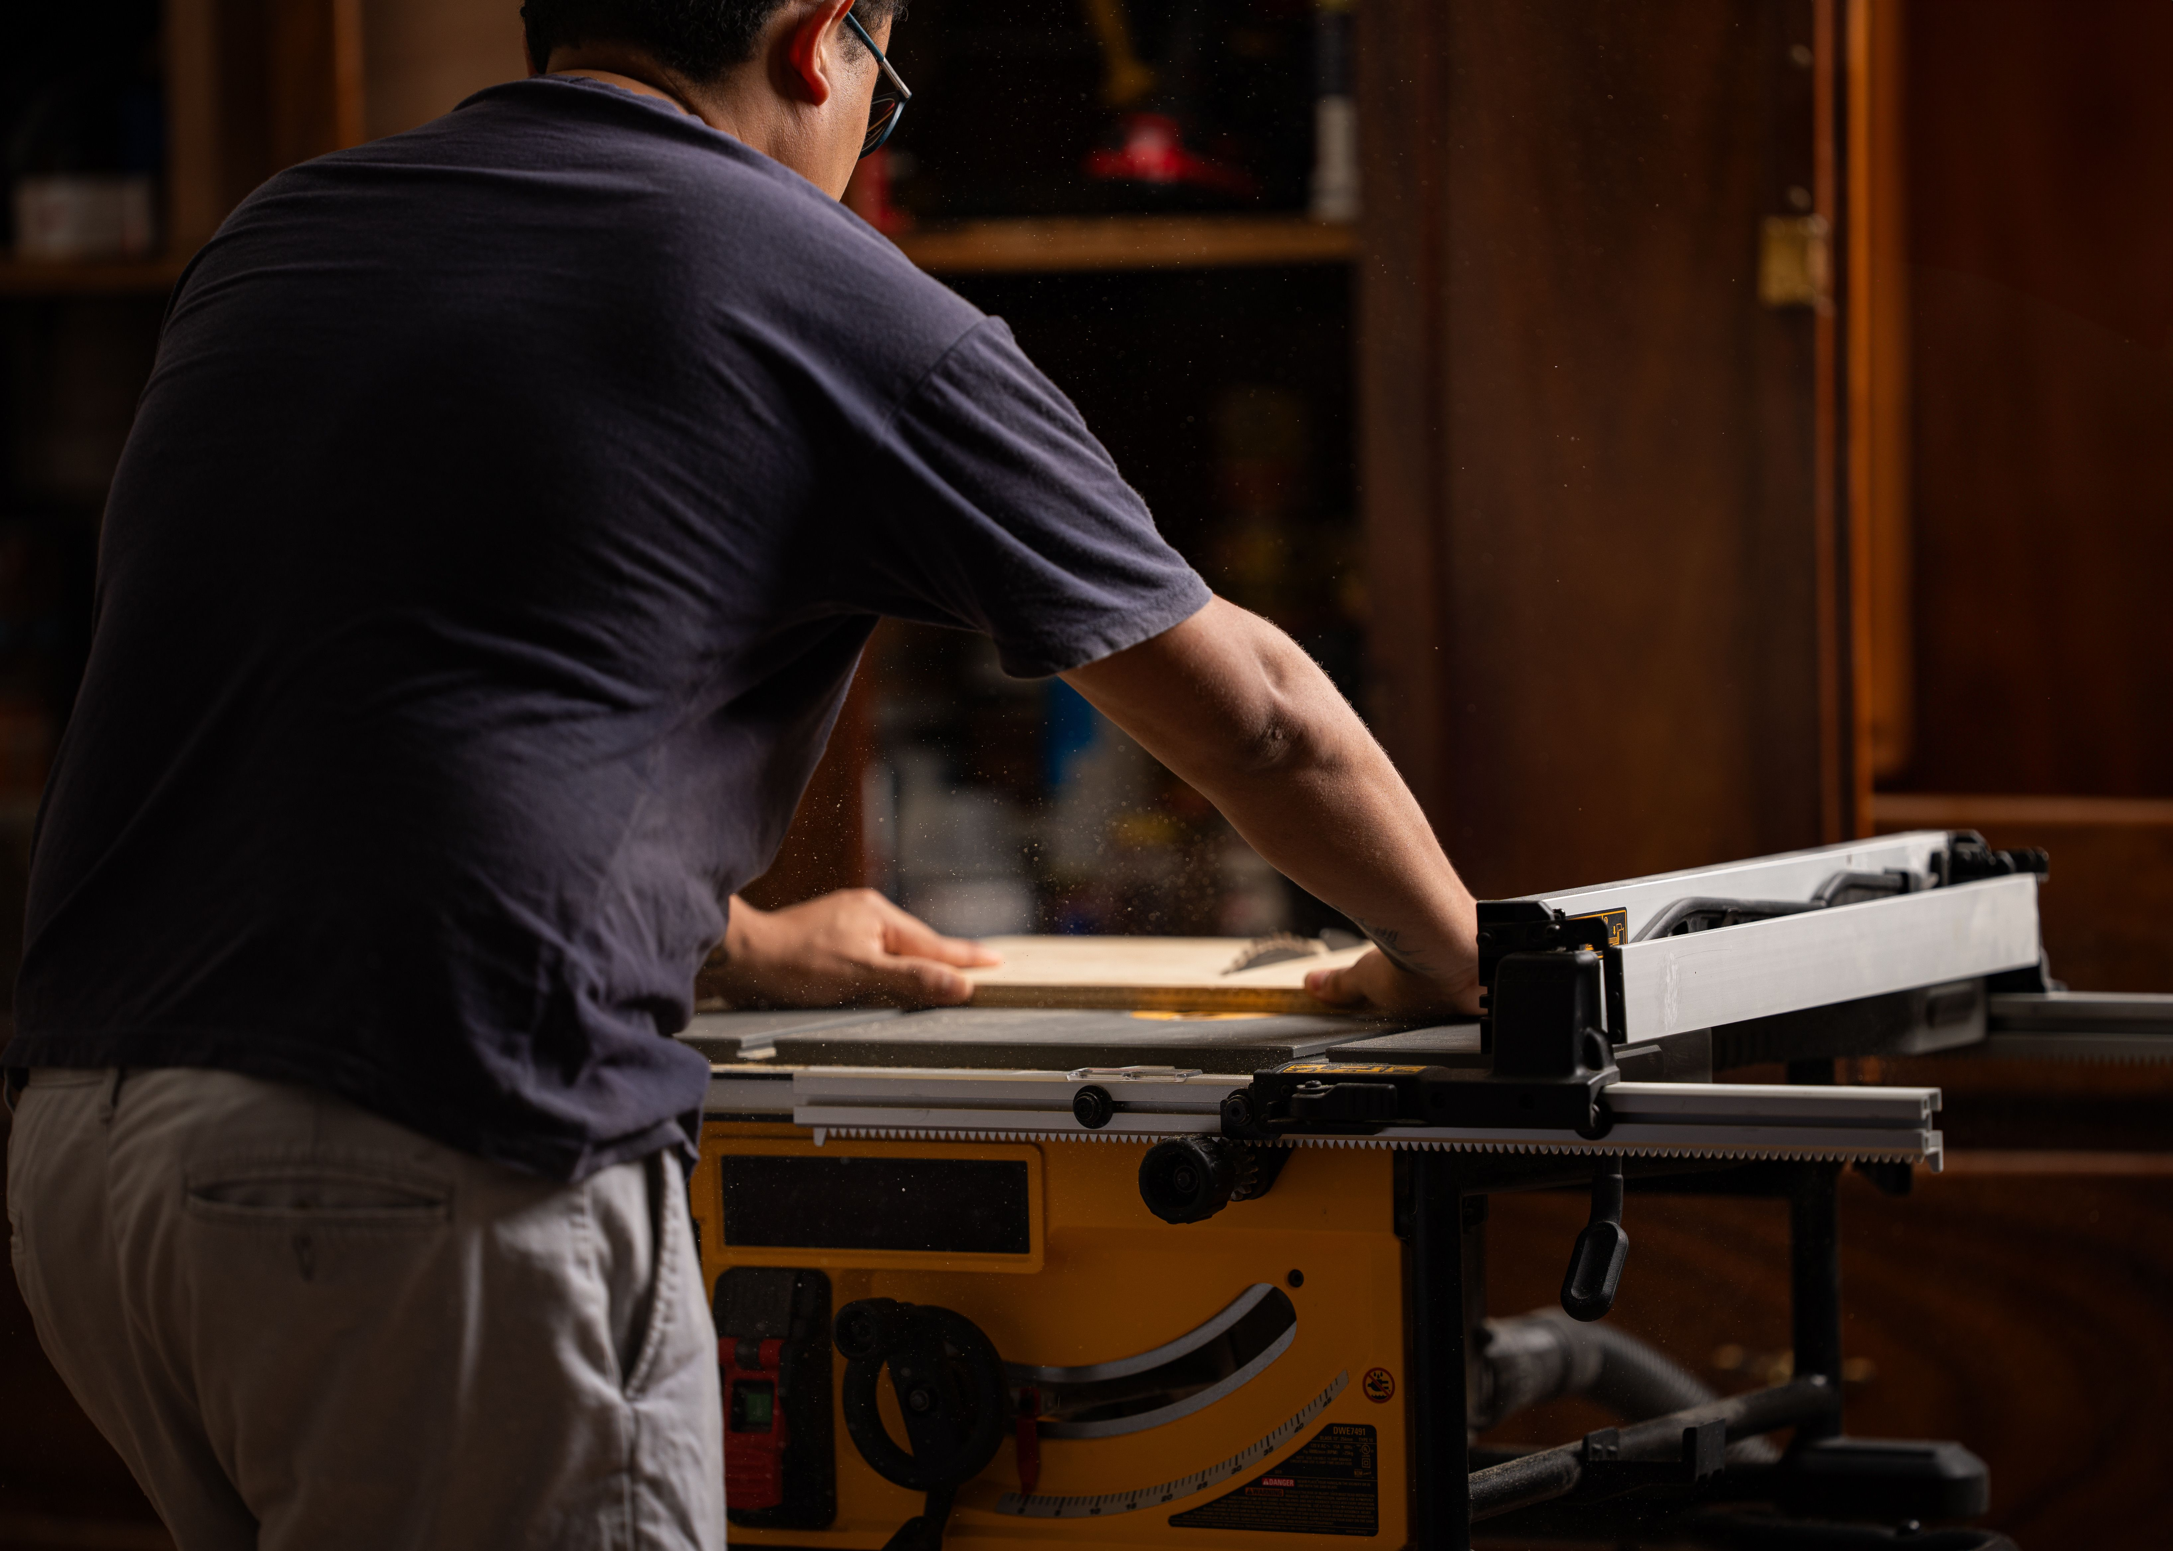
Walk into most home shops and you'll find a push stick hanging on a nail, used maybe once a month, while the last two inches of every rip cut get pushed through with fingers closer to the blade than anyone would admit out loud. Part of the problem is that "push stick," "push block," and "featherboard" get used almost interchangeably, when they actually protect against three different things. Knowing which one solves which problem is what makes people actually reach for the right tool instead of skipping all three.

Push Sticks: Straight-Line Ripping
A push stick's job is narrow and specific — it keeps your hand out of the blade's path while finishing a rip cut, especially the last several inches where your hand would otherwise be passing directly over or beside the blade. It's a hand extension, not a clamping or pressure tool. The notch at the end hooks the trailing edge of the workpiece and pushes it forward and slightly down onto the table. A push stick does one thing well: distance. It does not control the workpiece against the fence, and it does very little to resist kickback — that's not its job.

Push Blocks: Narrow Rips and Downward Control
Push blocks pick up where push sticks fall short. A dedicated design like the GRR-Ripper combines downward and forward pressure with a wide footprint on the workpiece, instead of a single narrow contact point. That matters most on narrow rips — anything under about 2 inches wide — where a push stick's single hook point can let the offcut tip, bind, or get pulled sideways into the blade. A push block controls the piece the whole time it's passing the blade, not just at the last few inches, which is why it's the right call for ripping thin strips, resawing, or any stock where a kickback would launch a piece small enough to really move. Anyone doing regular narrow-rip work — trim strips, edge banding, thin slats — should own one outright rather than relying on shop-made push sticks alone.
📷 Photo placeholder — a GRR-Ripper style push block guiding a narrow strip of wood through a table saw rip cut, showing the downward and forward pressure points in contact with the workpiece.

Featherboards: Consistent Lateral Pressure
Featherboards solve a different problem: keeping the workpiece pinned against the fence or table so it can't wander, lift, or get pushed back at you. On a table saw, a featherboard clamped ahead of the blade holds stock tight to the fence through the cut, which prevents the workpiece from drifting into the blade and binding — one of the more common causes of kickback on rip cuts. On a router table it's arguably even more important, since router bits spin at 16,000–24,000 RPM and any lateral wander changes the cut depth instantly, and router tables don't have a riving knife to catch a pinched workpiece the way a table saw does. Featherboards don't replace a push stick or push block — they handle sideways pressure while you're still responsible for feeding the stock forward safely.

Where Each One Is Actually Necessary
A push stick is close to mandatory any time your hand would otherwise pass within 6 inches of a spinning blade — on a table saw, that's essentially every rip cut. A push block moves from optional to necessary once you're ripping narrower than about 2 inches, or doing repeated narrow-rip work where a slip has real consequences. A featherboard is necessary any time the workpiece could drift off the fence — long rips, router table edge profiles, or any cut where you can't maintain constant hand pressure the entire way through. None of these are "nice to have" once the cut geometry calls for them; skipping the right one is how a routine cut turns into a kickback incident.

The False Security of a Cheap Push Stick
Not all push sticks are equal, and a thin, flexible notch-cut stick — the free ones stapled to a blade box, or a quick scrap-wood cutout with a shallow notch — can create a worse habit than using nothing, because it gives a false sense of control. If the notch is too shallow, it slips off the workpiece under load right when you need it most. If the stick flexes, you lose the precision to keep steady pressure, and your hand ends up compensating by getting closer to the blade. A push stick needs a notch deep enough to positively hook the material (at least 3/4" deep) and enough rigidity that it doesn't bow under normal push pressure — 1/2" or 3/4" plywood works better than 1/4" hardboard for this reason.

A 5-Minute DIY Push Stick to Start With
Before buying anything, cut one from a scrap of 1/2" or 3/4" plywood: a piece roughly 14–16 inches long and 4–5 inches wide at the handle end, tapering to about 1 inch at the working end. Cut a notch at the working end about 3/4" deep, angled slightly downward, sized to hook the back edge of typical 3/4"-thick stock. Round over the handle edge for grip, and add a hand-hold slot if you want extra security. This isn't a replacement for a dedicated push block on narrow-rip work, but it's a legitimate, safe tool for general ripping, and it costs a scrap of plywood and five minutes at the bandsaw or jigsaw.
📷 Photo placeholder — a simple shop-made plywood push stick pattern laid out with dimensions, showing the tapered body, deep notch at the working end, and rounded handle.
None of these three tools are optional extras — they're the difference between a rip cut you control and one that controls you. If your shop is missing a dedicated push block or a few featherboards, it's worth browsing Kerph's tool catalog to compare the real options before your next project puts your hands closer to the blade than you'd like.

