Hearing Protection for the Shop: What's Actually Effective
Real dB numbers for common shop tools, how to actually read an NRR rating, and which type of hearing protection is worth buying for a home workshop.
Category: Safety | Tags: hearing protection, NRR, earmuffs, shop safety, noise reduction | Author: Kerph Team
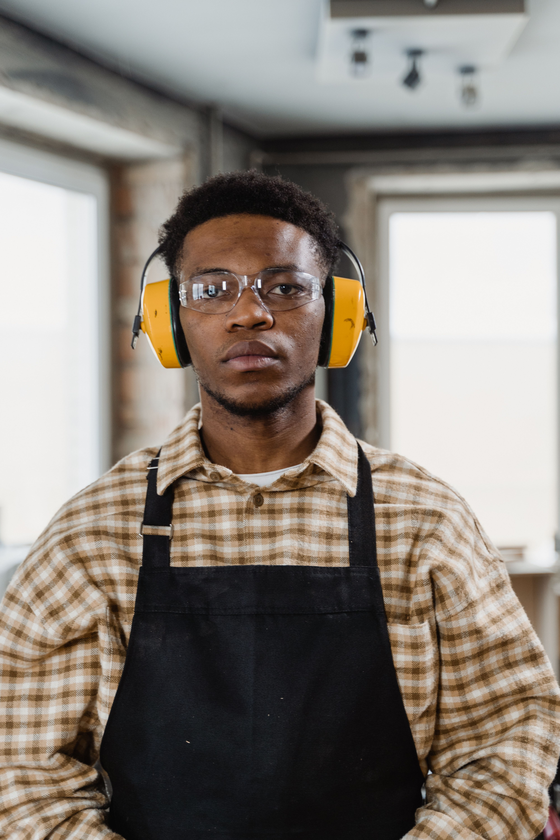
Hearing damage from shop tools doesn't announce itself the way a cut or a burn does — it happens gradually, over years, and by the time you notice a ringing that doesn't go away, the damage is already done and permanent. The frustrating part is that most woodworkers already own hearing protection; it's just sitting on a shelf because they don't have a real sense of which tools actually need it or whether the earmuffs they bought are doing anything. The numbers involved aren't complicated once you know how to read them.

What Your Tools Are Actually Putting Out
OSHA's permissible exposure limit is 90 dB averaged over an 8-hour shift, and the exposure time you're allowed gets cut in half for every 5 dB increase above that — meaning at 100 dB you're down to about 2 hours before you've hit your daily dose, and at 105 dB it's closer to 1 hour. Here's where common shop tools actually land:
• Table saw: 100–105 dB under load, higher momentarily when the blade first contacts material
• Planer or jointer: commonly 100 dB or higher, and often the loudest tool in a home shop because of the cutterhead's rotational speed
• Router (especially handheld, at higher RPM settings): can exceed 105–110 dB, and the pitch sits in a frequency range that feels more piercing than a saw's lower-frequency roar even at a similar dB level
• Shop vac / dust collector: typically 80–90 dB — often below the threshold that requires protection on its own, but it adds to cumulative exposure when running alongside another tool
• Random orbital sander: usually 85–95 dB depending on model and material
For context, normal conversation is around 60 dB, and the damage-risk threshold most hearing health guidance points to is around 85 dB for sustained exposure. Every tool on that list except the shop vac clears that bar comfortably, and several of them clear it by 15–20 dB, which is not a small margin given the logarithmic scale.

Reading an NRR Rating Correctly
Every hearing protector sold in the US carries a Noise Reduction Rating — a single number in decibels, tested in a lab under ideal conditions. The mistake almost everyone makes is subtracting that number straight from the tool's dB level and assuming that's their real protection. It isn't, and OSHA's own guidance says so directly: for a single hearing protector worn alone, take the labeled NRR, subtract 7, then divide by 2. A pair of earmuffs rated NRR 25 gives a real-world estimated reduction of about 9 dB — (25 − 7) ÷ 2 — not 25. That's the gap between lab conditions (a perfect seal, fitted by a technician) and how protection performs on a real head, with glasses, hair, or an imperfect fit breaking the seal. It's still meaningful — running a 103 dB planer down to an effective ~94 dB is a real difference in exposure time — but treating the label number as the actual reduction is the single most common mistake people make buying hearing protection.
📷 Photo placeholder — close-up of a hearing protection product label showing the NRR rating number, next to a pair of earmuffs, framed so the rating is clearly legible.

Earmuffs vs. Foam Plugs vs. Electronic Muffs
Foam plugs like 3M E-A-R Classic foam earplugs typically carry NRR ratings around 29–33, the highest of any common option, and they're cheap enough to keep a box on every bench. The catch is fit-dependent performance — they only hit their rated number when rolled thin and inserted deep enough to seal the canal, which most people don't do correctly on the first few tries. Standard passive earmuffs, like 3M Peltor X5A earmuffs, run NRR 30–31 and are more forgiving of fit since they don't require precise insertion — good for anyone who finds foam plugs fiddly. For the best of both, doubling up (plugs under muffs) adds roughly 5 dB more real-world reduction, worth doing for anything in the 105+ dB range like a router at high RPM.
Electronic earmuffs, such as models from Howard Leight Impact Sport, are worth the extra cost if you're in the shop for hours at a stretch and want to hear a shop partner talk between cuts — built-in microphones pass through normal ambient sound, then clamp down instantly on impulse noise above a safe threshold, like the moment a blade contacts material. They function as full protection during the loud moment and normal hearing the rest of the time, which is genuinely useful when you're not running a tool continuously but need protection ready the instant you are.
📷 Photo placeholder — three hearing protection options laid side by side on a workbench: a box of foam earplugs, a pair of passive earmuffs, and a pair of electronic earmuffs, for a visual comparison.

The Simple Rule of Thumb
If a tool is going to run continuously for more than a few minutes — a planer working through a stack of boards, a router table session, a long ripping run on the table saw — hearing protection isn't optional, full stop. Quick, isolated cuts under a minute matter less for cumulative exposure, but they still add up over a session, and the honest habit is to just keep protection on anytime a loud tool is running rather than deciding case by case. Keep a pair of muffs hanging in easy reach of your loudest machines, not buried in a drawer, since the biggest factor in whether people actually use hearing protection is how many seconds it takes to grab it.
Once you know which of your tools run loudest, it's worth tracking your gear and noting which stations need protection kept within reach — Kerph's workshop planner is a good place to map out where your loudest machines live relative to where you're standing most often.

