Oil Finishes vs. Film Finishes: Which Fits Your Project?
Oil soaks in and repairs easy; film finishes sit on top and protect hard. Here's the real tradeoff and how to pick the right one for what you're building.
Category: Finishing | Tags: wood finishing, oil finish, polyurethane, wipe-on poly, danish oil, film finish | Author: Kerph Team
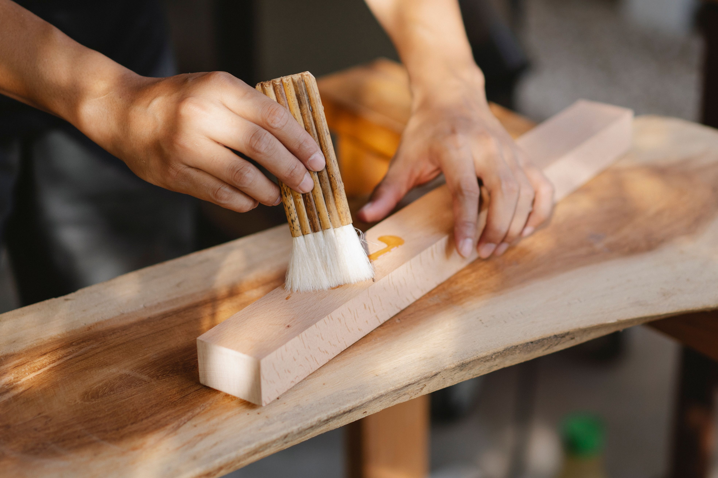
Every finishing question eventually comes down to the same fork in the road: something that soaks into the wood, or something that builds a layer on top of it. Both categories have real, opposite strengths, and picking wrong doesn't ruin the piece so much as guarantee you'll be annoyed with it in two years — a cutting board that's too fragile, or a dining table that scratches white the first time someone sets down a hot mug. Here's the actual tradeoff, not the marketing version.

What Oil Finishes Actually Do
Danish oil, tung oil, and boiled linseed oil all work the same basic way: they penetrate into the wood fibers and cure there, rather than building a layer on the surface. That gives you a low-sheen, "in the wood" look that a lot of people prefer for furniture, and it's genuinely hard to mess up — wipe on, let it sit 10-15 minutes, wipe off the excess, repeat for 2-3 coats. There's no brush marks to worry about, no dust nibs from a wet film catching debris in the air.
The tradeoff is protection. An oil finish adds almost no surface film to speak of, so it does very little against water rings, heat from a hot pan, or scratches — the wood underneath is still the wood underneath, just conditioned. Watco Danish Oil and Hope's 100% Pure Tung Oil are both well-regarded, reliable products in this category. The upside on the maintenance side is real, though: when an oil finish wears thin or gets a scuff, you sand lightly and wipe on another coat, and it blends in seamlessly because there's no discrete film to feather-edge against.

What Film Finishes Actually Do
Polyurethane, lacquer, and shellac all cure into a continuous plastic-like (or resin-like, for shellac) layer sitting on top of the wood rather than in it. That film is what actually blocks water, resists heat, and shrugs off everyday scuffs — it's the reason a poly-finished dining table survives spilled wine and hot casserole dishes that would leave a mark on an oil-only surface. Film finishes also come in sheen options from matte to high-gloss, giving you more control over final look.
The cost is application difficulty and repairability. Brushing on Minwax Helmsman Spar Urethane evenly across a wide tabletop without lap marks, bubbles, or dust nibs takes real technique and a controlled environment. And when a film finish does get damaged — a deep scratch, a chip at an edge — you generally can't spot-repair it invisibly. You're sanding back a wider area and refinishing the whole surface, or living with a visible repair line, because a new coat over an old one shows a seam where they overlap.
📷 Photo placeholder — side-by-side comparison shot of two matching wood samples, one with an oil finish (matte, low-sheen) and one with a film finish (glossy, visible surface build), lit to show the sheen difference clearly.

Matching Finish to Real Projects
Run it against what you're actually building:
• Cutting boards and butcher blocks: oil only, and food-safe oil specifically — mineral oil or walnut oil, never polyurethane, since a film finish will crack along knife cuts and trap bacteria in the gaps.
• Dining tables and desks: film finish. These see hot dishes, water glasses, and daily wear that oil alone won't survive without constant reapplication.
• Workbench tops: oil, on purpose. A film finish on a workbench chips and peels under tool impacts and glue squeeze-out, and you don't want a glossy slick surface under a hand plane anyway. A boiled linseed oil or straight tung oil coat lets the bench take abuse and just gets touched up.
• Heirloom furniture, jewelry boxes, display pieces: film finish, usually shellac or lacquer, for the depth and protection — these aren't handling daily abuse but benefit from the higher-end look.

The Middle Ground: Wipe-On Poly
If you want more protection than straight oil but don't want to fight a brush, wipe-on polyurethane splits the difference. It's real polyurethane thinned down with mineral spirits so it applies like an oil — wipe on with a rag, let it flash, wipe off or let it level — but it still builds an actual film with multiple thin coats. Minwax Wipe-On Poly is the standard here. It takes more coats than oil (usually 4-6 thin ones) to build equivalent protection to a couple of brushed coats, but the application is nearly foolproof and it's a good call for anyone who wants poly-level durability without poly-level application headaches.

A Simple Rule of Thumb
If food or hands touch it directly and often, or it needs to take real abuse without babying, lean oil. If it needs to survive spills, heat, and daily wear while looking good doing it, lean film. When in doubt, wipe-on poly is the safe middle answer for anything that gets moderate use and you don't want to overthink.
Whatever you land on, keep track of which finish went on which piece — it matters when it's time to recoat. If you're stocking up on finishing supplies alongside your other shop gear, check the tool catalog to compare options before you buy.

