Food-Safe Finishes for Cutting Boards and Bowls
Most cured finishes are food safe — the real risk is a finish that never fully hardens. Here's what to actually put on a board or bowl, and what to skip.
Category: Finishing | Tags: food safe finish, cutting board oil, mineral oil, walnut oil, wood bowls, board butter | Author: Kerph Team
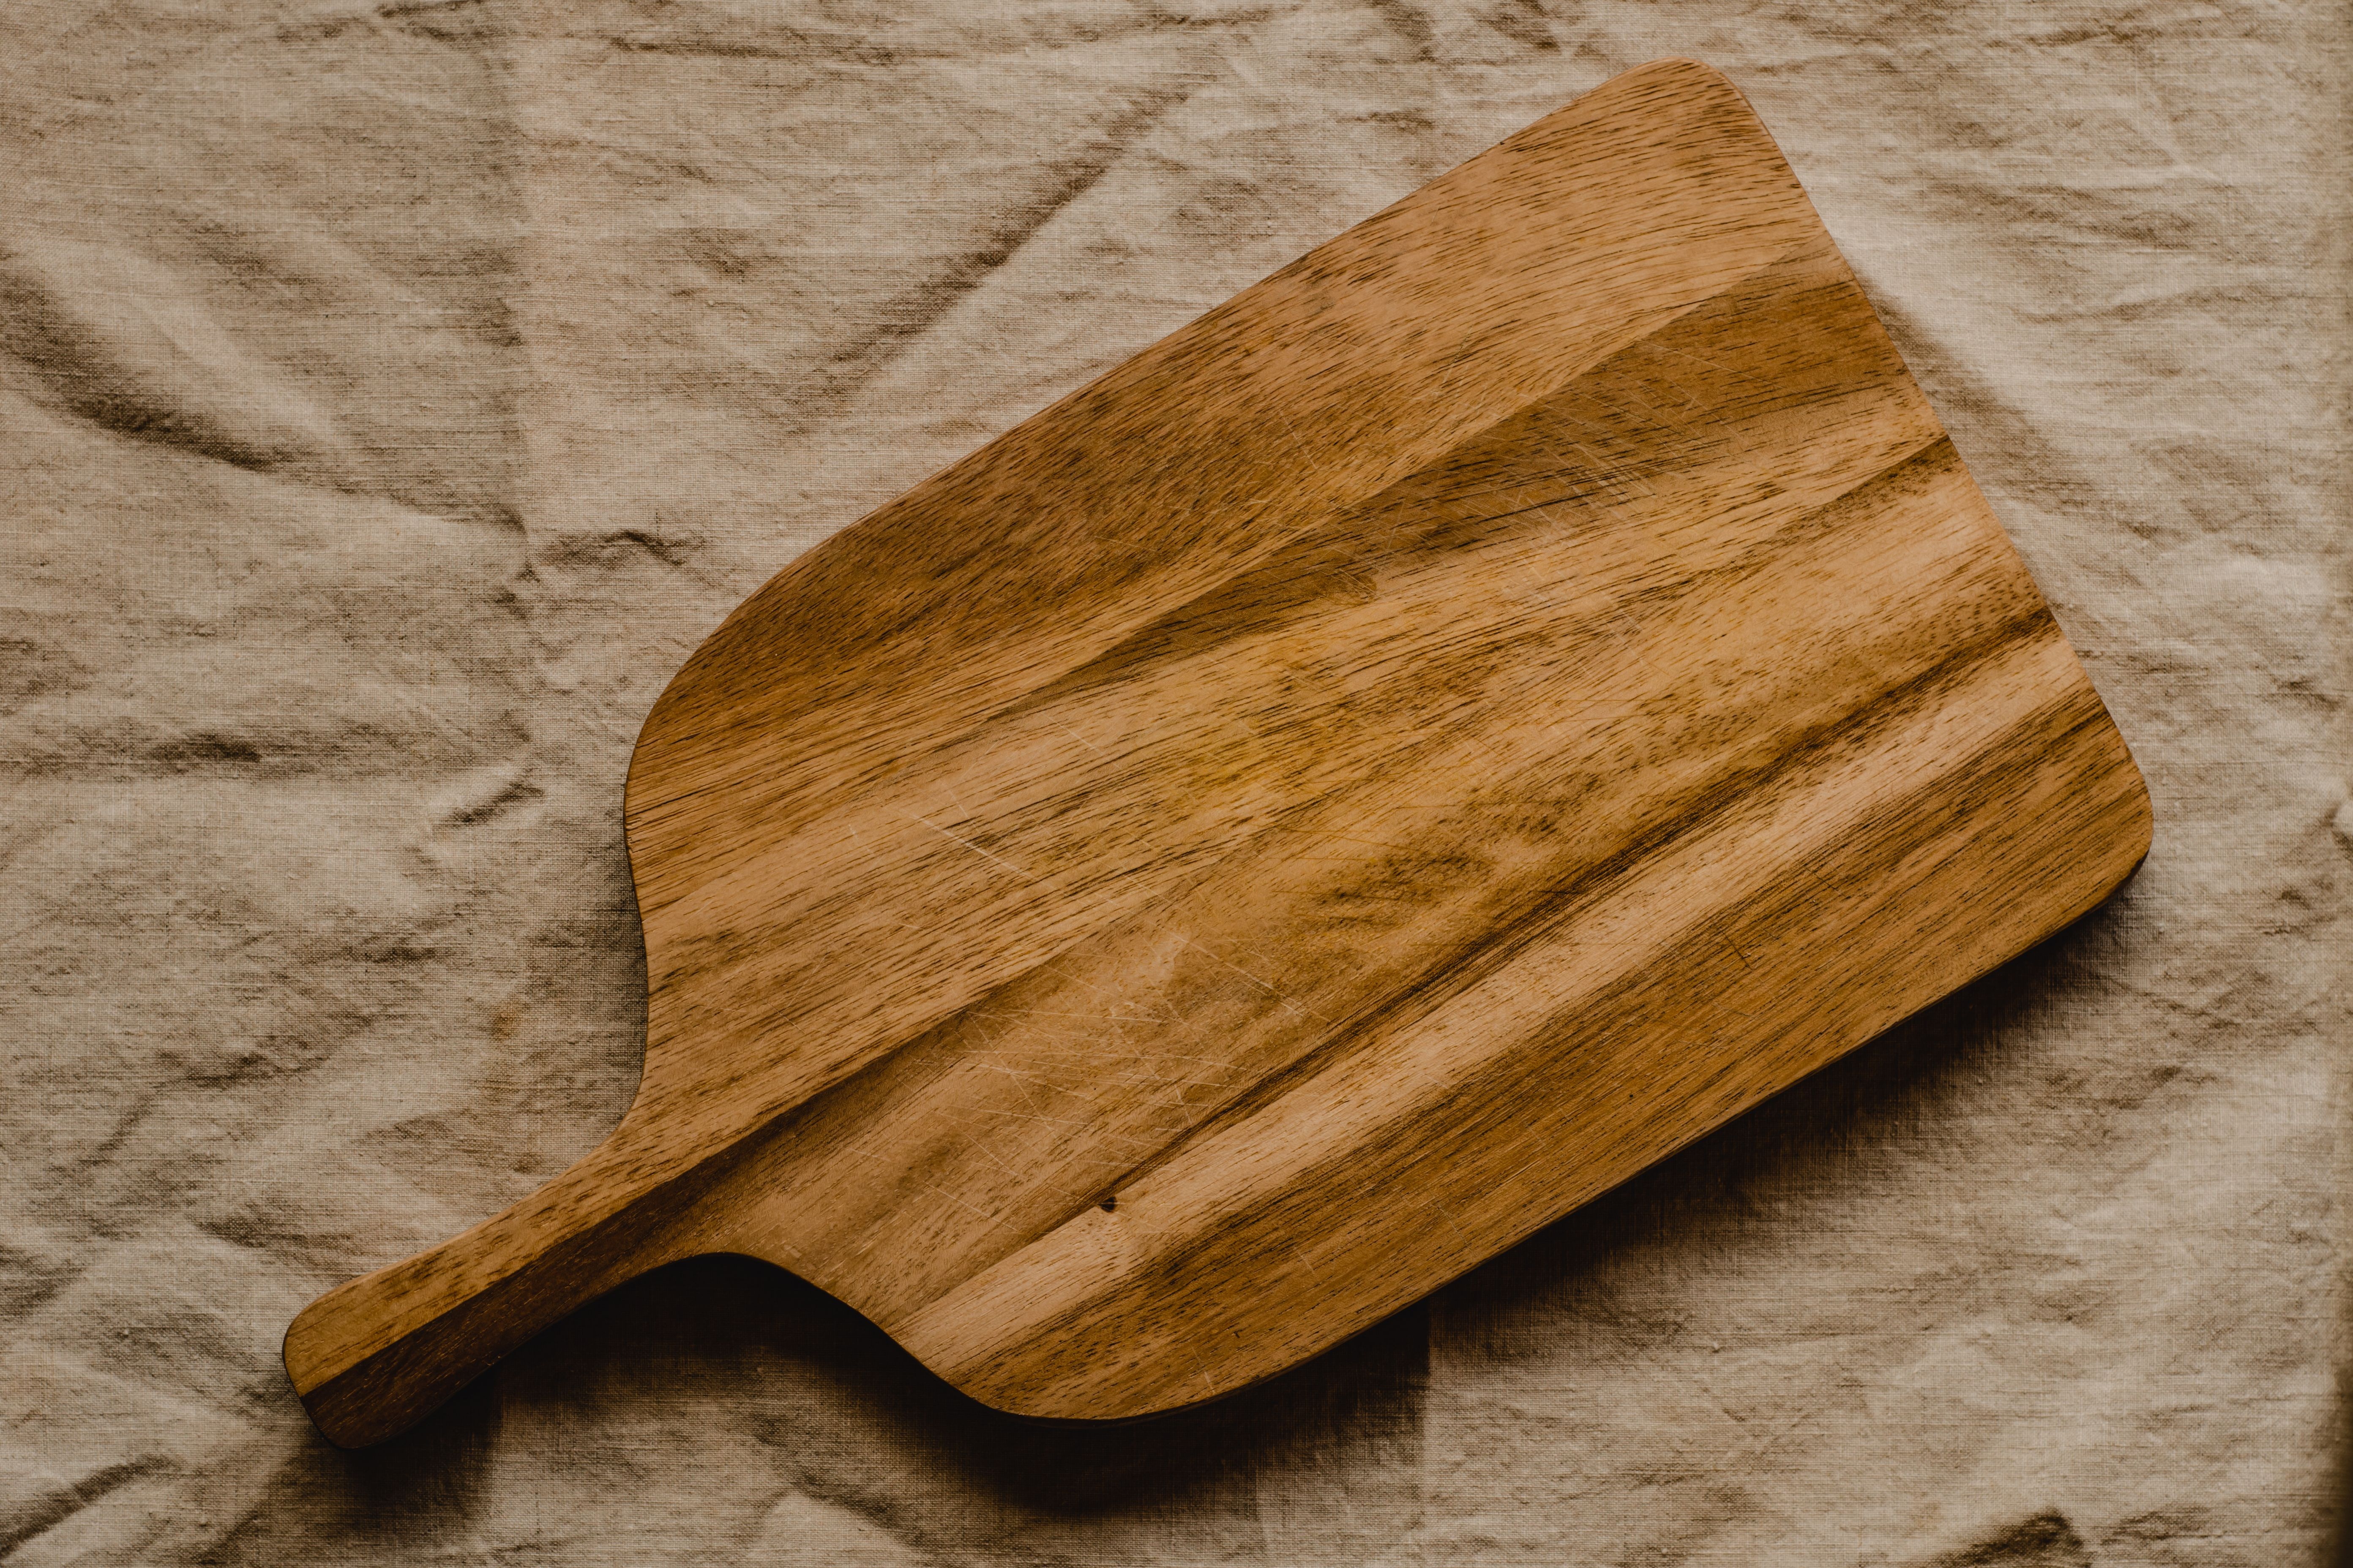
"Food safe" gets thrown around like it's a special ingredient, but the honest answer is that almost any finish is food safe once it's fully cured — cured means the solvents have evaporated off and the finish has hardened into something inert. The actual risk isn't toxicity from a finish that's dry to the touch. It's a finish that never fully hardens in the first place, sitting soft and gummy in the bottom of a knife cut where it can trap moisture and feed bacteria. That distinction is the whole story, and once you understand it, picking a finish for a cutting board or bowl gets simple.

What "Food Safe" Actually Means
The FDA doesn't certify wood finishes as "food safe" — there's no official stamp to look for. What matters practically is whether the finish cures to a hard, stable state or stays soft indefinitely. Fully cured polyurethane, cured shellac, cured lacquer, and any oil that polymerizes (hardens through oxidation) are all considered food-contact safe by any reasonable standard once cured, because there's nothing left to leach or off-gas. The one finish to genuinely avoid is raw (boiled or unboiled) linseed oil — it never fully hardens on its own in a reasonable timeframe, stays tacky in cracks and cut marks, and can support bacterial growth over time. That's the actual hazard people are worried about when they ask about food safety, not some general fear of finishes.

Mineral Oil — The Basic Workhorse
Food-grade mineral oil is the default answer for a reason: it's inert, colorless, odorless, doesn't go rancid because it's a petroleum product rather than a plant oil, and it's cheap. It never fully cures — it just sits in the wood and needs periodic reapplication — but that's fine, because reapplication is the whole maintenance routine and it takes two minutes. Howard Cutting Board Oil is straightforward food-grade mineral oil packaged for exactly this use. Apply liberally, let it sit 15-20 minutes, wipe off the excess.
📷 Photo placeholder — a wooden cutting board mid-application, with a small pool of mineral oil being spread across the surface with a cloth or paper towel, showing the wood grain darkening where it's been oiled versus the dry section still light.

Board Butter — Beeswax and Mineral Oil Together
A beeswax-and-mineral-oil blend, often called board butter, board cream, or board conditioner, gives you better water resistance than oil alone because the wax sits in the pores and on the surface after the oil has soaked in, slowing how fast water penetrates. It also leaves a nicer hand-feel and a slight sheen compared to straight oil. Howard Butcher Block Conditioner and Howard Feed-N-Wax both work well here — Feed-N-Wax was designed for furniture but is a genuinely good board butter formula too. Use it as the finishing step after a mineral oil coat, not a replacement for one.

Walnut Oil — The Polymerizing Alternative
Unlike mineral oil, food-grade walnut oil actually polymerizes and hardens over a few weeks, giving you a more durable, slightly built-up finish that needs reapplication far less often than straight mineral oil. Mahoney's Walnut Oil is the standard product here and is specifically processed and heat-treated to remove the proteins responsible for nut allergies, which is why it's the one people point to for cutting boards — but if anyone using the board has a tree nut allergy, skip it entirely and use mineral oil instead. It's not worth the risk over a marginal durability gain.

Food-Grade Shellac — For Bowls, Not Wet Boards
Shellac is a natural resin (secreted by the lac bug, dissolved in denatured alcohol) that's been used on food-contact items for centuries, and once cured it's inert and food safe. It builds a real film, unlike the oils above, which makes it a good option for decorative turned bowls, salad servers, or serving pieces that get handled and see dry or lightly damp food contact but aren't submerged, scrubbed, or cut on directly. Zinsser Bulls Eye SealCoat is a dewaxed shellac that works well for this. Don't use shellac on an actual cutting surface, though — knife marks will chip and lift the film, and it doesn't hold up to regular washing the way it needs to for a board in daily use.

A Simple Maintenance Routine
For boards in regular use: mineral oil about once a month, more often if the wood looks dry or pale, less if it's holding up fine. Every few months, follow an oil coat with a board butter application for the extra water resistance and shine. For bowls and display pieces finished in shellac, there's no ongoing maintenance beyond normal cleaning — the cured film handles it.

What to Avoid
Skip regular cooking oils — olive, vegetable, canola — even though they seem like the obvious food-safe choice sitting right in the kitchen. They're unsaturated fats that go rancid over weeks, leaving boards smelling sour no matter how well they're cleaned. Skip raw linseed oil for the curing reason above. And skip any finish, even a cured one, on a board that's already cracked deep enough to trap food and moisture permanently — at that point it's a maintenance issue, not a finish issue, and the board needs to be resurfaced or retired.
Building out a full finishing kit alongside the rest of your shop tools is easier when you can see what you already have on hand — track your owned tools and supplies so you're not guessing what's on the shelf next time a board needs reconditioning.

