French Cleat Systems: Worth Building?
French cleats hold more weight than pegboard and reconfigure in seconds, but they take real wall prep — here's when they're worth the build.
Category: Shop Organization | Tags: french cleat, shop organization, wall storage, pegboard, tool storage | Author: Kerph Team
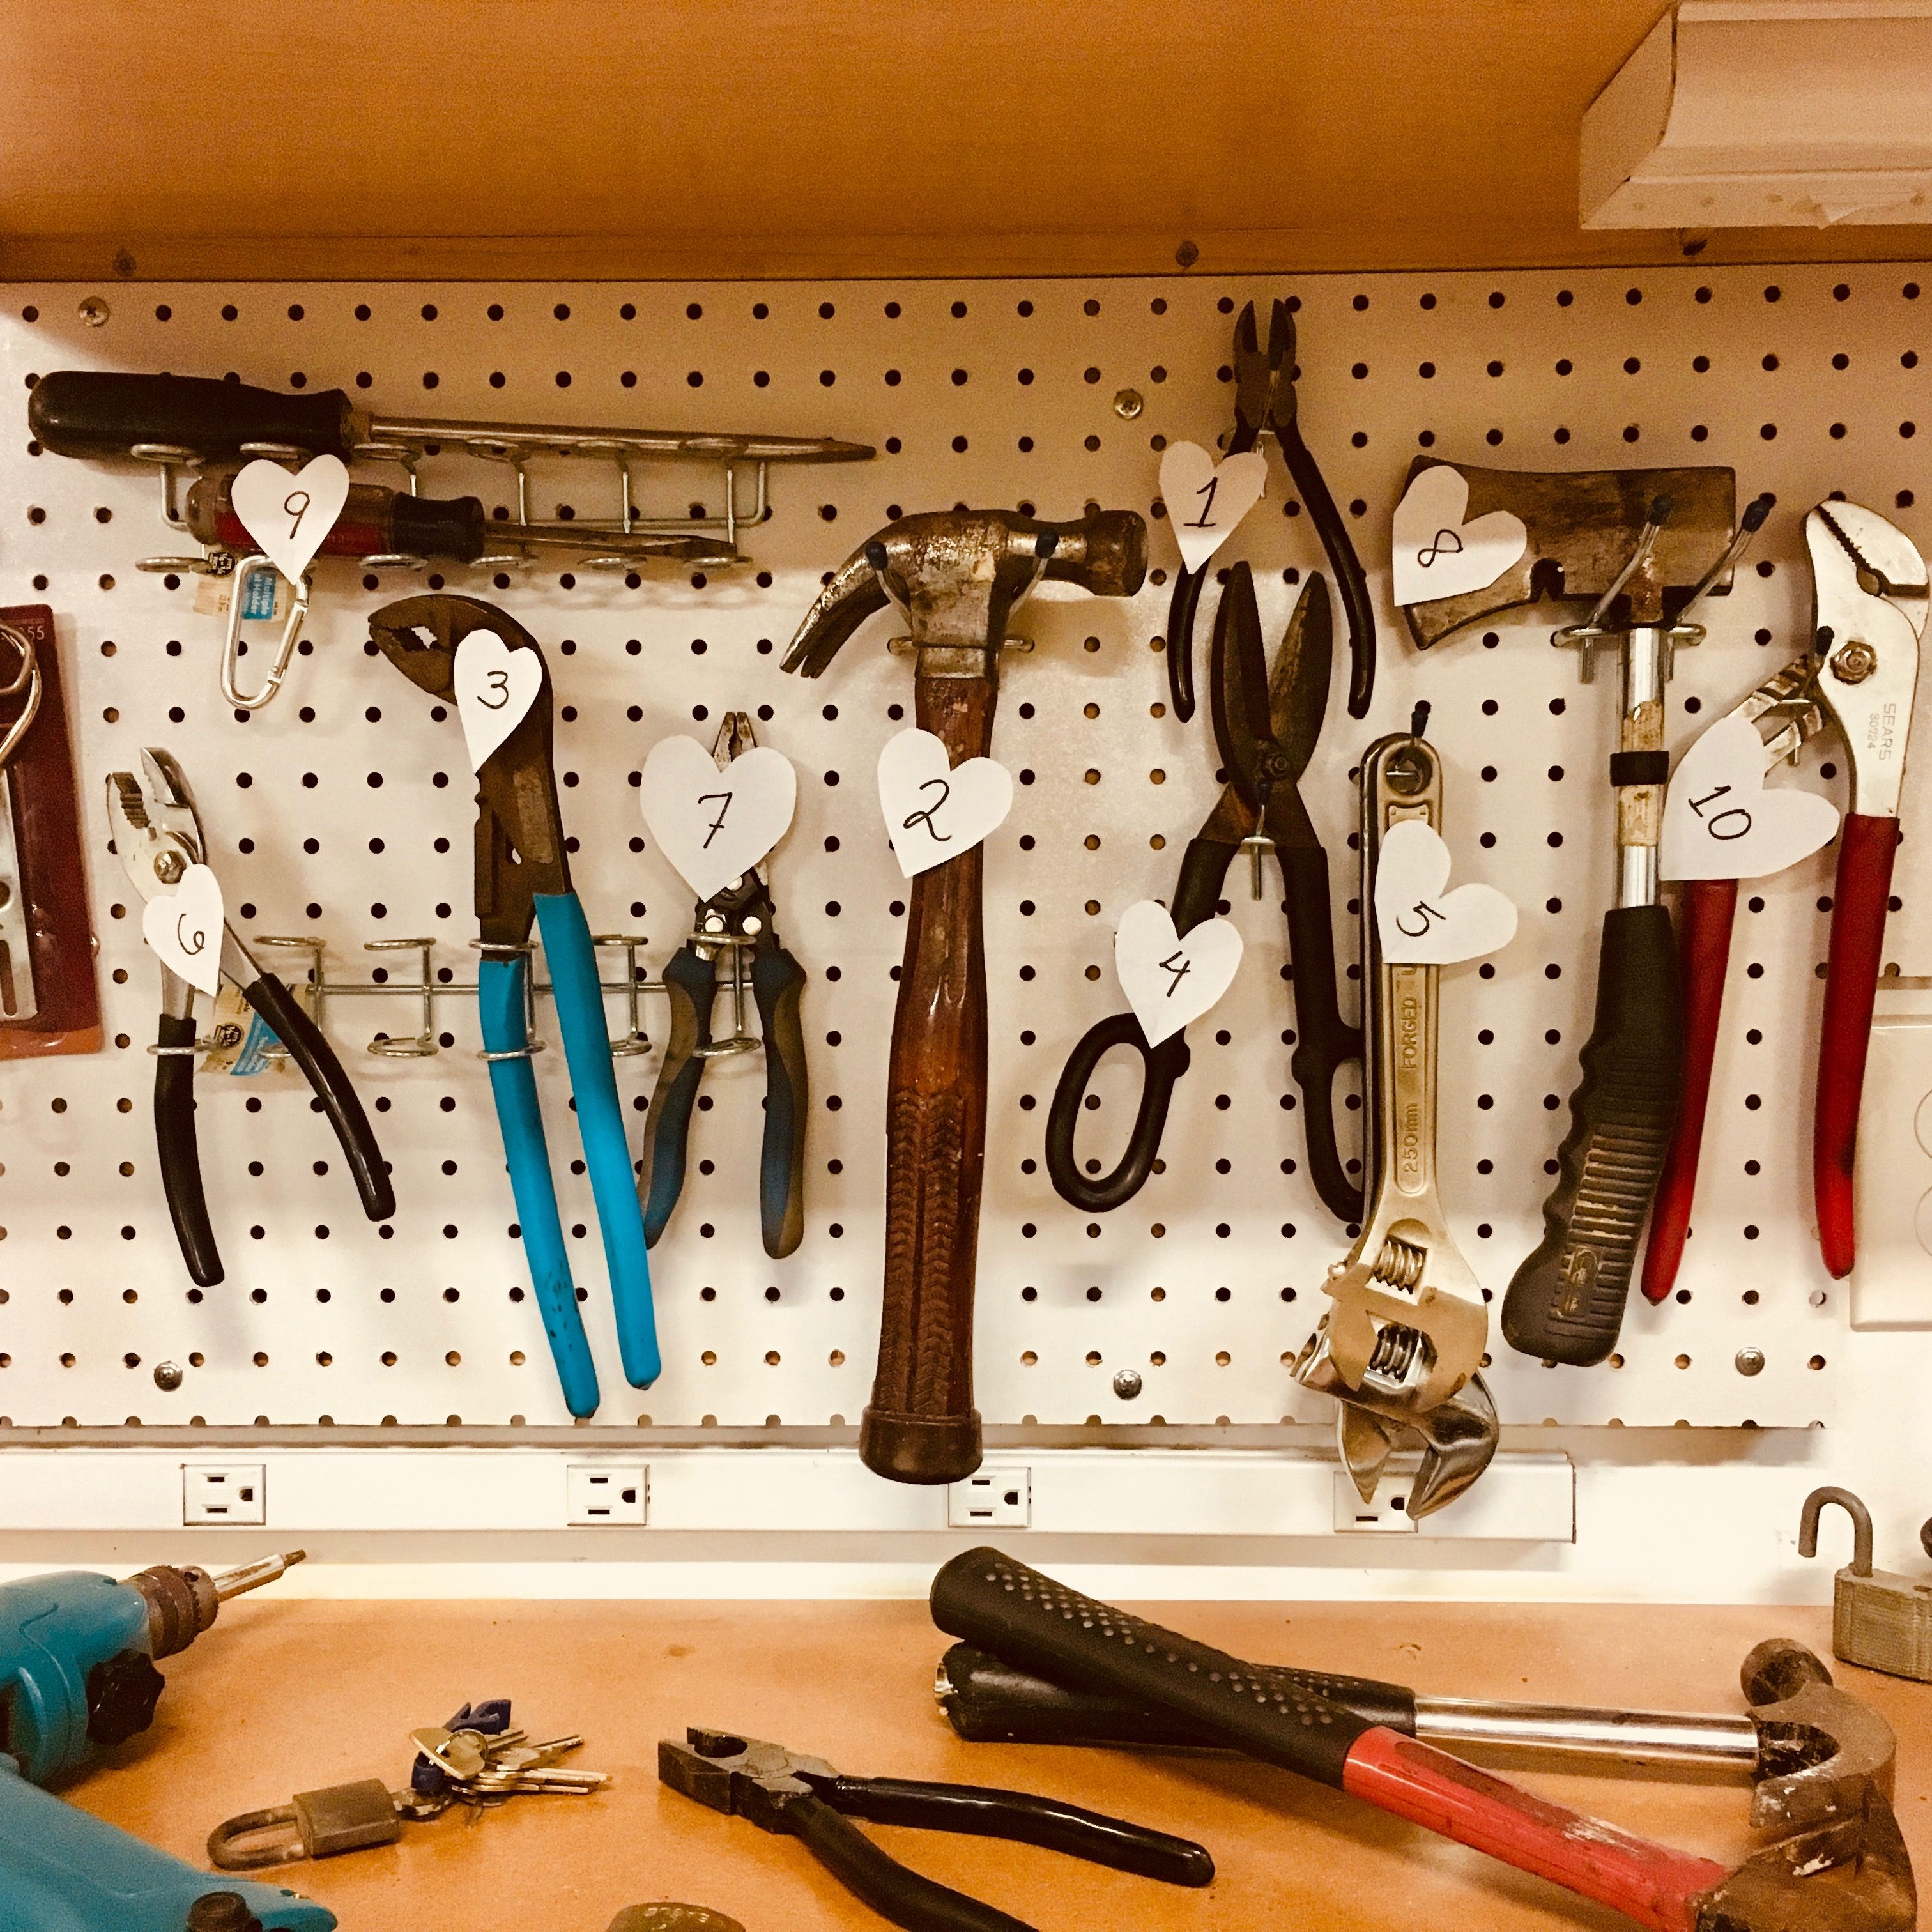
If you've spent any time in woodworking shop tours, you've seen a wall covered in identical wood strips with jigs, drawers, and tool holders hanging off them like they're floating. That's a French cleat system — one of those shop upgrades that looks fussy until you build one, then you wonder why you put up with pegboard sagging under a router base for five years.

What a French cleat actually is
A French cleat is just a strip of wood with one edge ripped at a 45-degree bevel, mounted to the wall with the bevel's long point facing up. Every tool holder, shelf, drawer, or jig storage box gets a matching 45-degree-beveled strip screwed to its back, angled the opposite direction. Set the tool's cleat against the wall cleat and slide it down — the two bevels lock together under the weight of the tool, so gravity is doing the holding, not a couple of screws or hooks. Lift straight up and it slides right back off. That's the entire mechanism. No clips, no pins, no proprietary hardware.
📷 Photo placeholder — close-up side profile shot showing two beveled cleat strips interlocked, one mounted to a wall and one screwed to the back of a tool holder, clearly showing the 45-degree bevel match

Why it beats pegboard for heavier or bulkier items
Pegboard's weakness isn't the board itself, it's the attachment point. A pegboard hook grabs two small holes, and the load is concentrated on whatever thin metal hook is in those holes. Hang a 8-pound circular saw holder off two pegboard hooks and you'll watch it slowly tear the holes into ovals over a few months, especially in 1/8" tempered hardboard pegboard rather than the thicker 1/4" stuff.
A French cleat spreads the load across the entire length of wherever the two bevels are in contact — on a 12"-wide tool holder, that's 12 inches of wood-on-wood bearing surface, not two small hook points. That's why cleat systems are standard for miter saw stations, router table cabinets, and drawer units holding 30-40 pounds of hardware — loads that would destroy pegboard mounting points in short order. For genuinely heavy modules, like a full tool chest drawer, shops often stack multiple cleats vertically on the same holder to spread the load further.

The real tradeoffs
Cleats aren't strictly better — they cost more time and material up front. A pegboard install is a sheet of pegboard, some spacers, and an afternoon. A cleat wall means ripping a full sheet of plywood into consistent 45-degree strips (which takes a table saw set up correctly and won't forgive an inconsistent angle), then mounting rows of them across studs with real screws, not just nailing hardboard to furring strips. Expect a half-day to a full day to get a decent-sized wall cleated, versus an hour or two for pegboard.
What you get for that time is total reconfigurability. Pegboard limits you to whatever hole pattern exists — move a hook an inch and you're picking a different hole. A cleat wall lets you hang, slide, and rearrange anything anywhere along the strip's length, and swap an entire module in under 10 seconds. If you rearrange your shop layout more than once a year, or you're building jigs faster than you can find wall space, that flexibility pays for the extra build time fast.
📷 Photo placeholder — wide shot of a full shop wall covered in horizontal French cleat strips with a mix of tool holders, small drawers, and a jig hanging at different positions, showing the reconfigurable layout in use

A simple build spec
The standard build uses 3/4" plywood, ripped into strips 3-4 inches wide on a table saw with the blade tilted to 45 degrees. Rip enough strips to cover your wall in horizontal rows spaced roughly 12-16 inches apart vertically (tighter spacing if you're hanging a lot of small, heavy items; wider spacing is fine for lightweight jigs and shelving). Mount the wall-side strips with the bevel's high point facing up and out — that orientation is what lets the mating cleat hook down onto it and lock under gravity instead of just resting there. Screw through the strip into studs, not just drywall anchors; a fully loaded cleat wall can carry hundreds of pounds, and that load needs to transfer into framing. On the tool-holder side, the mating strip mounts the opposite direction so the two bevels nest together when hung.
A lot of builders settle on a 16" or 32" module (matching stud spacing) so cleats always land on solid backing without extra blocking. If you'd rather not mill your own, a French cleat wall storage system kit gets you consistent bevels without a dead-accurate table saw setup, though it costs more per linear foot.

When pegboard or a plain shelf is honestly the better call
Don't cleat your whole shop just because it looks good in photos. For small, lightweight hand tools — pliers, clamps, measuring tools, screwdrivers — pegboard is faster to install, cheaper, and just as functional; that weight is well within what a pegboard hook handles indefinitely. Same goes for consumables and small parts bins, where a plain shelf beats building individual cleat-mounted holders for every little box. Cleats earn their keep on the heavier, bulkier, or frequently-reconfigured stuff — save the build time for where it matters.
Whichever system you land on, keeping track of what's mounted where (and what still needs a home) is easier with your shop laid out digitally first — map out your wall storage and clearance zones in Kerph before you start ripping plywood.

