Your First Ten Tools: What to Actually Buy
A real, prioritized shopping list for a new woodworking shop — what to buy first, what can wait, and why order matters more than most beginners think.
Category: Beginner Basics | Tags: beginner, tools, buying guide, shop setup, first tools | Author: Kerph Team
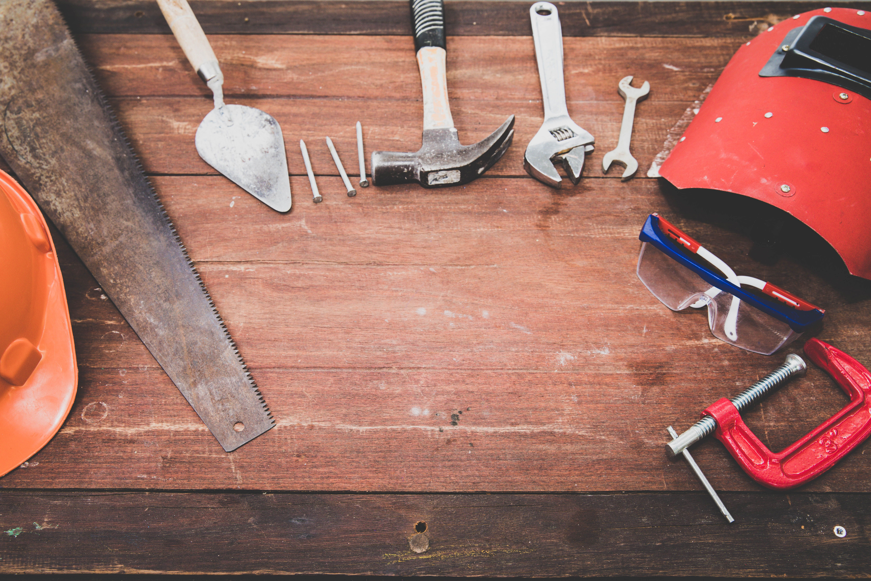
Every new woodworker asks the same question in a different order: "What do I actually need to start?" The honest answer is that you need almost nothing to begin, and the wrong ten tools will cost you more than the right five. This list is built on sequence, not just a shopping cart — each tool earns its spot because of what it lets you do that the one before it couldn't, and skipping ahead usually means buying the same category twice. Total cost across this whole list, buying mid-grade instead of bargain-bin, runs somewhere between $900 and $1,800 depending on how much you already own and how many sales you catch.

1. Safety gear — hearing, eyes, and dust, from day one
This isn't tool #10 padded onto the end of a list, it's #1, and it's non-negotiable before the first cut. A pair of earmuffs rated around 25-30 NRR, safety glasses that actually wrap (not the flimsy ones that fog and slide), and a basic N95 or half-face respirator for sanding and finishing. A 3M earmuff set runs $20-25 and will outlast every power tool on this list. Hearing damage and lung damage are cumulative and permanent — you don't get a warning shot.

2. A quality tape measure and combination square
Everything you build depends on two things: measuring correctly and marking a true line. A 25-foot Stanley FatMax tape measure ($15-20) and a 12-inch combination square you actually check for square out of the box — cheap ones are frequently off by a degree or more, which compounds into visibly crooked joints. Spend $25-35 on a square that's actually flat and true rather than $8 on one you'll fight for years.
📷 Photo placeholder — a combination square held against a factory-edge board with a bright light behind it, showing how to check the blade for true square (a real gap-check demonstration shot)

3. A decent drill/driver combo kit
An 18V or 20V brushless drill and impact driver combo kit is the single most-used pair of tools in most shops — driving screws, drilling pilot holes, driving hardware, even mixing finish. DeWalt's 20V combo kit or the equivalent from Makita or Ryobi lands around $150-200 with two batteries and a charger, and picking a battery platform here matters — every future cordless tool you buy (sander, router, vacuum) should share that battery system so you're not juggling three chargers.

4. A circular saw and a straightedge guide
Before you own a table saw, a circular saw paired with a clamp-on straightedge does 80% of what a table saw does for breaking down sheet goods and rough-cutting lumber to length — for a fraction of the price and a fraction of the floor space. A Makita circular saw runs $100-150, and a 50-inch aluminum straightedge guide is another $40-60. This combo is genuinely how a lot of experienced woodworkers still break down full sheets of plywood, table saw or not — a 4x8 sheet doesn't fit through most benchtop saws without a struggle anyway.

5. A random orbital sander
Hand-sanding a tabletop flat is a special kind of miserable. A 5-inch random orbital sander — the Bosch ROS20VSC is a common recommendation around $70-90 — variable speed, hook-and-loop discs, and it'll carry you through 90% of your finishing prep for years. Grab it with a stack of 120, 150, and 220-grit discs and you're set.
📷 Photo placeholder — random orbital sander in use on a tabletop, dust collection bag visible, showing proper two-handed grip and flat sanding technique

6. Clamps — more of them than feels reasonable
Nobody who's been woodworking more than a year says they own too many clamps. Start with a mix: four to six 24-inch Bessey parallel clamps for glue-ups (roughly $25-35 each, so budget $150-200 for a starter set), plus a handful of cheap spring clamps and quick-grip clamps for everyday holding and jig work. Glue-ups fail — joints creep apart, panels bow — almost exclusively because someone didn't have enough clamps on hand when the glue started grabbing.

7. A benchtop or contractor table saw
Once budget allows — and only once you've confirmed you'll use it regularly — a table saw is where accurate, repeatable rip cuts happen. A benchtop saw like the DeWalt DWE7485 compact jobsite saw runs $400-500 and is genuinely capable for a home shop. This is intentionally #7 on this list, not #1 — a lot of beginners buy a table saw before they own a single clamp, and end up with an expensive machine and nothing to actually finish a project with.

8. A shop vacuum
A wet/dry shop vac in the 6-10 gallon range does double duty: dust collection at the source when hooked to a sander or saw, and general cleanup. A RIDGID wet/dry shop vac runs $80-120 and includes the lifetime service agreement RIDGID is known for. Fine dust buildup isn't just annoying, it's a real respiratory and fire hazard over time, so this earns its spot well before anything cosmetic.

9. A router and a basic bit set
A router unlocks edge profiles, dadoes, mortises with a jig, flush-trimming, and joinery you simply can't do with the tools above it on this list. A mid-size fixed/plunge combo kit like the Bosch 1617EVSPK runs $180-220 and covers both handheld routing and router-table use if you build or buy a table later. Pair it with a basic 8-15 piece carbide bit set to start.

10. A basic chisel set
Rounding out the list: a set of four bevel-edge chisels (1/4", 1/2", 3/4", 1") for cleaning up joinery, paring, and the hand-work that power tools can't finish cleanly. Narex bevel-edge chisels are the standard beginner recommendation — genuinely good steel for $50-70 a set, well above bargain hardware-store chisels without jumping to premium Japanese or boutique pricing. They arrive dull enough that learning to sharpen them is basically mandatory, which isn't a bad first lesson to have.
This order assumes general furniture and project work — building shelves, tables, cabinets, boxes. If you're headed toward a specialty like turning or carving, the list changes completely: a lathe and turning tools, or carving gouges and a good bench vise, jump straight to the top and most of this list waits. For everything else, this sequence keeps you building real projects at every step instead of stalling out waiting for the "right" tool to show up. Once you've got a few of these in the shop, tracking what you own and what's still on the list in Kerph beats trying to remember it from memory at the store.

