Sharpening Chisels and Plane Irons: A Realistic Beginner's System
A simple three-stone system, one angle that actually matters, and how to know you've hit the edge — no sharpening cult required.
Category: Sharpening | Tags: sharpening, chisels, plane irons, honing, stones, hand tools | Author: Kerph Team
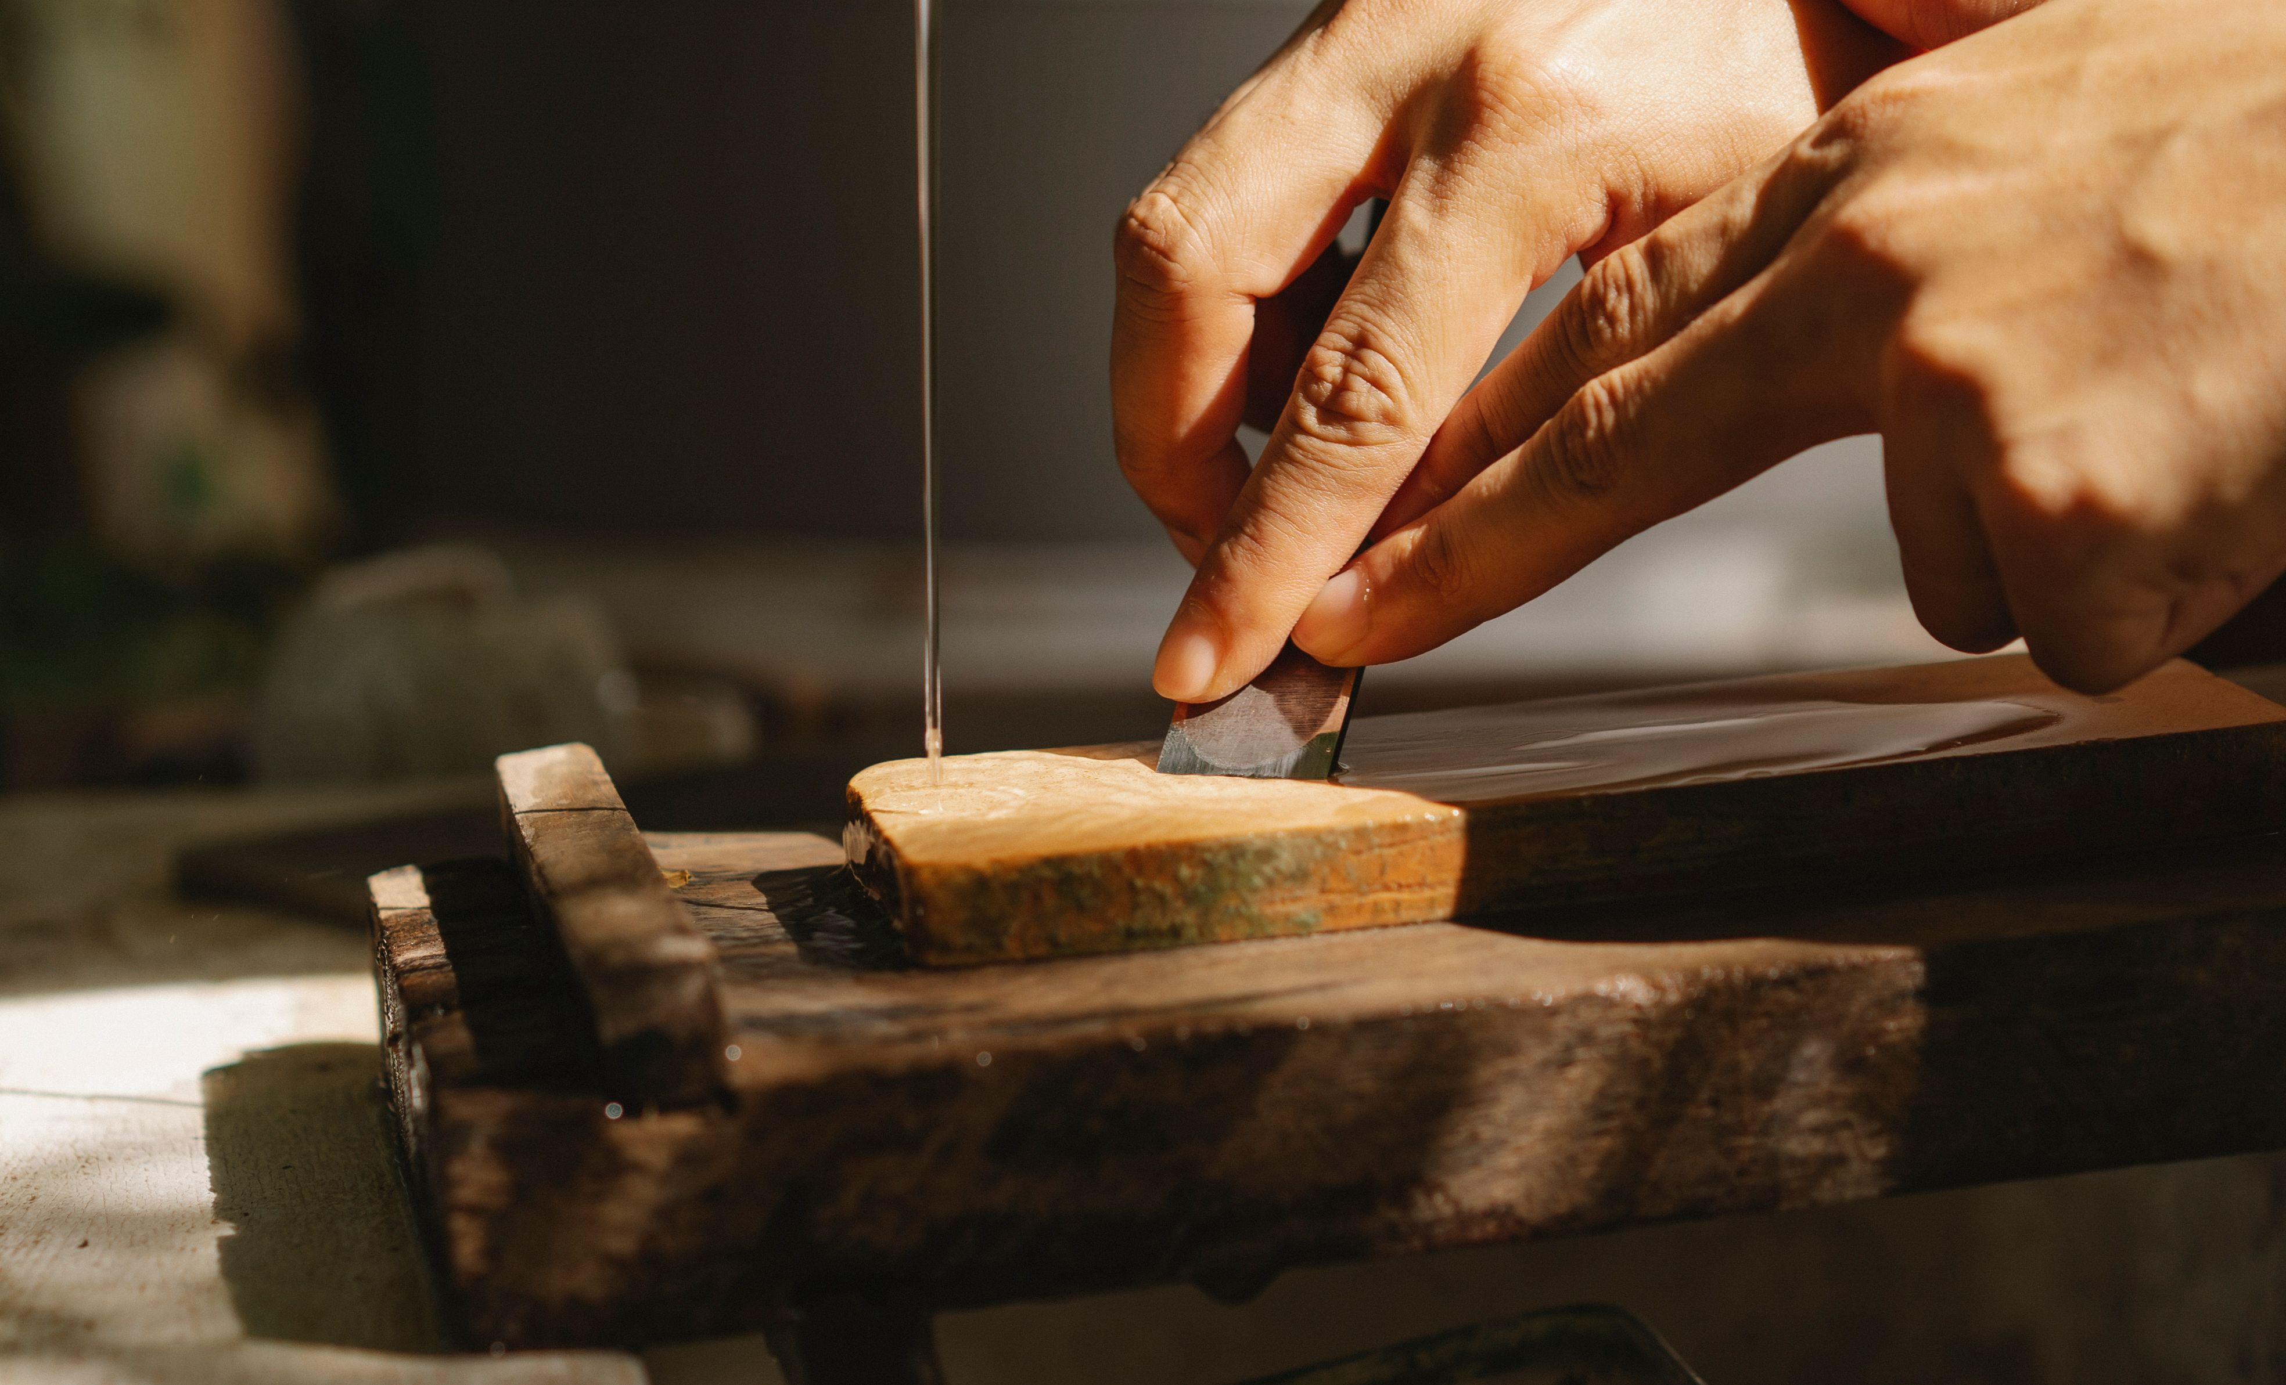
Sharpening has more internet opinions attached to it than almost any other woodworking skill, most of them aimed at people who are already good at it. If you're starting from zero, ignore the debates about Japanese waterstones versus oilstones versus 8,000-grit ceramic and start with a system you'll actually use every week. Here's one that works, doesn't require a chemistry degree, and gets you a genuinely sharp edge in about five minutes once you've done it a dozen times.

The stone progression: three grits, not ten
You need coarse, medium, and fine — that's it. A combination diamond plate set covering roughly 325, 1000, and a fine finishing stone around 8000 grit is the most forgiving setup for a beginner, since diamond plates stay flat forever (no flattening ritual required) and cut consistently regardless of pressure. A set like the DMT Diamond Whetstone line covers this well. Prefer the traditional route instead? A combination waterstone with 1000 grit on one side and 6000 on the other, plus a coarse 220-grit stone for repairs, gets you to the same place for less money — waterstones just need periodic flattening on a flattening plate.
• Coarse (220-400 grit): for repairing a chip, fixing a rolled edge, or re-establishing a bevel from scratch. You won't touch this stone often once your tools are in good shape.
• Medium (1000 grit): your everyday sharpening stone. Most sharpening sessions start and mostly happen here.
• Fine (6000-8000 grit): polishes out the medium-stone scratches and brings the edge to its final sharpness.
📷 Photo placeholder — three sharpening stones laid out side by side on a bench (coarse, medium, fine), labeled or visibly different in color/texture, with a chisel resting across them

25 degrees primary, 30-degree micro-bevel — and why consistency beats precision
The angle that matters is the one you can repeat every time, not the theoretically perfect one. A 25-degree primary bevel with a 30-degree secondary micro-bevel is the standard beginner setup: 25 degrees gives a strong enough edge for bench chisel and plane iron work without being too obtuse to cut cleanly, and the micro-bevel — a tiny secondary facet maybe 1/32" wide, honed slightly steeper right at the tip — means you're polishing just a sliver of steel on touch-ups instead of the whole bevel face, plus it adds a bit of extra support where the edge takes the most abuse.
New sharpeners obsess over hitting an exact angle and miss the point: a slightly-off-but-consistent angle sharpens faster and more predictably than a "perfect" angle you can't reproduce freehand. A bevel that wanders between sessions means removing far more steel than necessary just to re-establish a clean line, and edge quality becomes a coin flip.

Why a honing guide is worth it, freehand purists aside
There's a strain of woodworking culture that treats freehand sharpening as the "real" skill and honing guides as training wheels. Ignore it. A honing guide — something like the Veritas honing guide — clamps the blade at a fixed, repeatable angle and removes the hardest variable in sharpening: holding a consistent angle by feel while your hand also moves the blade. Freehand sharpening is a genuinely useful skill eventually, built over years of repetition, but a beginner doesn't need to fight two learning curves at once. A $40-50 honing guide gets consistent, sharp edges from week one, and plenty of professional furniture makers use one permanently rather than "graduating" off it.
📷 Photo placeholder — a chisel locked into a honing guide, positioned on a sharpening stone at the start of a stroke, showing the guide's roller and angle-setting mechanism clearly

How to actually tell you've reached the edge: the burr
This is the part beginners get wrong most — judging sharpness by how the edge looks instead of how it feels. When you've removed enough steel on the bevel side to reach the very edge, a thin ribbon of displaced metal folds over onto the flat back side. That's the burr, sometimes called a wire edge. Run a fingernail lightly across the back of the blade, perpendicular to the edge, and you'll feel a slight catch or roughness the entire length. That catch is proof you've sharpened all the way to the apex, not just polished the bevel short of it. No burr means you stopped too early, no matter how shiny the bevel looks.
Once you've raised a burr along the whole edge on the medium stone, flip to the back and lay it flat with a couple of light passes to remove the burr, then move to the fine stone and repeat at progressively lighter pressure until the burr is barely perceptible — then strop it off entirely.

Stropping: the 30-second edge that skips the whole process
A strop — a strip of leather charged with polishing compound, or a piece of MDF loaded with green honing compound — isn't a full sharpening session, it's a touch-up. A few passes pulls off the microscopic wire edge left over from honing and realigns the tip of the steel, which is usually all a chisel or plane iron needs between full sharpenings if it's being used regularly and not abused. Keep a strop sitting right on the bench and use it every 15-20 minutes of active paring or planing — it takes less time than walking to get coffee, and means you'll actually reach for it instead of pushing through a dulling edge.
A sharp chisel is safer, faster, and leaves a cleaner cut than a dull one fighting its way through the wood — worth building this into your regular shop routine rather than treating it as an occasional chore. If sharpening stones and honing guides are new additions to your kit, comparing options before you buy is worth the ten minutes it takes.

