The Shop Maintenance Guide: Table Saw, Band Saw & Jointer/Planer
Nobody skips maintenance on purpose -- it happens because there's no rhythm to it. A weekly, monthly, and quarterly routine for the three stationary tools doing the most work in a typical shop.
Category: Tool Maintenance | Tags: maintenance, table-saw, band-saw, jointer, planer, tool-care | Author: Kerph Team | Video: https://www.youtube.com/watch?v=tuCD1nJSY4Q
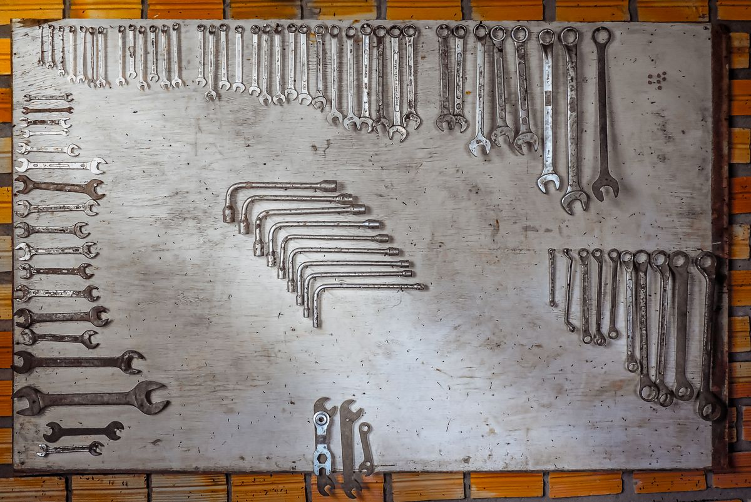
Nobody skips maintenance on purpose. It happens because there's no rhythm to it -- "I'll get to it" quietly turns into six months of pitch buildup and a fence that's crept out of true. None of what follows is complicated. It just needs a schedule, and most of it takes less time than finding the right allen wrench.
📷 Photo placeholder — a freshly waxed table saw top with a hand buffing it, cloth and paste wax can visible in frame.
This covers the three stationary tools doing the most work in a typical shop, on a weekly, monthly, and quarterly rhythm loose enough to actually stick to.

Table Saw
Weekly, it's really just housekeeping: brush and vacuum the sawdust out from under the table and off the motor housing (buildup around the motor is a heat problem, not just a mess), wipe the table down, and glance at the blade for resin buildup.
Monthly is where it actually matters. Rip a test board and check it against a combination square to confirm the blade's still parallel to the miter slot -- this is the single most common thing that drifts, and the thing most people never think to check. Wax the table and fence rails with a paste wax (a spray lubricant just attracts more dust than it repels), check the throat plate for chipping, and confirm the riving knife is still lined up with the blade.
Every few months, go a level deeper: check the drive belt's tension and condition, look for any trunnion bolts that have worked loose from vibration, and vacuum out the inside of the cabinet. That's where the fine dust actually collects, and it's the part everyone forgets exists.

Band Saw
📷 Photo placeholder — a band saw's lower wheel housing open, showing the wheel, tire, and a brush clearing dust out of it.
Band saw blades pick up resin and pitch constantly, and it's much easier to brush off fresh than after it's baked on for a month. That alone is worth doing weekly, along with a quick check on blade tracking and clearing dust from the lower wheel housing.
Once a month, check blade tension (a flex test works fine, or a real tension gauge if there's one around) and look at the guide bearings and blocks -- they should make light, even contact with the blade, not drag against it or float clear of it. Clean and wax the table while you're in there.
If tensioning by feel makes you nervous the first few times, this walkthrough shows the process start to finish.
Every few months, look over both wheel tires for glazing or cracking, put a little lubricant on the trunnion, and confirm the upper and lower wheels are still coplanar. A saw that's drifted out of alignment there is the single most common reason a blade won't stop wandering off the line, and most people chase every other explanation first.

Jointer & Planer
📷 Photo placeholder — a jointer cutterhead with a brush clearing chip buildup from between the knives, tables visible on either side.
These two get grouped together because the failure mode is basically identical: chip buildup wrecking an otherwise good cut. Weekly, clear the cutterhead and the infeed/outfeed rollers, and wipe the tables down.
📷 Photo placeholder — a thickness planer's dust chute partially removed, showing chip buildup inside it before clearing.
Monthly, check that the jointer's infeed and outfeed tables are still coplanar (and wax them while you're there), look over the knives or cutterhead inserts for nicks, and confirm the fence is still square.
This video shows the actual dial-indicator process for checking table coplanarity, if it's not something you've done before.
Every few months, rotate or resharpen the knives, check belt or chain tension, lubricate the planer's lift screws, and clear out the dust chute. A partially clogged chute is a sneaky, easy-to-miss cause of chip marks showing up on the workpiece for no obvious reason.

The maintenance log that actually survives
Sticky notes and paper logs rarely make it past the first month. They work a lot better attached to the tool record itself than living in a notebook that gets buried on a shelf somewhere. Kerph's My Tools list has maintenance reminders built in per tool, so the schedule runs itself instead of depending on memory.

