Dust Collection Setup: Tips & Tricks for a Shop That Actually Breathes
Dust collection fails quietly. Sizing, layout, and the small mistakes that quietly rob a dust collector of half its suction -- a practical list for planning or fixing your shop's dust collection.
Category: Dust Collection | Tags: dust-collection, shop-setup, airflow, safety | Author: Kerph Team | Video: https://www.youtube.com/watch?v=NzBZk1NxQfg
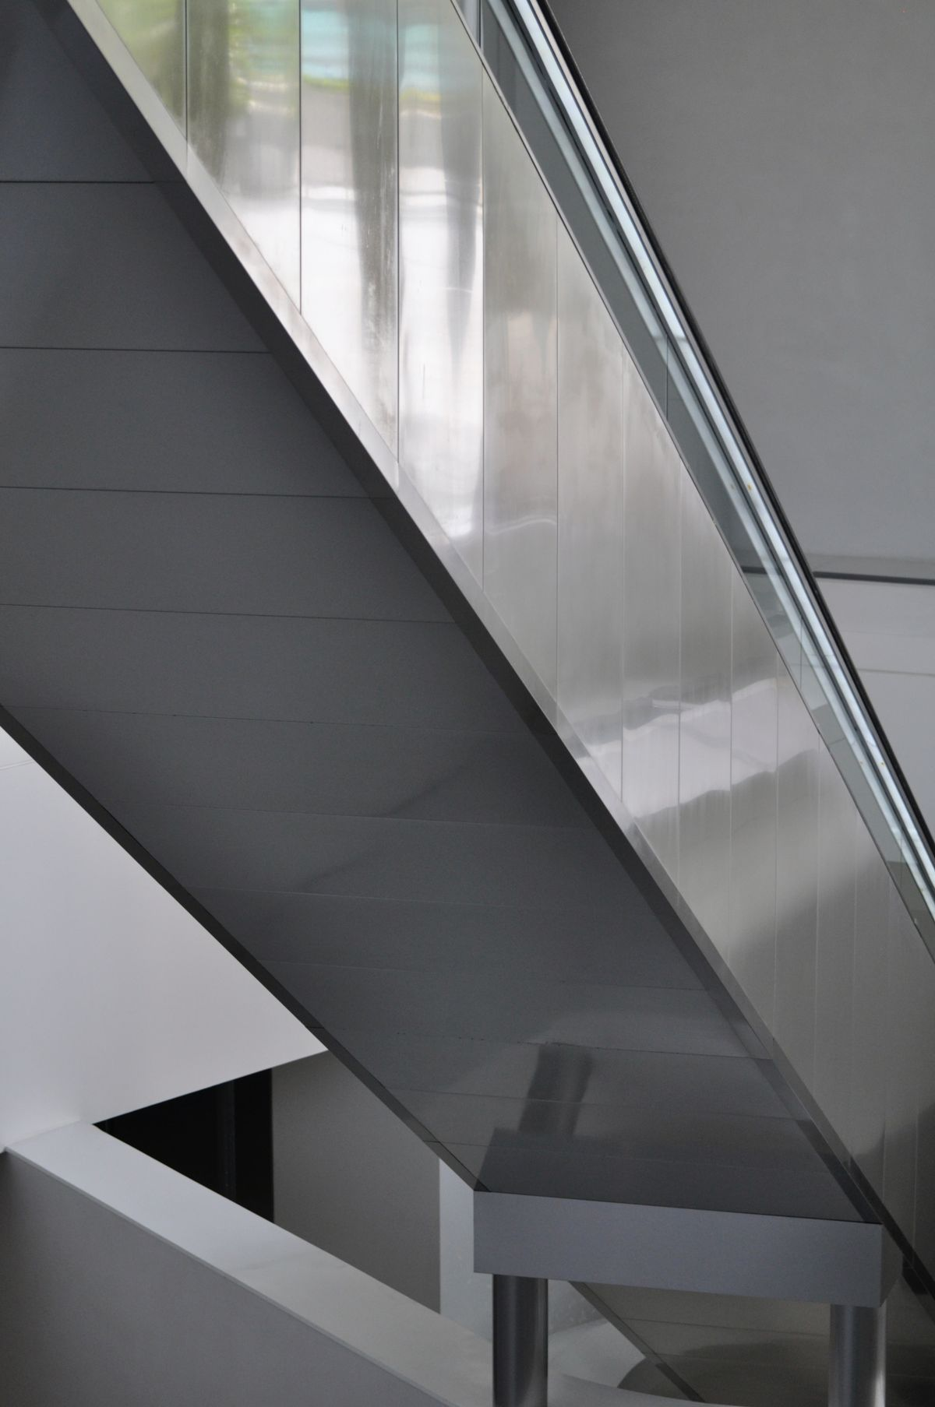
Dust collection has a way of failing quietly. A collector rated for 1,200 CFM can end up moving a few hundred by the time the air actually reaches the far end of an undersized branch line, and a shop just slowly fills up with fine dust that nobody notices accumulating until it's everywhere. The collector matters less than most people think. The system around it is what actually decides whether it works.
📷 Photo placeholder — a single-stage dust collector (e.g. a JET DC-1100VX) in a shop corner with its main trunk line running off toward the ceiling, showing real duct sizing for scale.

Size the main trunk to the collector, not the biggest machine
The main trunk needs to move as much air as the collector can actually produce -- undersize it and the whole system chokes, no matter how good the collector is. A common single-stage 1–2 HP setup, like a JET DC-1100VX, runs a 4"–6" main trunk; check the collector's rated CFM against a duct sizing chart before committing to a diameter, because guessing here is the single most common way a new dust collection system underperforms from day one.

Branch lines can step down, but do the CFM math first
Branch runs to an individual machine can usually step down from there, often to 4" for a single-machine drop. What actually matters is whether that branch can still deliver the CFM the tool needs -- a table saw wants somewhere around 350–400 CFM at the cutting zone, a jointer or planer with a wide cutterhead closer to 400–450+. A branch that looks fine on paper but runs too long, or has one too many fittings in it, can still starve the tool at the far end.
This walkthrough covers the CFM math in more detail if you want to run the numbers yourself before buying pipe.

Blast gates: one open at a time
Every blast gate left open splits the collector's suction across all of them, which is a very easy way to end up with a system that "should" be moving plenty of air but doesn't feel like it at any single machine. Close everything except whatever's actually running -- it's the single cheapest fix available, and it costs nothing but a habit. Kerph's Workshop Planner has a dedicated Dust Collection layer for placing and labeling blast gates right on the actual shop layout, so it's obvious at a glance which gate belongs to which run.
📷 Photo placeholder — a cyclone separator (e.g. an Oneida Super Dust Deputy) mounted between a shop vac and the ductwork, showing the debris bin underneath.

Minimize elbows, maximize sweep
Every 90° elbow costs roughly as much static pressure as several feet of straight pipe. Two 45s, or a long-sweep 90 instead of a tight one, move the same air with noticeably less resistance -- worth the few extra dollars in fittings on any run longer than a few feet.

Ground it if you're running plastic pipe
PVC and other plastic ducting build up static charge as dust moves through it, which is worth taking seriously rather than dismissing as shop folklore. Running a grounding wire through or along the inside of the pipe, bonded to a real ground, is standard practice for plastic dust collection systems -- do it from the start rather than after something gets somebody's attention.

Filter micron rating matters more than bag size
A big felt collection bag looks like it's doing the job, but standard bags are usually only rated down to somewhere around 30–75 microns. The dust that actually matters for lungs sails right through that and settles right back over the shop. Swapping to a 1-micron canister or cartridge filter is, dollar for dollar, probably the single highest-impact upgrade a dust collection system can get.

Plan the system before the pipe goes up
Duct runs are a lot easier to size right on a layout than to rebuild after the fact. Kerph's Dust Collection layer includes a sizing calculator that checks branch-vs-main duct sizing against a real collector fan curve and estimates system cost before a single foot of pipe gets bought -- worth ten minutes before committing to a path.

